AWS Certified Solution Architect Associate

How to choose region?

1. Compliance
   1. Compliance with data governance and legal requirements
2. Proximity
   1. Proximity to customers
   2. Reduced latency
3. Available services
   1. New services and features are not available in every region
4. Pricing
   1. Pricing varies region to region and is transparent in the service pricing page

AWS Availability Zone

1. Collection of one or more discrete data centers with redundant power, networking and connectivity, housed in a separate facility (usually 3, min 2, max 6)
2. They are physically isolated, connected with one another with the help of high bandwidth, low latency link

AWS Point of Presence (Edge Locations)

Global Services

1. IAM
2. CloudFront
3. WAF
4. Route 53

Regional Services

1. EC2
2. Elastic Beanstalk
3. Lambda
4. Rekognition

IAM

It is global service.

It controls authentication and authorization within an AWS account.

IAM is not used for application-level authentication.

Identity- who can access your resources

Access- what are the resources they can access

Identities

1. Root Users
2. Individual Users
3. Groups
4. Roles

Access

1. Policies
2. Customer managed Policies
3. AWS managed Policies
4. Permissions boundaries

Users

* Person or application who need to access AWS resources
* IAM users can be created to represent applications and these are known as “service accounts”.
* Each IAM user has three main components:
  + A username.
  + A password.
  + Permissions to access various resources.
* You can have up to 5000 users per AWS account.
* Each user account has a friendly name and an ARN which uniquely identifies the user across AWS.
* A unique ID is also created which is returned only when you create the user using the API, Tools for Windows PowerShell or the AWS CLI.
* The Access Key ID and Secret Access Key are not the same as a password and cannot be used to login to the AWS console.
* The Access Key ID and Secret Access Key can only be used once and must be regenerated if lost.
* A password policy can be defined for enforcing password length, complexity etc. (applies to all users).

Groups

* Group of users who have common access controls
* Groups are collections of users and have policies attached to them.
* A user can belong to multiple groups.
* A user need not always belong to a group. Policy attached to such user is called inline policy. But this is not best practice.
* You cannot nest groups (groups within groups). Group can only contain users not another group.

Roles

Assumed, no long-term credential, temporary credential, federated account, can delegate using roles, no credential associated with roles

* An IAM role is similar to an IAM user, in that it is an AWS identity with permission policies that determine what the identity can and cannot do in AWS. However, instead of being uniquely associated with one person, a role is intended to be assumable by anyone who needs it.
* A role does not have standard long-term credentials such as a password or access keys associated with it. Instead, when you assume a role, it provides you with temporary security credentials for your role session.
* Roles are created and then “assumed” by trusted entities and define a set of permissions for making AWS service requests.
* With IAM Roles you can delegate permissions to resources for users and services without using permanent credentials (e.g. user name and password).
* There are no credentials associated with a role (password or access keys).
* A role can be assigned to a federated user who signs in using an external identity provider.
* IAM roles with EC2 instances
  + Only one role can be assigned to an EC2 instance at a time.
  + A role can be assigned at the **EC2 instance creation time or at any time afterwards.**

Policies

* You can manage permissions for users and groups by creating policies document in JSON format and attaching it to specific user or group.
* Policies are documents that define permissions and can be applied to users, groups and roles.
* Policy documents are written in JSON (key value pair that consists of an attribute and a value).
* All permissions are implicitly denied by default.
* The most restrictive policy is applied.
* The IAM policy simulator is a tool to help you understand, test, and validate the effects of access control policies.

IAM Policies Structure

1. Version
2. Id: an identifier for the policy (optional)
3. Statement: one or more individual statements (required)
   1. Sid: statement identifier (optional)
   2. Effect: allow or deny (required) -> whether to allow or deny access
   3. Action: list of actions that this policy allows or denies (required)
   4. Principal: account/user/role to which this policy applies to
   5. Resource: list of resources to which the actions are applied to
   6. Condition: condition that specifies when will policy remain effective

Required fields of policy-> effect, action

IAM- Security

1. MFA
2. Password Policy

IAM – Password Policy

In AWS, we can setup a password policy

1. Set a minimum password length
2. Require specific character types
   1. Include uppercase letters
   2. Lowercase letters
   3. Numbers
   4. Non-alphanumeric characters
3. Allow all IAM users to change their own passwords
4. Require users to change their password after some time (password expiration)
5. Prevent password re-use

MFA (Multi-Factor Authentication)

1. Password you know + device you own
2. 6 digit token is generated

MFA devices options in AWS are

1. Virtual MFA Device
   1. Google Authenticator (phone only)
   2. Authy (multi-device)-> supports multiple tokens on a single device i.e. you can add as many users as you want in your MFA device.
2. U2F Security Key (Universal 2nd Factor Security Key)
   1. USB
   2. Physical device like Yubikey
   3. Supports for multiple root and IAM users using a single security key
3. Hardware MFA Devices
   1. Provided by Gemalto (3rd party)
   2. Provided by SurePassID (3rd party)

How can users access AWS?

To access AWS, we have three options

1. AWS Management Console-> protected by password + MFA
2. AWS Command Line Interface (CLI)-> protected by access keys
3. AWS Software Development Kit-> protected by access keys

Access Keys

1. Access AWS using CLI or SDK
2. Access keys are generated through AWS Console.
3. Access Key ID-> Username
4. Secret Access Key-> Password

AWS CLI

1. Open source

AWS SDK

1. AWS Software Development Kit (SDK)
2. Programmatic way to access AWS services
3. Supports
   1. SDKs (JavaScript, Python, PHP, .NET, Ruby, Java, Go, Node.js, C++)
   2. Mobile SDKs (Android, iOS,..)
   3. IoT Device SDKs (Embedded C, Arduino,..)
4. Ex: AWS CLI is built on AWS SDK for Python

CloudShell

1. Alternative to using terminal in cloud
2. Available in few regions only
3. Can increase or decrease font size
4. Can add multiple terminals
5. Can upload and download files

IAM Roles

1. Assign permissions to AWS services
2. Common Roles
   1. EC2 Instance Roles
   2. Lambda Function Roles
   3. Roles for CloudFormation

IAM Security Tools

1. IAM Credential Report (account level)
2. Access Advisor (user level)

IAM Credential Report

1. Account level
2. A report that lists all your account’s users and the status of their various credentials like passwords, access keys and MFA devices
3. Used for auditing and compliance

IAM Access Advisor

1. User level
2. Shows the service permissions granted to a user and when those services were last accessed
3. This information can be used to revise your policies and grant users with least privilege

IAM Best Practices

1. Do not use root account except for AWS account setup
2. One physical user=One AWS user
3. Assign users to groups and assign permissions to groups
4. Create a strong password policy
5. Use and enforce the use of MFA
6. Create and use roles for giving permissions to AWS services
7. Use Access Keys for Programmatic Access (CLI/SDK)
8. Audit permissions of your account with the IAM Credentials Report
9. Never share IAM users and access keys

Billing Information

1. By default, IAM user does not have permission to access Billing & Cost Management Dashboard
2. For this, we need to go to root account-> My Account-> Scroll down to section called IAM User and Role Access to Billing Information-> Check option Activate IAM Access-> Update

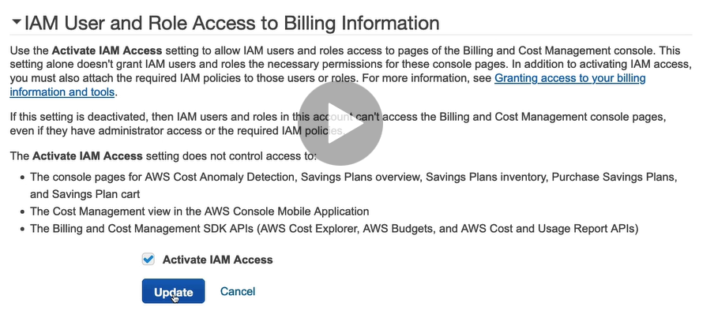

Budget

Budget Types

1. Cost Budget
2. Usage Budget
3. Reservation Budget
4. Saving Plan

Budget can be set based on actual or forecasted value.

## EC2 (Elastic Cloud Compute)

### Introduction

* Elastic Cloud Compute
* Infrastructure as a Service
* Virtual server in the cloud
* Allows you to rent and manage virtual servers in the cloud
* Has elastic compute power: It can grow and shrink based on load in your application
* Are not serverless
* You are able to provision an EC2 instance at the click of a button
* You can also use pre-configured template called AMI (Amazon Machine Image) to launch your resources.
* You will receive 750 compute hours per month on Free Tier Plan. t2.micro is part of AWS free tier.
* You can deploy your applications directly to EC2 instances.
* Amazon EC2 instances can run the Windows, Linux, or MacOS operating systems.
* **Integrated** – EC2 is integrated with most AWS services such as S3, RDS, and VPC to provide a complete, secure solution
* **Secure** – EC2 works in conjunction with VPC to provide a secure location
* **It mainly consists of following capabilities**
  + **Renting virtual server**
  + **Storing data on virtual drives (EBS)**
  + **Distributing incoming traffic (ELB)**
  + **Scaling (ASG)**

EC2 Configuration Options

1. Operating System (OS): Linux, Windows, Mac OS
2. How much compute power and cores (CPU)
3. How much random-access memory (RAM)
4. How much storage space
   1. Network-attached (EBS & EFS)
   2. Hardware (EC2 Instance Store)
5. Network card-speed of the card, public IP address
6. Firewall rules- Security Group
7. Bootstrap Script (configure at first launch)- EC2 User Data

EC2 User Data

1. It is possible to bootstrap our instances using an EC2 User data script.
2. Bootstrapping means launching commands when a machine starts.
3. This script runs only once i.e., when the instance first starts
4. EC2 User data is used to automate boot tasks such as
   1. Installing updates
   2. Installing software
   3. Downloading common files from the Internet
5. EC2 User Data Script runs with the root user

When we create an EC2 Instance, a public IP address and a private IP address is also generated. Next time on stopping same instance and starting it again, new public IP address will be generated while private IP address will still remain same.

EC2 Instance type

1. AWS has the following naming convention:
   1. m5.2xlarge
   2. m=instance class
   3. 5=generation
   4. 2xlarge=size within the instance class
2. General Purpose
   1. Balance between compute, memory and networking
   2. T2.micro is General Purpose EC2 Instance
   3. t..m
3. Compute Optimized
   1. Great for compute-intensive tasks that requires high performance processors
   2. Batch processing
   3. Media transcoding
   4. High performance web servers
   5. High performance computing (HPC)
   6. Scientific modeling and Machine Learning
   7. Dedicated gaming servers
   8. C
4. Memory optimized
   1. Fast performance for workloads that process large data sets in memory
   2. M
5. Storage Optimized
   1. Great for storage intensive tasks that require high sequential read and write access to large data sets on local storage
   2. i…d
6. Accelerated Computing

Security Group

1. Firewall at instance level
2. They control how traffic is allowed into or out of our EC2 instance
3. Contains only allow rules
4. Stateful
5. Security Group rules can reference by IP or by Security Group
6. By default, all inbound traffics is blocked. All outbound traffic is authorized.
7. Can be attached to multiple instances
8. Locked down to a region/ VPC combination. i.e. If we switch to new region or if new VPC is created, we need to create new Security Group
9. Security Group lives outside the EC2- if traffic is blocked the EC2 instance won’t even see it
10. It is good to maintain one separate security group for SSH access
11. If your application is not accessible (time out), then it is a security group issue
12. If your application gives a “connection refused” error, then it is an application error or it is not launched

Classis Ports to know

1. 22 - SSH (Secure Shell)- log into a Linux instance
2. 21 – FTP (File Transfer Protocol)- upload files into a file share
3. 22 - STFP (Secure File Transfer Protocol)-upload files using SSH
4. 80 - HTTP - access unsecured websites
5. 443 - HTTPS - access secured websites
6. 3389 - RDP (Remote Desktop Protocol)- log into a Windows Instance

SSH Summary

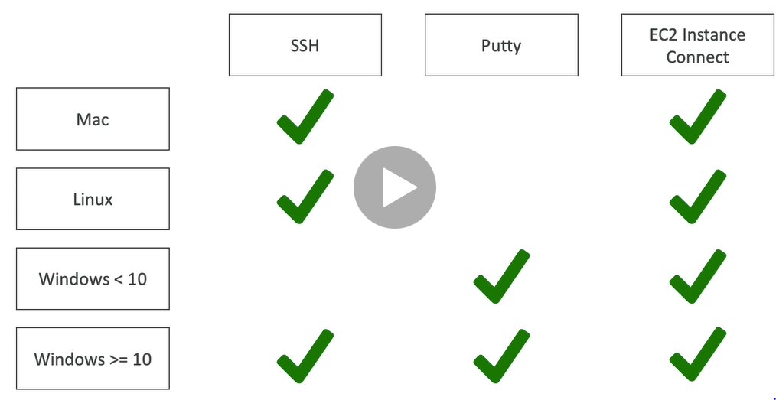

To use EC2 Instance Connect, we need to add inbound rule in Security Group sections for SSH.

### Amazon Machine Image (AMI)

* An Amazon Machine Image (AMI) is a special type of virtual appliance that is used to create a virtual machine within the Amazon Elastic Compute Cloud.
* An AMI includes the following:
  + One or more [**EBS**](https://digitalcloud.training/certification-training/aws-certified-cloud-practitioner/aws-storage/) snapshots, or, for instance-store-backed AMIs, a template for the root volume of the instance
  + Launch permissions that control which AWS accounts can use the AMI to launch instances.
  + A block device mapping that specifies the volumes to attach to the instance when it’s launched.
* AMIs come in three main categories:
  + **Community AMIs** – free to use, generally you just select the operating system you want.
  + **AWS Marketplace AMIs** – pay to use, generally come packaged with additional, licensed software.
  + **My AMIs** – AMIs that you create yourself.

### Metadata and User Data

* User data is data that is supplied by the user at instance launch in the form of a script.
* Instance metadata is data about your instance that you can use to configure or manage the running instance.
* User data is limited to 16KB.
* User data and metadata are not encrypted.
* Instance metadata is available at http://169.254.169.254/latest/meta-data.

### Instance Metadata Query

* The Instance Metadata Query tool allows you to query the instance metadata without having to type out the full URI or category names.

### EC2 in real world

1. Deploy a database

Deploy a database to EC2 gives you full control over the database.

1. Deploy a web application

Deploy web application to multiple availability zones to make web application highly available.

### Methods to access EC2 instance

1. AWS Management Console
2. Secure Shell (SSH)
3. EC2 Instance Connect (EIC)
4. AWS Systems Manager
5. AWS Management Console

* You are able to configure and manage instances via a web browser.

1. Secure Shell (SSH)

* Allows you to connect to your instance from local laptop using SSH Client and keys
* Puttygen converts .pem(privacy enhanced mail) file to ..ppk (putty private key)

1. EC2 Instance Connect

* Browser based connection
* Allows you to connect to instance without using SSH client and keys and directly using terminal in web browser
* For this, you must grant IAM users permission to push public key to the instance.

1. AWS System Manager

* Allows you to manage EC2 instances via a web browser or CLI

Note

The must common way to connect to Linux EC2 instance is via Secure Shell (SSH)

For this key pair is generated.

A key pair, consists of a private key and a public key, which proves your identity when connecting to an EC2 instance.

When user connects to SSH Client laptop, he uses private key. When he connects to EC2 instance, he uses public key.

### EC2 Pricing Model

1. On demand
2. Spot
3. Reserved Instance
4. Dedicated Hosts
5. Savings Plans
6. On demand

* Fixed price in which you are billed based on instance type used
* You pay for what you use
  + For Linux or Windows: billing per second, after the first minute
  + All other operating systems- billing per hour
* No contract
* Use on-demand instances when
  + You cannot make upfront payment or long-term commitment
  + Your applications have unpredictable workloads that cannot be interrupted
  + Your applications are under-development
  + Your applications will not run for more than a year

1. Spot

* Spot instance lets you take advantage of unused EC2 capacity
* Your request is available only if capacity is available
* Use Spot instance when
  + Your application is not concerned about start and stop time of execution
  + Your workload can be interrupted
  + Useful for workloads that are resilient to failure
  + Not suitable for critical jobs or databases
  + Applications that are only feasible at very low compute prices.
  + Users with an urgent need for a large amount of additional compute capacity.
* You can save upto 90% off on-demand prices
* You pay for spot that is in effect at the beginning of each hour
* If Amazon terminate your instances you do not pay, if you terminate you pay for the hour.
* Define max spot price and get the instance while current spot price<your max
  + If current spot price>your max price you can choose to stop or terminate your instance with a 2 minutes grace period.

1. Reserved Instance

* Allows you to commit to a specific instance type for 1 or 3 years e.g. You want to reserve t2.micro instance type
* Use reserved instance when
  + Applications with steady state or predictable usage
  + Your application has steady state usage and you can commit for 1 or 3 years
  + You can make upfront payment
  + Your application requires capacity reservation
* You can save upto 75% off on-demand prices using Standard Reserved Instance
* You are required to sign a contract of 1 or 3 years
* You can pay all-upfront, partial upfront or no upfront. All upfront for maximum term earns the highest discount
* Standard RI, Convertible RI, Scheduled RI
* Convertible RIs provide up to 54% off on-demand price – provides the capability to change the attributes of the RI as long as the exchange results in the creation of RIs of equal or greater value. We can change instance type in such type of RI.
* Scheduled RIs are available to launch within the time window you reserve. With Scheduled Reserved Instances, you can reserve capacity that is scheduled to recur daily, weekly, or monthly, with a specified start time and duration, for a one-year term.

1. Dedicated Hosts

* Allows you to pay for physical server that is dedicated to running your instances. No other AWS customers is going to have applications running on this server. The server basically belongs to you
* Use dedicated hosts when
  + You want to bring your own server-bound software license from vendors like Microsoft and Oracle
  + You have regulatory or corporate compliance requirements around tenancy model
* You can save upto 70% off on-demand prices
* You can bring your existing per-core, per-socket and per-VM software licenses.
* Available as On-Demand or with Dedicated Host Reservation.
* Each dedicated host can only run one EC2 instance size and type.
* Most expensive option.
* Billing is per host.

1. Dedicated Instance

* Virtualized instances on hardware just for you.
* Also uses physically dedicated EC2 servers.
* Does not provide the additional visibility and controls of dedicated hosts (e.g. how instance are placed on a server).
* Billing is per instance.
* May share hardware with other non-dedicated instances in the same account.
* Available as On-Demand, Reserved Instances, and Spot Instances.
* Cost additional $2 per hour per region.

1. Savings Plan

* You do not commit for specific instance type instead you commit to compute usage (measured per hour) for 1 to 3 years
* Use savings plan when
  + You want to lower your bill across multiple compute services
  + You want flexibility to change compute services, instance types, OS or regions
* You can save upto 72% off on-demand prices
* Savings can be shared across various compute services like EC2, Fargate and lambda

How to terminate Spot Instance?

1. First of all, we will create a spot request where we need to specify
   1. Maximum price
   2. Desired number of instances
   3. Launch Specification
   4. Request type-One time/Persistent
   5. Valid From, Valid Until
2. There are two type of request
   1. One time Request: As soon as instance is launched based on your request, your spot request will go away
   2. Persistent Request: Spot request will remain from valid from to valid until period of time. If somehow instance gets interrupted, spot request will get back into action and it will re-start spot instances for you. If you terminate instance but your spot request is still active, spot request will be smart enough to launch instances.
3. You can only cancel Spot Instances requests that are open, active or disabled
4. Cancelling a Spot Request does not terminate instances. It is our responsibility to terminate instances not AWS responsibility.
5. You must first cancel a Spot Request and then terminate the associated Spot instances.

Spot Fleet

1. Define a way to get a set of spot instances and optionally on-demand instances
2. It will try to meet target capacity with price constraints you define
3. Strategies to allocate Spot Instances
   1. lowestPrice
   2. diversified
   3. capcityOptimized
4. Spot Fleets allow us to automatically request Spot Instances with the lowest price

### EC2 Instance Type

1. General Purpose
2. Compute Optimized
3. Memory Optimized
4. Accelerated Computing
5. Storage Optimized

### Features

1. Elastic Load Balancing
2. EC2 Autoscaling
3. Elastic Load Balancing

* Automatically distributes your incoming traffic across multiple EC2 instances
* Types
  + Classic Load Balancer
  + Application Load Balancer
  + Gateway Load Balancer
  + Network Load Balancer

1. EC2 Autoscaling

* Scale up or scale down based on workload in your application
* Reduces impact of system failure and improves availability of your applications
* You can also use autoscaling with Aurora and DynamoDB

Classic Load Balancer

* All incoming traffics will be equally distributed among number of servers we have

Application load Balancer

* Incoming traffics are distributed based on needs of customers
* It has some level of intelligence.
* It enables content-based routing and allows requests to be routed to different application/server behind single load balance.

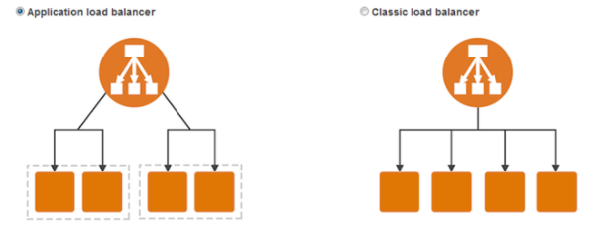

Note

Horizontal Scaling vs Vertical Scaling

Horizontal Scaling (Scaling out)- adds or replaces instances

Vertical Scaling (Scaling up)- upgrades an existing instance

Tag

Allows you to track your instance by adding key/value pair

Eg: We can add a tag to specify “This instance is dedicated for Management purpose.”

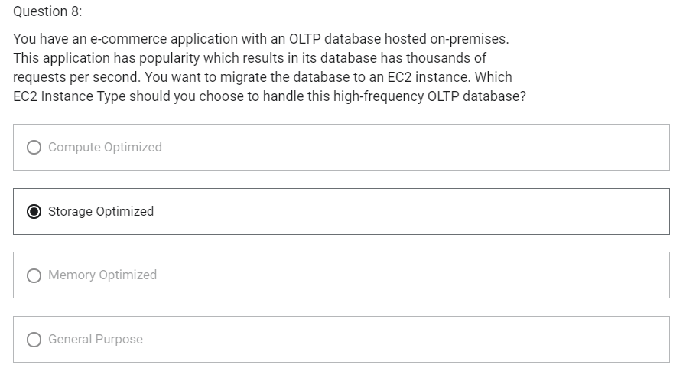

IPv4 vs IPv6 vs Elastic IP

1. Networking has two sorts of IPs:
   1. IPv4
   2. IPv6
2. When you have a public IP, you are accessible over the Internet.
3. When you have a private IP, you are only accessible within your private network.
4. Public IP
   1. Public IP means the machine can be identified on the Internet (www)
   2. Must be unique across the whole web (no two machines can have same public IP)
   3. Can be geo-located easily
5. Private IP
   1. Private IP means the machine can only be identified on a private network only
   2. The IP must be unique across the private network
   3. But two different private networks (two companies) can have same Ips.
   4. Machines connect to Internet using an Internet Gateway
   5. Only a specified range of IPs can be used as private IP
6. Elastic IP
   1. When you stop and then start an EC2 instance, it can changes its public IP
   2. If you need to have a fixed public IP for your instance, you need an Elastic IP
   3. An Elastic IP is a public IPv4 you own as long as you don’t delete it
   4. You can attach it to one instance at a time
   5. With Elastic IP address, you can mask the failure of an instance by rapidly remapping the address to another instance
   6. You can only have 5 Elastic IP in your account (you can ask AWS to increase that)
   7. After we create an Elastic IP, we will be charged for it until it is associated with some other instance. So, quickly associate Elastic IP with instance.

Placement Groups

1. Sometimes you want control over how EC2 Instances are placed (EC2 Instance placement strategy)
2. When you create a placement group, you specify one of the following strategies for the group
   1. Cluster- clusters instances into a low-latency group in a single AZ
   2. Spread- spreads instances across underlying hardware (max 7 instances per group per AZ)- critical applications
   3. Partition- spreads instances across many different partitions (which rely on different sets of racks) within an AZ
3. We can add instance to existing placement group or to a new placement group at the time of creating EC2 instance and configuring instance details.

Placement Groups-Cluster

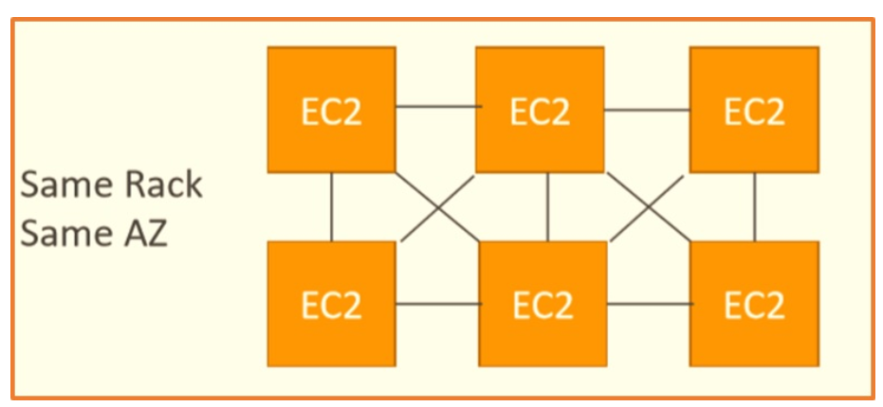

1. All instances are in same rack (same hardware) and same AZ
2. Pros
   1. High network throughput (10 Gbps bandwidth between instances)
   2. Low latency
3. Cons
   1. If the rack fails, all instances fail at the same time
4. Use case
   1. Big Data job that needs to complete fast
   2. Application that needs extremely low latency and high network throughput

Placement Groups- Spread

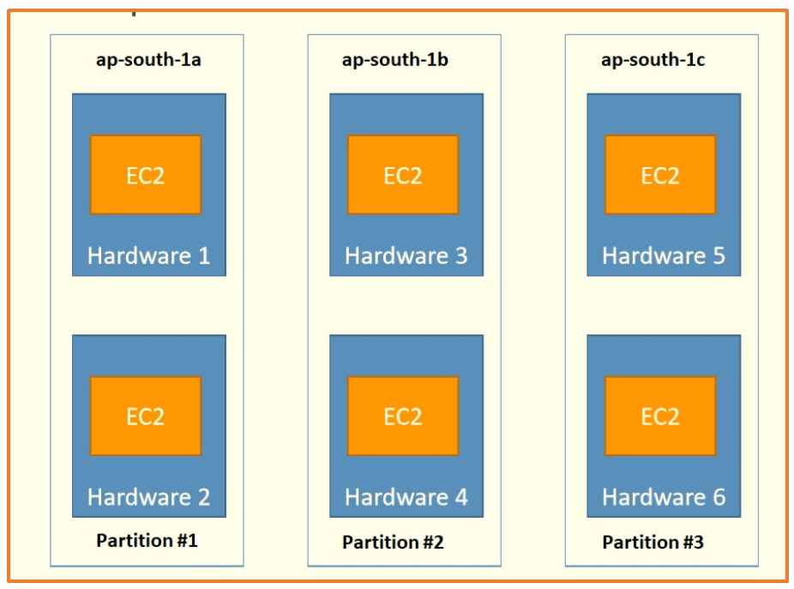

1. All the instances are on different physical hardware
2. Instances are in different hardware in different AZ
3. Pros
   1. Can span across Availability Zones (AZ)
   2. Reduced risk of simultaneous failure
4. Cons
   1. Limited to 7 instances per AZ per placement group
5. Use case
   1. Application that needs to maximize high availability
   2. Critical Applications where each instance must be isolated from failure from each other

Placement Groups- Partition

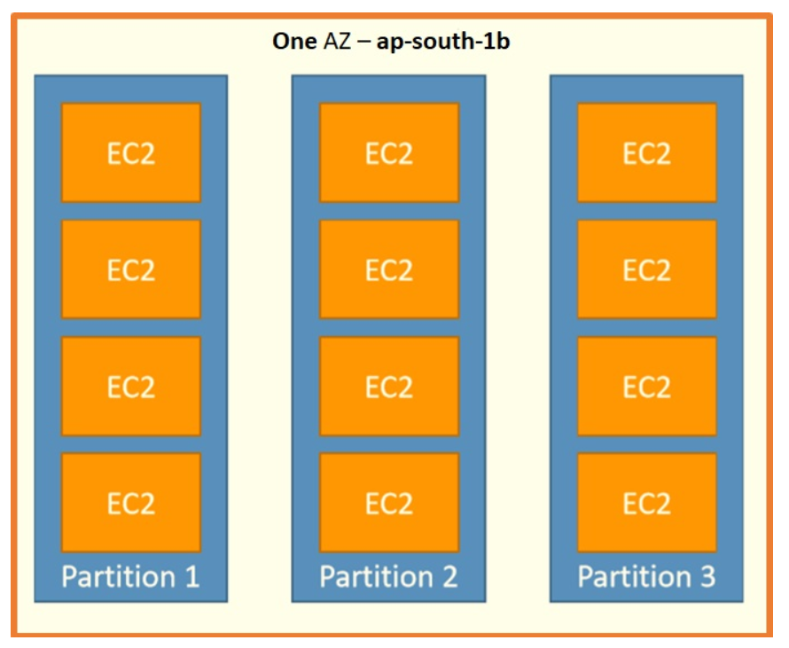

1. Within one AZ , span  multiple partitions, and what is partition, an isolation created by AWS in their data centers which is a physical boundary and ensures one partition's availability does not affects others.
2. Pros
   1. Can span across multiple AZs in the same region
   2. Upto 100s of EC2 instances
   3. Instances in a partition do not share racks with the instances in the other partitions
   4. A partition failure can affect many EC2 but won’t affect other partitions
   5. EC2 instances get access to partition information as metadata
3. Cons
   1. Upto 7 partitions per AZ
4. Use case
   1. HDFS
   2. HBase
   3. Cassandra
   4. Kafka

Elastic Network Interface (ENI)

1. Logical component in a VPC that represents a virtual network card
2. The ENI can have following attributes
   1. Primary private IPv4, one or more secondary IPv4
   2. One Elastic IP (IPv4) per private IPv4
   3. One public IPv4
   4. One or more Security Groups
   5. A MAC address
3. You can create ENI independently and attach them on the fly on EC2 instances for failover
4. Bound to a specific AZ
5. ENI that is created at the time of instance creation will get terminated on termination of corresponding instance
6. ENI that is created independently will remain even when instance gets terminated

EC2 Hibernate

1. We know we can stop, terminate instances
   1. Stop: data on disk (EBS) remains intact in the next step
   2. Terminate: EBS volume (root) gets terminated on termination of instance
2. On start, the following happens
   1. First start: OS boots and the EC2 User Data script is run
   2. Following starts: the OS boots up
   3. Then your application starts, caches get warmed up and that can take time
3. EC2 Hibernate
   1. The in-memory (RAM) state is preserved
   2. Instance boot is much faster
   3. Under the hood: the RAM state is written to a file in the root EBS volume
   4. The root EBS volume must be encrypted
4. Use cases
   1. Long-running processing
   2. Saving the RAM state
   3. Services that take time to initialize
5. Supported instance families- C3, C4, C5, M3, M4, M5, R3, R4, R5
6. Instance RAM size- must be less than 150 GB
7. Instance size- not supported for bare metal instances
8. AMI- Amazon Linux 2, Linux AMI, Ubuntu and Windows
9. Root Volume: must be large, EBS, encrypted, not Instance Store
10. Available for on-demand and reserved instances
11. An instance cannot be hibernated more than 60 days

EC2 Nitro

1. Underlying Platform for the next generation of EC2 instances
2. New virtualization technology
3. Allows for better performance
   1. Better networking options (enhanced networking, HPC, IPv6)
   2. Higher Speed EBS (Nitro is necessary for 64,000 EBS IOPS-max 32,000 on non-Nitro)

EC2- vCPU

1. Multiple threads can run on one CPU (multithreading)
2. Each thread is represented as a virtual CPU (vCPU)

EC2- Optimizing CPU options

1. EC2 instances come with combination of RAM and vCPU
2. In some cases, you may want to change the vCPU options:
   1. # of CPU cores- you can decrease it, helpful if you need high RAM and low number of CPU
   2. # of threads per core- disable multithreading to have 1 thread per CPU, helpful for high performance computing (HPC) workloads
3. Specified during instance launch

EC2- Capacity reservation

1. Capacity Reservations ensure you have EC2 capacity when needed
2. No need for 1 or 3 year commitment
3. Capacity access is immediate, you get billed as soon as it starts
4. Specify
   1. AZ in which to reserve capacity (only one)
   2. Number of instances for which to reserve capacity
   3. Instance attributes including the instance type, tenancy and platform/OS

## EBS (Elastic Block Storage)

### Introduction

* Block storage service
* Like physical hard drive, network drive
* Accessible to a single EC2 instance at a time
* EBS instances can be either General Purpose SSD or Provisioned IOPs SSD
* Data persists even when instance is not running
* Recommended for
  + Quickly accessible data
  + Long-term data storage
  + Running a database on an instance
* EBS volume data persists independently of the life of the instance.
* EBS volumes do not need to be attached to an instance.
* You can attach multiple EBS volumes to an instance.
* You cannot attach an EBS volume to multiple instances (use Elastic File Store instead).
* EBS volumes must be in the same AZ as the instances they are attached to. EBS Volumes are bound to a specific AZ.
* Termination protection is turned off by default and must be manually enabled (keeps the volume/data when the instance is terminated).
* Root EBS volumes are deleted on termination by default.
* Extra non-boot volumes are not deleted on termination by default.
* The behavior can be changed by altering the “DeleteOnTermination” attribute.
* Free Tier: 30 GB of free EBS storage of type General Purpose SSD per month.
* Have a provisioned capacity (size in GBs and IOPS)
  + You get billed for all provisioned capacity
  + You can increase the capacity of the drive over time
* To migrate an EBS volume across AZ
  + Take a snapshot
  + Restore snapshot to another AZ

## EBS Snapshot

* Make a backup (snapshot) of your EBS volume at a point in time
* Not necessary to detach volume to do snapshot, but recommended
* Can copy snapshots across AZ or Region
* Snapshots are stored on S3
* Snapshot can be used to create AMI
* Does not provide granular backup (not a replacement for backup software).
* If you make periodic snapshots of a volume, the snapshots are incremental, which means that only the blocks on the device that have changed after your last snapshot are saved in the new snapshot.
* Even though snapshots are saved incrementally, the snapshot deletion process is designed so that you need to retain only the most recent snapshot in order to restore the volume.
* Snapshots can only be accessed through the EC2 APIs.
* EBS volumes are AZ specific but snapshots are region specific.

### Amazon Machine Image (AMI)

* An Amazon Machine Image (AMI) is a special type of virtual appliance that is used to create a virtual machine within the Amazon Elastic Compute Cloud.
* AMI are a customization of an EC2 instance
* AMI are built for a specific region (and can be copied across regions)
* When we build an AMI, this will also create EBS Snapshots
* An AMI includes the following:
  + One or more [**EBS**](https://digitalcloud.training/certification-training/aws-certified-cloud-practitioner/aws-storage/) snapshots, or, for instance-store-backed AMIs, a template for the root volume of the instance
  + Launch permissions that control which AWS accounts can use the AMI to launch instances.
  + A block device mapping that specifies the volumes to attach to the instance when it’s launched.
* AMIs come in three main categories:
  + **Community AMIs** – free to use, generally you just select the operating system you want.
  + **AWS Marketplace AMIs** – pay to use, generally come packaged with additional, licensed software.
  + **My AMIs** – AMIs that you create yourself.

## EC2 Instance Store

Introduction

* EBS volumes are network drives. If you need high performance hardware disk, use EC2 Instance Store
* Local storage that is physically attached to host computer and cannot be removed
* Storage is temporary as data loss occurs when EC2 instance is stopped
* Are ephemeral or temporary
* Recommended for
  + Temporary storage need
  + Faster with higher I/O speed
  + Good for buffer/cache/scratch data/temporary content
* Instance store volumes cannot be detached/reattached.

EBS Volume Types

1. EBS Volumes come in 6 types
   1. Gp2/gp3 (SSD)-> General Purpose SSD
      1. General purpose SSD volume that balances price and performance for a wide variety of workloads
   2. Io1/io2 (SSD)-> Provisioned IOPS SSD
      1. Highest performance SSD volume for mission-critical low-latency or high-throughout workloads
      2. Critical business applications with sustained IOPS performance
      3. Great for databases workloads
   3. St1 (HDD)-> Throughput Optimized HDD
      1. Low cost HDD volume designed for frequently accessed, throughput-intensive workloads
      2. Big Data, Data Warehouse, Log Processing
      3. Cannot be boot volume
   4. Sc1 (HDD)-> Cold HDD
      1. Lowest cost HDD volume designed for less frequently accessed workloads
      2. Cannot be boot volume
2. EBS Volumes are characterized in Size | Throughout | IOPs
3. Only gp2/gp3 and io1/io2 can be used as boot volumes
4. Gp2: IO increases if the disk size increases
5. Io1: can increase IO independently

EBS Multi-Attach- io1/io2 family

1. Io1/io2 family
2. Attach same EBS volume to multiple EC2 instances in the same AZ
3. Each instance has full read and write permissions to the volume
4. Use case
   1. Achieve higher application availability in clustered Linux applications (ex: Teradata)
   2. Applications must manage concurrent write operations
5. Suppose, we have io2 volume with Multi-Attach, then we can attach multiple instances in same AZ into this volume

EBS Encryption

1. When you create an encrypted EBS volume, you get the following
   1. Data at rest is encrypted inside the volume
   2. All the data in flight moving between instance and volume is encrypted
   3. All snapshots are encrypted
2. Encryption and decryption are handled transparently (you have nothing to do)
3. Encryption has minimal impact on latency
4. EBS Encryption leverages keys from KMS (AES-256)

Encryption: encrypt an unencrypted EBS volume

1. Create an EBS snapshot of volume (Snapshot of unencrypted EBS volume is also unencrypted)
2. Encrypt the EBS snapshot (using copy)
3. Create new EBS volume from snapshot (the volume will also be encrypted)
4. Now you can attach the encrypted volume to the original instance

## Amazon Elastic File System (EFS)

Introduction

* Hierarchical structure
* EFS works with EC2 instances in multi-AZ
* Can be mounted by multiple EC2 instances can be mounted in EC2 or on-premises servers
* Can connect to instance in another VPC
* Can concurrently connect 1 to 1000s of EC2 instances, from multiple AZs.
* Uses NFSv4.1 protocol
* Only supports the Linux file system
* More expensive than EBS
* By default you can create up to 10 file systems per account.
* Use Security group to control access to EFS
* There are two performance modes:
  + Performance Mode
    - “General Purpose” performance mode (default)-> latency sensitive use cases
    - “Max I/O” performance mode-> higher latency, throughput, highly parallel (big data, media processing)
  + Throughput mode
    - Bursting (1 TB= 50 MiB/s + burst of up to 100MiB/s)
    - Provisioned (set your throughput regardless of storage size e.g. 1GiB/s for 1 TB storage)
* Storage Tiers
  + Lifecycle management feature
  + Move file after N days
  + Standard- for frequently accessed files
  + Infrequent access (EFS-IA): lower price to store, cost to retrieve files

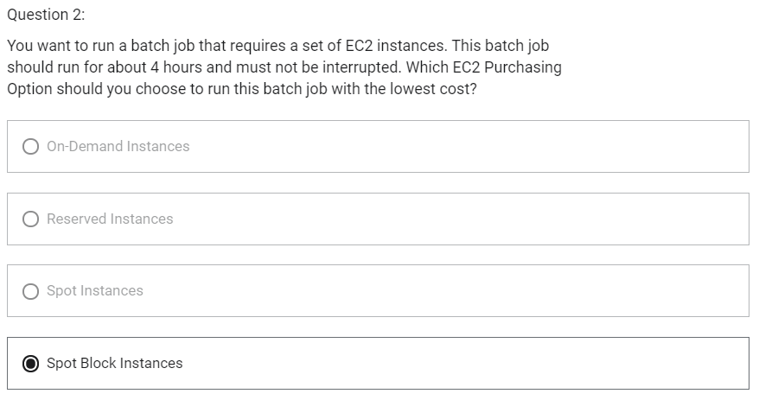

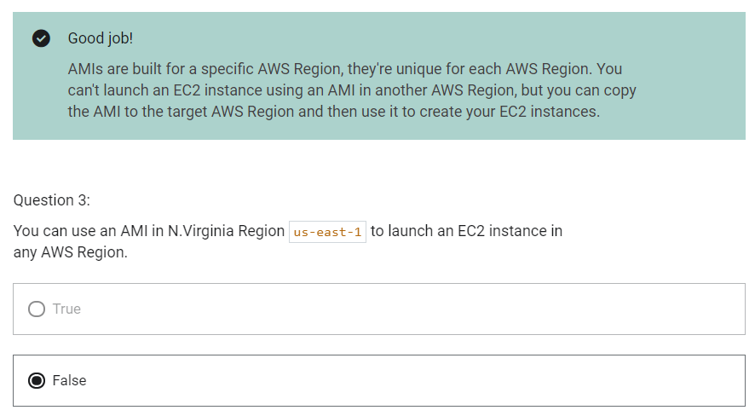

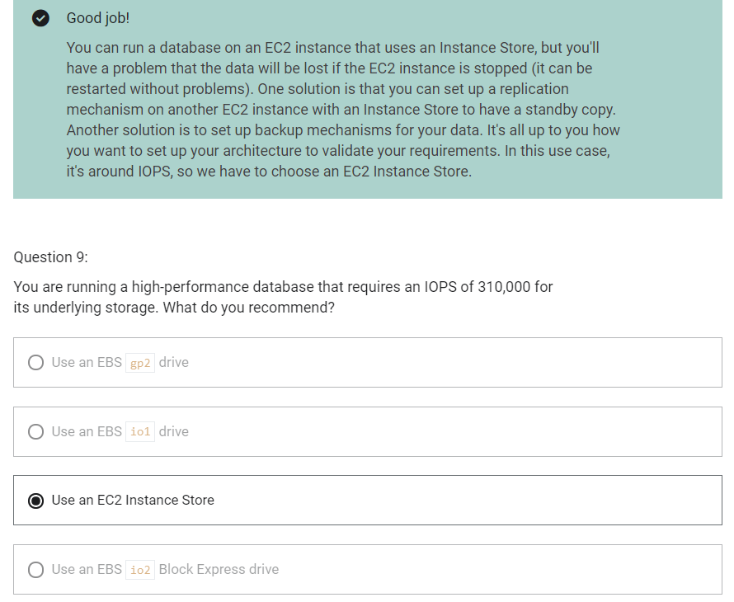

High availability and Scalability

Scalability

1. Scalability means that an application/system can handle greater loads by adapting
2. There are two kinds of scalability
   1. Vertical Scalability
   2. Horizontal Scalability (=elasticity)
3. Vertical Scalability
   1. Increasing the size of the instance
   2. Scale up/down
   3. T1.micro-> t2.large
   4. Common for non-distributed systems such as a database
   5. RDS, ElastiCache are services that can scale vertically
   6. There is usually a limit to how much you can vertically scale
4. Horizontal Scalability
   1. Increasing the number of instances/ systems for your application
   2. Scale out/in
      1. Scale out- add new instance
      2. Scale in- remove existing instance
   3. Common for distributed systems

High Availability

1. High availability means running your application/ system in at least 2 AZ
2. Goal of high AZ is to survive a data center loss

Load Balancing

1. Distribute incoming traffic to multiple downstream instances

Elastic Load Balancer

1. Managed load balancer
2. It is integrated with many AWS services
   1. EC1, EC2 Auto Scaling Groups, Amazon ECS
   2. AWS Certificate Manager (ACM), CloudWatch
   3. Route 53, AWS WAF, AWS Global Accelerator

Health Check

1. Health checks are crucial for load balancers
2. They enable load balancer to know if instances it forwards traffic to are available to reply to requests
3. The health check is done on a port and a route (/health is common)
4. If the response is not 200 (ok), then the instance is unhealthy

Types of Load balancer

1. Classic Load Balancer
   1. Layer 4 (TCP)
   2. Layer 7 (HTTP, HTTPS)
2. Application Load Balancer
   1. Layer 7 (HTTP, HTTPS)
   2. Operates at Application Layer
   3. Load balancing to multiple HTTP applications across machines (target groups)
   4. Load balancing to multiple applications on the same machine
   5. Support for HTTP/2 and WebSocket
   6. Support redirects (from HTTP to HTTPs for example)
   7. Routing tables to different target groups
      1. Routing based on path in URL (example.com/users and example.com/posts)
      2. Routing based on hostname in URL (one.example.com and other.example.com)
      3. Routing based on Query String, Headers (example.com/users?id=123&order=false)
   8. ALB can route to multiple target groups which can be
      1. EC2 instances
      2. ECS tasks
      3. Lambda functions
      4. IP addresses- must be private IP
   9. Fixed hostname (XXX.region.elb.amazonaws.com)
   10. The application servers do not see the IP of the client directly
       1. The true IP of the client is inserted in the header X-Forwarded-For
       2. We can also get Port (X-Forwarded-port) and proto (X-Forwarded-Proto)
3. Network Load Balancer
   1. Layer 4 (TCP, UDP)
   2. Operates at Transport Layer
   3. Handles millions of requests per seconds
   4. Less latency-> 100 ms (vs 400 ms for ALB)
   5. NLB has one static IP per AZ, and supports assigning Elastic IP
   6. NLB are used for extreme performance, TCP or UDP traffic
   7. Not included in the AWS free tier
   8. Target Groups
      1. EC2 instances
      2. IP Addresses- must be private IPs
      3. Application Load Balancer
4. Gateway Load Balancer
   1. Layer 3 – IP packets
   2. Operates at Network Layer
   3. Deploy, scale and manage a fleet of 3rd party network virtual appliances in AWS
   4. Example: Firewalls, Intrusion Detection and Prevention Systems, Deep Packet Inspection Systems, Payload Manipulation
   5. Combines the following functions
      1. Transparent Network Gateway- single entry/exit for all traffic
      2. Load Balancer- distributes traffic to your virtual appliances
   6. Uses GENEVE protocol on port 6081
   7. Target Groups
      1. EC2 instances
      2. IP Addresses- must be private IPs

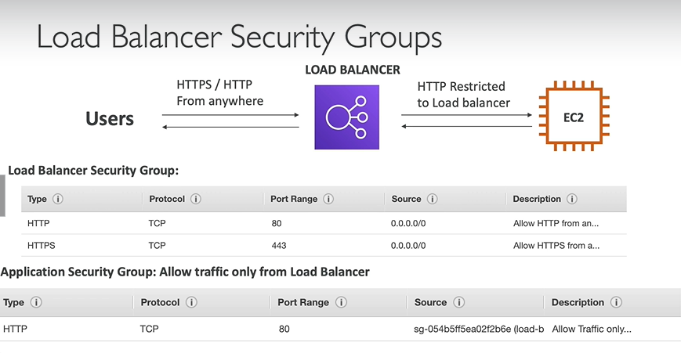

Sticky Sessions (Session Affinity)

1. It is possible to implement stickiness so that the same client is always redirected to same instance behind a load balancer
2. This works for Classic Load Balancers and Application Load Balancers
3. The “cookie: used for stickiness has an expiration date you control
4. Use case
   1. Make sure the user does not lose his session data
5. Enabling stickiness may bring imbalance to the load over the backend EC2 instances

Sticky Sessions- Cookie Names

1. Application-based Cookies
   1. Custom cookie
      1. Generated by the target
      2. Can include any custom attributes required by the application
      3. Cookie name must be specified for each target group
      4. Don’t use AWSALB, AWSALBAPP, AWSALBTG (reserved for use by the ELB)
   2. Application Cookie
      1. Generated by load balancer
      2. Cookie name is AWSALBAPP
2. Duration-based Cookies
   1. Cookie generated by the load balancer
   2. Cookie name is AWSALB for ALB, AWSELB for CLB

Cross Zone Load Balancing

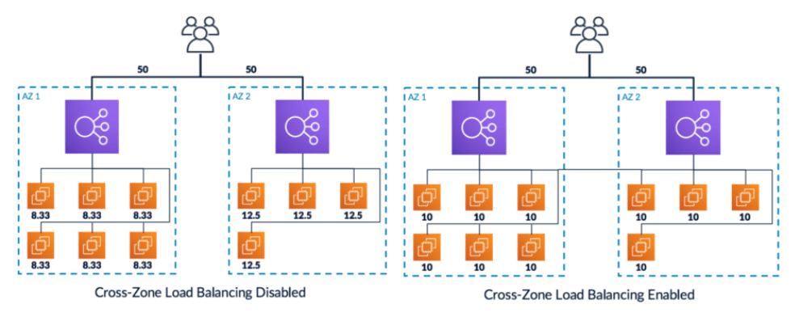

1. With Classic Zone Load Balancing
   1. Each load balancer instance distributes evenly across all registered instances in all AZ
2. Without Classic Zone Load Balancing
   1. Requests are distributed in the instances of the node of the Elastic Load Balancer

Cross-Zone Load Balancing

1. Application Load Balancer
   1. Always on (cannot be disabled)
   2. No charges for inter AZ data
2. Network Load Balancer
   1. Disabled by default
   2. You pay charges ($) for inter AZ data if enabled
3. Classic Load Balancer
   1. Disabled by default
   2. No charges for inter AZ data if enabled

SSL/TLS

1. SSL Certificate allows traffic between your clients and your load balancer to be encrypted in transit (in-flight encryption)
2. SSL refers to Secure Sockets Layer used to encrypt connections
3. TLS refers to Transport Layer Security, which is newer version
4. Public SSL certificates are issued by Certificate Authorities (CA)
5. SSL Certificates have an expiration date and must be renewed regularly

Load Balancer- SSL Certificates

1. The load balancer uses an X.509 certificate (SSL/TLS server certificate)
2. You can manage certificates using ACM (AWS Certificate Manager)
3. You can create/ upload your own certificates alternatively
4. HTTPS listener:
   1. You must specify a default certificate
   2. You can add an optional list of certs to support domains
   3. Clients can use SNI (Server Name Indication) to specify the hostname they reach
   4. Ability to specify a security policy to support older versions of SSL/TLS

SSL- Server Name Indication

1. SNI solves the problem of loading multiple SSL certificates onto one web browser (to serve multiple websites)
2. It is a “newer” protocol and requires the client to indicate the hostname of the target server in the initial SSL handshake
3. The server will then find the correct certificate or return the default one
4. Only works for ALB & NLB, CloudFront
5. Does not work with CLB

Elastic Load Balancers- SSL Certificates

1. Classic Load Balancer
   1. Support only one SSL certificate
   2. Must use multiple CLB for multiple hostname with multiple SSL certificates
2. Application Load Balancer
   1. Supports multiple listeners with multiple SSL certificates
   2. Uses Server Name Indication (SNI) to make it work
3. Network Load Balancer
   1. Supports multiple listeners with multiple SSL certificates
   2. Uses Server Name Indication (SNI) to make it work

Connection Draining

1. Feature naming
   1. For CLB- Connection Draining
   2. For ALB & NLB- Deregistration Delay
2. It will give some time to complete “in-flight requests” while the instance is de-registering or unhealthy
3. It is a **process** that ensures that existing, in-progress requests are given time to complete when the instance is de-registering
4. One the connection is drained, ELB will stop sending new requests to the EC2 instance which is de-registering
5. Between 1 to 3600 seconds (default:300 seconds)
6. Can be disabled (set value to 0)
7. Set to a low value if your requests are short

Auto Scaling Group

1. The goal of Auto Scaling Group (ASG) is to:
   1. Scale out (add EC2 instances) to match an increased load
   2. Scale in (remove EC2 instances) to match a decreased load
   3. Ensure we have a minimum and a maximum number of machines running
   4. Automatically register new instances to a load balancer
2. Number of instances in ASG
   1. Minimum size
   2. Actual Size/ Desired Capacity
   3. Maximum Size
3. ASGs have following attributes
   1. A launch configuration
      1. AMI + Instance Type
      2. EC2 User Data
      3. EBS Volumes
      4. Security Groups
      5. SSH Key Pair
   2. Minimum Size/ Maximum Size/ Initial Capacity
   3. Network + Subnets Information
   4. Load Balancer Information
   5. Scaling Policies

Auto Scaling Alarms

1. It is possible to scale an ASG based on CloudWatch alarms
2. Metrics are computed for overall ASG instance (metrics is calculated as average not min or max)
3. Based on the alarm
   1. We can create scale-out policies (increase the number of instances)
   2. We can create scale-in policies (decrease the number of instances)

Auto Scaling New Rules

1. Target Average CPU Usage
2. Number of requests on the ELB per instance
3. Average Network In
4. Average Network Out

Auto Scaling Custom Metric

1. It is not always compulsory to scale based on metrics provided by AWS. We can create our custom metric like number of connected users

ASG Brain Dump

1. Scaling Policies can be on CPU, Network and can even be on custom metrics or based on a schedule
2. ASGs use launch configurations or Launch Templates
3. To update an ASG, you must provide a new launch configuration/ launch template
4. IAM roles attached to an ASG will get assigned to EC2 instances
5. ASG is free. You pay for the underlying resources being launched
6. Having instances under an ASG means that if they get terminated for whatever reason, the ASG will automatically create new ones as a replacement
7. ASG can terminate instances marked as unhealthy by an LB (and hence replace them)

AutoScaling Policies

1. Dynamic Scaling Policies
   1. Target Tracking Scaling
      1. Most simple and easy to set-up
      2. Example: I want the average ASG CPU to stay at around 40%
   2. Simple/Step Scaling
      1. When a CloudWatch alarm is triggered (CPU>70%), then add 2 units
      2. When a CloudWatch alarm is triggered (CPU<30%), then remove 1
   3. Scheduled Actions
      1. Anticipate a scaling based on known usage patterns
      2. Ex: increase the min capacity to 10 at 5 pm on Fridays
2. Predictive Scaling
   1. Continuously forecast load and schedule scaling ahead

Good Metrics to scale on

1. CPU Utilization
2. RequestCountPerTarget
3. Average Network In/ Out
4. Any Custom Metric

ASG- Scaling Cooldowns

1. The cooldown period is **a configurable setting for your Auto Scaling group** that helps to ensure that it doesn't launch or terminate additional instances before the previous scaling activity takes effect.
2. After a scaling activity happens, you are in the cooldown period (default 300 seconds)
3. During the cooldown period, the ASG will not launch or terminate additional instances (to allow metrics to stabilize)

ASG Default Termination Policy

1. Find the AZ which has the most number of instances
2. If there are multiple instances in the AZ to choose from, delete the one with the oldest launch configuration
3. ASG tries to balance the number of instances across AZ by default

Lifecycle Hooks

1. By default, as soon as an instance is launched in the ASG, it is in service
2. You have the ability to perform extra steps before the instance goes in service (Pending state)
3. You have the ability to perform some actions before the instance is terminated (Terminating state)

Launch Template vs Launch Configuration

1. Both requires ID of AMI, instance type, a key pair, security groups and other parameters that you use to launch EC2 instances (tags, EC2 User Data)
2. Launch Configuration (legacy)
   1. Must be re-created every time
3. Launch Template (newer)
   1. Recommended by AWS going forward
   2. Can have multiple versions
   3. Create parameters subsets (partial configuration for re-use and inheritance)

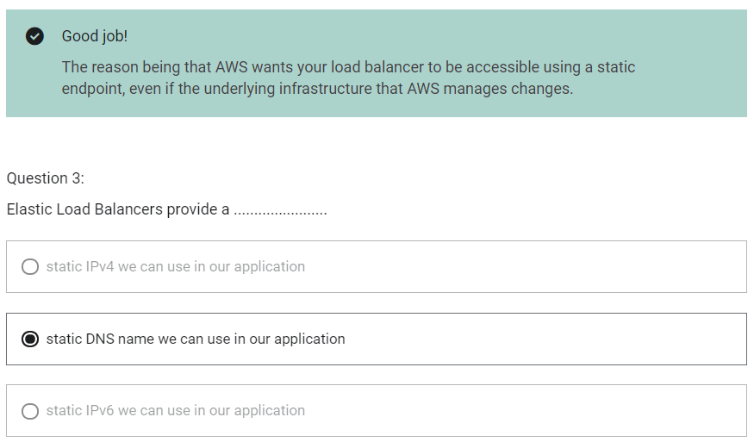

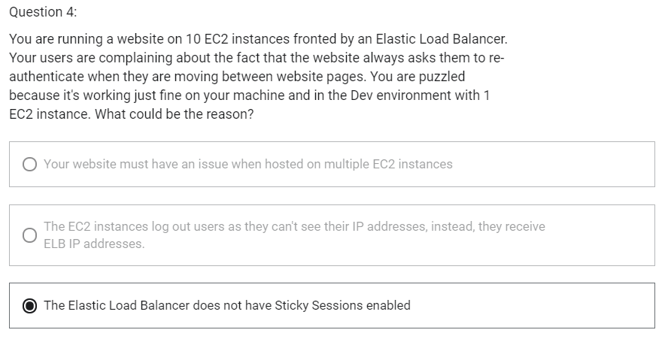

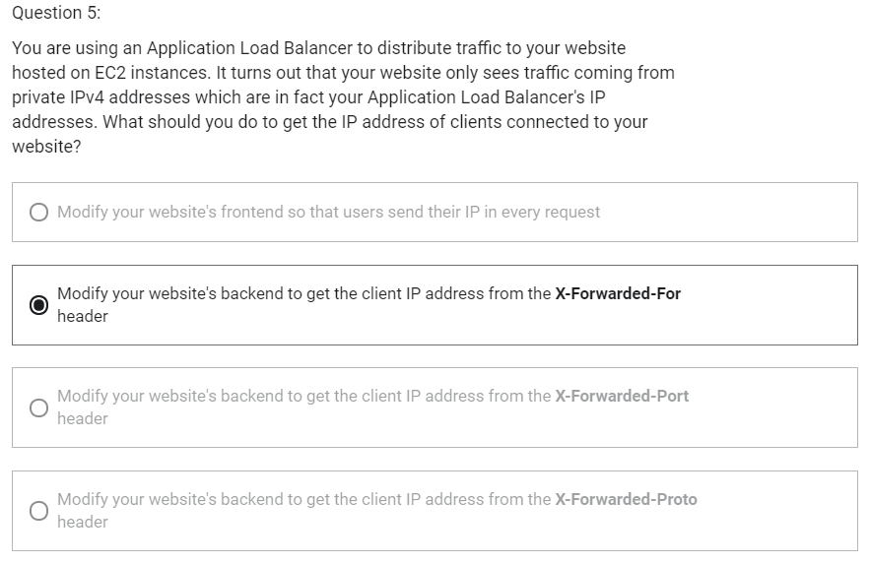

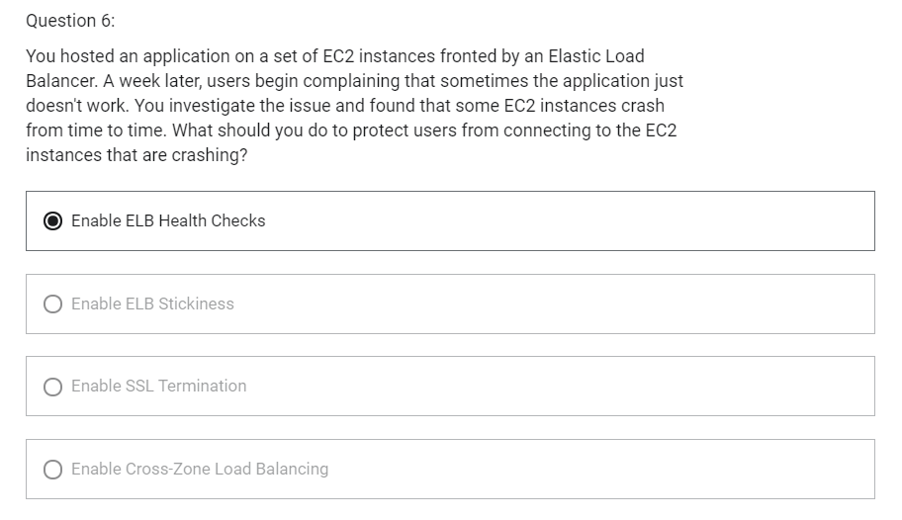

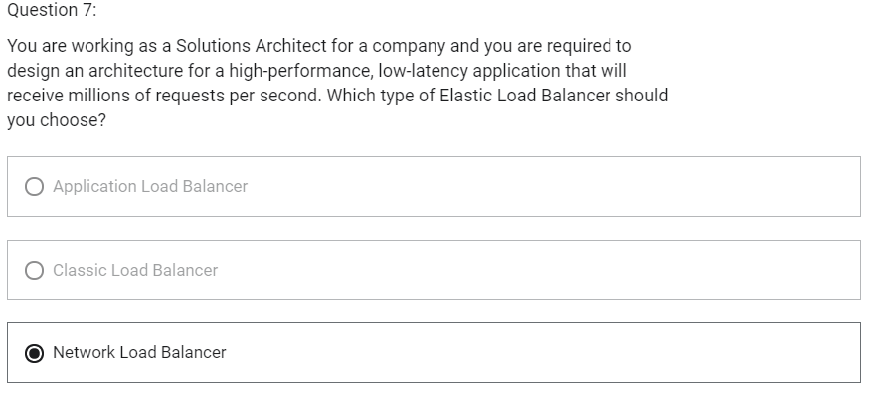

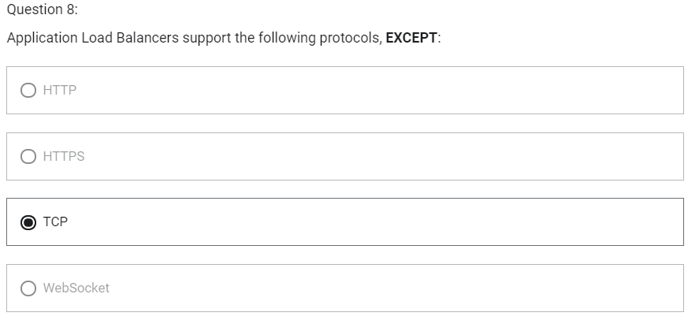

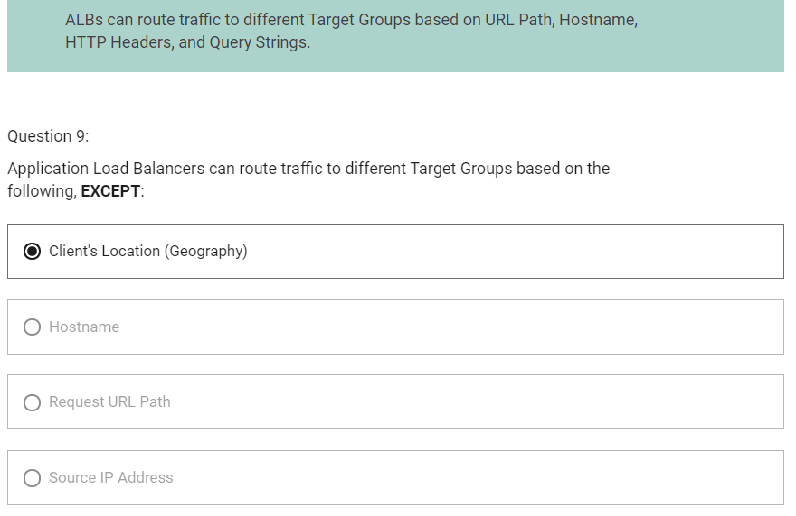

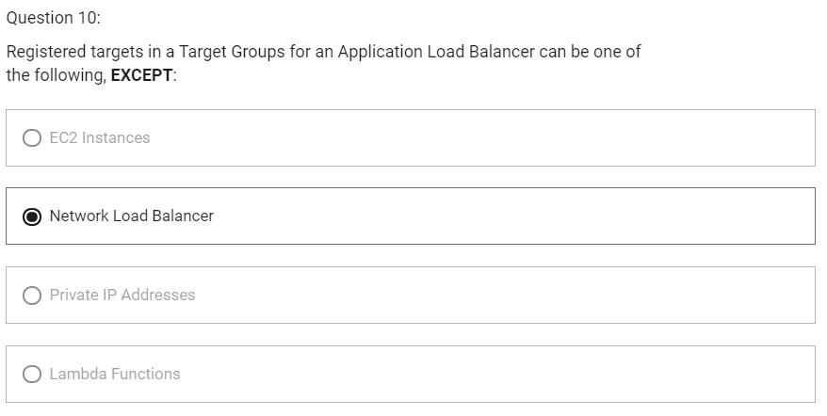

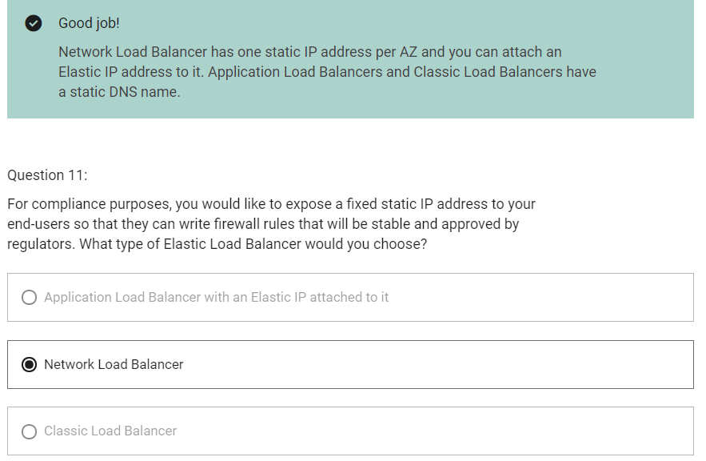

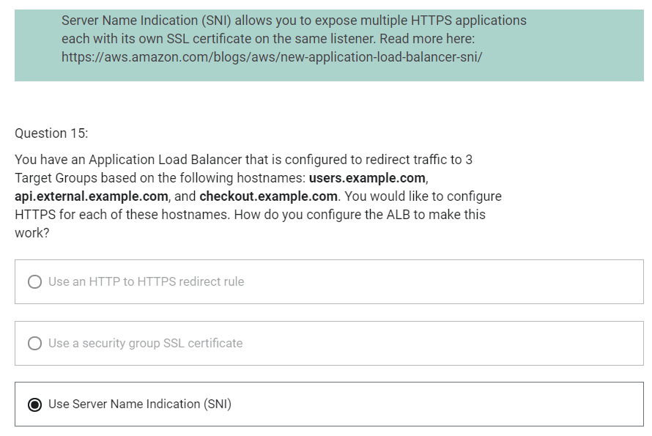

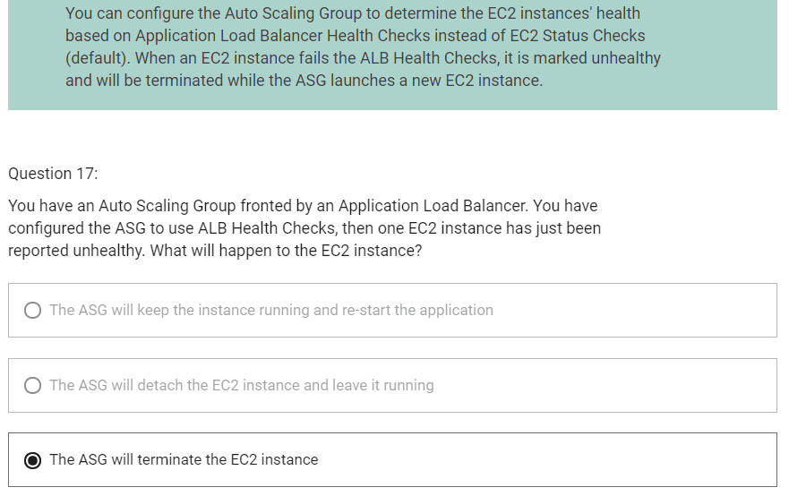

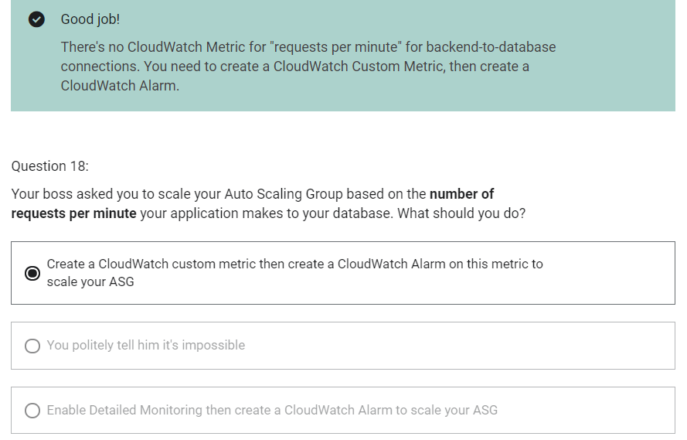

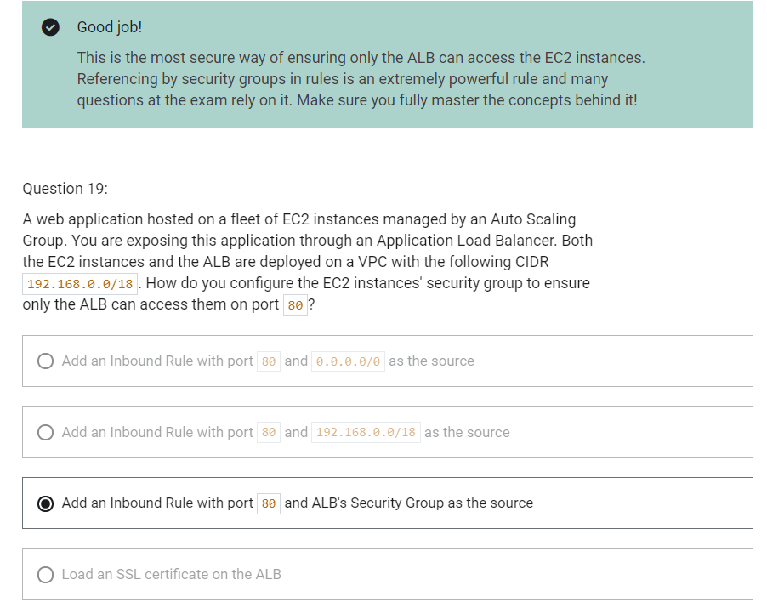

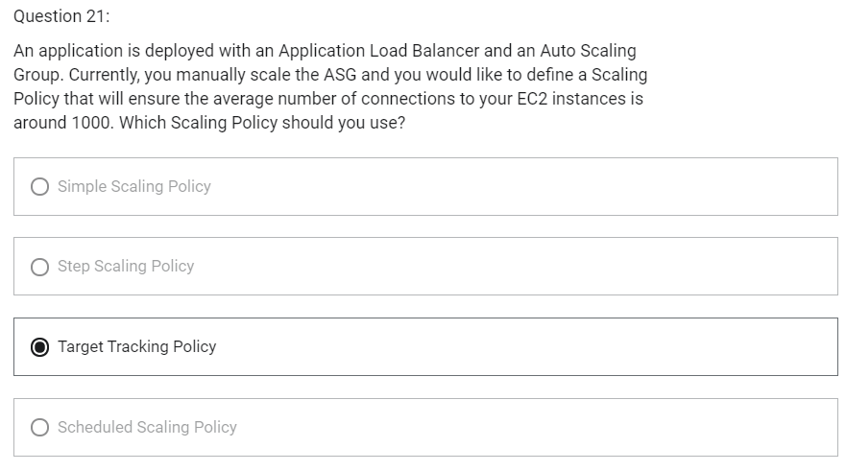

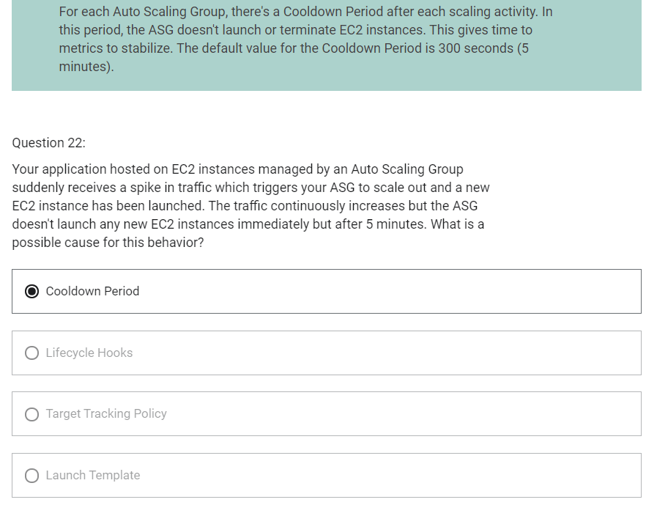

RDS

1. RDS stands for Relational Database Service
2. It is managed database service that use SQL as a query language
3. It allows you to create databases in the cloud that are managed by AWS
   1. Postgres
   2. MySQL
   3. MariaDB
   4. Oracle
   5. Microsoft SQL Server
   6. Aurora (AWS Proprietary database)

Advantages over using RDS versus deploying database on EC2

1. RDS is a managed service
   1. Automated provisioning, OS patching
   2. Continuous backups and restore to specific timestamp (Point in Time Restore)
   3. Monitoring dashboards
   4. Read replicas for improved read performance
   5. Multi-AZ setup for disaster recovery
   6. Maintenance windows for upgrades
   7. Scaling capacity (vertical and horizontal)
   8. Storage backed by EBS (gp2 or io1)
2. BUT You cannot SSH into your instance

RDS Backups

1. Backups are automatically enabled in RDS
2. Automated backups
   1. Daily full backup of database (during the maintenance window)
   2. Transaction logs are backed-up by RDS every 5 minutes
   3. Ability to restore to any point in time (from oldest backup to 5 minutes ago)
   4. 7 days retention (can be increased to 35 days)
3. DB Snapshots
   1. Manually triggered by the user
   2. Retention of backup for as long as you want

RDS- Storage Auto Scaling

1. Helps you increase storage on your RDS database instance dynamically
2. When RDS detects you are running out of free database storage, it scale automatically
3. Avoid manually scaling your database storage
4. You have to set Maximum Storage Threshold (maximum limit for DB storage)
5. Automatically modify storage if
   1. Free storage is less than 10% of allocated storage
   2. Low-storage lasts at least 5 minutes
   3. 6 hours have passed since last modification
6. Useful for applications with unpredictable workloads
7. Supports all RDS database engines(MariaDB, MySQL, PostgreSQL, SQL Server, Oracle)

Read Replicas

1. Up to 5 read replicas
2. Within AZ, Cross AZ or Cross Region
3. Replication is asynchronous, so reads are eventually consistent
4. Read/ Write happens in main database
5. Read happens in read replica. Read replicas are used for SELECT (=read) only kind of statements (not INSERT, UPDATE, DELETE)

RDS Read Replicas- Network Cost

1. In AWS, there is a network cost when data goes from one AZ to another
2. For RDS Read Replicas within the same region, you do not pay that fee
3. In RDS Read Replicas, network cost within same region is free. Network between region is paid.

RDS Multi-AZ (Disaster Recovery)

1. Synchronous replication
2. One DNS Name- automatic app failover to standby
3. Increase availability
4. Failover in case of loss of AZ, loss of network, instance or storage failure
5. No manual intervention in apps
6. Not used for scaling
7. Read Replicas can be setup as Multi AZ for Disaster Recovery
8. No read and write happens in Standby instance

RDS- from Single AZ to Multi AZ

1. Zero downtime operation (no need to stop DB)
2. Just click on “modify” for the database
3. The following happens internally
   1. A snapshot is taken
   2. A new DB is restored from the snapshot in a new AZ
   3. Synchronization is established between the two databases

RDS Security- Encryption

1. At rest encryption
   1. Is done only when you first create the database instance
   2. Possibility to encrypt the master and read replicas with AWS KMS-AES-256 encryption
   3. Encryption has to be defined at launch time
   4. If the master is not encrypted, the read replicas cannot be encrypted
   5. Transparent Data Encryption (TDE) available for Oracle and SQL Server
2. In-flight encryption
   1. SSL certificates to encrypt data to RDS in flight
   2. Provide SSL options with trust certificate when connecting to database
   3. To enforce SSL
      1. PostgreSQL: rds.force_ssl=1 in the AWS RDS Console (Parameter Groups)
      2. MySQL: Within the DB: GRANT USAGE ON *.* TO ‘mysqluser’@’%’ REQUIRE SSL;

RDS Encryption Operations

1. Encrypting RDS backups
   1. Snapshots of unencrypted RDS databases are un-encrypted
   2. Snapshots of encrypted RDS databases are encrypted
   3. Can copy a snapshot into an encrypted one
2. To encrypt an un-encrypted RDS database
   1. Create a snapshot of the unencrypted database
   2. Copy the snapshot and enable encryption for the snapshot
   3. Restore the database from encrypted snapshot
   4. Migrate applications to the new database, and delete the old database

RDS Security- Network and IAM

1. Network Security
   1. RDS Databases are usually deployed within a private subnet, not in a public one
   2. RDS security works by leveraging security groups- it controls which IP/security group can communicate with RDS
2. Access Management
   1. IAM policies help control who can manage AWS RDS (through RDS API)
   2. Traditional username and password can be used to login into the database
   3. IAM based authentication can be used to login into RDS MySQL and PostgreSQL

RDS- IAM Authentication

1. IAM database authentication works with MySQL and PostgreSQL
2. You do not need a password, just an authentication token obtained through IAM and RDS API calls
3. Auth token has a lifetime of 15 minutes

AWS responsibility- No SSH access

Aurora

1. Aurora is a proprietary technology from AWS (not open source)
2. PostgreSQL and MySQL are both supported as Aurora database
3. Is cloud optimized
4. 5x performance improvement over MySQL on RDS
5. 3x performance of Postgres on RDS
6. Aurora storage automatically grows in increments of 10GB, upto 128 TB
7. Aurora can have 15 replicas while MySQL has 5, and the replication process is faster
8. Failover in Aurora is instantaneous
9. Aurora costs more than RDS (20% more)
10. Shared storage volume

Aurora High Availability and Read Scaling

1. 6 copies of your data across AZ
   1. 4 copies out of 6 needed for write
   2. 3 copies out of 6 copies for reads
2. One Aurora instance takes writes (master)
3. Automated failover for master in less than 30 seconds
4. Master + up to 15 Aurora Read Replicas server reads
5. Support for Cross Region Replication

Aurora DB Cluster

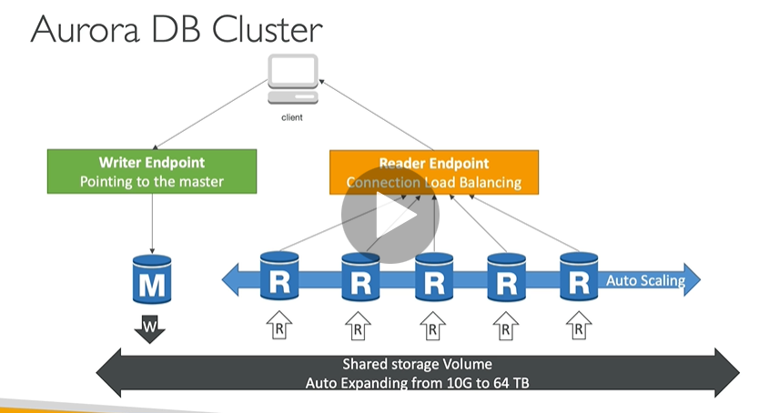

Features of Aurora

1. Automatic fail-over
2. Backup and Recovery
3. Isolation and Security
4. Industry compliance
5. Push-button scaling
6. Automated Patching with Zero Downtime
7. Advanced Monitoring
8. Routine Maintenance
9. Backtrack: restore data at any point of time without using backups

Aurora Security

1. Similar to RDS
2. Encryption at rest using KMS
3. Automated backups, snapshots and replicas are also encrypted
4. Encryption in flight using SSL
5. Possibility to authenticate using IAM token (same method as RDS)
6. You are responsible for protecting the instance with security groups
7. You can not SSH

Aurora Replicas- Auto Scaling

1. It is possible to scale read replicas of Aurora

Aurora- Custom Endpoints

1. Define a subset of Aurora instances as a custom endpoint
2. Example: run analytical queries on specific replicas
3. Reader endpoint is generally not used after defining Custom Endpoints

Aurora Serverless

1. Automated database instantiation and auto-scaling based on actual usage
2. Good for infrequent, intermittent or unpredictable workloads
3. No capacity planning needed
4. Pay per second

Aurora Multi-Master

1. In case you want immediate failover for write node
2. Multiple instances can perform read/write

Global Aurora

1. Aurora Cross Region Read Replicas
   1. Useful for disaster recovery
2. Aurora Global Database (recommended)
   1. 1 primary region (read/write)
   2. Upto 5 secondary (read-only) regions, replication lag is less than 1 second
   3. Upto 16 read replicas per secondary region
   4. Helps for decreasing latency
   5. Promoting another region (for disaster recovery) has an RTO (recovery time of) < 1 minute

Aurora Machine Learning

1. Supported services
   1. Amazon SageMaker
   2. Amazon Comprehend

ElastiCache

1. The same way RDS is to get managed Relational Databases
2. ElastiCache is to get managed Redis or Memcached
3. Caches are in-memory databases with really high performance, low latency
4. Helps reduce load off of databases for read intensive workloads
5. Helps make your application stateless
6. AWS takes care of OS maintenance/ patching optimizations, setup, configurations, monitoring, failover recovery and backups
7. Using ElastiCache involves heavy application code changes

DB Cache

1. Application queries ElastiCache, if not available, get from RDS and store in ElastiCache
2. Helps relieve load in RDS
3. Cache must have an invalidation strategy to make sure only the most current data is used in there

ElastiCache- User Session Store

1. User logs into any of the application
2. The application writes the session data into ElastiCache
3. The user hits another instance of our application
4. The instance retrieves the data and the user is already logged in

ElastiCache- Redis vs Memcached

Redis

1. Multi AZ with Auto-Failover
2. Read Replicas to scale reads and have high availability
3. Data Durability using AOF persistence
4. Backup and restore features

Memcached

1. Multi-node for partitioning of data (sharding)
2. No high availability (replication)
3. Non persistent
4. No backup and restore
5. Multi-threaded architecture

ElastiCache- Cache Security

1. All caches in ElastiCache
   1. Do not support IAM authentication
   2. IAM policies on ElastiCache are only used for AWS API-level security
2. Redis AUTH
   1. You can set a “password/token” when you create a Redis cluster
   2. This is an extra level of security of your cache (on top of security groups)
   3. Support SSL in flight encryption
3. Memcached
   1. Supports SASL-based authentication (advanced)

Patterns for ElastiCache

1. Lazy Loading
   1. All the read data is cached
   2. Data can become stale in cache
2. Write Through
   1. Adds or updates data in cache when written to a DB
   2. No stale data
3. Session Store
   1. Store temporary session data in a cache (using TTL features)

ElastiCache- Redis Use Case

1. Gaming Leaderboards are computationally complex
2. Redis Sorted Sets guarantee both uniqueness and element ordering
3. Each time a new element is added, it is ranked in real tie, then added in correct order

Important Ports

1. FTP - 21
2. SSH - 22
3. SFTP – 22 (same as SSH)
4. HTTP – 80
5. HTTPS – 443

RDS Database Ports

1. PostgreSQL – 5432
2. MySQL – 3306
3. Oracle RDS – 1521
4. MSSQL Server – 1433
5. MariaDB – 3306 (same as MySQL)
6. Aurora – 5432 (if PostgreSQL compatible) or 3305 (if MySQL compatible)

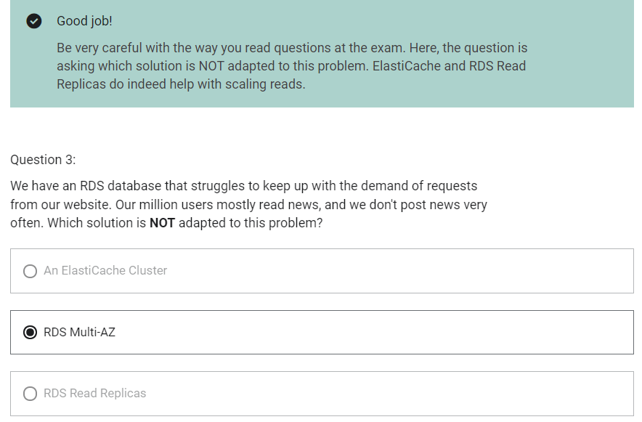

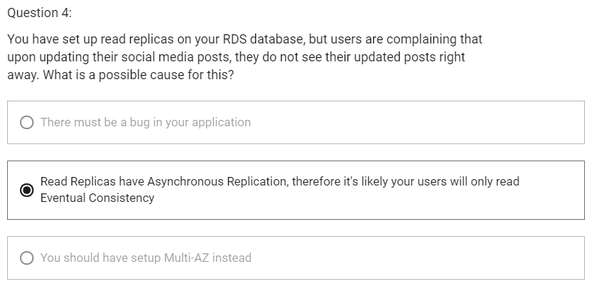

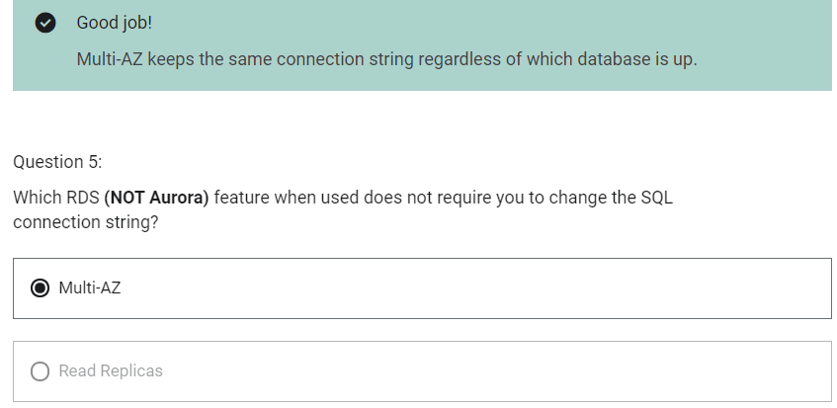

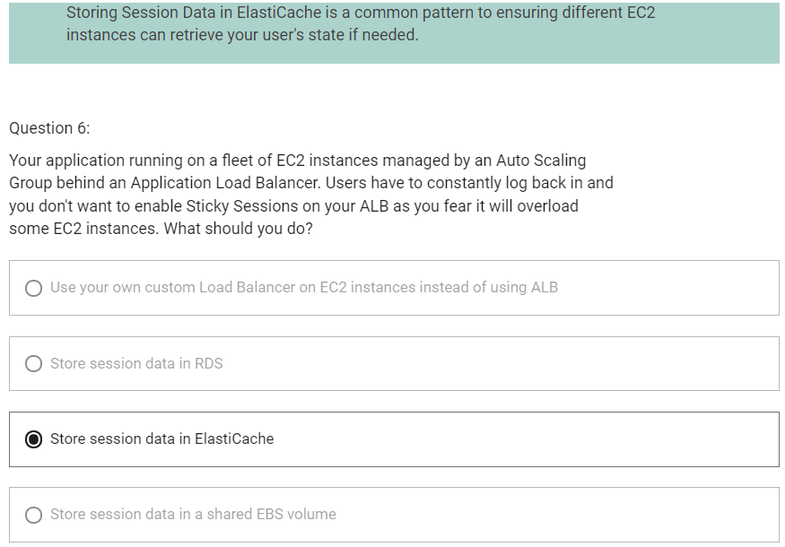

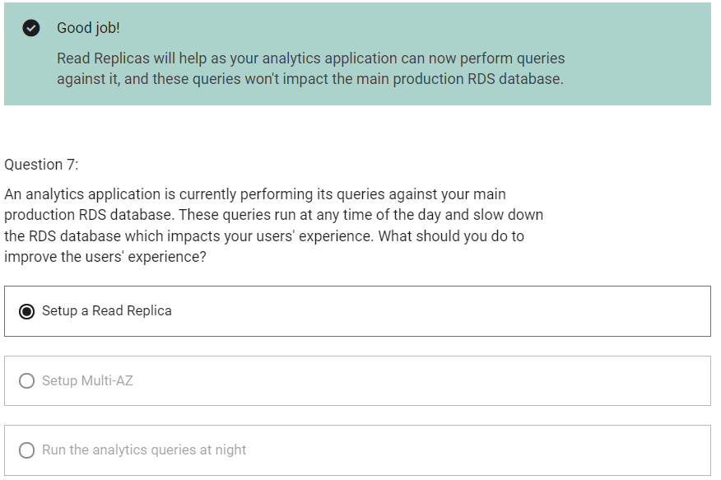

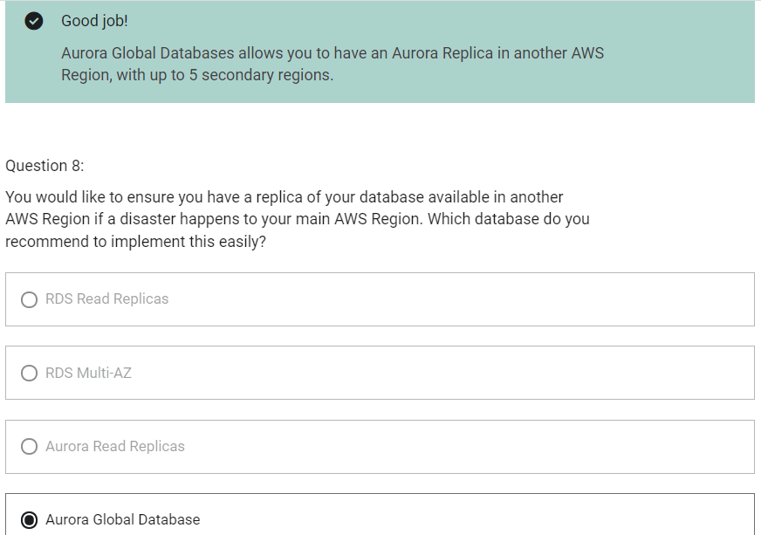

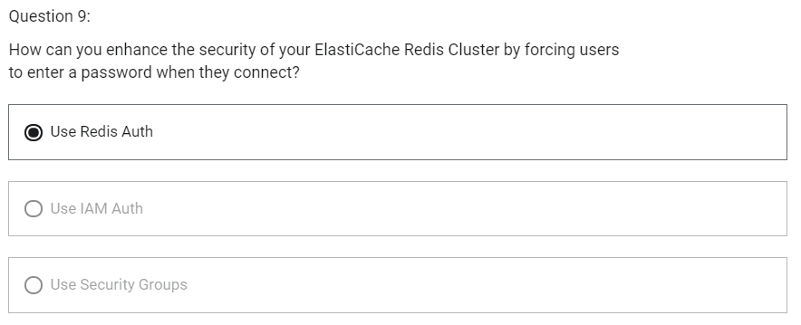

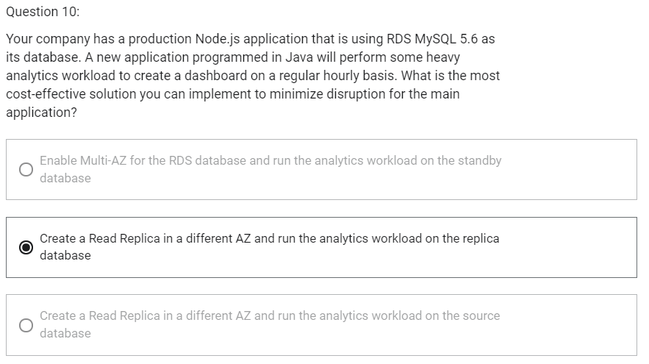

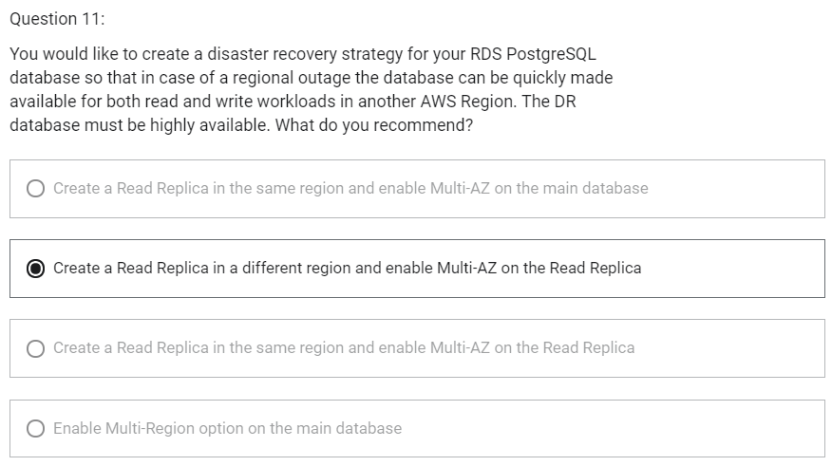

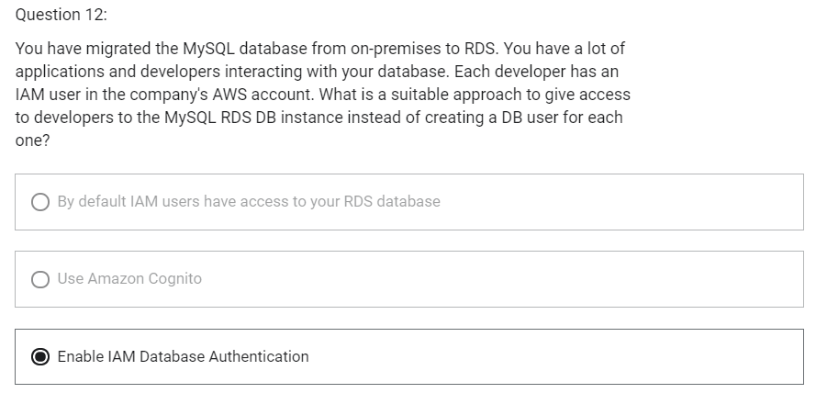

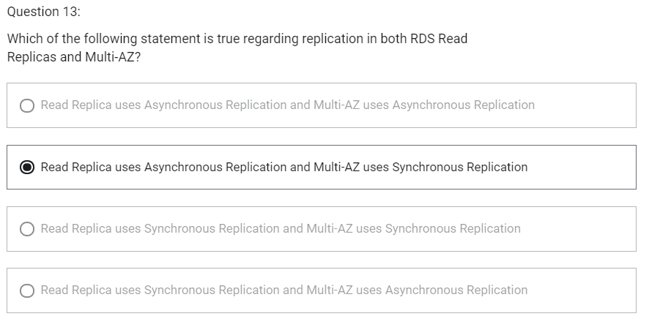

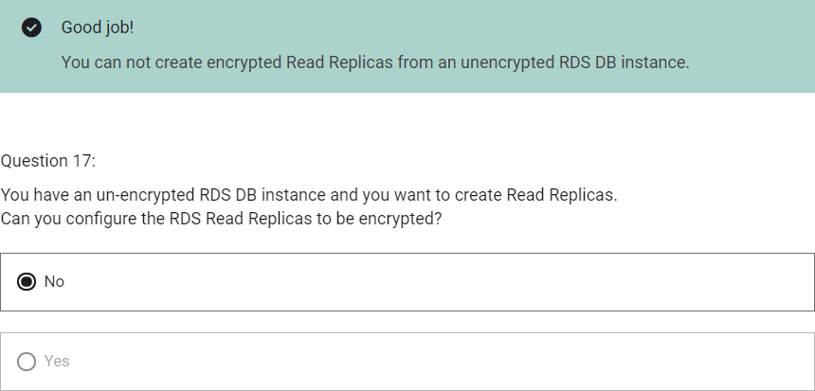

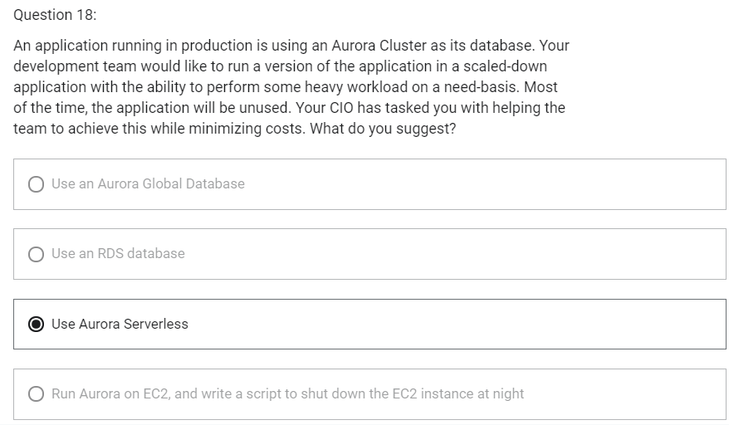

DNS Terminologies

1. Domain Registrar
   1. Amazon Route 53
   2. GoDaddy
2. DNS Records
   1. A
   2. AAAA
   3. CNAME
   4. NS
3. Zone File
   1. Contains DNS records
4. Name Server
   1. Resolves DNS queries
5. Top Level Domain (TLD)
   1. .com
   2. .org
6. Second Level Domain (SLD)
   1. Amazon.com
   2. Google.com

<http://api.www.example.com>

TLD-> .com

SLD-> example.com

Sub Domain-> [www.example.com](http://www.example.com)

Domain Name-> api.www.example.com

http-> Protocol

FQDN (Fully Qualified Domain Name)-> <http://api.www.example.com>

Route 53

1. Highly available, scalable, fully managed and Authoritative DNS
   1. Authoritative-> customer (you) can update the DNS records
2. Route 53 is also a Domain Registrar-> helps in domain name registration
3. Ability to check the health of your resources
4. The only AWS service which provides 100% availability SLA
5. Why Route 53?
   1. 53 is a reference to the traditional DNS port

Route 53- Records

1. How you want to route traffic for a domain
2. Each record contains
   1. Domain/ Subdomain name: example.com
   2. RecordType: A or AAAA
   3. Value: 123.456.789.123
   4. Routing Policy: how route 53 responds to queries
   5. TTL: amount of time the record cached at DNS Resolvers
3. Route 53 supports following DNS record types
   1. A – maps a hostname to IPv4
   2. AAAA – maps a hostname to IPv6
   3. CNAME – maps a hostname to another hostname
      1. The target is a domain name which must have a A or AAAA record
      2. Can not create a CNAME record for the top node of a DNS namespace
      3. Ex: you cannot create for example.com, but you can create for [www.example.com](http://www.example.com)
   4. NS – Name Servers for the Hosted Zone

Route 53 – Hosted Zones

1. A container for records that define how to route traffic to a domain and its subdomain
2. Public Hosted Zones
   1. Allows anyone from Internet to query your record
   2. Contains records that specify how to route traffic on the Internet (public domain names)
3. Private Hosted Zones
   1. Allows querying only from private network like your VPC
   2. Contains records that specify how you route traffic within one or more VPCs (private domain names)
4. You pay $0.5 per month per hosted zone

Route 53-TTL

1. Time to Live
2. Time period for which result of record is cached into client machine
3. High TTL
   1. E.g. 24 hr
   2. Less traffic on route 53
   3. Possibly outdated records
4. Low TTL
   1. E.g. 60 sec
   2. More traffic on Route 53
   3. Records are outdated for less time
   4. Easy to change records
5. Except for Alias records, TTL is mandatory for each DNS record

CNAME vs Alias

CNAME

1. Points a hostname to any other hostname (app.mydomain.com-> blabla.anything.com)
2. Only for non root domain (something.mydomain.com)

Alias

1. Points a hostname to an AWS Resource (app.mydomain.com-> blabla.amazonaws.com)
2. Works for root domain and non root domain (mydomain.com)
3. Free of charge
4. They have native health check capability

Route 53- Alias Records

1. Maps a hostname to an AWS resource
2. An extension to DNS functionality
3. Automatically recognizes changes in the resource’s IP addresses
4. Unlike CNAME, it can be used for the top node of a DNS namespace E.g. example.com
5. Alias record is always of type A/AAAA for AWS resources (IPv4/IPv6)
6. You cannot set TTL. Its set automatically by Route 53

Route 53- Alias Records Targets

1. Elastic Load Balancers
2. CloudFront Distributions
3. API Gateway
4. Elastic Beanstalk environments
5. S3 Websites
6. VPC Interface Endpoints
7. Global Accelerator
8. Route 53 record in the same hosted zone
9. You cannot set an ALIAS record for an EC2 DNS name

Routing Policy

1. Define how Route 53 responds to DNS queries
2. Route 53 supports the following routing policies
   1. Simple
   2. Weighted
   3. Failover
   4. Latency based
   5. Geolocation
   6. Multi-value Answer
   7. Geoproximity

Routing Policy- Simple

1. Route traffic to a single resource
2. Can specify multiple values in the same record
3. If multiple values are returned, a random one is chosen by the client
4. When alias is enabled, specify only one AWS resource
5. Cannot be associated with health checks

Routing Policy- Weighted

1. Control the % of the requests that go to each specific resource
2. Assign each record a relative weight
   1. Traffic (%)= weight for a specific record/ Sum of all the weights for all records
   2. Weights don’t need to sum up to 100
3. DNS records must have the same name and type
4. Can be associated with Health Checks
5. Use cases
   1. Load balancing between regions
   2. Testing new application versions
6. Assign a weight of 0 to a record to stop sending traffic to a resource
7. If all records have weight of 0, then all records will be returned equally

Routing Policy- Latency-based

1. Redirect to the resource that has the least latency close to us
2. Helpful when latency for users is a priority
3. Latency is based on traffic between users and AWS Regions
4. Can be associated with Health Checks (has a failover capability)

Route 53- Health Checks

1. HTTP Health Checks are only for public resources
2. Health check-> Automated DNS failover
   1. Health checks that monitor an endpoint
   2. Health checks that monitor other health checks (calculated health checks)
   3. Health checks that monitor CloudWatch Alarms (helpful for private resources)
3. Health checks are integrated with CloudWatch metrics

Health Checks- Monitor an Endpoint

1. About 15 global health checks will check the endpoint health
   1. Healthy/Unhealthy Threshold- 3 (default)
   2. Interval- 30 sec (can be set to 10 sec- higher cost)
   3. Supported protocol- HTTP, HTTPS and TCP
   4. If >18% of health checkers report the endpoint is healthy, Route 53 considers it Healthy. Otherwise, it is Unhealthy
   5. Ability to choose which locations you want Route 53 to use
2. Health checks pass only when the endpoint responds with 2xx and 3xx status codes
3. Health Checks can be setup to pass/fail based on text in the first 5120 bytes of the response

Route 53- Calculated Health Checks

1. Combine the results of multiple health checks into a single Health Check
2. You can use OR, AND or NOT
3. Can monitor upto 256 child health checks
4. Specify how many of the health checks need to pass to make the parent pass
5. Usage
   1. Perform maintenance to your website without causing all health checks to fail

Health Checks- Private Hosted Zones

1. Route 53 health checkers are outside the VPC
2. They cannot access private endpoints (private VPC or on-premises resource)
3. You can create a CloudWatch Metric and associate a CloudWatch Alarm, then create a Health Check that checks the alarm itself

Routing Policy- Failover

1. Route traffic to healthy instance
2. There will be primary and secondary record. Primary record should be associated with health check
3. Active-Passive

Routing Policy- Geolocation

1. Different from latency-based
2. This routing is based on user location
3. Specify location by continent, country or by US State (if there is overlapping most precise location is selected)
4. Should create a “Default” record (in case there is no match on location)
5. Use case
   1. Website localization
   2. Restrict content distribution
   3. Load balancing
6. Can be associated with Health Checks

Routing Policy- Geoproximity

1. Route traffic to your resources based on geographic location of users and resources
2. Ability to shift more traffic to resources based on the defined bias
3. To change the size of the geographic region, specify bias values
   1. To expand (1 to 99) – more traffic to the resource
   2. To shrink (-1 to -99) – less traffic to the resource
4. Resources can be
   1. AWS resources (specify AWS region)
   2. Non-AWS resources (specify latitude and longitude)
5. You must use Route 53 Traffic Flow (advanced) to use this feature

Route 53- Traffic flow

1. Simplify the process of creating and maintaining records in large and complex configurations
2. Visual editor to manage complex routing decision trees
3. Configurations can be saved as Traffic Flow Policy
   1. Can be applied to different Route 53 Hosted Zones (different domain names)
   2. Supports versioning

Routing Policy- Multi-value

1. Use when routing traffic to multiple resources
2. Route 53 return multiple values/resources
3. Can be associated with Health Checks (return only values for healthy resources
4. Upto 8 healthy records are returned for each Multi-Value query
5. Multi-Value is not a substitute for having an ELB

Domain Registrar vs DNS Service

1. You buy or register your domain name with a Domain Registrar typically by paying annual charges (E.g. GoDaddy, Amazon Registrar Inc,..)
2. Domain Registrar usually provides you with a DNS service to manage your DNS records
3. But you can use another DNS service to manage your DNS records
4. Ex: purchase the domain from GoDaddy and use Route 53 to manage DNS records
5. Domain Registrar!=DNS Service. But every Domain Registrar usually comes with some DNS features

3rd Party Registrar with Amazon Route 53

1. If you buy your domain on a 3rd party registrar, you can still use Route 53 as the DNS Service provider
   1. Create a Hosted Zone in Route 53
   2. Update NS Records on 3rd party website to use Route 53 Name Servers

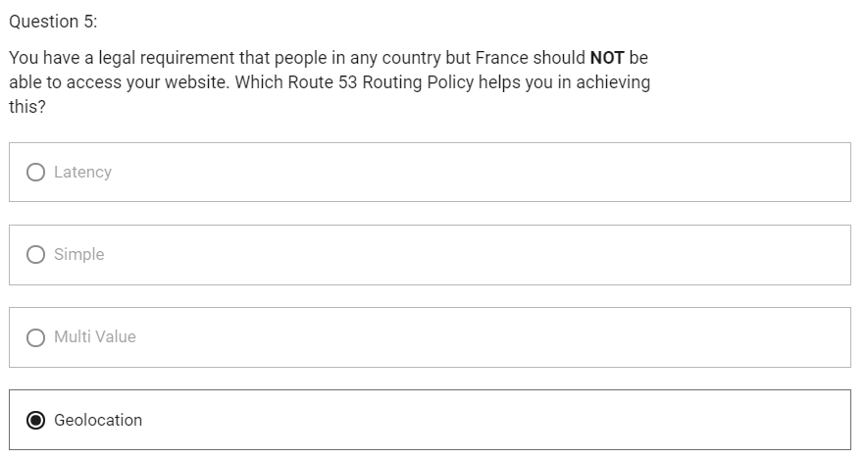

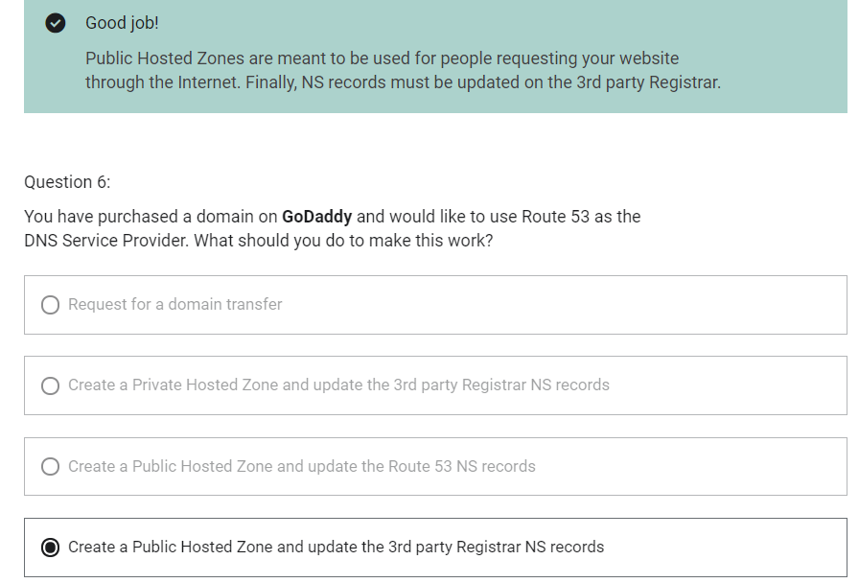

Instantiating Applications quickly

1. EC2 Instances
   1. Use a Golden AMI- Install your applications, OS dependencies, etc.. beforehand and launch your EC2 instance from the Golden AMI
   2. Bootstrap using User Data- For dynamic configuration, use User Data scripts
   3. Hybrid- mix Golden AMI and User Data (Elastic Beanstalk)
2. RDS Databases
   1. Restore from a snapshot- the database will have schemas and data ready
3. EBS Volumes
   1. Restore from a snapshot- the disk will already be formatted and have data

ElasticBeanstalk

1. It is a developer centric view of deploying an application on AWS
2. Managed service
   1. Automatically handles capacity provisioning, load balancing, scaling, application health monitoring, instance configuration, ..
   2. Just the application code is the responsibility of the developer
3. We will still have full control over the configuration
4. Beanstalk is free but you pay for the underlying instances

Elastic Beanstalk- Components

1. Application
2. Application version
3. Environment
   1. Collection of AWS services running an application version
   2. Tiers: Web Server Environment Tier & Worker Environment Tier
   3. You can create multiple environments (dev, test, prod, ..)

Elastic Beanstalk- Supported Platforms

1. Go
2. JavaSE
3. Java with Tomcat
4. .NET Core on Linux
5. .NET on Windows Server
6. Node.js
7. PHP
8. Python
9. Ruby
10. Packer Builder
11. Single Container Docker
12. Multi-container Docker
13. Preconfigured Docker
14. If not supported, you can write your custom platform

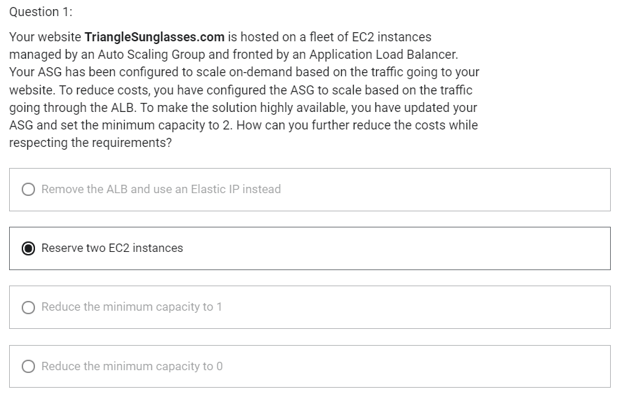

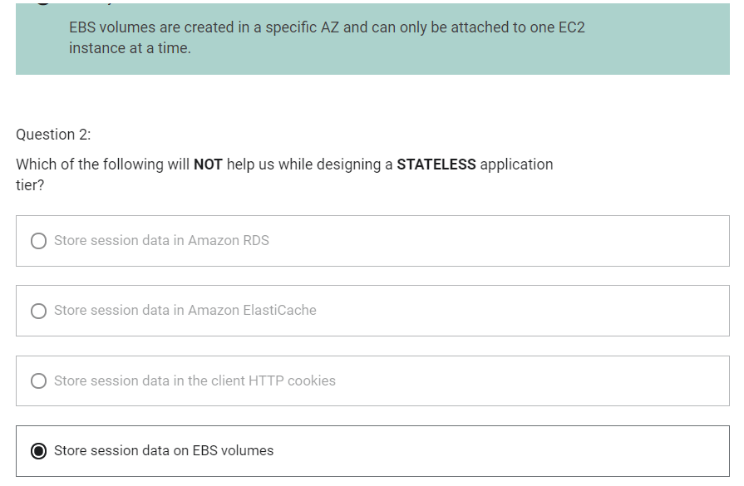

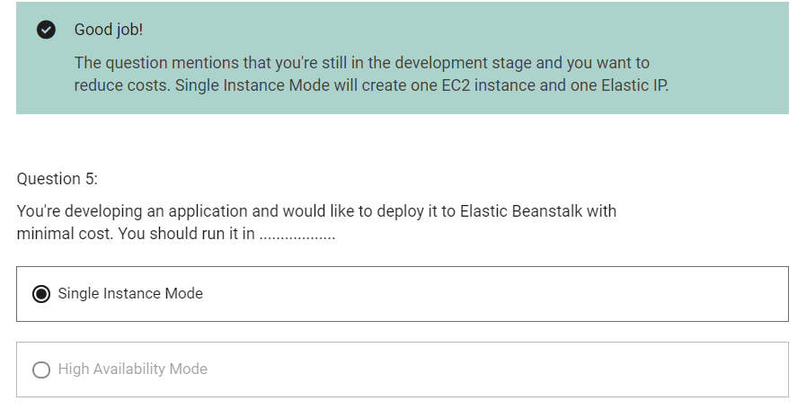

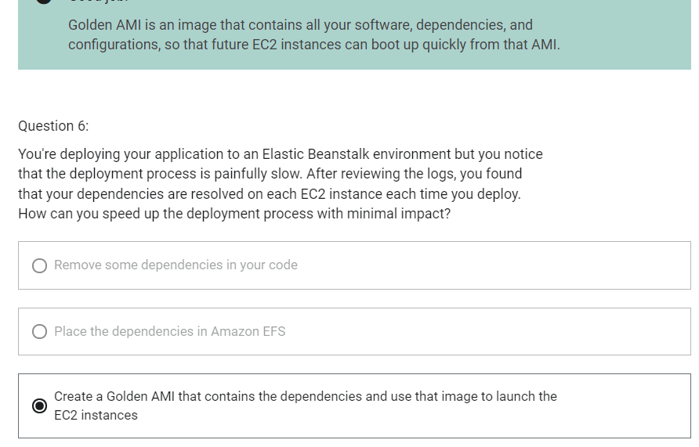

Amazon S3

1. “infinitely scaling” storage
2. Objects are stored in bucket
3. Buckets must have a globally unique name
4. Buckets are defined at regional level
5. Naming convention
   1. No uppercase
   2. No underscore
   3. 3-63 characters long
   4. Not an IP
   5. Must start with lowercase letter or number
6. Objects consist of:
   1. Key
      1. Key is the full path. Key is composed of prefix + object_name
      2. S3://my-bucket/my_file.txt
      3. S3://my-bucket/my_folder1/another_folder/my_file.txt
   2. Value
      1. content of the body
      2. Max object size is 5 TB (5000 GB)
      3. If uploading more than 5 GB, must use “multi-part upload”
   3. Version ID (if versioning is enabled)
   4. Tags
   5. Metadata

Amazon S3- Versioning

1. You can version your files in Amazon S3
2. It is enabled at the bucket level
3. Same key overwrite will increment the version: 1,2,3,…
4. It is the best practice to version your buckets
   1. Protect against unintended deletes
   2. Easy roll back to previous version
5. Any file that is not versioned prior to enabling versioning will have version “null”
6. Suspending versioning does not delete previous versions
7. When we delete a file, it is not deleted permanently, a delete marker is added on top.
8. To delete permanently, we need to delete both object and delete marker.

Amazon S3- Encryption

S3 Encryption for Objects

1. Encryption can be performed in object level or bucket level.
2. When default encryption is enabled in bucket level, encryption will be performed for every files uploaded into that bucket.
3. There are four methods of encrypting objects in S3
4. SSE-S3: encrypts S3 objects using keys handled and managed by AWS
5. SSE-KMS: leverage AWS Key Management Service to manage encryption keys
6. SSE-C: when you want to manage your own encryption keys
7. Client Side Encryption

SSE-S3

1. Encryption using keys handled and managed by Amazon S3
2. Object is encrypted server side
3. AES-256 encryption type
4. Must set header: “x-amz-server-side-encryption”: “AESS56”

SSE-KMS

1. Encryption using keys handled and managed by KMS
2. Object is encrypted server side
3. KMS Advantages
   1. User control
   2. Audit trail
4. Must set header: “x-amz-server-side-encryption”: “aws:kms”

SSE-C

1. Encryption using data leys fully managed by customer outside of KMS
2. Amazon S3 does not store the encryption key you provide
3. HTTPS must be used. HTTPS is mandatory for SSE-C.
4. Server-side encryption
5. Encryption key must be provided in HTTP headers, for every HTTP request made

Client Side Encryption

1. Client Library such as the Amazon S3 Encryption Client
2. Clients must encrypt data themselves before sending to S3
3. Clients must decrypt themselves when retrieving from S3
4. Customer fully manages the keys and encryption cycle

Encryption in transit (SSL/TLS)

1. Amazon S3 exposes
   1. HTTP endpoint: non encrypted
   2. HTTPS endpoint: encryption in flight
2. Encryption in flight is also called SSL/TLS

S3 Security

1. User based
   1. IAM policies- which API calls should be allowed for a specific user from IAM console
2. Resource based
   1. Bucket Policies- bucket wide rules from the S3 console, allows cross account
   2. Object Access Control list- finer grain
   3. Bucket Access Control list
3. An IAM principal can access an S3 object if
   1. The user IAM permissions allow it OR the resource policy allows it
   2. AND there is no explicit DENY

S3 Bucket Policies

1. JSON based policies
   1. Resources: buckets and objects
   2. Actions: Set of API to Allow or Deny
   3. Effect: Allow/Deny
   4. Principal: the account or user to apply policy to
2. Used for
   1. Grant public access to the bucket
   2. Force objects to be encrypted at upload
   3. Grant access to another account (Cross Account)

Block Public Access

1. Block Public Access in will block public Access to the bucket
2. It can be set on account level

S3 Security- Other

1. Networking
   1. Supports VPC Endpoint
2. Logging and Audit
   1. S3 Access Logs can be stored in other S3 bucket
   2. API calls can be logged in AWS CloudTrail
3. User Security
   1. MFA Delete- MFA can be required in versioned buckets to delete objects
   2. Pre-signed URLs- URLs that are valid only for a limited time

S3 Websites

1. S3 can host static websites and have them accessible on the www
2. The website URL will be
   1. <bucket-name>.s3-website-<AWS-region>.amazonaws.com
   2. <bucket-name>.s3-website.<AWS-region>.amazonaws.com
3. If you get a 403 (Forbidden) error, make sure the bucket policy allows public reads

S3 CORS

CORS (Cross Region Resource Sharing)

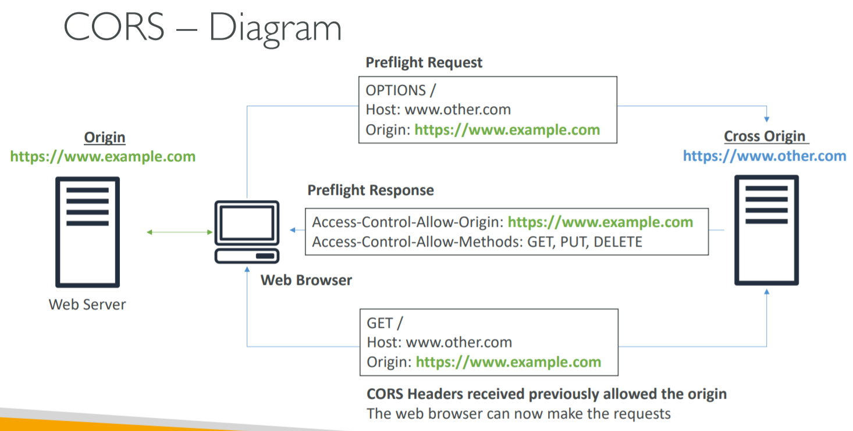

1. An origin is a protocol, domain and port
   1. E.g. <https://www.example.com> (implied port is 443 for HTTPS, 80 for HTTP)
2. CORS means Cross Origin Resource Sharing
3. Web Browser based mechanism to allow requests to other origins while visiting the main origin
4. Same origin: <http://example.com/app1> and <http://example.com/app2>
5. Different origins: <http://www.example.com> and <http://other.example.com>
6. The request won’t be fulfilled unless the other origin allows for the request, using CORS Headers (ex: Access- Control-Allow-Origin)

S3 CORS

1. If website_1 needs to access resource on website_2 through a web browser, then, website_2 needs to have CORS setting to allow request to be done otherwise the web-browser is going to block it.
2. If a client does a cross-origin request on our S3 bucket, we need to enable correct CORS headers
3. You can allow for a specific origin or for * (all origins)
4. CORS header should be defined in cross origin bucket not in first origin bucket

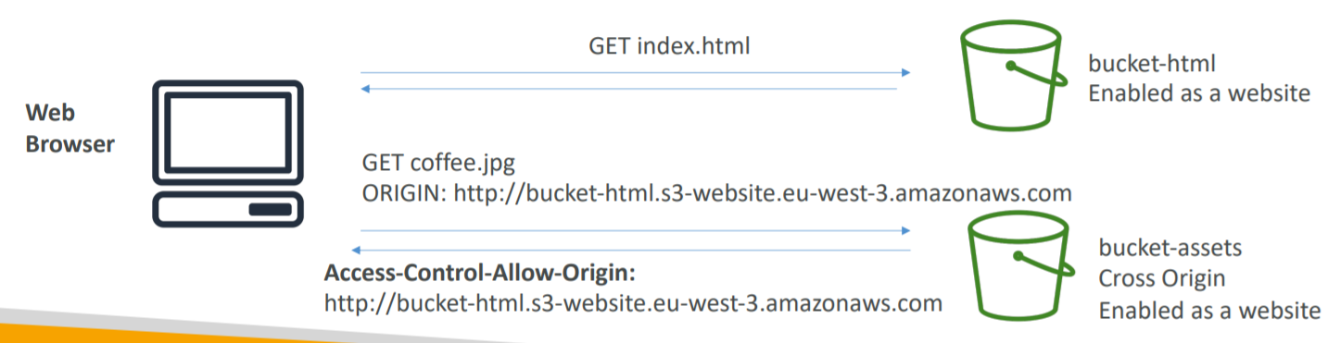

Amazon S3- Consistency Model

1. After a
   1. Successful write of a new object (new PUT)
   2. Or an overwrite or delete of an existing object (overwrite PUT or DELETE)
2. Any
   1. Subsequent read request immediately receives the latest version of the object (read after write consistency)
   2. Subsequent list request immediately reflects changes (list consistency)
3. Available at no additional cost, without any performance impact

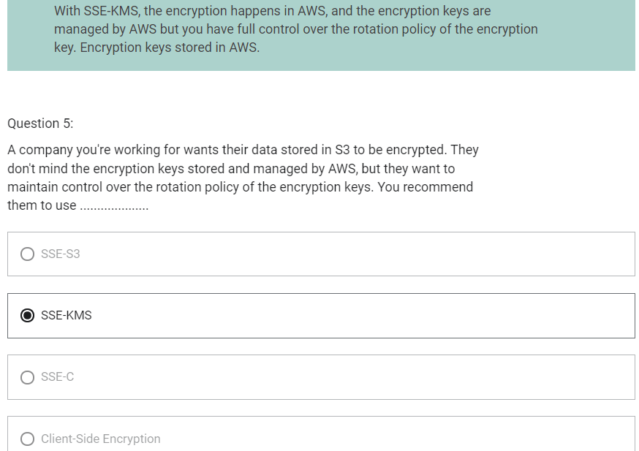

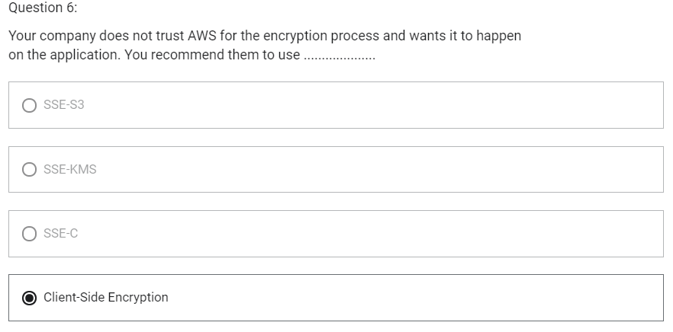

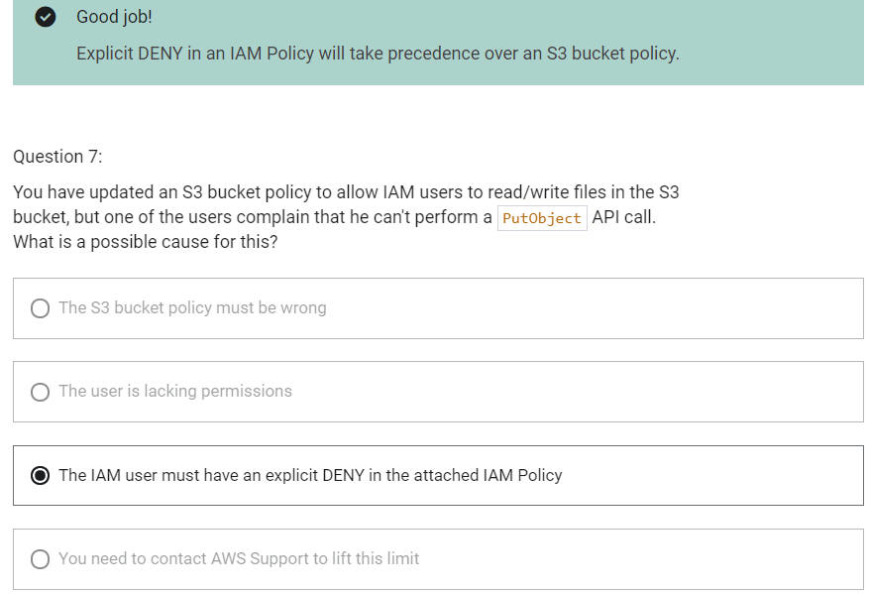

Policy Simulator

1. It helps us to test, understand and troubleshoot IAM policies that are attached to users, groups, roles or resources

EC2 Instance Metadata

1. Metadata = Info about EC2 instance
2. Userdata = launch script of the EC2 instance
3. It allows AWS EC2 instance to “learn about themselves” without using an IAM Role for that purpose
4. The URL is <http://169.254.169.254/latest/meta-data>
5. You can retrieve the IAM Role name from the metadata, but you cannot retrieve the IAM Policy

AWS SDK

1. Software Development Kit
2. Used to perform actions on AWS directly from your application code
3. Official SDKs are
   1. Java
   2. .NET
   3. Node.js
   4. PHP
   5. Python
   6. Go
   7. Ruby
   8. C++
4. We have to use AWS SDK when coding against AWS Services
5. AWS CLI uses Python SDK
6. If you do not specify of configure a default region, then us-east-1 will be chosen by default

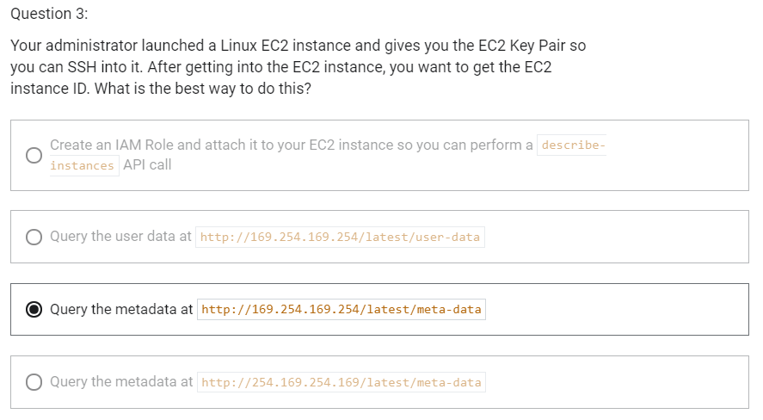

S3 MFA Delete

1. MFA forces user to generate a code on a device before doing important operations on S3
2. To use MFA-Delete, enable versioning on S3 bucket
3. You will need MFA to
   1. Permanently delete an object version
   2. Suspend versioning on the bucket
4. You won’t need MFA for
   1. Enabling versioning
   2. Listing deleted versions
5. Only the bucket owner (root account) (not even admin) can enable/disable MFA-Delete
6. MFA-Delete currently can only be enabled using CLI

S3 Default Encryption

S3 Default Encryption vs Bucket Policies

1. We can “force encryption” by using bucket policy and refuse any API call to PUT an S3 object without encryption headers.
2. Another way is to use the “default encryption” option in S3. If unencrypted object is uploaded into bucket, it will be encrypted using default encryption option. If the object is already encrypted, it will not be re-encrypted.
3. Note: Bucket Policies are evaluated before “default encryption”
4. If we need to force encryption mechanism of SSE-S3, you need to use bucket policy.
5. If the requirement is we need to encrypt every single object being encrypted into bucket, then we should use “Default Encryption”.
6. “Default Encryption” will not apply same encryption mechanism to all files. It is just making sure that if an object is uploaded in unencrypted manner, then it will automatically be encrypted using “default encryption” mechanism.

S3 Access Logs

1. For audit purpose, you may want to log all access to S3 buckets
2. Any request made to S3, from any account, authorized or denied, will be logged into another S3 bucket.
3. That data can be analyzed using data analysis tools or Amazon Athena
4. By enabling server access logging, S3 console will automatically update your bucket access control list (ACL) to include access to the S3 log delivery group.

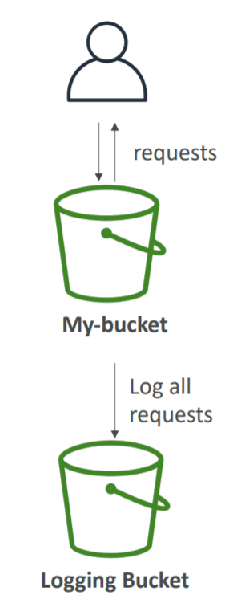

S3 Access Logs: Warning

1. Do not set your logging bucket to be the monitored bucket
2. It will create a logging loop and your bucket will grow in size exponentially

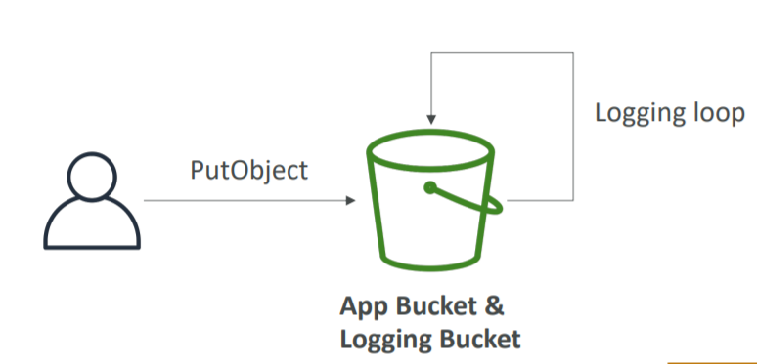

S3 Replication (CRR and SRR)

1. Replicate data between two objects asynchronously
2. Must enable versioning in both source and destination
3. Types of S3 Replication are
   1. Same Region Replication (SRR)
   2. Cross Region Replication (CRR)
4. Buckets can be in different accounts
5. Copying is asynchronous
6. Must give proper IAM permissions to S3
7. Use case for SRR
   1. Log aggregation
   2. Live replication between production and test accounts
8. Use case for CRR
   1. Compliance
   2. Lower latency access
   3. Replication across accounts
9. After activating replication, only new objects are replicated (not retroactive)
10. For delete operations
    1. Can replicate delete markers from source to target (optional setting-> Delete Marker Replication)
    2. Deletions with a version ID are not replicated (to avoid malicious deletes)
11. There is no chaining of replication
    1. If bucket 1 has replication into bucket 2, which has replication into bucket 3
    2. Then objects created in bucket 1 are not replicated to bucket 3

S3 pre-signed URLs

1. Can generate pre-signed URLs using SDK or CLI
   1. For downloads (easy, can use CLI)
   2. For uploads (harder, must use SDK)
2. Valid for a default of 3600 seconds, can change timeout with –expires-in [TIME_BY_SECONDS] argument
3. Users given a pre-signed URL inherit the permissions of the person who generated the URL for GET/PUT
4. Examples
   1. Allows only logged-on users to download a premium video on your S3 bucket
   2. Allow an ever changing list of users to download files by generating URLs dynamically
   3. Allow temporarily a user to upload a file to a precise location in our bucket

S3 Storage Classes

1. Amazon S3 Standard- General Purpose
2. Amazon S3 Standard- Infrequent Access (IA)
3. Amazon S3 One Zone Infrequent Access
4. Amazon S3 Intelligent Tiering
5. Amazon Glacier
6. Amazon Glacier Deep Archive
7. S3 Standard

* General purpose storage
* Data is stored across multiple availability zones
* Recommended for
  + Data that are frequently accessed
* Durability of 99.999999999%
* Availability of 99.99%

1. S3 Intelligent Tiering

* Automatically moves your data to most cost-effective storage class
* Automatic cost savings
* Data is stored across multiple availability zones
* Recommended for
  + Data with unknown or changing access pattern like new app or data lake
* Durability of 99.999999999%
* Availability of 99.9%

1. S3 Standard- Infrequent Access

* Data is accessed less frequently but requires rapid access (millisecond access)
* Cheaper than S3 Standard
* Data is stored across multiple availability zones
* Recommended for
  + Data which is not frequently accessed but requires rapid access (millisecond access)
* Durability of 99.999999999%
* Availability of 99.9%

1. S3 One Zone- Infrequent Access

* Data is accessed less frequently but requires rapid access (millisecond access)
* Costs 20% less than S3 Standard Infrequent Access
* Data is stored in single availability zone
* Data can be lost
* Recommended for
  + Data which is not frequently accessed but requires rapid access (millisecond access)
  + Availability and Durability is not so essential
  + Used for storing secondary backup copies of on-premises data
* Durability of 99.999999999%
* Availability of 99.5%

1. S3 Glacier

* Cold Storage for archival data
* Data Retrieval takes longer time
* 3 retrieval options:
  + Expedited 1-5 min
  + Standard 3-5 hours
  + Bulk 5-12 hours
* Data is stored in multiple availability zones
* Recommended for
  + Storage of archival data
* Durability of 99.999999999%
* Each item in Glacier is not called Object. It is called Archive. Each archive can be a file of upto 40 TB.
* Archives are not store in Bucket. They are stored in Vaults.
* Minimum storage duration of 90 days

1. S3 Glacier Deep Archive

* Like S3 Glacier but longer access time
* 2 retrieval options:
  + Standard 12 hours
  + Bulk 48 hours
* Cheapest of all S3 options
* Data is stored in multiple availability zones
* Recommended for
  + Long-term archival data which is accessed once or twice a year
  + Retaining data for regulatory compliance requirement
* Durability of 99.999999999%
* Minimum storage duration of 180 days

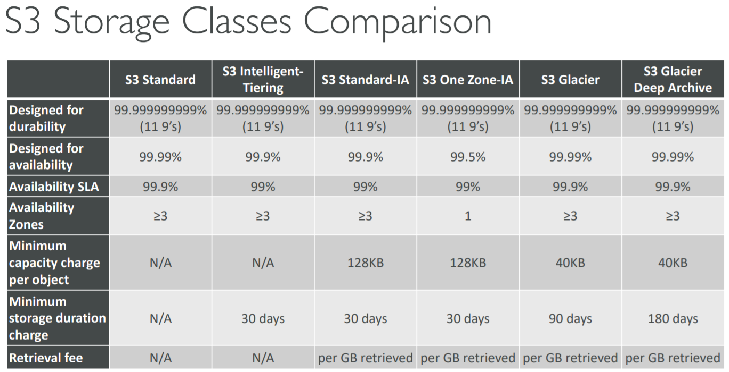

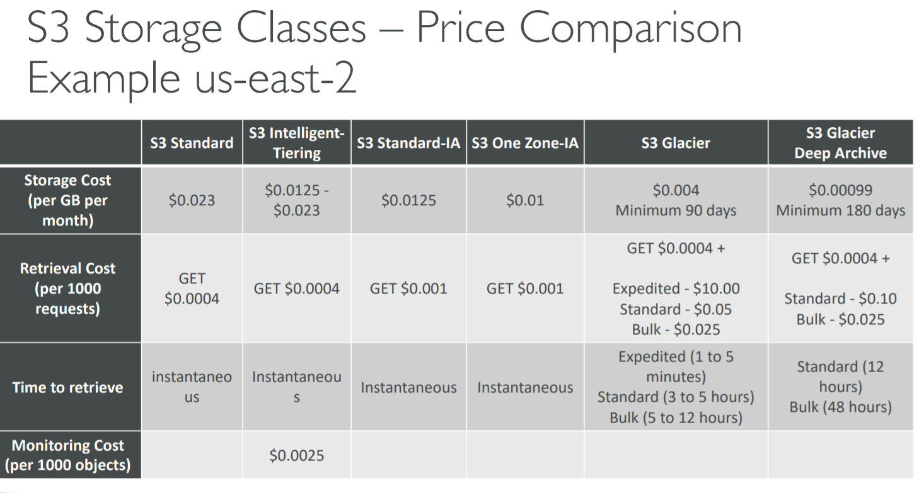

S3 Lifecycle Rules

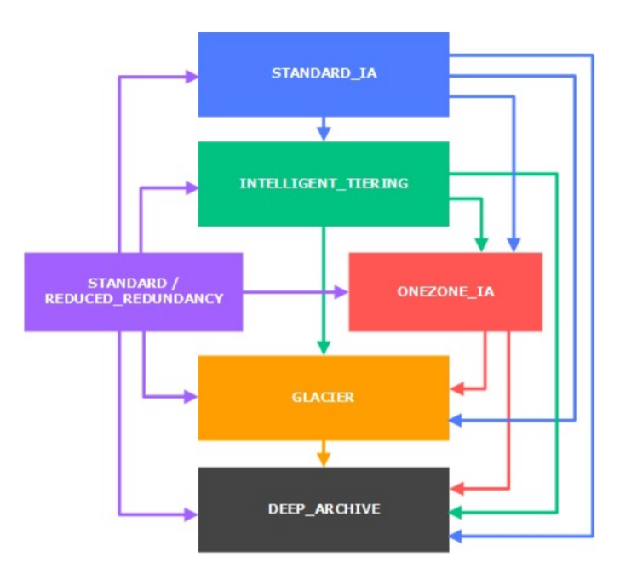

1. Moving objects between storage classes
2. You can transition objects between storage classes
3. For infrequently accessed objects, move them to STANDARD_IA
4. For archive objects, you don’t need in real-time, GLACIER or DEEP_ARCHIVE
5. Moving objects can be automated using a lifecycle configuration

S3 Lifecycle Rules

1. Transition actions
   1. It defines when objects are transitioned to another storage class
      1. Move objects to Standard IA class 60 days after creation
      2. Move to Glacier for archiving after 6 months
2. Expiration actions
   1. Configure objects to expire (delete) after some time
      1. Access log files can be set to delete after a 365 days
      2. Can be used to delete old versions of files (if versioning is enabled)
      3. Can be used to delete incomplete multi-part uploads
3. Rules can be created for a certain prefix (ex- s3://mybucket/mp3/*)
4. Rules can be created for certain objects tags (ex- Department: Finance)

S3 Lifecycle Scenarios

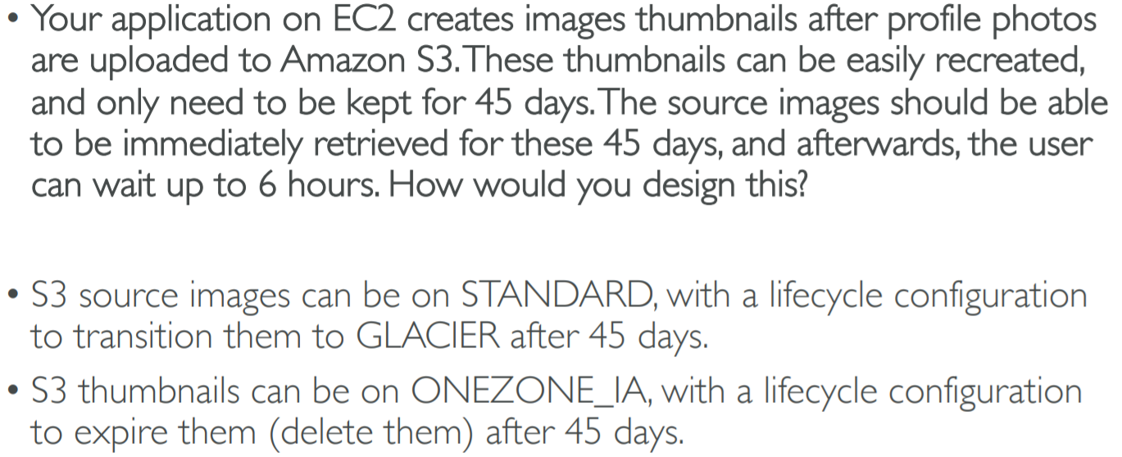

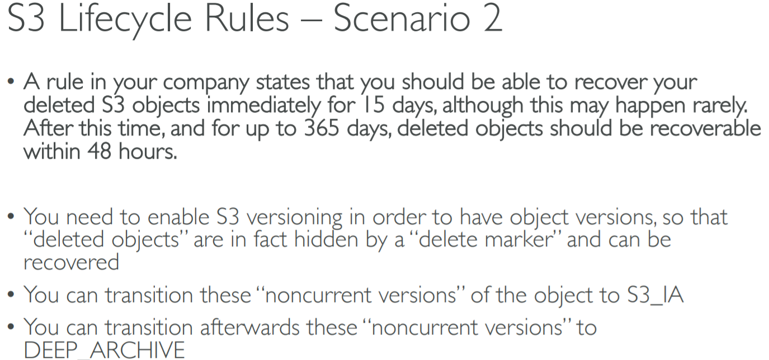

S3 Analytics- Storage Class Analysis

1. You can setup S3 Analytics to determine when to transition objects from Standard to Standard_IA
2. Does not work for ONEZONE_IA or GLACIER
3. Report is updated daily
4. Takes about 24hrs to 48hrs to first start
5. Good first step to put together Lifecycle Rules (or improve them)

S3- Baseline Performance

1. Amazon S3 automatically scale to high request rates, latency 100-200 ms
2. Your application can achieve at least 3,500 PUT/COPY/POST/DELETE and 5,500 GET/HEAD requests per second per prefix in a bucket
3. There are no limits to the number of prefixes in a bucket
4. Example (object_path=> prefix)
   1. Bucket/folder1/sub1/file => /folder1/sub1
   2. Bucket/folder1/sub2/file => /folder1/sub2
   3. Bucket/1/file => /1/
   4. Bucket/2/file => /2/
5. If you spread reads across all four prefixes evenly, you can achieve 22,000 requests per second for GET and HEAD

S3- KMS Limitation

1. If you use SSE-KMS, you may be impacted by the KMS limits
2. When you upload, it calls the GenerateDataKey KMS API
3. When you download, it calls the Decrypt KMS API
4. Count towards the KMS quota per second (5500, 10000, 30000 req/s based on region)
5. You can request a quota increase using the Service Quotas Console

S3 Performance

1. Multi-Part upload

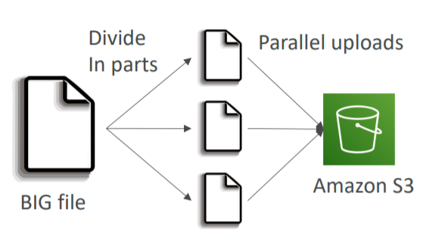

* 1. Recommended for files >100MB
  2. Must use for files>5GB
  3. Can help parallelize uploads (speed up transfer)

1. S3 Transfer Acceleration

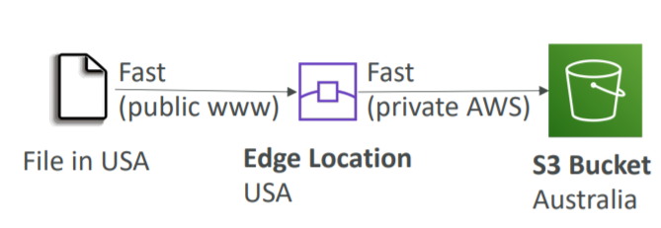

* 1. Increase transfer speed by transferring file to an AWS edge location which will forward the data to the S3 bucket in the target region
  2. Compatible with multi-part upload

S3 Performance- S3 Byte-Range Fetches

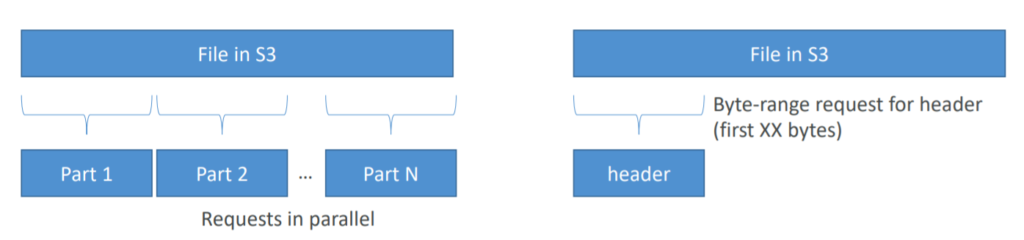

1. Parallelize GETs by requesting specific byte ranges
2. Better resilience in case of failures
3. Can be used to retrieve only partial data (for example the head of a file)

S3 Select and Glacier Select

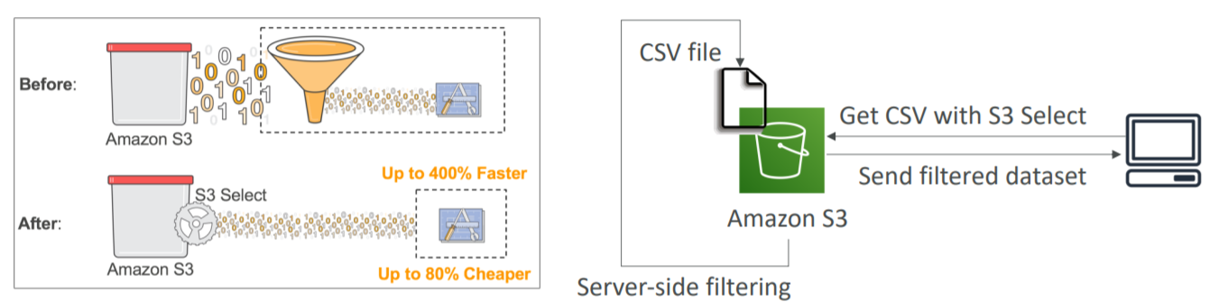

1. Retrieve less data using SQL by performing server-side filtering
2. Can filter by rows and columns (simple SQL statements)
3. Less network transfer, less CPU cost client-side

S3 Event Notifications

1. Some events happen in S3 bucket which may be ObjectCreated, ObjectRemoved, ObjectRestored, Replication
2. You want to react to all these events happening
3. This is possible through S3 Event Notification
4. Object name filtering is possible (*.jpg)
5. Use case
   1. Generate thumbnails of images uploaded to S3
6. Possible targets are
   1. SNS
   2. SQS
   3. Lambda function
7. Can create as many “S3 events” as desired
8. S3 event notifications typically deliver events in seconds but can sometimes take a minute or longer
9. If you want to make sure that every single event notification is delivered, then you need to enable versioning
10. If two writes are made to a single non-versioned object at the same time, it is possible that only a single event notification will be sent
11. If you want to ensure that an event notification is sent for every successful write, you can enable versioning on your bucket.

S3 Requester Pays

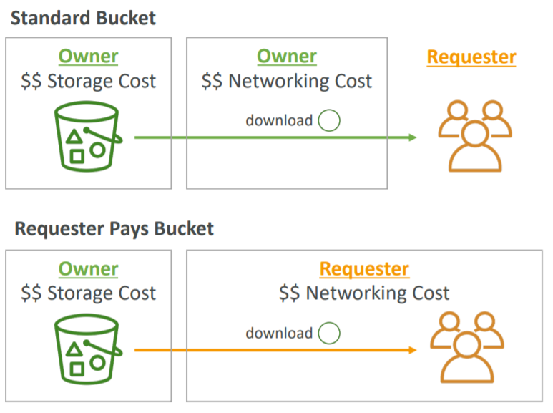

1. In general, bucket owner pay for all Amazon S3 storage and data transfer costs associated with their bucket
2. With Requester Pays buckets, the requester instead of the bucket owner pays the cost of the request and the data download from the bucket
3. Helpful when you want to share large datasets with other accounts
4. The requester must be authenticated (cannot be anonymous)

Amazon Athena

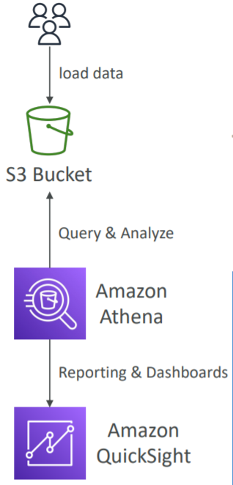

1. Analyze data in S3 using serverless SQL
2. Serverless query service to perform analytics against S3 objects
3. Uses standard SQL language to query the files
4. Supports CSV, JSON, ORC, Avro and Parquet (built on Presto)
5. Pricing: $5 per TB of data scanned
6. Use compressed or columnar data for cost-savings (less scan)
7. Use cases
   1. Building intelligence
   2. Analytics
   3. Reporting
   4. Analyze and query VPC Flow Logs, ELB Logs, CloudTrail trails, etc

Glacier Vault Lock

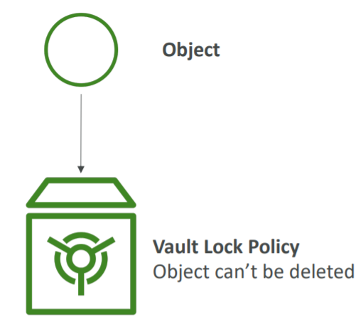

1. Adopt a WORM (Write Once Read Many) model
2. Lock the policy for future edits (can no longer be changed)
3. Helpful for compliance and data retention
4. The object is sent to Glacier and we can create a Vault Lock Policy specifying object cannot be deleted and the policy itself also cannot be deleted

S3 Object Lock

1. Versioning must be enabled
2. Adopt a WORM (Write Once Read Many) model
3. Block an object version deletion for a specified amount of time
4. Object retention
   1. Retention Period: specifies a fixed period
   2. Legal Hold: same protection, no expiry date
5. Modes
   1. Governance Mode: Users cannot overwrite or delete an object version or alter its lock settings unless they have special permissions
   2. Compliance Mode: a protected object version cannot be overwritten or deleted by any user, including the root user in your AWS account. When an object is locked in compliance mode, its retention mode can’t be changed and its retention period cannot be shortened

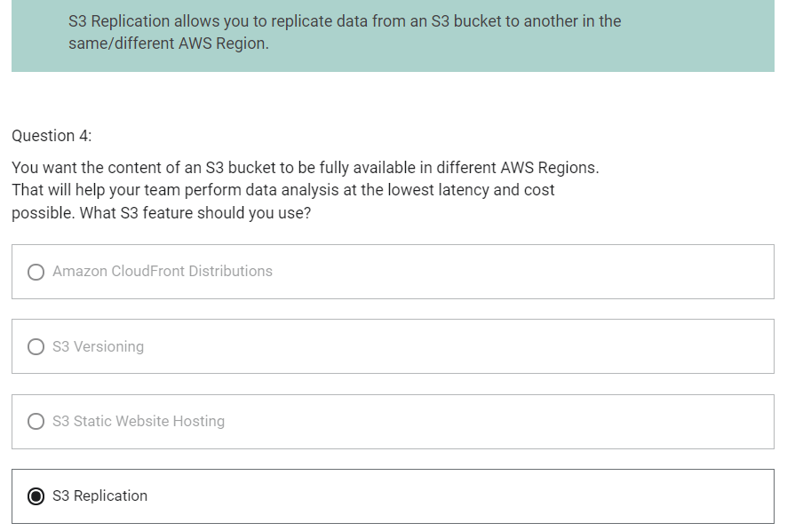

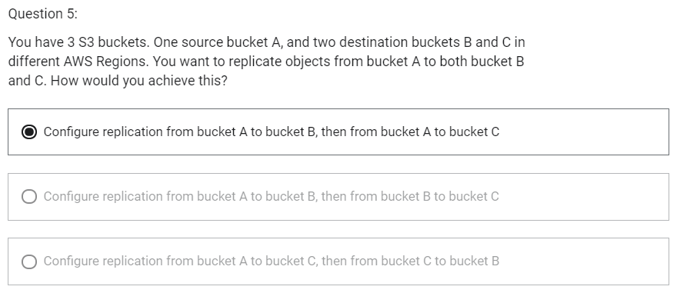

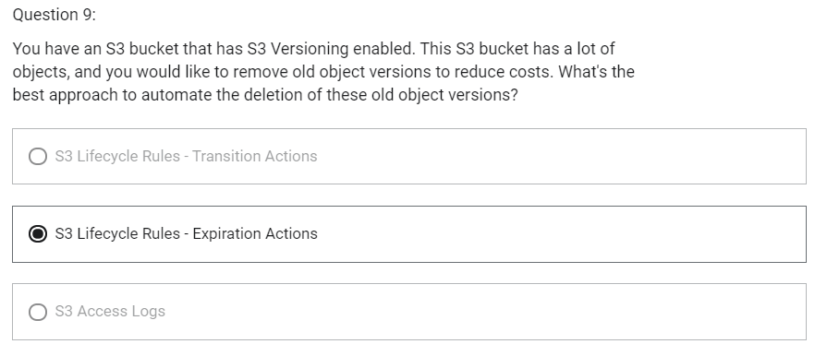

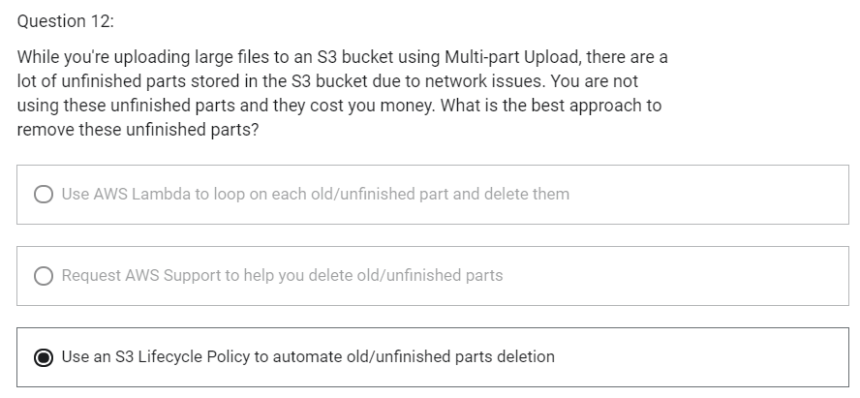

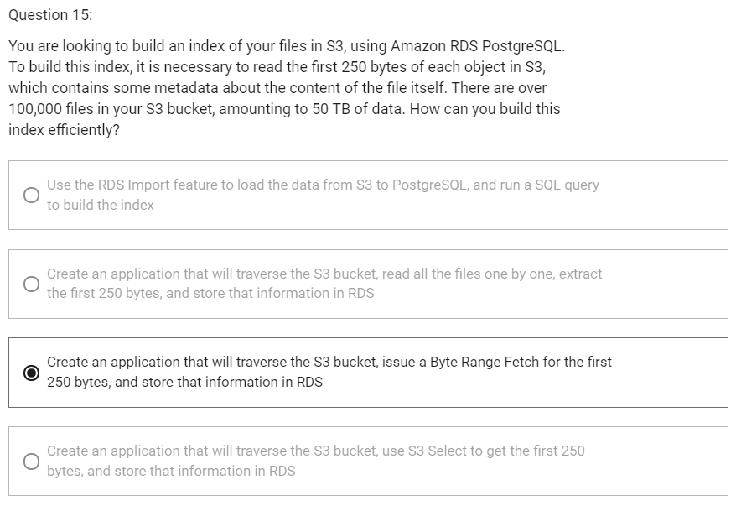

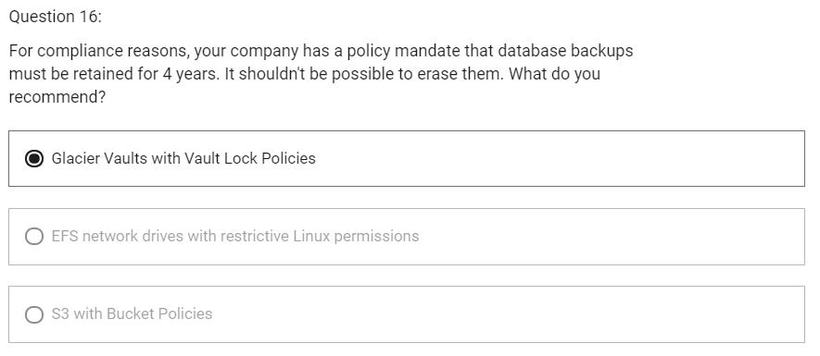

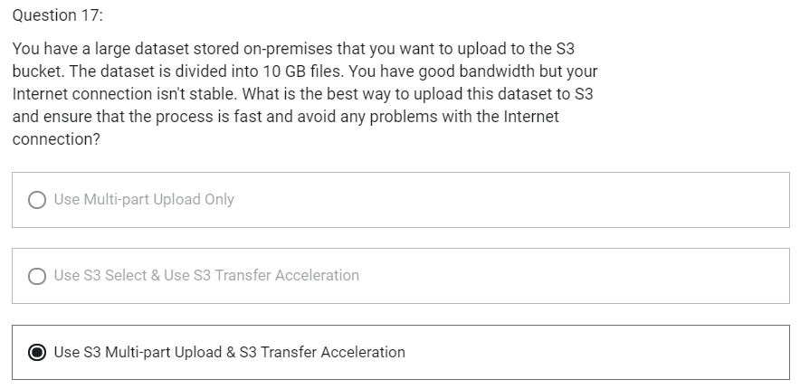

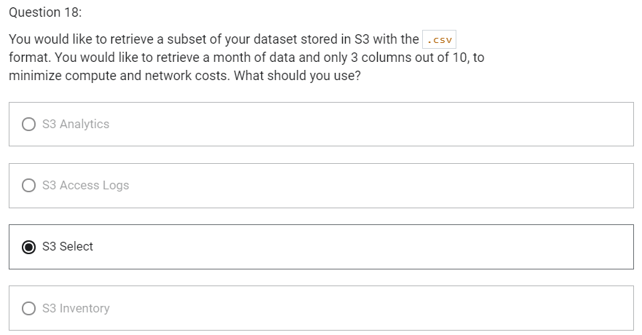

AWS CloudFront

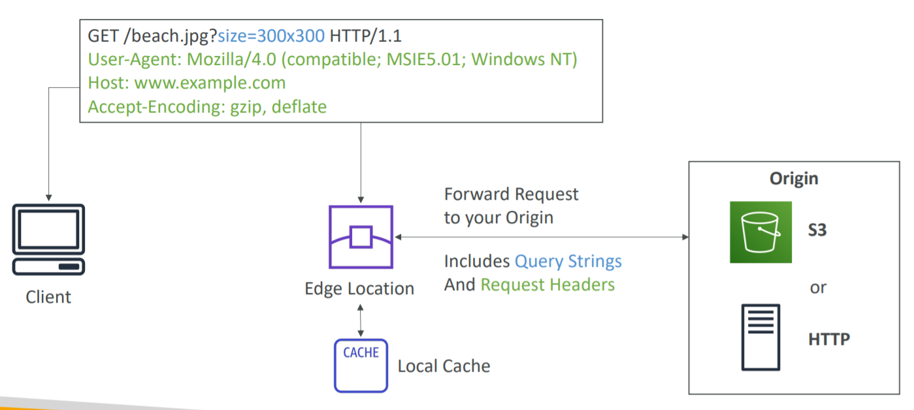

1. Content Delivery Network (CDN)
2. Improves read performance
3. Content is cached at the edge
4. DDoS protection
5. Integration with Shield, AWS WAF
6. Can expose external HTTPS and can talk to internal HTTPS backends

CloudFront- Origins

1. S3 bucket
   1. For distributing files and caching them at the edge
   2. Enhanced security with CloudFront Origin Access Identity (OAI)
   3. CloudFront can be used as an ingress (to upload files to S3)
2. Custom Origin (HTTP)
   1. Application Load Balancer
   2. EC1 Instance
   3. S3 website
   4. Any HTTP backend you want

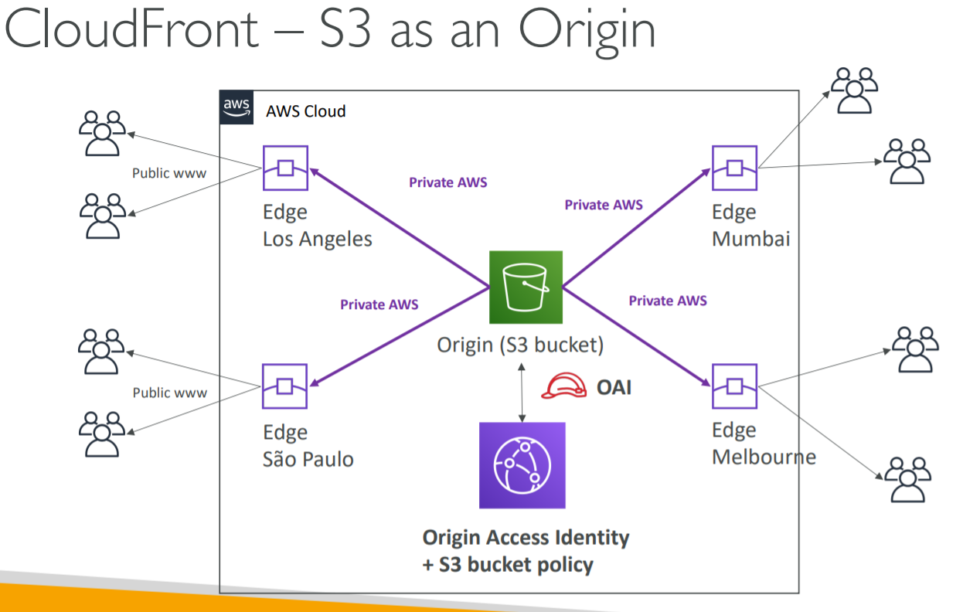

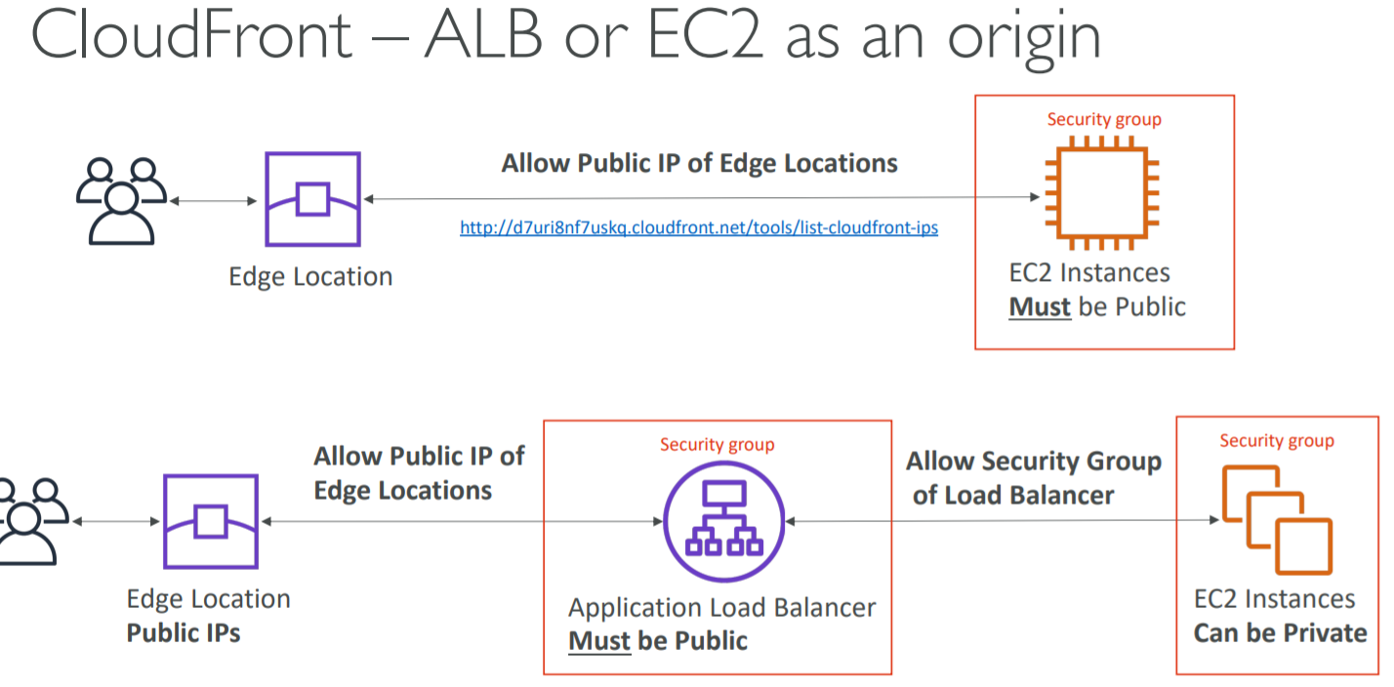

CloudFront- Geo Restriction

1. You can restrict who can access your distribution
   1. Whitelist
      1. Allow your users to access your content only if they are in one of the countries on a list of approved countries
   2. Blacklist
      1. Prevent your users from accessing your content if they are in one of the countries on a blacklist of banned countries
2. The “country” is determined using a 3rd party Geo-IP database
3. Use Case
   1. Copyright Laws to control access to content

CloudFront vs S3 Cross Region Replication

1. CloudFront
   1. Uses Global Edge Network
   2. Files are cached for a TTL (maybe a day)
   3. Great for static content that must be available everywhere
2. S3 Cross Region Replication
   1. Must be setup for each region you want replication to happen
   2. Files are updated in near real-time
   3. Read only
   4. Great for dynamic content that needs to be available at low-latency in few regions

CloudFront Signed URL/Signed Cookies

1. Suppose you have a CloudFront distribution and you want to make it private and you want to give access to people i.e. You want to distribute paid shared content to premium users over the world
2. We can use CloudFront Signed URL/ Cookie
3. First of all, when we create a URL/Cookie, we need to attach a policy with
   1. Includes URL expiration
   2. Includes IP ranges to access the data from
   3. Trusted signers (which AWS accounts can create signed URLs)
4. How long should the URL be valid for?
   1. Shared content (movie, music): make it short (a few minutes)
   2. Private content (private to the user): you can make it last for years
5. Signed URL-> access to individual files (one signed URL per file)
6. Signed Cookie-> access to multiple files (one signed cookie for many files)

CloudFront Signed URL vs S3 Pre-signed URL

CloudFront Signed URL

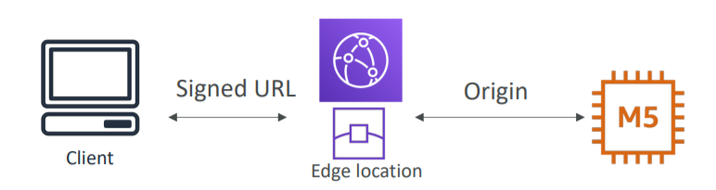

1. Allows access to a path, no matter the origin
2. Account wide key-pair, only the root can manage it
3. Can filter by IP, Path, date, expiration
4. Can leverage caching features

S3 Pre-Signed URL

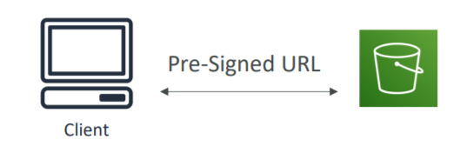

1. Issue a request as the person who pre-signed the URL
2. Uses the IAM key of the signing IAM principal
3. Limited lifetime

CloudFront – Pricing

1. CloudFront Edge Locations are all around the world
2. The cost of data out per edge location varies
3. You can reduce the number of edge locations for cost reduction
4. Three price classes are
   1. Price Class All: all regions- best performance
   2. Price Class 200: most regions, but excludes the most expensive regions
   3. Price Class 100: only the least expensive regions

CloudFront- Multiple Origin

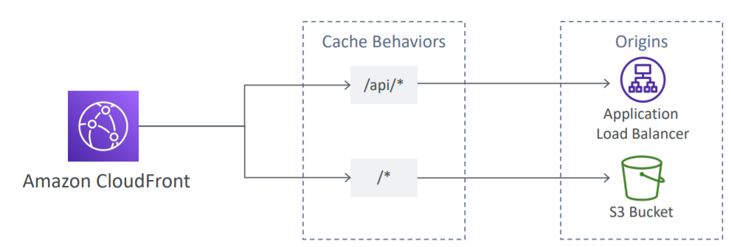

1. To route to different kind of origins based on the content type
2. Based on path pattern
   1. /images/*
   2. /api/*
   3. /*

CloudFront- Origin Groups

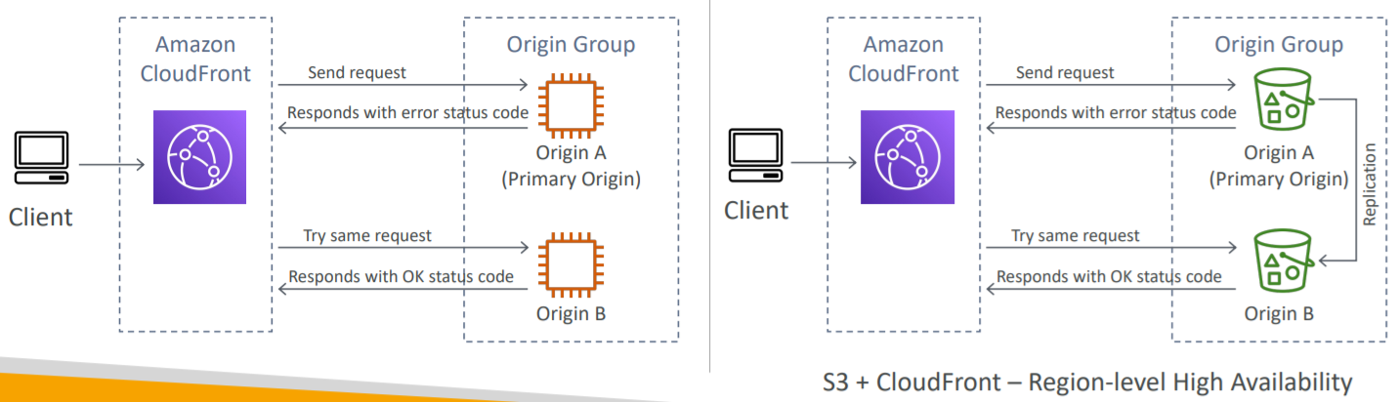

1. To increase high-availability and do failover
2. Origin Group- one primary and one secondary origin
3. If the primary origin fails, the second one is used
4. S3+CloudFront -> Region-level High Availability

CloudFront- Field Level Encryption

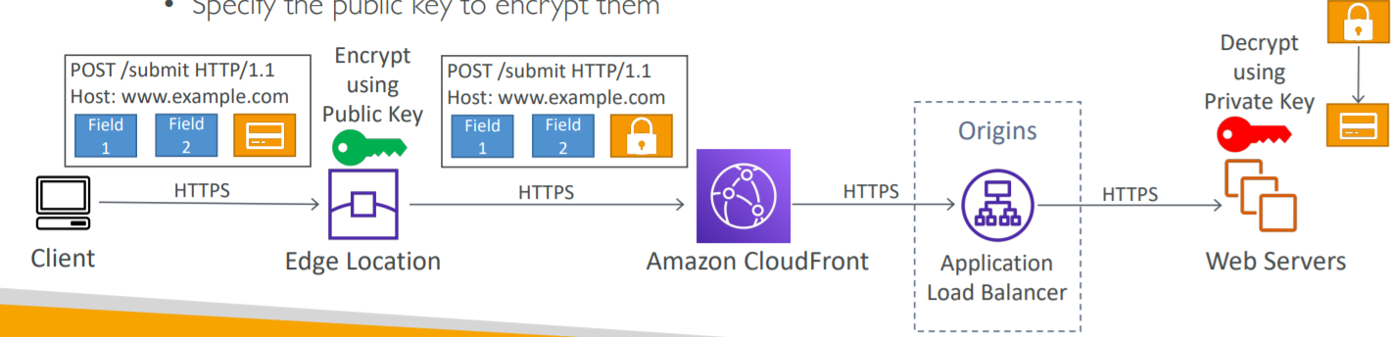

1. Protect user sensitive information through application stack
2. Adds an additional layer of security along the HTTPS
3. Sensitive information encrypted at the edge close to user
4. Uses asymmetric encryption
5. Usage
   1. Specify set of fields in POST requests that you want to be encrypted (up to 10 fields)
   2. Specify the public key to encrypt them

Unicast IP vs Anycast IP

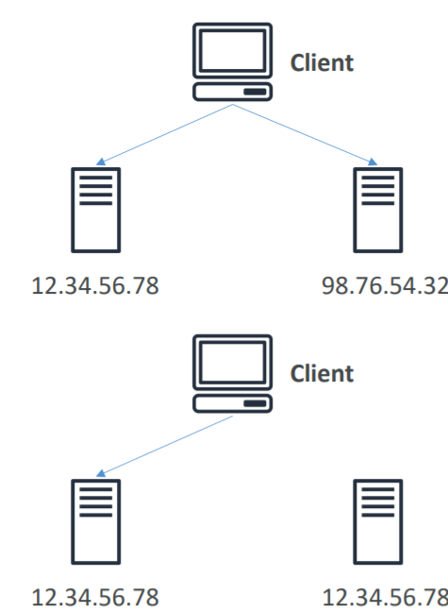

1. Unicast IP
   1. One server holds one IP address
2. Anycast IP
   1. All servers hold the same IP address and the client is routed to the nearest one

AWS Global Accelerator

1. Works with Elastic IP, EC2 instances, ALB, NLB, private or public

AWS Global Accelerator vs CloudFront

1. They both use the AWS global network and its edge locations around the world
2. Both services integrate with AWS Shield for DDoS protection

CloudFront

1. Improves performance for both cacheable content (such as images and videos)
2. Dynamic content (such as API acceleration and dynamic site delivery)
3. Content is served at the edge

Global Accelerator

1. Improves performance for a wide range of applications over TCP or UDP
2. Proxying packets at the edge to applications running in one or more AWS Regions
3. Good fit for non-HTTP use cases, such as gaming (UDP), IoT (MQTT), or Voice over IP
4. Good for HTTP use cases that require static IP addresses
5. Good for HTTP use cases that require deterministic, fast regional failover

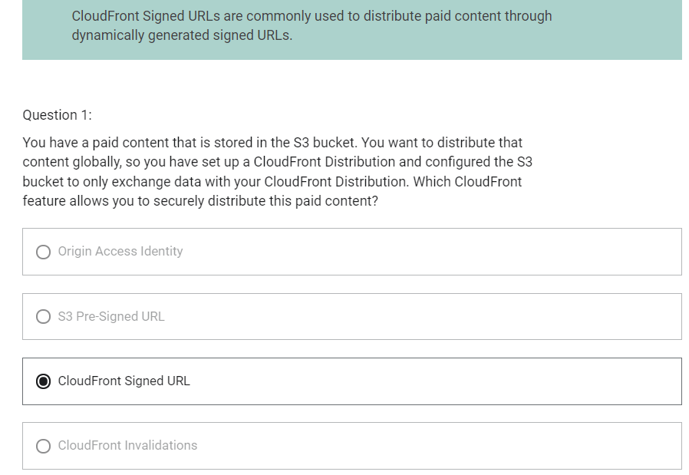

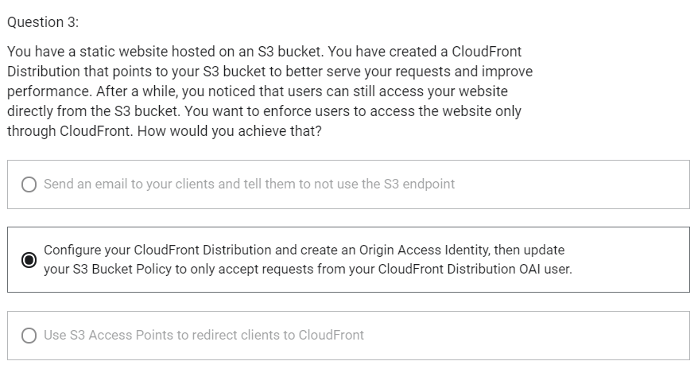

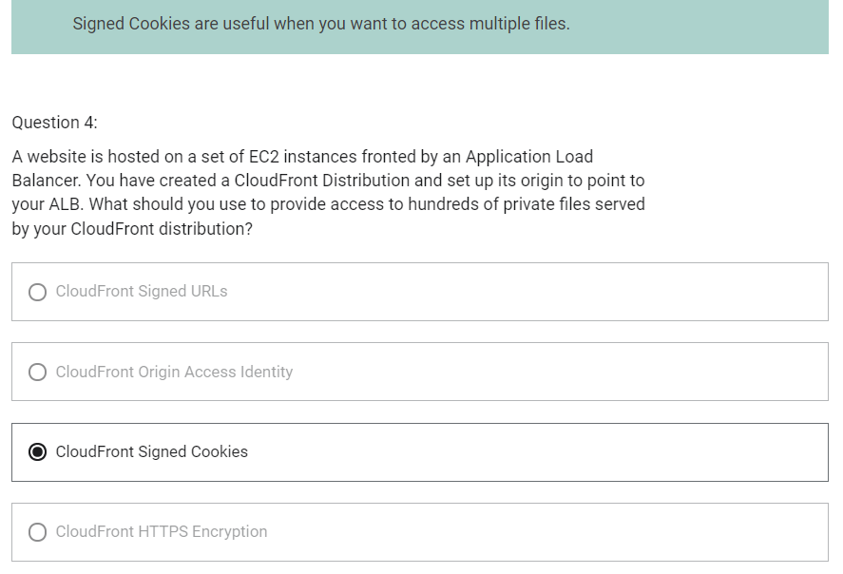

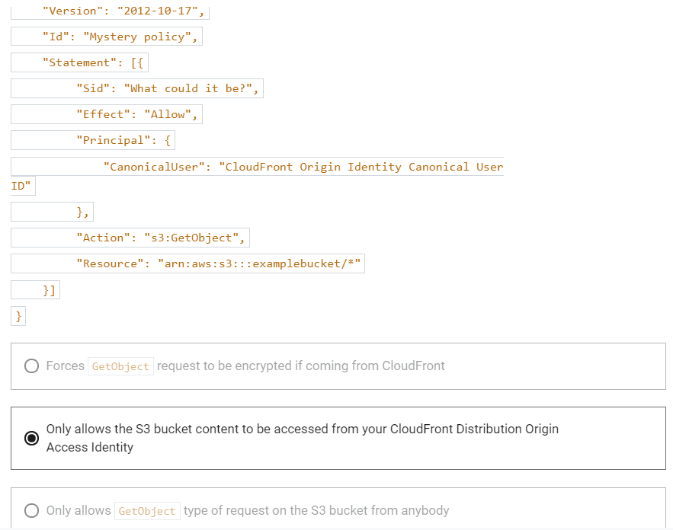

Snow Family

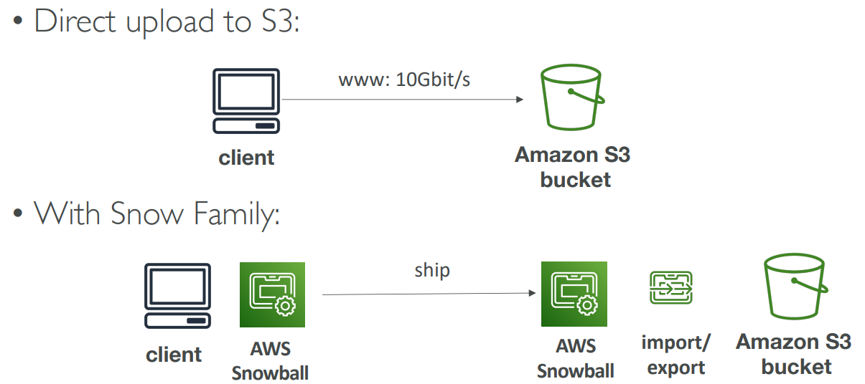

1. Offline devices to perform data migrations
2. If it takes more than a week to transfer over the network, use Snowball devices
3. Data is migrated through physical route not network route
4. Use cases
   1. Data Migration- Snowcone, Snowball Edge, Snowmobile
   2. Edge computing- Snowcone, Snowball Edge

Snowcone

1. Small, portable computing, anywhere, rugged and secure, withstand harsh environment
2. Used for edge computing, storage and data transfer
3. 8 TB of usable storage

Snowball Edge (for data transfers)

1. Physical data transport solution
2. Pay per data transfer job
3. Provide block storage and Amazon S3-compatible object storage
4. Snowball Edge comes in two flavours
   1. Snowball Edge Storage Optimized
      1. 80 TB of HDD capacity for block volume and S3 compatible object storage
   2. Snowball Edge Compute Optimized
      1. 42 TB of HDD capacity for block volume and S3 compatible object storage

Snowmobile

1. Transfer exabytes of data
2. Each snowmobile has 100 PB of capacity
3. High security: Temperature controlled, GOS, 24X7 video surveillance
4. Better than snowball if you transfer more than 10 PB

1 EB = 1,000 PB = 1,000,000 TB

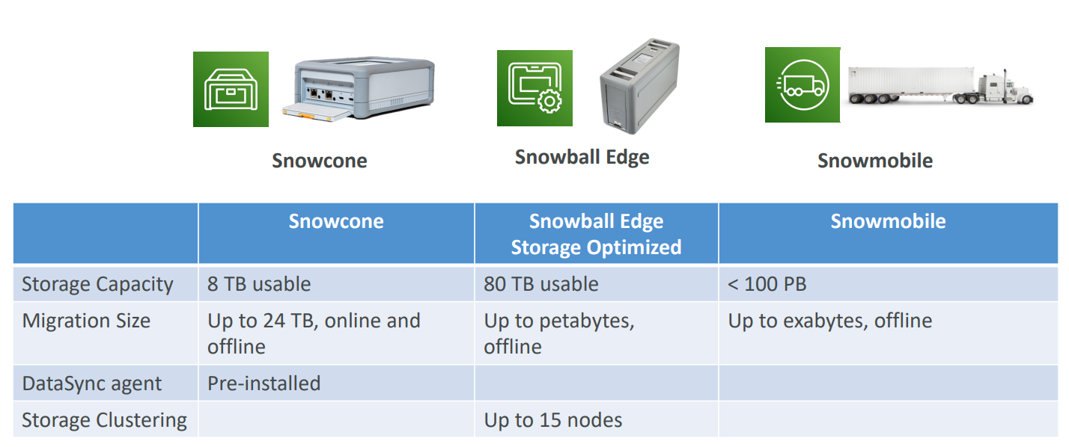

What is Edge Computing

1. Process data while it is being created on an edge location
   1. A truck on the road
   2. A ship on the sea
   3. A mining station underground
2. These locations may have
   1. Limited/ no Internet access
   2. Limited/ no easy access to computing power
3. We setup a Snowball Edge/ Snowcone device to do edge computing

Snow Family- Edge Computing

1. Snowcone (smaller)
   1. 2 CPUs
   2. 4 GB of memory
   3. Wired or wireless access
   4. USB-C power using a cord or optional battery
2. Snowball Edge- Compute Optimized
   1. 52 vCPUs
   2. 208 GiB of RAM
   3. Optional GPU (useful for video processing or machine learning)
   4. 42 TB usable storage
3. Snowball Edge- Storage Optimized
   1. Up to 40 vCPUs, 80 GiB of RAM
   2. Object storage clustering available
4. All of these can run EC2 instances and AWS lambda functions using AWS IoT Greengrass

AWS OpsHub

1. Historically, to use Snow Family devices, you needed a CLI (Command Line Interface tool)
2. Today, you can use AWS OpsHub (a software you install on your computer/laptop) that provides Graphical Interface to manage your Snow Family Devices.

Solution Architecture: Snowball into Glacier

1. Snowball cannot import to Glacier directly
2. You must use Amazon S3 first, in combination with an S3 lifecycle policy

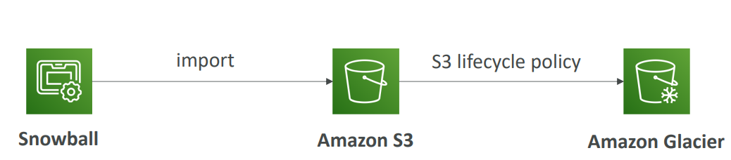

Amazon FSx

1. Fully managed service
2. Launch 3rd party high-performance file systems on AWS
3. FSx for Lustre
4. FSx for Windows File Server
5. FSx for NetApp ONTAP

Amazon FSx for Windows

1. FSx for Windows is a fully managed Windows file system share drive
2. Supports SMB protocol and Windows NTFS
3. Microsoft Active Directory integration, ACLs, user quotas
4. Built on SSD, scale up to 10s of GB/s, millions of IOPS, 100s PB of data
5. Can be accessed from your on-premise infrastructure
6. Can be configured to be Multi-AZ (high availability)
7. Data is backed up daily to S3

Amazon FSx for Lustre

1. Lustre is a type of parallel distributed file system, for large-scale computing
2. The name Lustre is derived from Linux and Cluster
3. Use case
   1. Machine learning
   2. High Performance Computing (HPC)
   3. Video processing
   4. Financial Modeling
   5. Electronic Design Automation
4. Scales up to 100s GB/s, millions of IOPS, sub-ms latencies
5. Seamless integration with S3
   1. Can “read S3” as a file system (through FSx)
   2. Can write the output of the computations back to S3(through FSx)
   3. Can be used from on-premises servers

FSx File System Deployment Options

1. Scratch File System
   1. Temporary storage
   2. Data is not replicated
   3. Use case
      1. Short term processing
      2. Optimize costs
2. Persistent File System
   1. Long term storage
   2. Data is replicated within same AZ
   3. Can replace failed files within minutes
   4. Use case
      1. Long term processing
      2. Sensitive data

AWS Storage Options

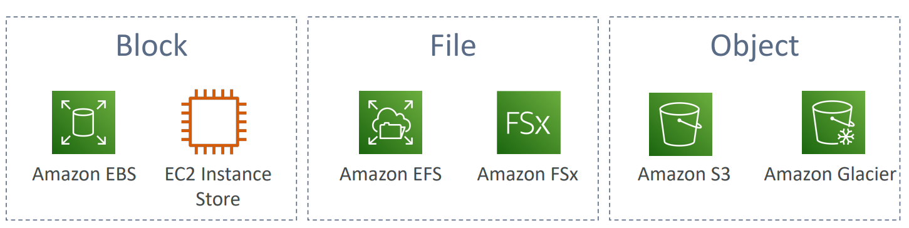

Storage Gateway

1. Bridge between on-premises data and cloud data in S3
2. Use case
   1. Disaster recovery
   2. Backup restore
   3. Tiered storage
3. 3 types of Storage Gateway
   1. File Gateway
   2. Volume Gateway
   3. Tape Gateway

File Gateway

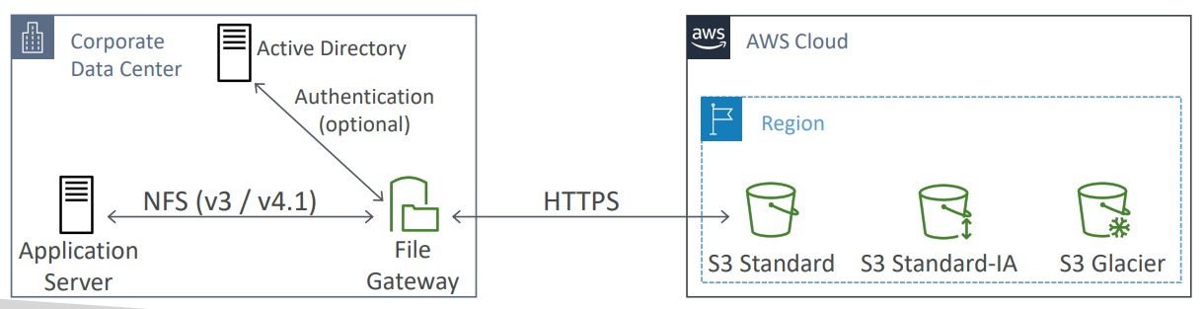

1. Configured S3 buckets are accessible using NFS and SMB protocol
2. Supports S3 Standard, S3 IA, S3 One Zone IA
3. Bucket access using IAM roles for each File Gateway
4. Most recently used data is cached in file gateway
5. Can be mounted on many servers
6. Integrated with Active Directory (AD) for user authentication

Volume Gateway

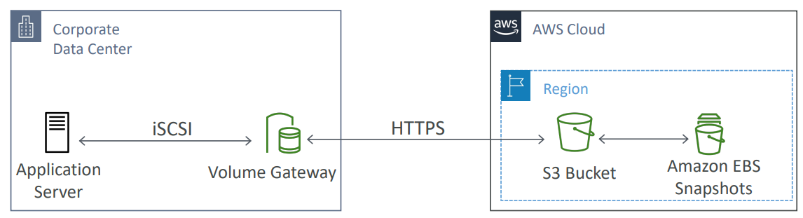

1. Block storage using iSCSI protocol backed by S3
2. Backed by EBS snapshots which can help restore on-premises volumes
3. Two types of Volume Gateway
   1. Cached Volumes: low latency access to most recent data
   2. Stored volumes: entire dataset is on premise, scheduled backups to S3

Tape Gateway

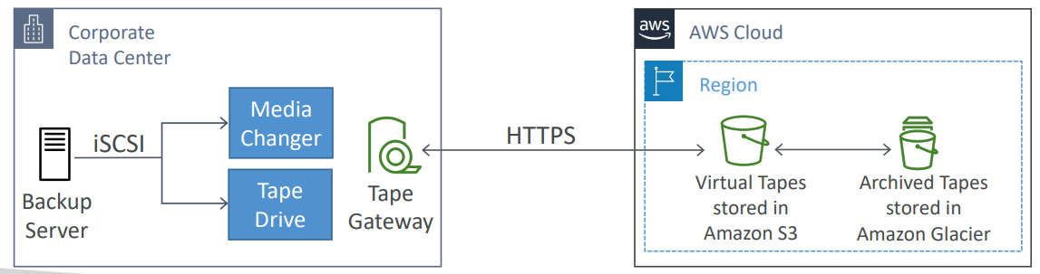

1. Some companies have backup processed using physical tapes
2. Virtual Tape Library (VTL) backed by Amazon S3 and Glacier
3. Back up data using existing tape-based processes (and iSCSI interface)
4. Works with leading backup software vendors

Storage Gateway- Hardware Appliance

1. Using Storage Gateway means you need on-premises virtualization
2. Otherwise, you can use a Storage Gateway Hardware Appliance
3. You can buy it on amazon.com
4. Works with File Gateway, Volume Gateway, Tape Gateway
5. Has the required CPU, memory, network, SSD cache resources
6. Helpful for daily NFS backups in small data centers

AWS Storage Gateway Summary

1. On premises data to the cloud-> Storage Gateway
2. File access / NFS- user auth with Active Directory-> File Gateway (backed by S3)
3. Volumes/ Block Storage/ iSCSI-> Volume gateway (backed by S3 with EBS snapshots)
4. VTL Tape Solution/ Backup with iSCSI-> Tape Gateway (backed by S3 and Glacier)
5. No on-premises virtualization-> Hardware Appliance

Amazon FSx File Gateway

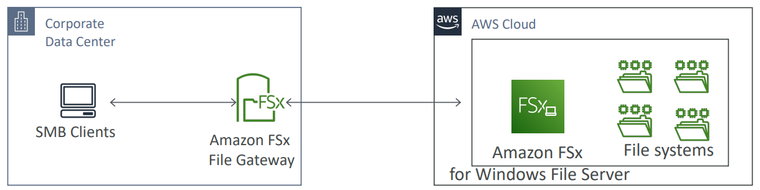

1. Native access to Amazon FSx for Windows File Server
2. Local cache for frequently accessed data
3. Windows native compatibility (SMB, NTFS, Active Directory,..)
4. Useful for group file shares and home directories

AWS Transfer Family

1. Fully managed service for file transfers into and out of Amazon S3 or Amazon EFS using FTP protocol
2. Supported protocols
   1. AWS Transfer for FTP (File Transfer Protocol (FTP))
   2. AWS Transfer for FTPS (File Transfer Protocol over SSL (FTTPS))
   3. AWS Transfer for SFTP (Secure File Transfer Protocol (SFTP))
3. Managed infrastructure, scalable, reliable, highly available (multi-AZ)
4. Pay per provisioned endpoint per point + data transfers in GB
5. Store and manage users credentials within the service
6. Integrate with existing authentication systems (Microsoft Active Directory, LDAP, Okta, Amazon Cognito, custom)
7. Usage
   1. Sharing files
   2. Sharing public datasets
   3. CRM
   4. ERP

Storage Comparison

1. S3- Object Storage
2. Glacier- Object Archival
3. EFS- Network File System for Linux, POSIX filesystem
4. FSx for Windows- Network File System for Windows servers
5. FSx for Lustre- High Performance Computing Linux file system
6. EBS volumes- Network storage for one EC2 instance at a time
7. Instance Storage- Physical storage for your EC2 instance (high IOPS)
8. Storage Gateway- File Gateway, Volume Gateway (cache and stored), Tape Gateway
9. Snowball/ Snowmobile- to move large amount of data to the cloud, physically
10. Database- for specific workloads, usually with indexing and querying

Two patterns of application communication

1. Synchronous Communication (application to application)
2. Asynchronous/ Event based Communication (application to queue to application)

To decouple your applications

1. Using SQS: queue model
2. Using SNS: pub/sub model
3. Using Kinesis: real-time streaming model

SQS (Simple Queuing Service)

1. Producers send message to queue
2. Consumers will poll messages from queue
3. Fully managed service, used to decouple applications

Amazon SQS- Standard Queue

1. Fully managed service, used to decouple applications
2. Attributes
   1. Unlimited throughput, unlimited number of messages in queue
   2. Default retention of messages: 4 days, maximum 14 days
   3. Low latency (<10 ms on publish and receive) limitation of 256 KB per message sent
3. Can have duplicate messages (at least once delivery)
4. Can have out of order messaging
5. Message persists in SQS until a consumer deletes it. Consumers delete messages after processing them
6. Consumers will poll SQL for messages (receive up to 10 messages at a time)

Amazon SQS- Security

1. Encryption
   1. In-flight encryption using HTTPS API
   2. At-rest encryption using KMS keys
   3. Client-side encryption if the client wants to perform encryption/decryption itself
2. Access Controls
   1. IAM policies to regulate access to the SQS API
3. SQS Access Policies (similar to S3 bucket policies)
   1. Useful for cross-account access to SQS queues
   2. Useful for allowing other services (SNS, S3, ..) to write to an SQL queue

SQS- Queue Access Policy

1. Use case
   1. Cross Account Access
   2. Publish S3 Event Notifications to SQS Queue

SQS- Message Visibility Timeout

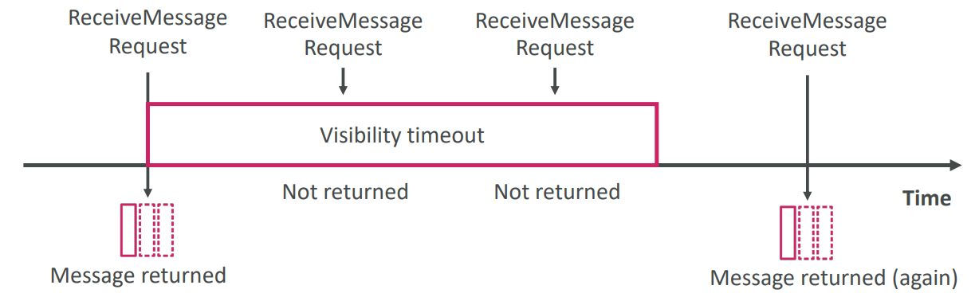

1. After a message is polled by a consumer, it becomes invisible to other consumers for visibility timeout period
2. By default, the “message visibility timeout” is 30 seconds
3. That means the message has 30 seconds to be processed
4. After the message visibility timeout is over, the message is “visible” in SQS
5. If a message is not processed within the visibility timeout, it will be processed twice
6. A consumer could call the ChangeMessageVisibility API to get more time
7. If visibility timeout is high (hours), and consumer crashes, re-processing will take time
8. If visibility timeout is too low (seconds), we may get duplicates
9. Visibility timeout can be set from 0 seconds and 12 hours

SQS- Dead Letter Queue

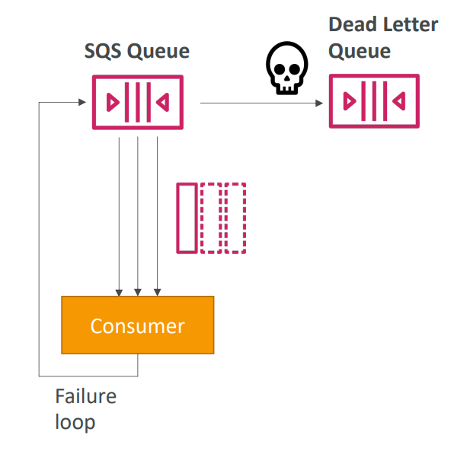

1. If a consumer fails to process a message within the Visibility Timeout, the message goes back to the queue
2. We can set a threshold of how many times a message can go back to the queue
3. After the MaximumReceives threshold is exceeded the message goes into a dead letter queue (DLQ)
4. Useful for debugging
5. Make sure to process the messages in the DLQ before they expire
   1. Good to set a retention of 14 days in the DLQ
6. Value of MaximumReceives can be between 1 and 1000

SQS- Delay Queue

1. Delay a message (consumers don’t see it immediately) up to 15 minutes
2. Range- 0sec-15 minutes
3. Default is 0 seconds (message is available right away)
4. Can set a default at queue level
5. Can override the default on send using the DelaySeconds parameter

SQS- Long Polling

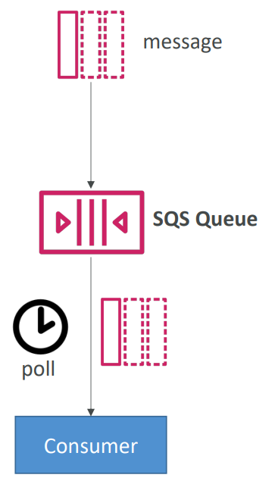

1. It as a way to optimize number of API calls made to SQS while decreasing latency
2. When a consumer requests messages from the queue, it can optionally “wait” for messages to arrive if there are none in the queue
3. This is called Long Polling
4. Long Polling decreases the number of API calls made to SQS while increasing the efficiency and latency of your application
5. The wait time can be between 1 sec to 20 sec (20 sec preferable)
6. Long Polling is preferable to Short Polling
7. Long Polling can be enabled at the queue level or at the API level using WaitTimeSeconds

SQS- Request-Response Systems

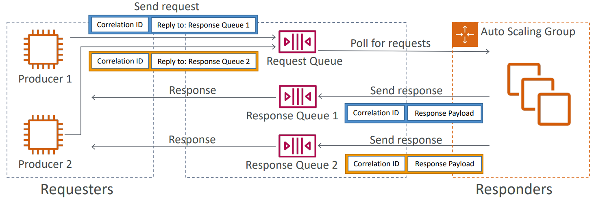

1. Requester creates a temporary queue for receiving each response message
2. To implement Request- Response Systems, use SQS Temporary Queue Client
3. It leverages virtual queues instead of creating/deleting queues (cost-effective)

SQS- FIFO Queue

1. FIFO- First In First Out (ordering of messages in the queue)
2. Exactly-once send capability (by removing duplicates)
3. Messages are processed in order by the consumer
4. Has limited throughout of 300 msg/s without batching and 3000 msg/s with batching
5. To create FIFO queue, we should name queue as queue_name.fifo

SQS with Auto Scaling Group (ASG)

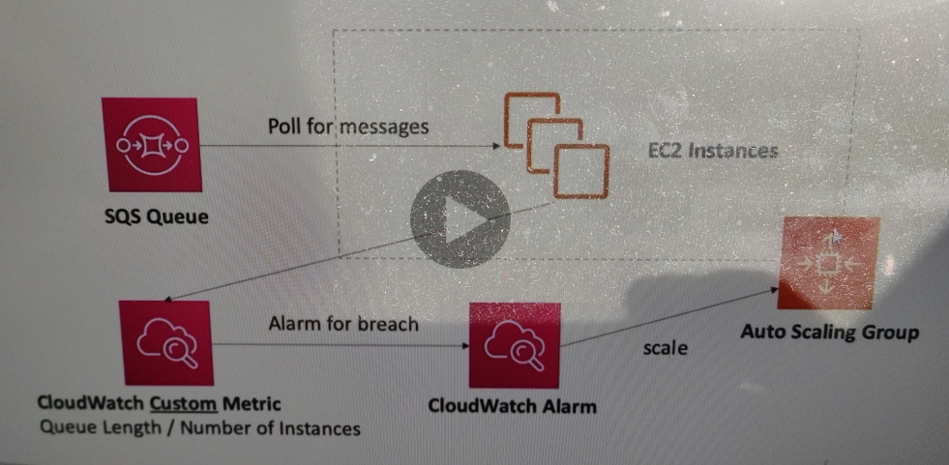

SNS (Simple Notification Service)

1. Publisher Subscriber mechanism to send one message to many receivers
2. The “event producer” only sends message to one SNS topic
3. As many “event receivers” (subscriptions) as we want to list to the SNS topic notifications
4. Each subscriber to the topic will get all the messages (note: new feature to filter messages)
5. Up to 10,000,000 subscribers per topic
6. 100,000 topics limit
7. Subscribers can be
   1. SQS
   2. HTTP/HTTPS
   3. Lambda
   4. Emails
   5. SMS messages
   6. Mobile Notifications
8. End-point can be
   1. HTTP
   2. HTTPS
   3. Email
   4. Email-JSON
   5. AWS Lambda
   6. Amazon SQS
   7. SMS
   8. Amazon Kinesis Data Firehouse
9. SNS integrates with a lot of AWS services
   1. CloudWatch
   2. Auto Scaling Groups Notifications
   3. Amazon S3
   4. CloudFormation

AWS SNS- How to publish

1. Topic Publish (using SDK)
   1. Create a topic
   2. Create a subscription (one or many)
   3. Publish to the topic
2. Direct Publish (for mobile apps SSDK)
   1. Create a platform application
   2. Create a platform endpoint
   3. Publish to the platform endpoint
   4. Works with Google GCM, Apple APNS, Amazon ADM..

Amazon SNS- Security

1. Encryption
   1. In-flight encryption using HTTPS API
   2. At-rest encryption using KMS keys
   3. Client-side encryption if the client wants to perform encryption/decryption itself
2. Access Control
   1. IAM policies to regulate access to the SNS API
3. SNS Access Policies (similar to S3 bucket policies)
   1. Useful for cross-account access to SNS topics
   2. Useful for allowing other services (S3) to write to an SNS topic

SNS + SQS: Fan Out

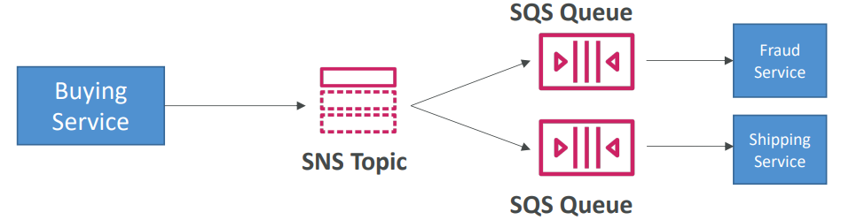

1. Push once in SNS, receive in all SQS queues that are subscribers
2. Fully decoupled, no data loss
3. SQS allows for
   1. Data persistence
   2. Delayed processing
   3. Retries of work
4. Ability to add more SQS subscribers over time
5. Make sure your SQS queue access policy allows for SNS to write

Application: S3 Events to multiple queues

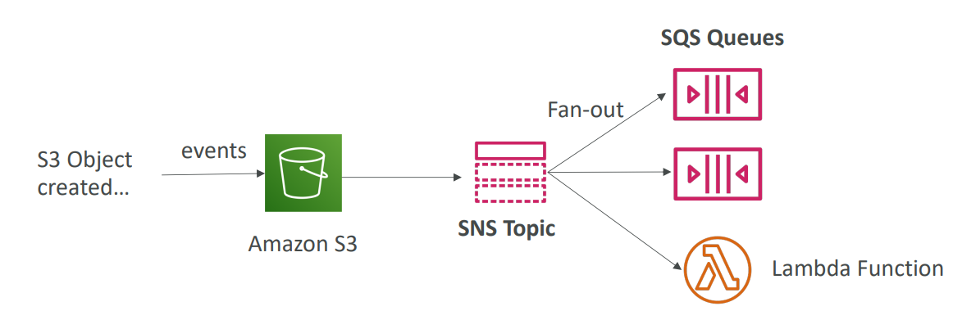

1. For the same combination of event type (eg. Object create) and prefix (eg. Images/) you can only have one S3 Event rule
2. If you want to send the same S3 event to many SQS queues, use fan-out

Amazon SNS- FIFO Topic

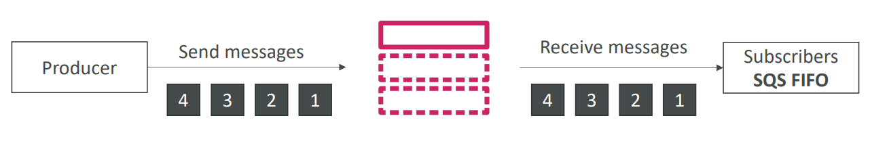

1. Similar feature as SQS FIFO
   1. Ordering by Message Group ID (all messages in the same group are ordered)
   2. Deduplication using a Deduplication ID or Content Based Deduplication
2. Can only have SQS FIFO queues as subscribers
3. Limited throughput (same throughput as SQS FIFO)

SNS FIFO + SQS FIFO: Fan Out

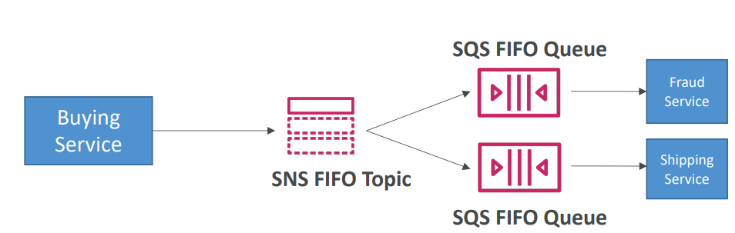

1. In case you need fan out + ordering + deduplication

SNS - Message Filtering

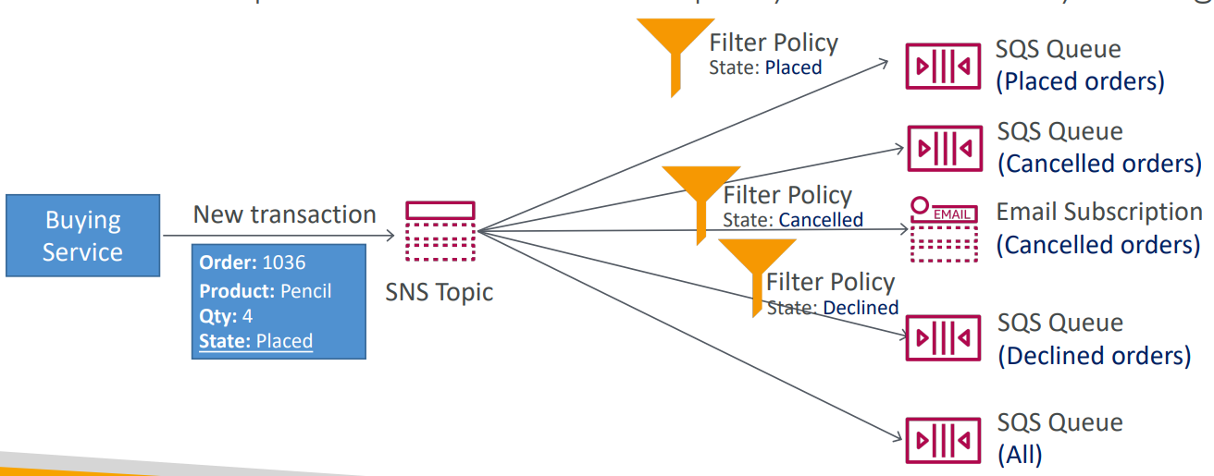

1. JSON Policy used to filter messages sent to SNS topic’s subscription
2. If a subscription does not have a filter policy, it receives every message

Kinesis Overview

1. Makes it easy to collect, process and analyze streaming data in real-time
2. Ingest real-time data such as
   1. Application logs
   2. Metrics
   3. Website clickstreams
   4. IoT telemetry data
3. Four components of Kinesis
   1. Kinesis Data Streams- capture, process and store data streams
   2. Kinesis Data Firehouse- load data streams into AWS data stores
   3. Kinesis Data Analytics- analyze data streams with SQL or Apache Flink
   4. Kinesis Video Streams- capture, process and store video streams

Kinesis Data Streams

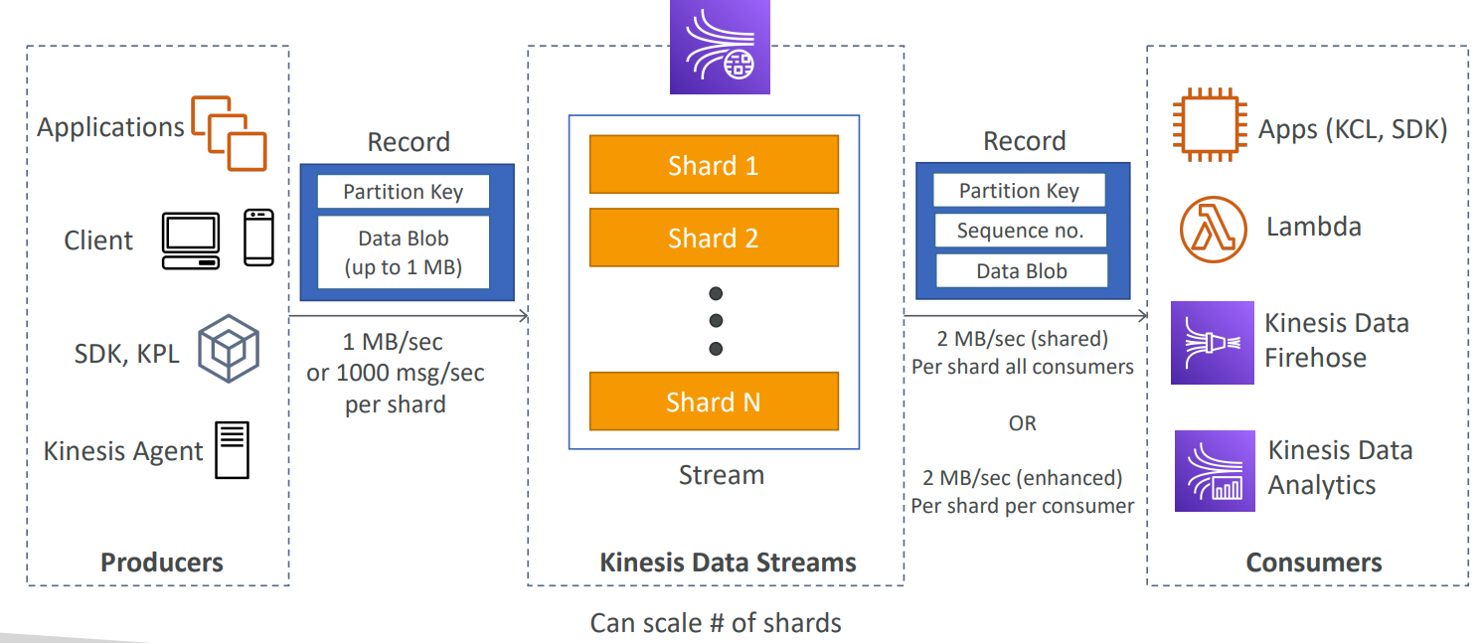

1. Billing is per shared provisioned, can have as many shards as you want
2. Retention between 1 day (default) to 365 days
3. Ability to reprocess (replay) data
4. Once data is inserted in Kinesis, it can’t be deleted (immutability)
5. Data that shares the same partition goes to the same shard (ordering)
6. Producers
   1. AWS SDK
   2. Kinesis Producer Library (KPL)
   3. Kinesis Agent
7. Consumers
   1. Write your own: Kinesis Client Library (KCL), AWS SDK
   2. Managed: AWS lambda, Kinesis Data Firehouse, Kinesis Data Analytics

Kinesis Data Firehouse

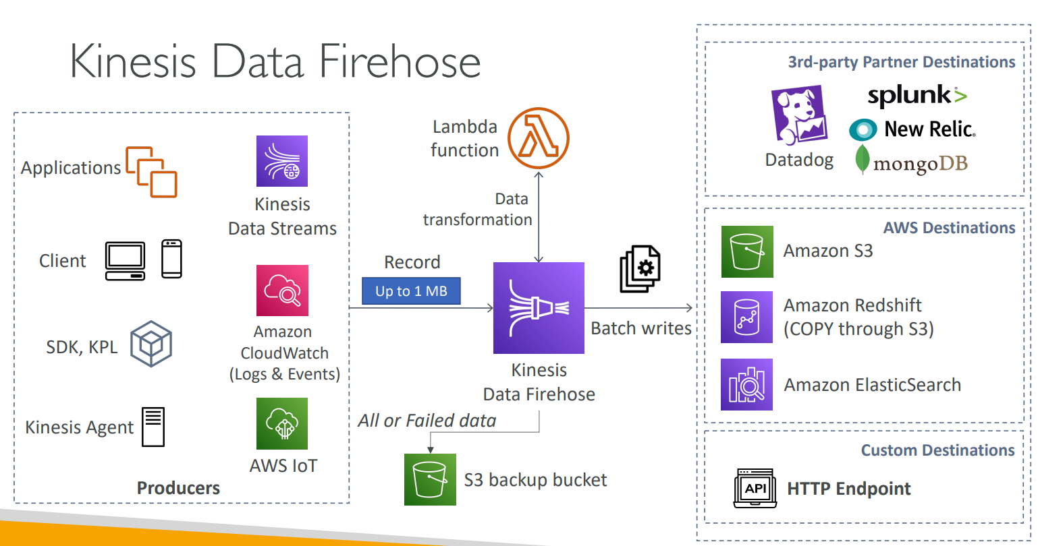

1. Fully Managed Service, no administration, automatic scaling, serverless
2. Can send data to
   1. AWS: Redshift/ Amazon S3/ ElasticSearch
   2. 3rd party partner: Splunk/ MongoDB/ DataDog/ NewRelic
   3. Custom: send to any HTTP endpoint
3. Pay for data going through Firehouse
4. Near Real Time
   1. 60 seconds latency minimum for non full batches
   2. Or minimum 32 MB of data at a time
5. Supports many data formats, conversion, transformations, compression
6. Supports custom data transformations using AWS Lambda
7. Can send failed or all data toa backup S3 bucket

Kinesis Data Streams vs Firehouse

Kinesis Data Streams

1. Streaming service for ingest at scale
2. Write custom code (producer/consumer)
3. Real time(200 ms latency)
4. Manage scaling (shard splitting/merging)
5. Data storage for 1 to 365 days
6. Supports replay capability

Kinesis Data Firehouse

1. Load streaming data into S3/Redshift/ES/3rd Party/ Custom HTTP
2. Fully managed
3. Near real-time (buffer time min 60 sec)
4. Automatic scaling
5. No data storage

Kinesis Data Analytics

1. Perform real-time analytics on Kinesis Streams using SQL
2. Fully managed, no servers to provision
3. Automatic scaling
4. Real-time analytics
5. Pay for actual consumption rate
6. Can create streams out of the real-time queries
7. Use cases
   1. Time-series analytics
   2. Real-time dashboards
   3. Real-time metrics

Ordering data into Kinesis

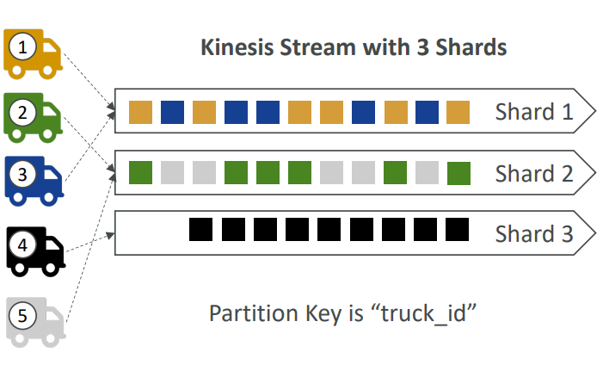

1. Imagine you have 100 trucks (truck_1, truck_2, .. truck_100) on the road sending their GPS positions regularly into AWS.
2. You want to consume the data in order for each truck, so that you can track their movement accurately
3. How should you send that data into Kinesis
4. Answer: send using a “partition key” value of the “truck_id”
5. The same key will always go to the same shard

Ordering data into SQS

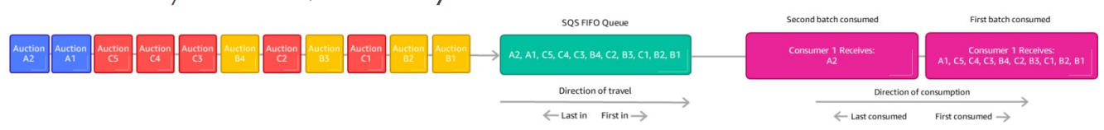

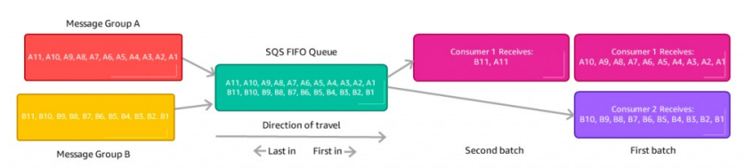

1. For SQS Standard, there is no ordering
2. For SQS FIFO, if you do not use a Group ID, messages are consumed in the order they are sent, with only one consumer
3. For SQS FIFO, if you use a Group ID, there can be multiple consumers per group and messages to one group will be received by one consumer

SQS vs SNS vs Kinesis

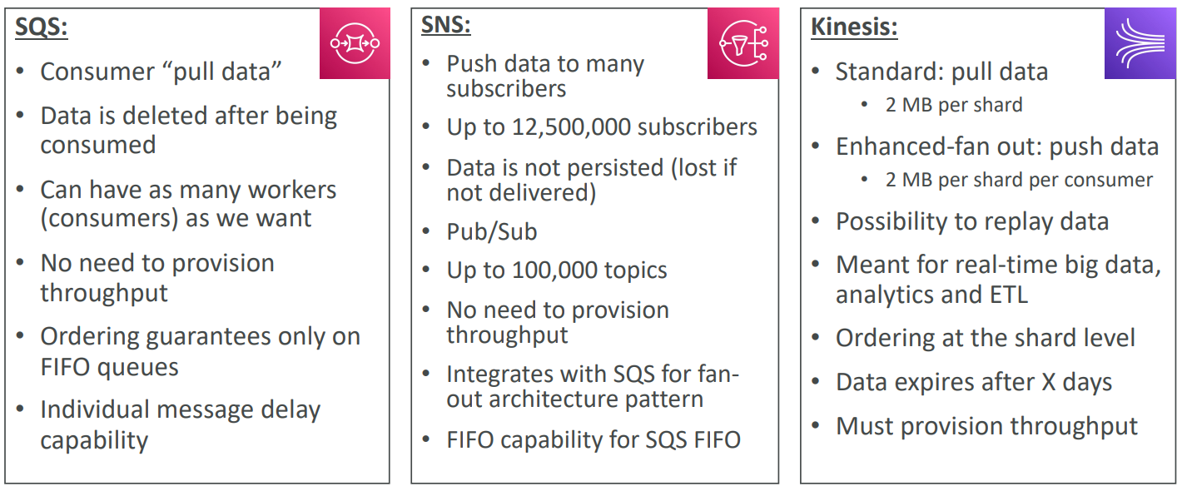

Amazon MQ

1. SQS, SNS are “cloud-native” services and they are using proprietary protocols from AWS
2. Traditional applications running from on-premise may use open protocols such as: MQTT, AMQP, STOMP, Openwire, WSS
3. When migrating to the cloud, instead of re-engineering the application to use SQS and SNS, we can use Amazon MQ
4. Amazon MQ = managed Apache ActiveMQ
5. It does not scale as much as SQS/SNS
6. Has both queue feature (SQS) and topic features (SNS)
7. It runs on a dedicated machine, can run in High Availability with failover

Amazon MQ- High Availability

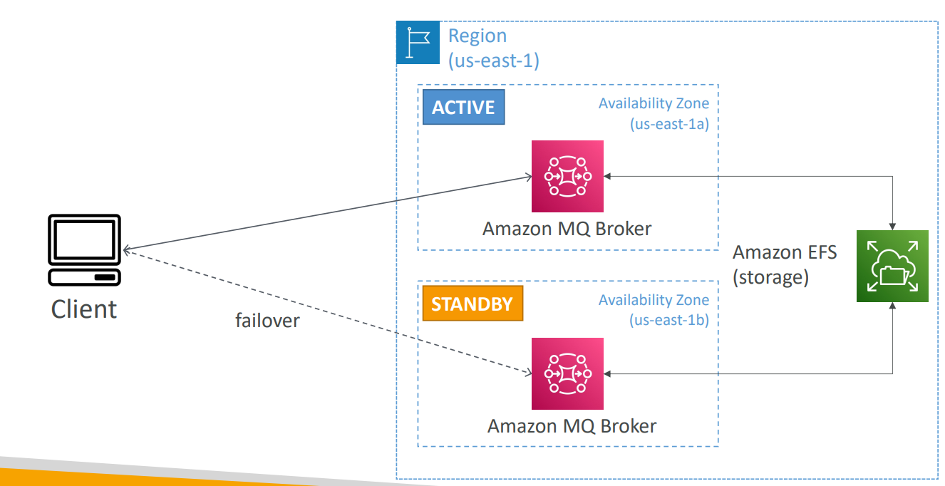

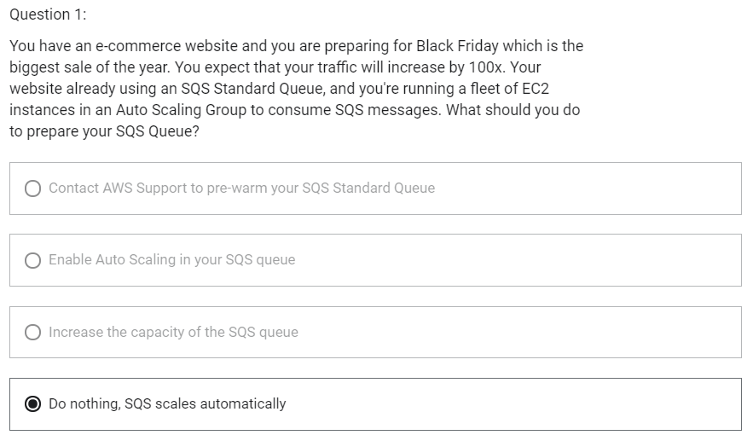

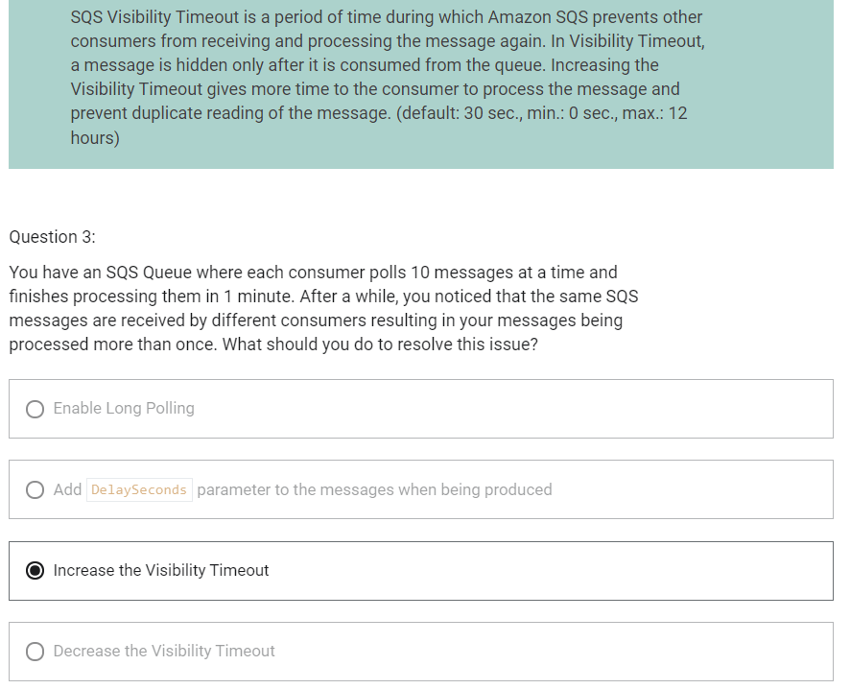

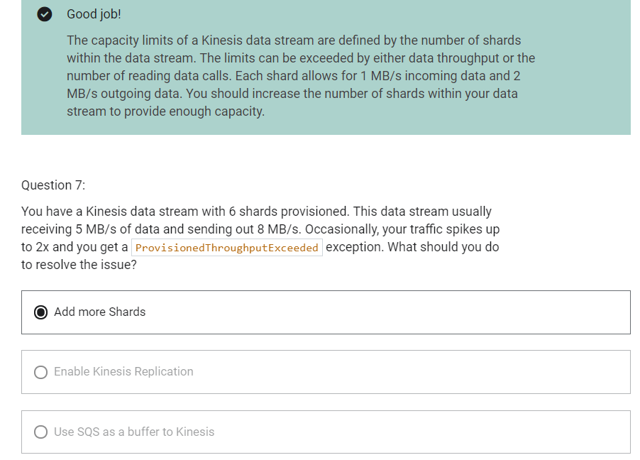

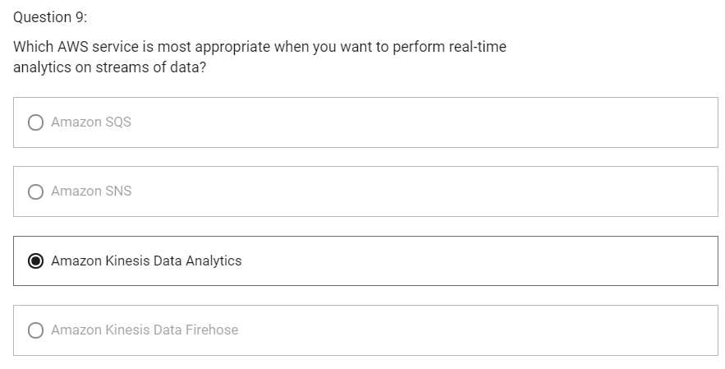

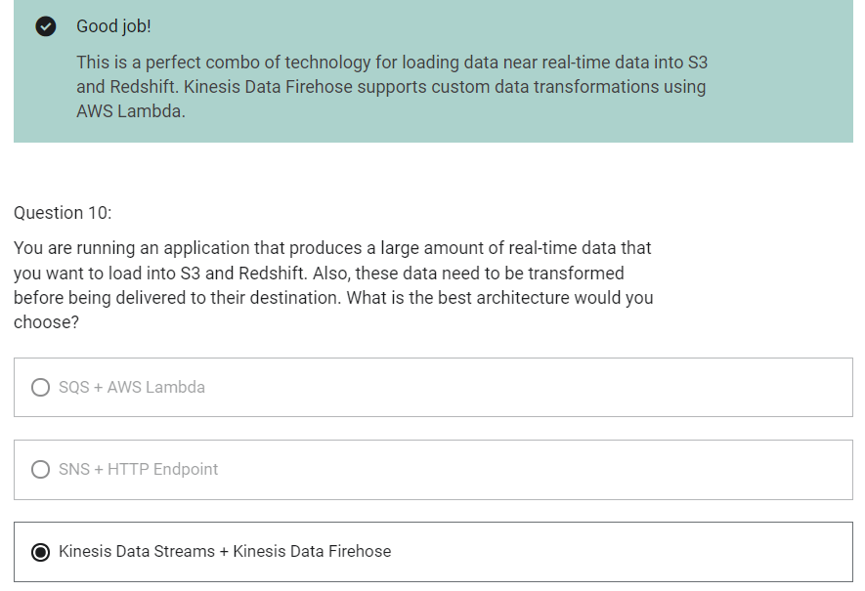

ECS

1. Elastic Container Service
2. Launch Docker Containers on AWS
3. You must provision and maintain the infrastructure
4. AWS takes care of starting/ stopping containers
5. Has integrations with the Application Load Balancer
6. Amazon Elastic Container Service (ECS) has two Launch Types:
   1. Amazon EC2 Launch Type
   2. Fargate Launch Type

Fargate

1. Serverless
2. Launch Docker containers on AWS
3. You do not provision and maintain the infrastructure
4. AWS just runs containers for you based on the CPU/RAM you need

IAM Roles for ECS Tasks

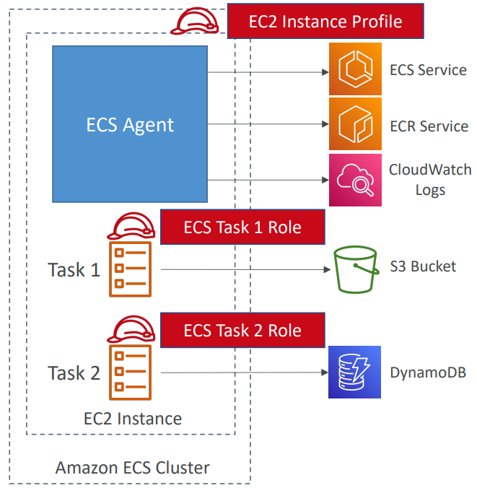

1. EC2 Instance Profile
   1. Used by ECS agent
   2. Makes API calls to ECS service
   3. Send container logs to CloudWatch logs
   4. Pull Docker image from ECR
   5. Reference sensitive data in Secrets Manager or SSM Parameter Store
2. ECS Task Role
   1. Allow each task to have a specific role
   2. Use different roles for the different ECS Services you run
   3. Task role is defined in the task definition

ECS Data Volumes- EFS File Systems

1. Works for both EC2 tasks and Fargate tasks
2. Ability to mount EFS volumes onto tasks
3. Tasks launched in any AZ will be able to share the same data in the EFS volume
4. Fargate + EFS = serverless + data storage without managing servers
5. Use case
   1. Persistent multi-AZ shared storage for your containers

Load Balancing for EC2 Launch Type

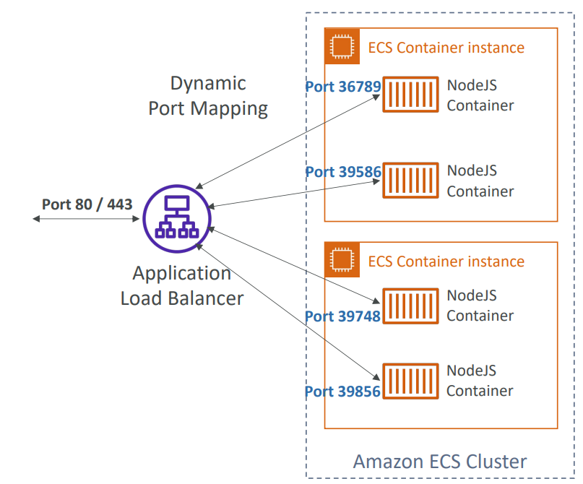

1. You get a dynamic port mapping
2. ALB supports finding the right port on your EC2 Instances
3. You must allow on the EC2 instance’s security group any port from the ALB security group

Load Balancing for Fargate

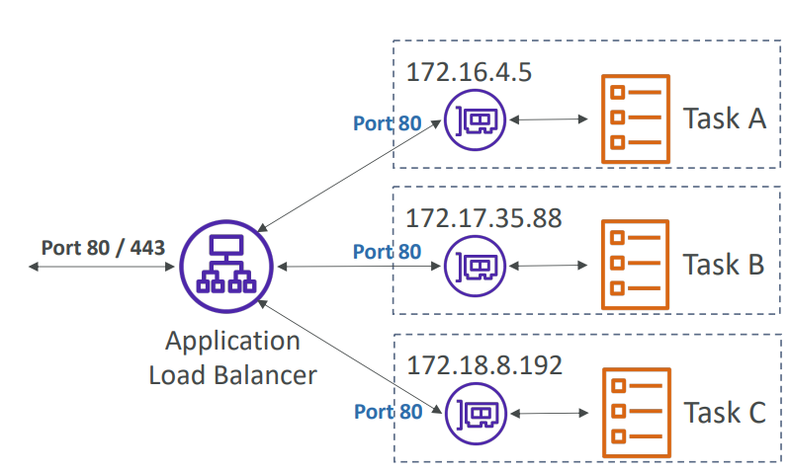

1. Each task has a unique IP
2. You must allow on the ENI’s security group the task port from the ALB security group

ECS tasks invoked by Event Bridge

1. If you want to automate and invoke ECS task, we can use Event Bridge

ECS Scaling

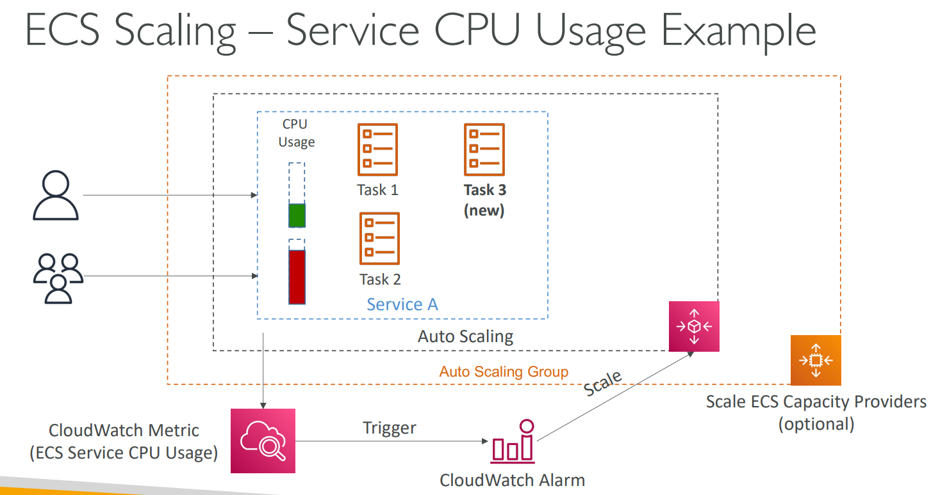

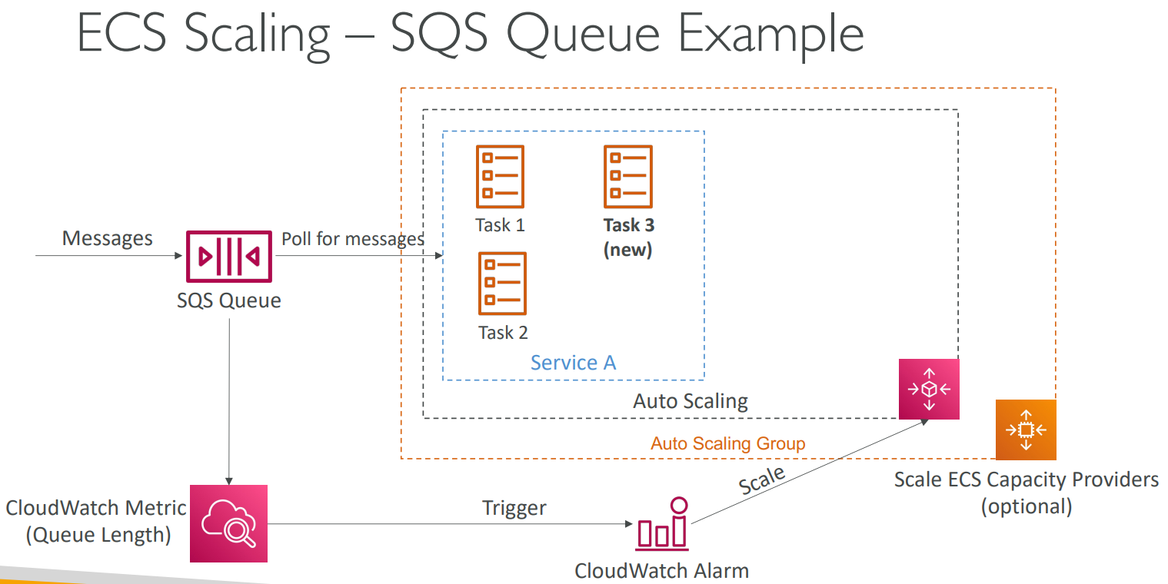

1. ECS can be scaled based on different metrics
   1. Based on Service CPU Usage
   2. Based on SQS Queue Length
2. There are two levels of scaling
   1. Service Scaling
   2. Backend EC2 Instances scaling

ECS Rolling Updates

1. When updating from V1 to V2, we can control how many tasks can be started and stopped, and in which order

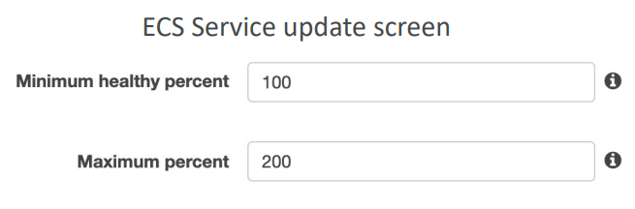

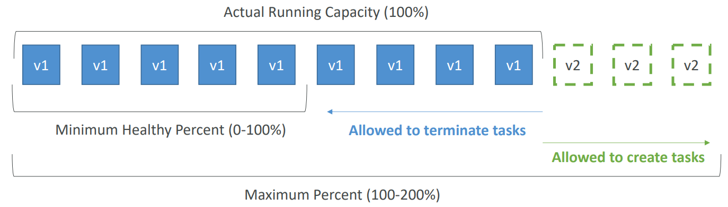

Min 50%, Max 100%

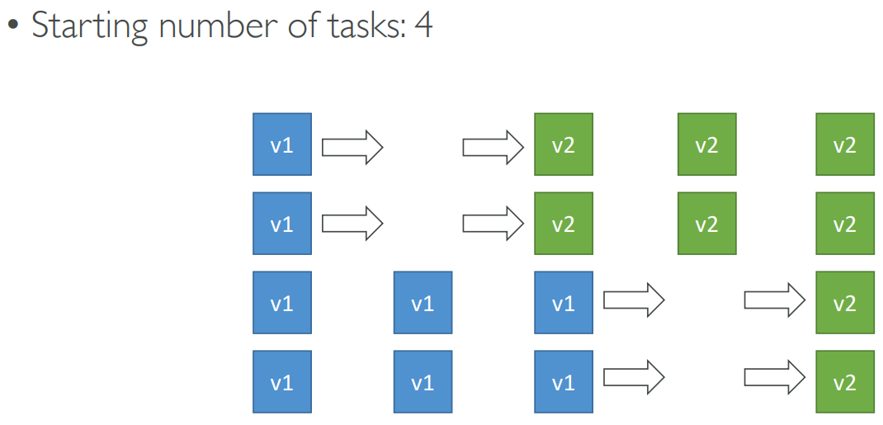

Min 100%, Max 150%

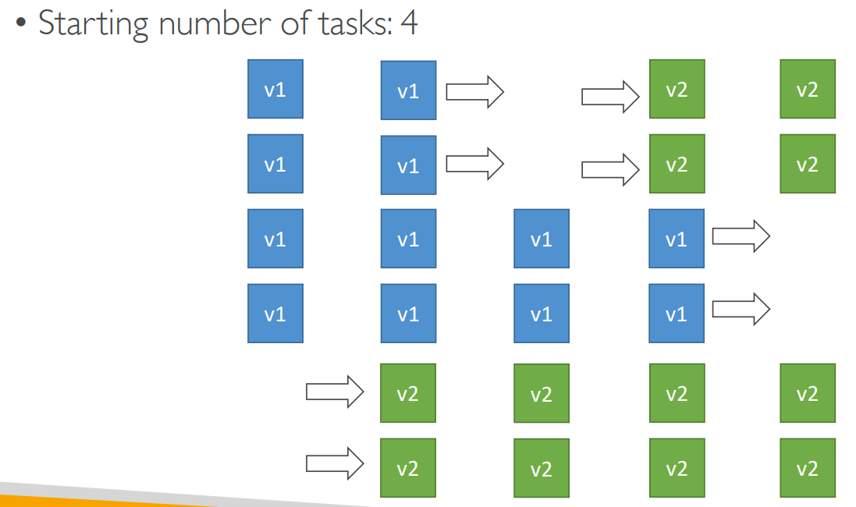

Amazon ECR- Elastic Container Registry

Amazon EKS

1. Amazon Elastic Kubernetes Service
2. It is a way to launch managed Kubernetes clusters on AWS
3. Kubernetes is an open source system for automatic deployment, scaling and management of containerized (usually Docker) application
4. It is an alternative to ECS, similar goal but different API
5. EKS supports EC2 if you want to deploy worker nodes or Fargate to deploy serverless containers
6. Use case
   1. If your company is already using Kubernetes on-premises or in another cloud, and wants to migrate to AWS using Kubernetes
7. Kubernetes is cloud-agnostic (can be used in any cloud – Azure, GCP ..)

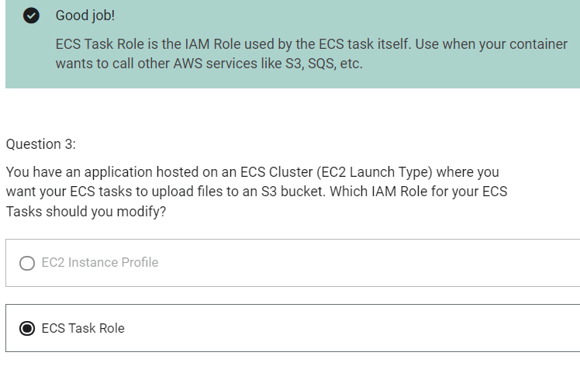

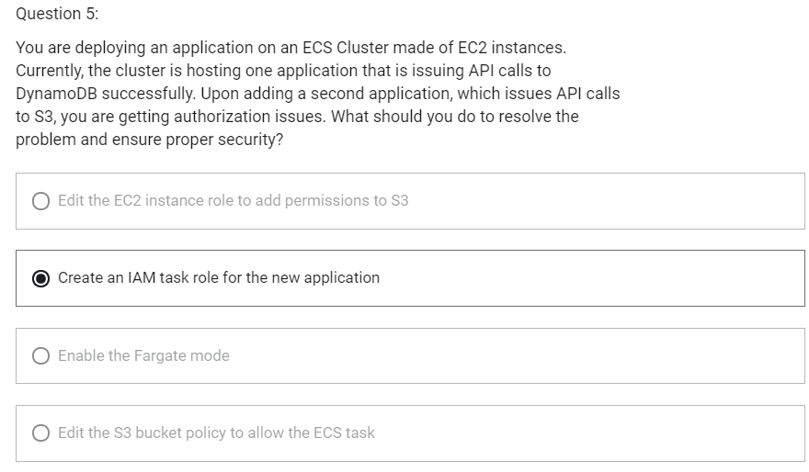

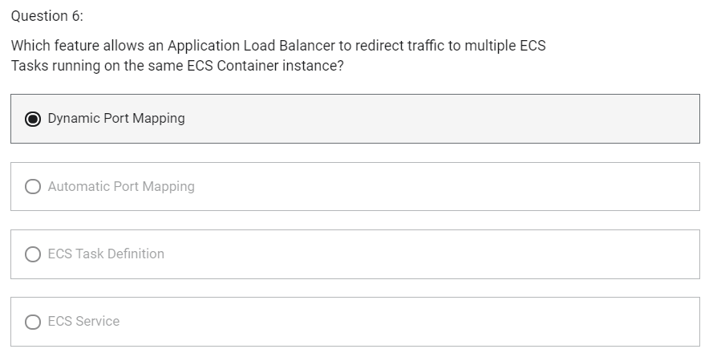

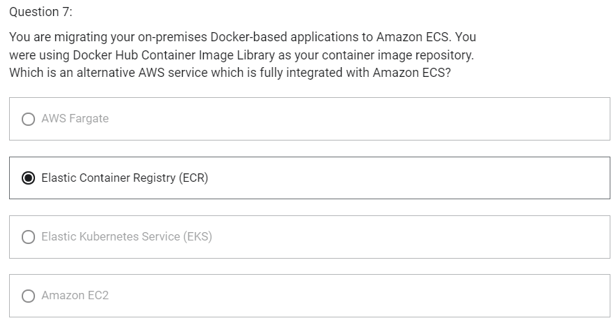

Serverless

1. Developers do not have to manage servers
2. They just deploy code
3. Initially, they used to deploy functions so called Function as a Service
4. Serverless does not mean there are no servers it means you just don’t manage/ provision/ see them
5. Serverless in AWS
   1. AWS Lambda
   2. DynamoDB
   3. AWS Cognito
   4. AWS API Gateway
   5. Amazon S3
   6. AWS SNS & SQS
   7. AWS Kinesis Data Firehouse
   8. Aurora Serverless
   9. Step Functions
   10. Fargate

Lambda

Introduction

1. Serverless compute service that allows you to run your code without managing servers
2. Allows developers to focus on core business logic for the application they are developing instead of worrying about managing servers
3. Scales automatically
4. Lambda functions can be written in popular programming languages like Java, Go, Node Js, C#, Python
5. You can author your code using your favorite development environment locally and upload or you can write code via the console.
6. Lambda can execute your code in response to some events
7. Lambda functions have a 15-minute timeout. So, lambda is not for processes that run longer than 15 minutes.
8. Can have memory between 128 MB to 10240 MB
9. Timeout- 3 sec to 15 min
10. Provides monitoring dashboard
11. Benefits of AWS lambda
    * Easy Pricing
      + Pay per request and compute time
      + Free tier of 1 million AWS Lambda requests and 400,000 GBs of compute time
    * Integrated with whole AWS suite of services
    * Integrated with many programming languages
    * Easy monitoring through AWS CloudWatch
    * Easy to get more resources per functions (up to 10GB of RAM)
12. AWS Lambda language support
    * Node.js (JavaScript)
    * Python
    * Java (Java 8 compatible)
    * C# (.NET Core)
    * Golang
    * C# /Powershell
    * Ruby
    * Custom Runtime API (community supported, ex Rust)
    * Lambda Container Image
      + The container image must implement the Lambda Runtime API
      + ECS/ Fargate is preferred for running arbitrary Docker images
13. AWS Lambda Integrations (main ones)
    * API Gateway- to create REST API
    * Kinesis- Perform data transformations on fly
    * DynamoDB- To create some trigger, whenever some event takes place in database, trigger lambda function
    * S3- trigger lambda function each time file is created in S3
    * CloudFront
    * CloudWatch Events/ EventBridge- whenever something happens in AWS infrastructure and make it able to react
    * CloudWatch Logs- stream logs wherever you want
    * SNS- react to notifications in SNS topics
    * SQS- Process message from SQS Queues
    * Cognito- React to whenever user logs in to database
14. Use case
    * Serverless Thumbnail creation
    * Serverless CRON job
15. AWS Lambda Pricing
    * Pay per calls
      + First 1 million requests are free
      + $0.2 per 1 million requests thereafter
    * Pay per duration (in increment of 1 ms)
      + 400,000 GB-seconds of compute time per month is free
        - == 400,000 seconds if function is 1 GB RAM
        - == 3,200,000 seconds if function is 128 MB RAM
      + After that $1 for 600,000 GB-seconds
16. AWS lambda limits to know – per region
    * Execution
      + Memory allocation: 128 MB-10GB (1 MB increments)
      + Maximum execution time: 900 seconds (15 minutes)
      + Environment variables (4 KB)
      + /tmp space: 512 MB
      + Concurrency executions: 1000 (can be increased)
    * Deployment
      + Lambda function deployment size (compressed .zip): 50 MB
      + Size of uncompressed deployment (code + dependencies): 250 MB
      + Can use /tmp to load other files at startup
      + Size of environment variables: 4 KB

Lambda@Edge

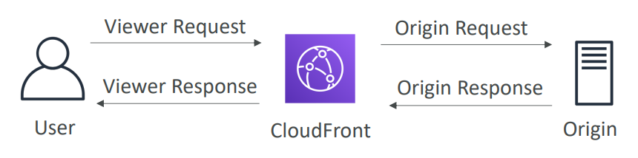

1. Lambda@Edge function runs code in each CloudFront Edge, globally
2. You have deployed a CDN using CloudFront
3. What if you wanted to run a global AWS Lambda alongside?
4. Or how to implement request filtering before reaching your application?
5. For this, you can use Lambda@Edge
   1. Build more responsive applications
   2. You don’t manage servers, lambda is deployed globally
   3. Customize the CDN content
   4. Pay only for what you use
   5. You can use lambda to change CloudFront requests and responses
      1. After CloudFront receives a request from a viewer (viewer request)
      2. Before CloudFront forwards the request to the origin (origin request)
      3. After CloudFront receives the response from the origin (origin response)
      4. Before CloudFront forwards the response to the viewer (viewer response)
   6. You can also generate responses to viewers without ever sending the request to the origin
6. Use case
   1. Website Security and Privacy
   2. Dynamic Web Application at the Edge
   3. Search Engine Optimization (SEO)
   4. Intelligently Route Across Origins and Data Centers
   5. Bot Mitigation at the Edge
   6. Real-time Image Transformation
   7. A/B Testing
   8. User Authentication and Authorization
   9. User Prioritization
   10. User Tracking and Analytics

Amazon DynamoDB

1. Fully managed, highly available with replication across multiple AZs
2. NoSQL database- not a relational database
3. Scales to massive workloads, distributed database
4. Millions of requests per seconds, trillions of rows, 100s of TB of storage per table
5. Fast and consistent in performance (low latency on retrieval)
6. Integrated with IAM for security, authorization and administration
7. Enable event driven programming with DynamoDB Streams
8. Los cost and auto-scaling capcbilities

DynamoDB- Basics

1. DynamoDB is made of Tables
2. Each table has a Primary Key (must be decide at creation time)
3. Primary key is the combination of Partition Key and Sort Key (optional)
4. Each table can have an infinite number of items (=rows)
5. Each item has attributes (can be added over time- can be null), anything except primary is attribute
6. Maximum size of an item is 400KB
7. Data types supported are
   1. Scalar Types- String, Number, Binary, Boolean, Null
   2. Document Types- List, Map
   3. Set Types- String Set, Number Set, Binary Set

DynamoDB -Read/ Write Capacity Modes

1. Control how you manage your tables capacity (read/write throughput)
2. Provisioned Mode (default)
   1. You specify the number of reads/writes per second
   2. You need to plan capacity beforehand
   3. Pay for provisioned Read Capacity Unit (RCU) and Write Capacity Unit (WCU)
   4. Possibility to add auto-scaling mode for RCU and WCU
3. On-Demand Mode
   1. Read/Write automatically scale up/down with your workloads
   2. No capacity planning needed
   3. Pay for what you use, more expensive
   4. Great for unpredictable workloads

DynamoDB Accelerator (DAX)

1. Fully-managed, highly available, seamless in-memory cache for DynamoDB
2. Help solve read congestion by caching
3. Microseconds latency for cached data
4. Does not require application logic modification
5. 5 minutes TTL for cache (default)

DAX vs ElastiCache

DAX is useful for

1. Individual object cache
2. Query and Scan cache

Amazon ElastiCache is useful for

1. Store Aggregation Result

DynamoDB Streams

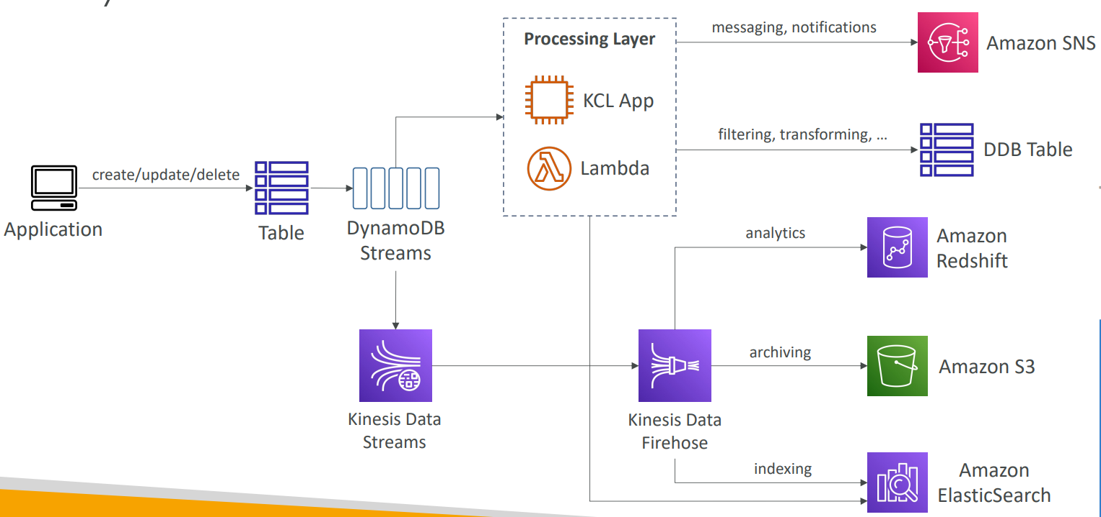

1. Ordered stream of item-level modifications (create/update/delete) in a table
2. Stream records can be
   1. Sent to Kinesis Data Streams
   2. Read by AWS Lambda
   3. Read by Kinesis Client Library applications
3. Data retention for up to 24 hours
4. Use cases
   1. React to changes in real-time (welcome email to users)
   2. Analytics
   3. Insert into derivative tables
   4. Insert into ElasticSearch

DynamoDB - Global Tables

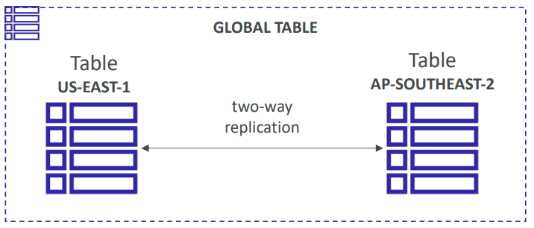

1. Make a DynamoDB table accessible with low latency in multiple regions
2. Active-Active Replication
3. Applications can READ and WRITE to the table in any region
4. To enable DynamoDB Global Table, we must first enable DynamoDB Streams as a pre-requisite

DynamoDB – Time To Live (TTL)

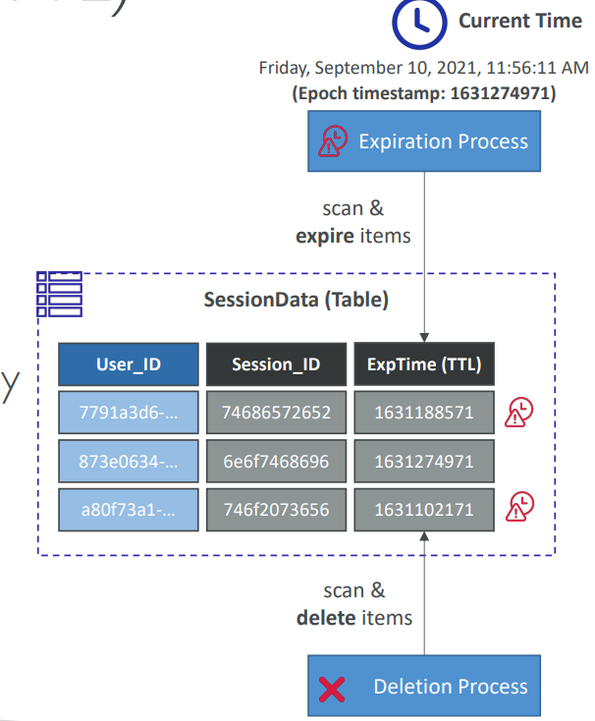

1. Automatically delete items after an expiry timestamp
2. Use case
   1. Reduce stored data by keeping only current items
   2. Adhere to regulatory obligations that says rows can be kept only for 7 days

DynamoDB – Indexes

1. Global Secondary Indexes (GSI) and Local Secondary Indexes (LSI)
2. Allow to query on attributes other than the primary key
3. With index, we can query by attributes (fields other than primary key)

DynamoDB – Transactions

1. Way to write to either multiple tables or none of them as part of one specific write

AWS API Gateway

1. Create serverless API
2. Support for the WebSocket Protocol
3. Handle API versioning (v1,v2 ..)
4. Handle different environments (dev, test, prod ..)
5. Handle security (Authentication and Authorization)
6. Create API keys, handle request throttling
7. Swagger/ Open API import to quickly define APIs
8. Transform and validate requests and responses
9. Generate SDK and API specifications
10. Cache API responses
11. Integrations
    1. Lambda Function
    2. HTTP
    3. AWS Service
12. Endpoint Types
    1. Edge-Optimized (default)- for global clients
    2. Regional- for clients within the same region
    3. Private- can be accessed from your VPC using an interface VPC endpoint (ENI)

API Gateway- Security

1. IAM Permissions

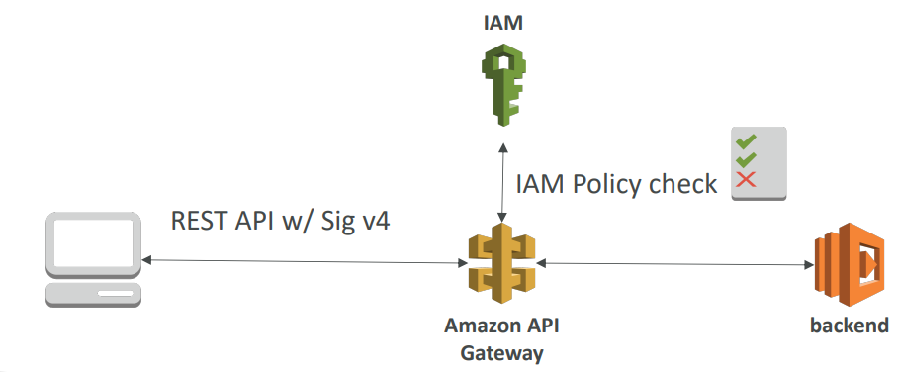

* 1. Create an IAM policy authorization and attach to User/ Role
  2. API Gateway verifies IAM permissions passed by the calling application
  3. Good to provide access within your own infrastructure
  4. Leverages “Sig v4” capability where IAM credential are in headers

1. Lambda Authorizer (formerly Custom Authorizers)

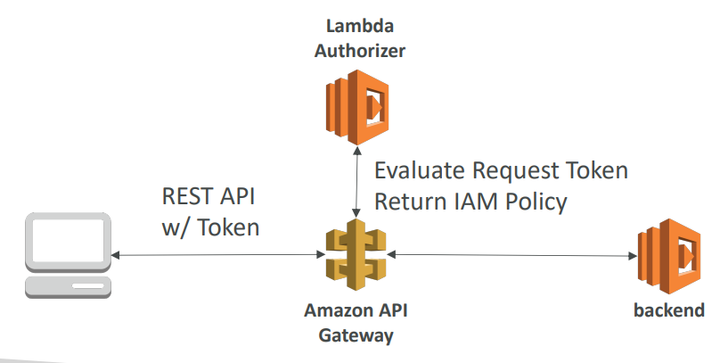

* 1. Uses AWS Lambda to validate the token in header being passed
  2. Option to cache result of authentication
  3. Helps to use OAuth/ SAML/ 3rd party type of authentication
  4. Lambda must return an IAM policy for the user

1. Cognito User Pools

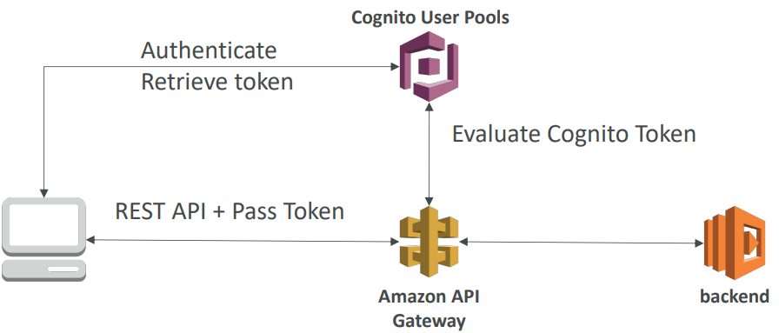

* 1. Cognito fully manages user lifecycle
  2. API gateway verifies identity automatically from AWS Cognito
  3. No custom implementation required
  4. Cognito only helps with authentication, not authorization

API Gateway- Security- Summary

1. IAM
   1. Great for users/ roles already within your AWS account
   2. Handle authentication + authorization
   3. Leverages Sig v4
2. Custom Authorizer
   1. Great for 3rd party tokens
   2. Very flexible in terms of what IAM policy is returned
   3. Handle Authentication + Authorization
   4. Pay per lambda invocation (can use caching to minimize number of invocations made)
3. Cognito User Pool
   1. You manage your own user pool (can be backed by Facebook, Google login, etc ..)
   2. No need to write any custom code
   3. Must implement authorization in the backend

AWS Cognito

We want to give our users an identity so that they can interact with our application

Cognito User Pools

1. Sign in functionality for app users
2. Integrate with API Gateway

Cognito Identity Pools (Federated Identity)

1. Provide AWS credentials to users so they can access AWS resources directly
2. Integrate with Cognito User Pools as an identity provider

Cognito Sync

1. Synchronize data from device to Cognito
2. May be deprecated and replaced by AppSync

AWS Cognito - User Pools (CUP)

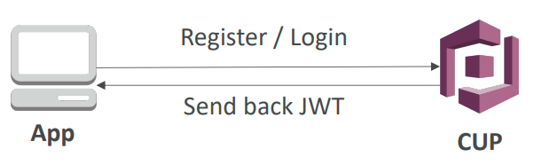

1. Create a serverless database of user for your mobile applications
2. Simple login: Username (or email)/ password combination
3. Possibility to verify emails/ phone numbers and add MFA
4. Can enable Federated Identities (Facebook, Google, SAML ..)
5. Sends back a JSON Web Tokens (JWT)
6. Can be integrated with API Gateway for authentication

AWS Cognito- Federated Identity Pools

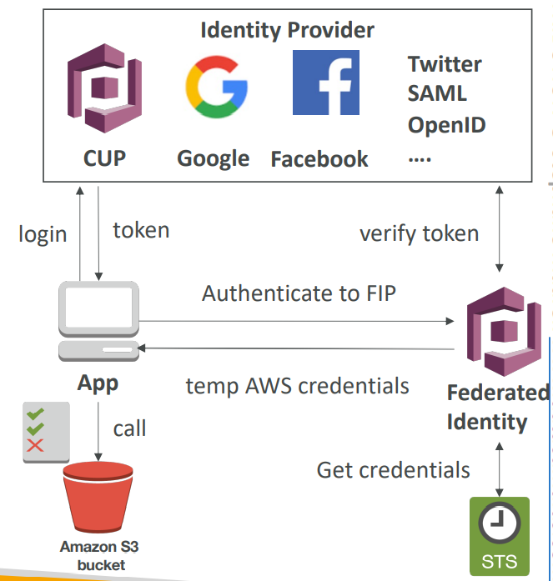

1. Goal- Provide direct access to AWS Resources from the Client Side
2. How
   1. Log in to federated identity provider- or remain anonymous
   2. Get temporary AWS credentials back from the Federated Identity Pool
   3. These credentials come with a pre-defined IAM policy stating their permissions
3. Example
   1. Provide temporary access to write to S3 bucket using Facebook Login

AWS Cognito Sync

1. Store preferences, configuration, state of app
2. Cross device synchronization (any platform – IOS, Android, etc ..)
3. Offline capability (synchronization when back online)
4. Requires Federated Identity Pool in Cognito (not User Pool)
5. Store data in datasets (up to 1 MB)
6. Upto 20 datasets to synchronize

AWS SAM (Serverless Application Model)

1. Framework for developing and deploying serverless applications
2. All the configuration is YAML code
   1. Lambda functions
   2. DynamoDB tables
   3. API Gateway
   4. Cognito User Pools
3. SAM can help you to run Lambda, API Gateway, DynamoDB locally
4. SAM can use CodeDeploy to deploy lambda functions

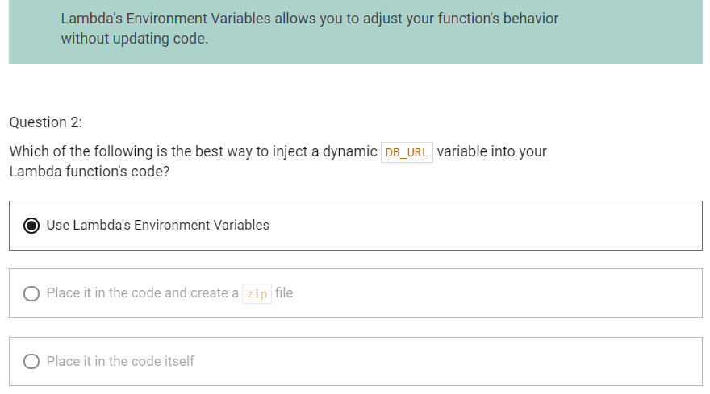

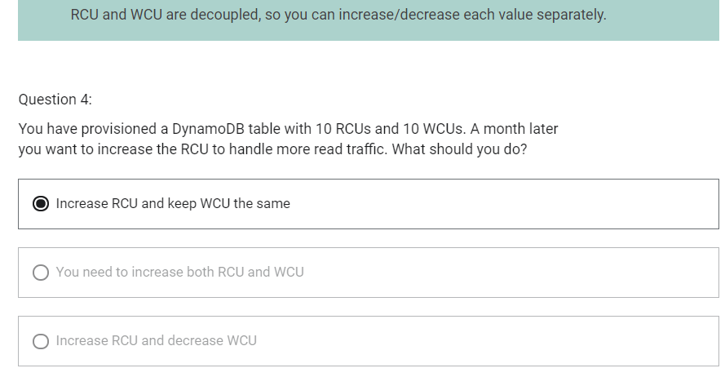

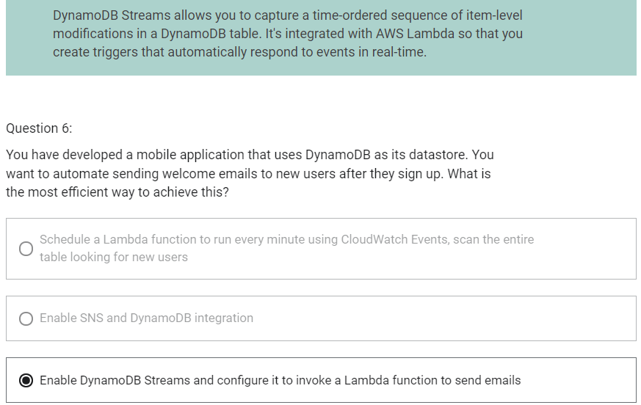

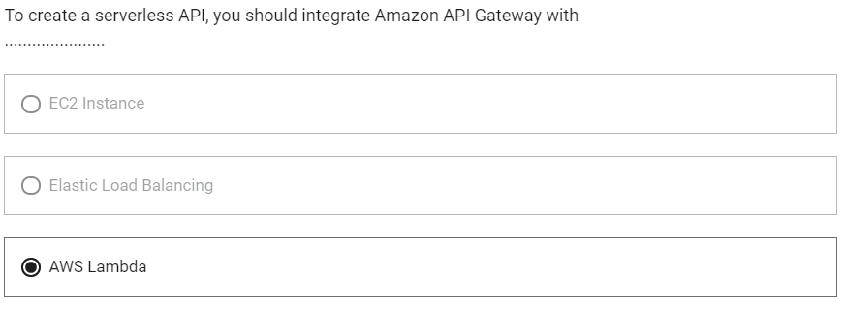

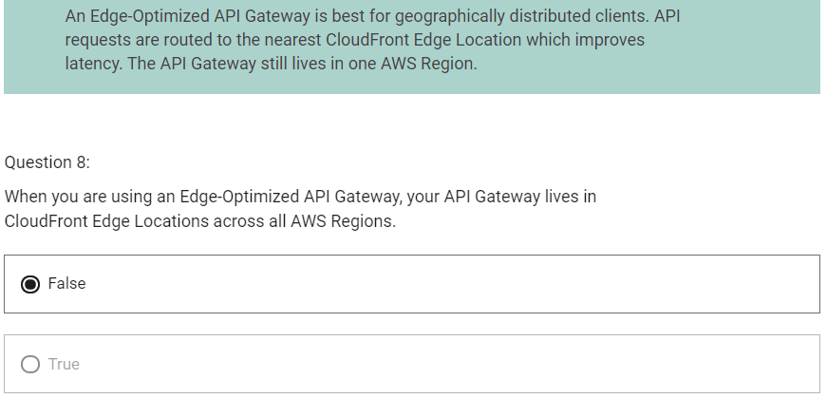

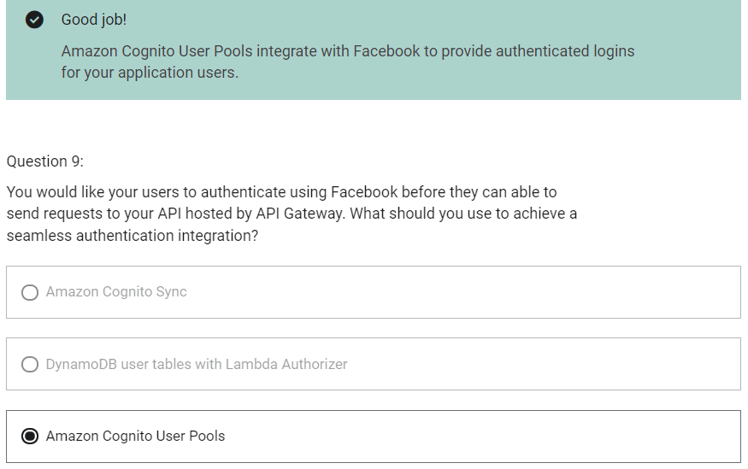

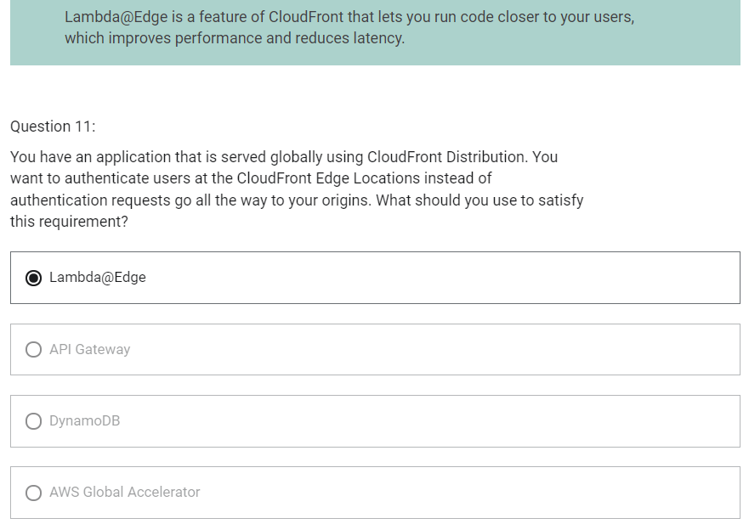

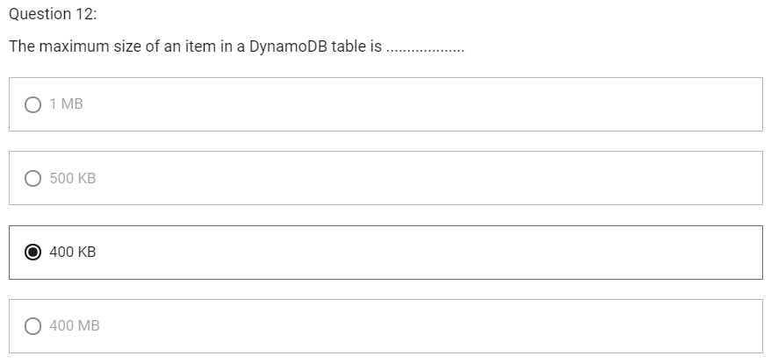

Micro Services architecture

1. With a microservices approach, software is composed of small services that communicate over well-defined application programming interfaces (APIs) that can be deployed independently.
2. Many services interact with each other directly using a REST API
3. With this, we can have a leaner development lifecycle for each service
4. You are free to design each micro-service the way you want
5. Synchronous patterns
   1. API Gateway
   2. Load Balancers
6. Asynchronous patterns
   1. SQS
   2. Kinesis
   3. SNS
   4. Lambda triggers (S3)
7. Challenges with micro-services
   1. Repeated overhead for creating each new microservice
   2. Issues with optimizing server density/utilization
   3. Complexity of running multiple versions of multiple microservices simultaneously
   4. Proliferation of client-side code requirements to integrate with many separate services
8. Some of the challenges are solved by Serverless patterns
   1. API Gateway, Lambda scale automatically and you pay per usage
   2. You can easily clone API, reproduce environments
   3. Generated client SDK through Swagger integration for API Gateway

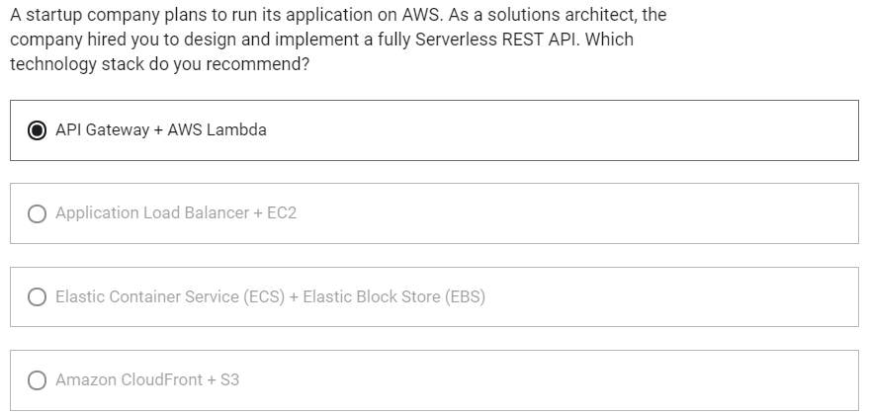

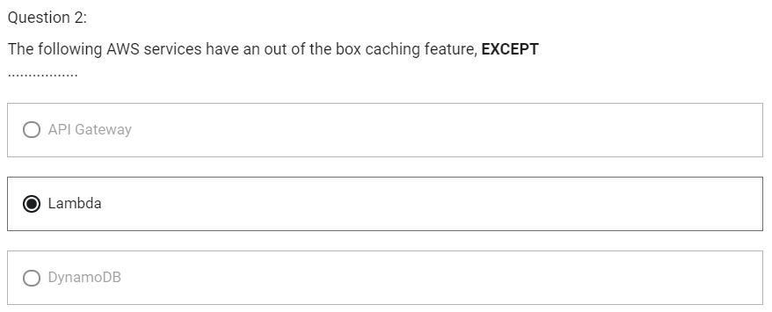

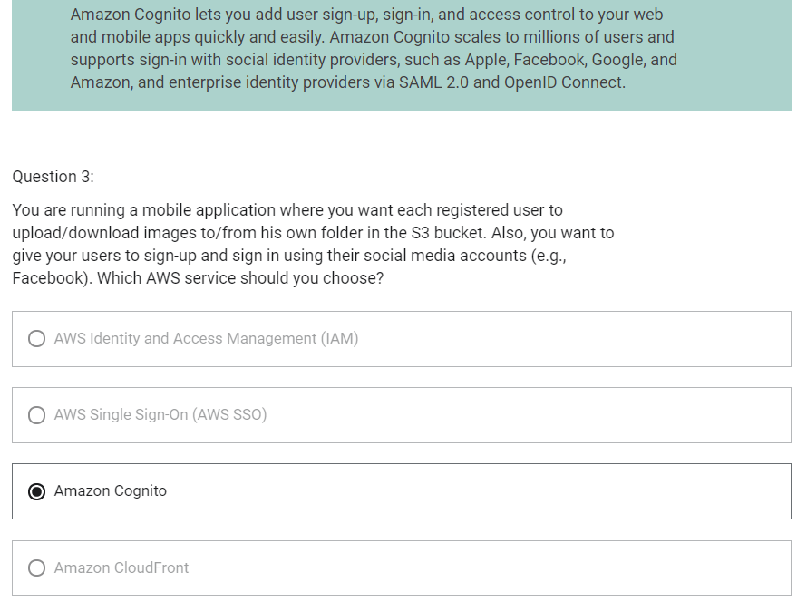

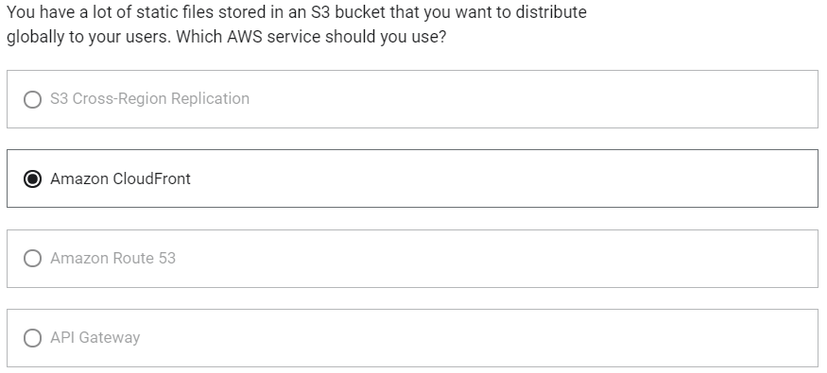

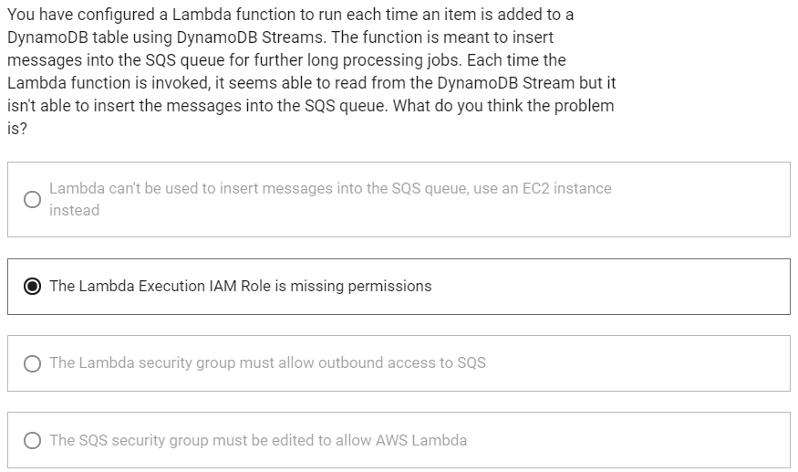

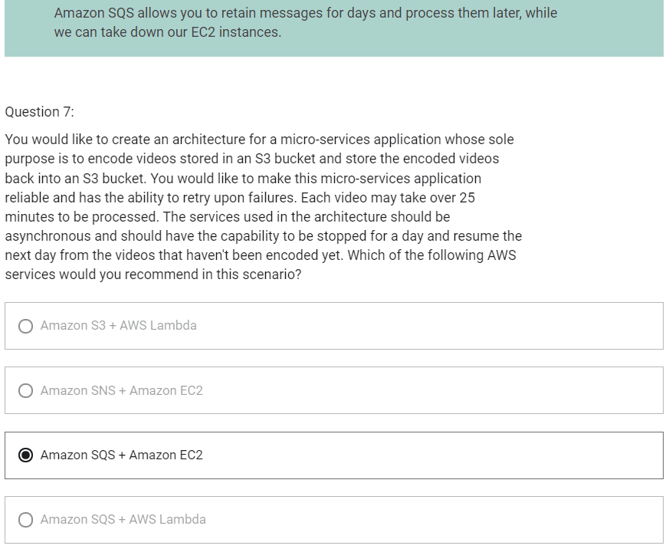

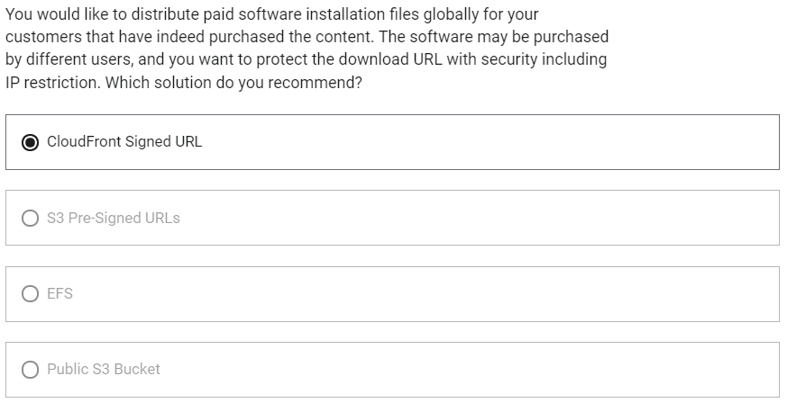

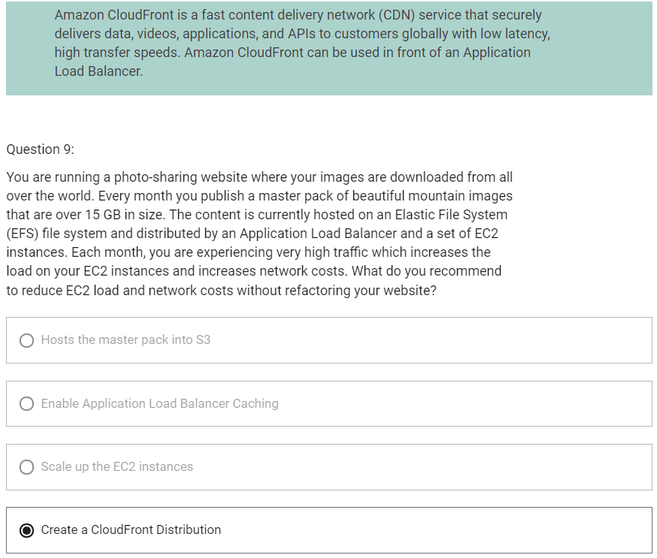

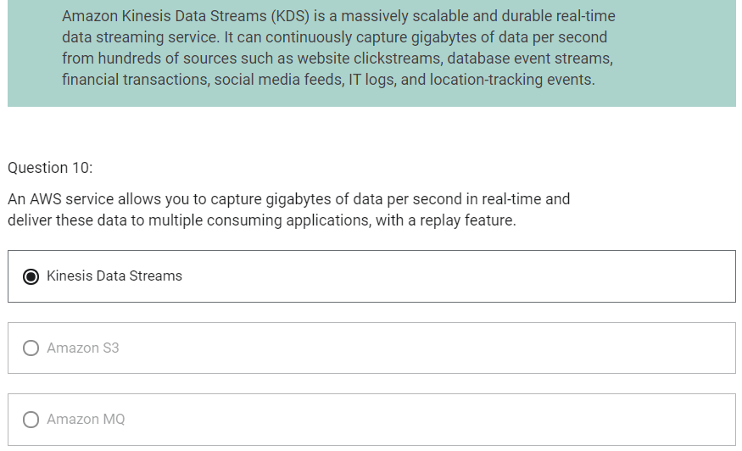

Choosing the right database

1. RDBMS- RDS, Aurora- great for joins
2. NoSQL database- DynamoDB (JSON), ElastiCache (key/value pairs), Neptune (graphs)- no joins, no SQL
3. Object Store- S3 (for big objects), Glacier (for backups/archives)
4. Data warehouse- Redshift (OLAP), Athena
5. Search- ElasticSearch (JSON)- free text, unstructured searches

RDS

1. Must provision an EC2 instance and EBS Volume type and size
2. Support for Read Replicas and Multi- AZ
3. Security through IAM, Security Groups, KMS, SSL in transit
4. Backup/ Snapshot/ Point in time restore feature
5. Managed and scheduled maintenance
6. Monitoring through CloudWatch
7. Use case
   1. Store relational datasets
   2. Perform SQL queries
   3. Transactional inserts/ update/ delete

RDS for Solutions Architect

1. Operations
   1. Small downtime when failover happens, when maintenance happens
   2. Scaling in read replicas
2. Security
   1. AWS is responsible for OS security
   2. We are responsible for setting up KMS, security groups, IAM policies, authorizing users in database and enforcing use of SSL
3. Reliability
   1. Multi AZ feature
4. Performance
   1. Performance depends on EC2 instance type, EBS volume type
   2. Ability to add read replicas
   3. Has storage auto-scaling feature if enabled
   4. Manual scaling of instances
5. Cost
   1. Pay per hour based on provisioned EC2 and EBS

Aurora

1. Compatible for PostgreSQL/ MySQL
2. Data is help in 6 replicas, across 3 AZ
3. Auto healing capability
4. Multi AZ, Auto Scaling Read Replicas
5. Read replicas can be Global
6. Aurora database can be Global for DR or latency purposes
7. Auto scaling of storage from 10GB to 128 TB
8. Define EC2 instance type for aurora instances
9. Same security/ monitoring/ maintenance features as RDS
10. Aurora Serverless- for unpredictable/ intermittent workloads
11. Aurora Multi-Master- for continuous writes failover
12. Use case
    1. Same as RDS but with less maintenance/ more flexibility/ more performance

RDS for Solutions Architect

1. Operations
   1. Less operations
   2. Auto scaling storage
2. Security
   1. AWS is responsible for OS security
   2. We are responsible for setting up KMS, security groups, IAM policies, authorizing users in database and enforcing use of SSL
3. Reliability
   1. Multi AZ, highly available possibly more than RDS due to Aurora Serverless option, Aurora Multi-Master option
4. Performance
   1. 5x performance due to architectural optimizations
   2. Up to 15 read replicas (only 5 for RDS)
5. Cost
   1. Pay per hour based on provisioned EC2 and storage usage
   2. Possibly lower costs compared to Enterprise grade databases such as Oracle

ElastiCache

1. Managed Redis/ Memcached
2. In-memory data store, sub millisecond latency
3. Must provision an EC2 instance type
4. Support for Clustering (Redis) and Multi AZ, Read Replicas (sharding)
5. Security through IAM, Security Groups, KMS, Redis Auth
6. Backup/ Snapshot/ Point in time restore feature
7. Managed and scheduled maintenance
8. Monitoring through CloudWatch

ElastiCache for Solutions Architect

1. Operations
   1. Same as RDS
2. Security
   1. AWS is responsible for OS security
   2. We are responsible for setting up KMS, Security Groups, IAM policies, users (Redis Auth), enforcing use of SSL
3. Reliability
   1. Clustering
   2. Multi AZ
4. Performance
   1. Sub millisecond performance
   2. In memory read replicas for sharding
5. Cost
   1. Pay per hour based on EC2 and storage usage

DynamoDB

1. AWS proprietary technology, managed NoSQL database
2. Serverless, provisioned capacity, auto scaling, on demand capacity
3. Can replace ElastiCache as a key/value store (storing session data)
4. Highly available, Multi AZ by default
5. Read and Writes are decoupled
6. DAX for read cache
7. Reads can be eventually consistent or strongly consistent
8. Security, authentication and authorization is done through IAM
9. DynamoDB Streams to integrate with AWS Lambda
10. Backup/ Restore feature, GlobalTable feature
11. Monitoring through CloudWatch
12. Can only query on primary key, sort key or indexes

DynamoDB for Solutions Architect

1. Operations
   1. No operations needed
   2. Auto scaling capability
   3. Serverless
2. Security
   1. Full security through IAM policies, KMS encryption, SSL in flight
3. Reliability
   1. Multi AZ
   2. Backups
4. Performance
   1. Single digit millisecond performance
   2. DAX for caching reads
   3. Performance does not degrade if your application scales
5. Cost
   1. Pay per hour based on EC2 and storage usage
   2. No need to guess in advance any capacity- can use auto scaling

S3

1. Key/value store for objects
2. Great for big objects, not so great for small objects
3. Serverless, scales infinitely
4. Max object size is 5 TB
5. Tiers: S3 Standard, S3 IA, S3 One Zone IA, Glacier for backups
6. Features
   1. Versioning
   2. Encryption
   3. Cross Region Replication
7. Security
   1. IAM
   2. Bucket Policies
   3. ACL
8. Encryption
   1. SSE-S3
   2. SSE-KMS
   3. SSE-C
   4. Client side encryption
   5. SSL in transit
9. Use case
   1. Static files
   2. Key value store for big files
   3. Website hosting

S3 for Solutions Architect

1. Operations
   1. No operations needed
2. Security
   1. IAM
   2. Bucket Policies
   3. ACL
   4. Encryption (Server/ Client)
   5. SSL
3. Reliable
   1. 99.999999999% durability
   2. 99.99% availability
   3. Multi AZ
   4. CRR
4. Performance
   1. Scales to thousands of read/ writes per second
   2. Transfer acceleration
   3. Multi-part upload for big files
5. Cost
   1. Pay per storage usage
   2. Network cost
   3. Requests number

Athena

1. Fully serverless database with SQL capabilities
2. Used to query data in S3
3. Pay per query
4. Output results back to S3
5. Secured through IAM

Athena for Solutions Architect

1. Operation
   1. No operations needed, serverless
2. Security
   1. IAM + S3 Security
3. Reliability
   1. Managed service
   2. Uses Presto engine, highly available
4. Performance
   1. Queries scale based on data size
5. Cost
   1. Pay per query/ per TB of data scanned

Redshift

1. Redshift is based on PostgreSQL, but it is not used for OLTP
2. It is OLAP -online analytical processing (analytics and data warehousing)
3. 10x better performance than other data warehouses
4. Can scale to PBs of data
5. Columnar storage of data
6. Massively Parallel Query Execution (MPP)
7. Pay as you go based on the instances provisioned
8. Has a SQL interface for performing the queries
9. BI Tools such as AWS Quicksight or Tableau integrate with it
10. Data is loaded from S3, DynamoDB, DMS, other DBs
11. From 1 node to 128 nodes, up to 128 TB of space per node
12. Leader node: for query planning, results aggregation
13. Compute node: for performing the queries, send results to leader
14. Redshift Spectrum: perform queries directly against S3 (no need to load)
15. Backup and Restore
16. Security through VPC/ IAM/KMS
17. Monitoring
18. Redshift Enhanced VPC Routing: COPY/ UPLOAD goes through VPC

Redshift- Snapshots and Disaster Recovery

1. Redshift has no “Multi-AZ” mode
2. For recovery, we need to take snapshots. Snapshots are point-in-time backups of a cluster stored internally in S3
3. Snapshots are incremental (only what has changed is saved)
4. You can restore a snapshot into a new cluster
5. There are two modes for snapshots
   1. Manual
   2. Automated
      1. Every 8 hours
      2. Every 5 GB
      3. On a schedule
6. You can configure Amazon Redshift to automatically copy snapshots (automated or manual) of a cluster to another AWS Region

Loading data into Redshift

1. There are 3 ways to ingest data into Redshift
   1. Amazon Kinesis Data Firehouse
   2. S3 using COPY command
   3. EC2 Instance using JDBC driver

Redshift Spectrum

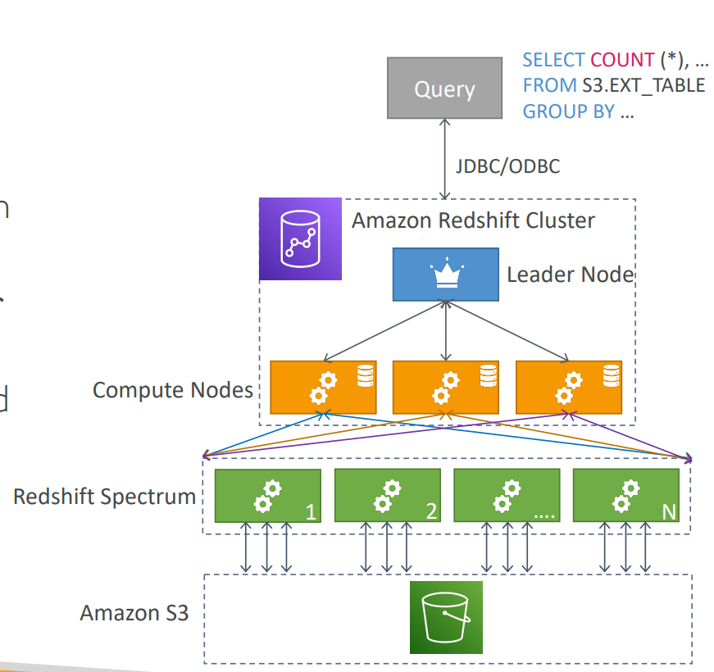

1. Query data that is already in S3 without loading it
2. Must have a Redshift cluster available to start the query
3. The query is then submitted to thousands of redshift Spectrum nodes

Redshift for Solutions Architect

1. Operation
   1. Like RDS
2. Security
   1. IAM
   2. VPC
   3. KMS
   4. SSL
3. Reliability
   1. Auto healing features
   2. Cross region snapshot copy
4. Performance
   1. 10x performance vs other data warehousing
   2. Compression
5. Cost
   1. Pay per node provisioned
   2. 1/10th of the cost vs other warehouses
6. Vs Athena
   1. Faster queries/ joins/ aggregations due to indexes

Glue

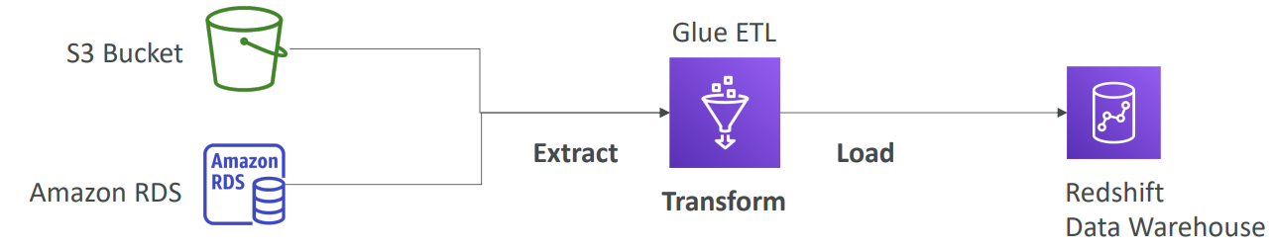

1. Serverless
2. Fully managed Extract, Transform and Load (ETL) service
3. Used to prepare and transform data for analytics
4. Glue Data Catalog
   1. Catalog of datasets

Neptune

1. Fully managed graph database
2. Highly available across 3 AZ
3. Up to 15 replicas
4. Point-in-time recovery
5. Continuous backup to Amazon S3
6. Support for KMS encryption at rest + HTTPS

Neptune for Solutions Architect

1. Operations
   1. Similar to RDS
2. Security
   1. IAM
   2. VPC
   3. KMS
   4. SSL
   5. IAM Authentication
3. Reliability
   1. Multi-AZ
   2. Clustering
4. Performance
   1. Best suited for graph clustering to improve performance
5. Cost
   1. Pay per node provisioned

ElasticSearch/ OpenSearch

1. Amazon ElasticSearch is now OpenSearch
2. In DynamoDB, you can only find by primary key or indexes
3. With ElasticSearch, you can search any field, even partial matches
4. It is common to use ElasticSearch as a complement to another database
5. ElasticSearch also has some usage for Big Data applications
6. You can provision a cluster of instances
7. Built-in integrations for
   1. Amazon Kinesis Data Firehouse
   2. AWS IoT
   3. Amazon CloudWatch Logs for data ingestion
8. Security through Cognito and IAM, KMS encryption, SSL and VPC
9. Comes with Kibana (visualization) and Logstash (log ingestion)
10. ElasticSearch along with Kibana and Logstash is called ELK Stack

ElasticSearch for Solutions Architect

1. Operation
   1. Similar to RDS
2. Security
   1. Cognito
   2. IAM
   3. VPC
   4. KMS
   5. SSL
3. Reliability
   1. Multi-AZ
   2. Clustering
4. Performance
   1. Performance is based on ElasticSearch project
   2. Can scale to petabytes of data
5. Cost
   1. Pay per node provisioned

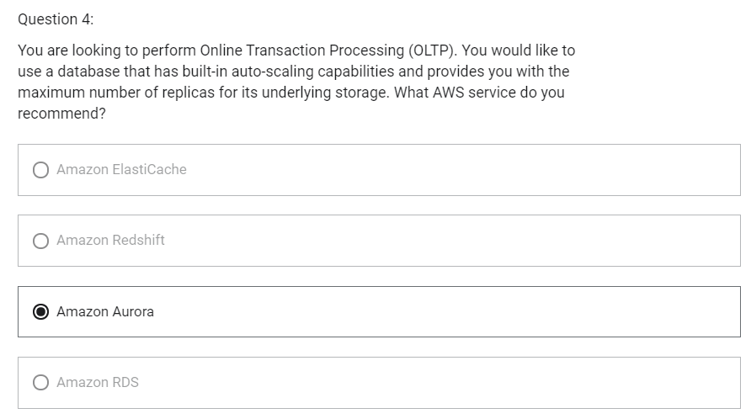

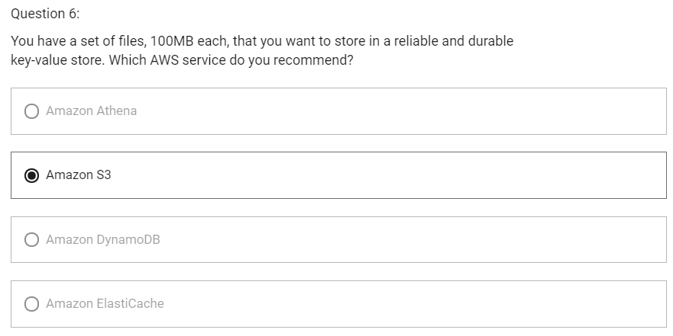

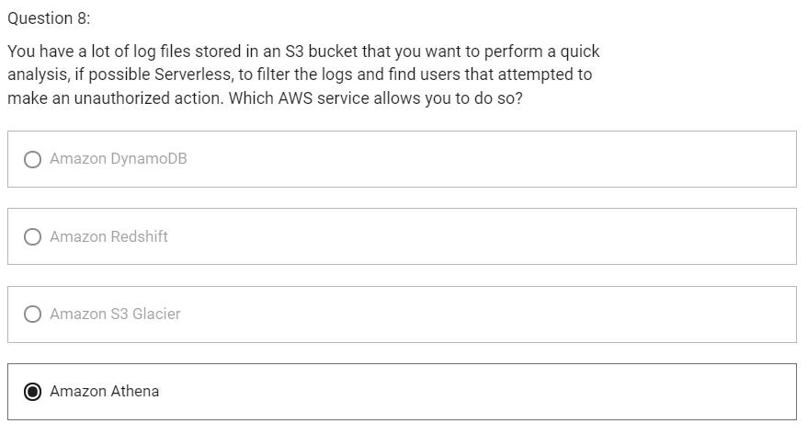

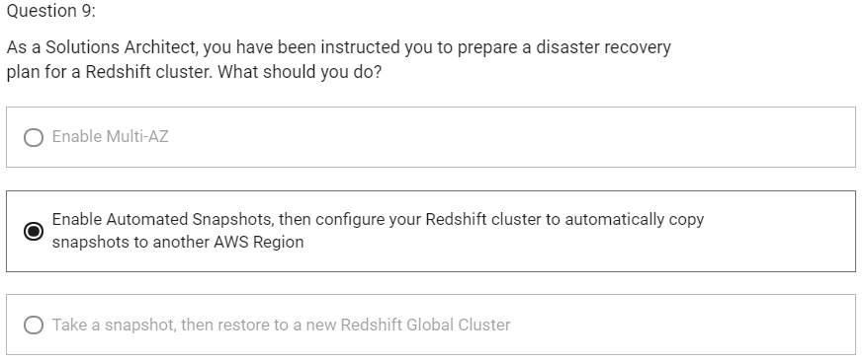

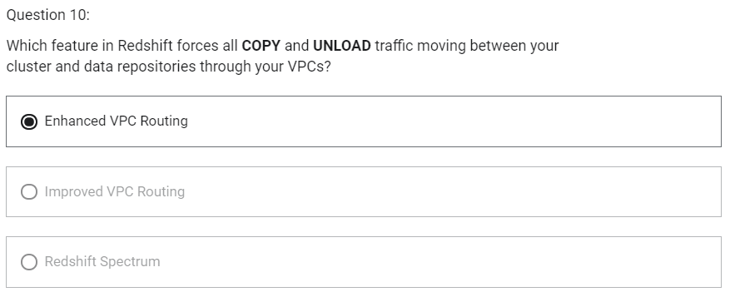

CloudWatch Metrics

1. CloudWatch provides metrics for every services in AWS
2. Metric is a variable to monitor (CPUUtilization, NetworkIn, ..)
3. Metrics belong to namespaces
4. Dimension is an attribute of a metric (instance id, environment, etc)
5. Up to 10 dimensions per metric
6. Metrics have timestamps

EC2 Detailed Monitoring

1. EC2 Instance metrics have metrics “every 5 minutes”
2. With detailed monitoring (for a cost), you get data “every 1 minute”
3. This will help you to react faster in case of changing metrics and scale using ASG
4. AWS Free Tier allows us to have 10 detailed monitoring metrics
5. Note: EC2 Memory Usage is by default not pushed (must be pushed from inside the instance as a custom metric)

CloudWatch Custom Metrics

1. Possibility to define and send your own custom metrics to CloudWatch
2. Example: memory (RAM) usage, disk space, number of logged in users
3. Use API call PutMetricData
4. Ability to use dimensions (attributes) to segment metrics
   1. Instance.id
   2. Environment.name
5. Metric resolution (two possible value)
   1. Standard- 1 minute (60 sec)
   2. High resolution- 15/10/30 sec – higher cost
6. Important: Accepts metric data points two weeks in the past and two hours in the future

CloudWatch Dashboards

1. Great way to setup custom dashboards for quick access to key metrics and alarms
2. Dashboards are global
3. Dashboards can include graphs from different AWS accounts and regions
4. You can change time zone and time range of the dashboards
5. You can setup automatic refresh (10s, 1m, 5m, 15m)
6. Dashboards can be shared with people who don’t have an AWS account (public email address, 3rd party SSO provider through Amazon Cognito)
7. Pricing
   1. 3 dashboards (up to 50 metrics) for free
   2. $3/dashboard/month afterwards

CloudWatch Logs

1. Log groups: arbitrary name, usually representing an application
2. Log stream: instances within application/ log files/ containers
3. Can define log expiration policies (never expire, 30 days, etc)
4. CloudWatch Logs can send logs to
   1. Amazon S3
   2. Kinesis Data Streams
   3. Kinesis Data Firehouse
   4. AWS Lambda

CloudWatch Logs – Sources

1. SDK, CloudWatch Logs Agent, CloudWatch Unified Agent
2. Elastic Beanstalk: collection of logs from application
3. ECS: collection from containers
4. AWS Lambda: collection from function logs
5. VPC Flow Logs: VPC specific logs
6. API Gateway
7. CloudTrail based on filter
8. Route 53: Log DNS queries

CloudWatch Logs - Metric Filter & Insights

1. CloudWatch Logs can use filter expressions
   1. Example find a specific IP inside of a log
   2. Or count occurrences of “ERROR” in your logs
2. Metric filters can be used to trigger CloudWatch Alarms
3. CloudWatch Logs Insights can be used to query logs and add queries to CloudWatch Dashboards

CloudWatch Logs – S3 Export

1. Log data can take up to 12 hours to become available for export
2. The API call is CreateExportTask
3. Not near-real time or real time. Use Logs Subscriptions instead

CloudWatch Logs – Subscriptions

1. Subscriptions are filters that are applied on top of CloudWatch Logs and we can send to destinations which can be Lambda function (managed by AWS or custom), Kinesis Data Firehouse, Kinesis Data Streams

CloudWatch Logs Aggregation Multi-Account and Multi-Region

1. Logs from multiple accounts and multiple regions can be centralized

CloudWatch Logs for EC2

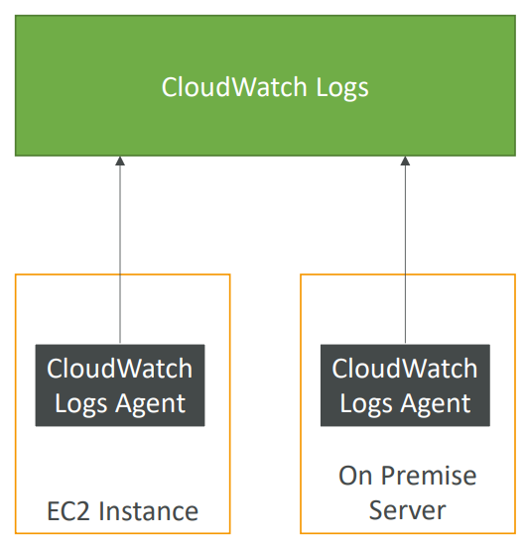

1. By default, no logs from your EC2 machine will go to CloudWatch
2. You need to run a CloudWatch agent on EC2 to push the log files you want
3. Make sure IAM permissions are correct
4. CloudWatch log agent can be setup on-premises too

CloudWatch Logs Agent and Unified Agent

1. For virtual servers (EC2 instances, on-premises servers, ..)
2. CloudWatch Logs Agent
   1. Old version of the agent
   2. Can only send to CloudWatch Logs
3. CloudWatch Unified Agent
   1. Collect additional system level metrics such as RAM, processes, etc
   2. Collect logs to send to CloudWatch Logs
   3. Centralized configuration using SSM Parameter Store

CloudWatch Unified Agent – Metrics

1. CPU (active, guest, idle, system, user, steal)
2. Disk metrics (free, used, total)
3. Disk IO (writes, reads, bytes, iops)
4. RAM (free, inactive, used, total, cached)
5. Netstat (number of TCP and UDP connections, net packets, bytes)
6. Processes (total, dead, bloqued, idle, running, sleep)
7. Swap space (free, used, used %)

CloudWatch Alarm

1. Alarms are used to trigger notifications for any metric
2. Has various options
   1. Sampling
   2. %
   3. Max
   4. Min
3. Alarm States
   1. OK- means alarm is not triggered
   2. INSUFFICIENT_DATA- there is no sufficient data to determine state of alarm
   3. ALARM- threshold has reached so alarm is set
4. Period
   1. Length of time in seconds to evaluate the metric
   2. High resolution custom metrics: 10 sec, 30 sec or multiples of 60 sec

CloudWatch Alarm Targets

1. Amazon EC2 – stop, terminate, reboot or recover an EC2 Instance
2. EC2 Auto Scaling Group- trigger Auto Scaling Action
3. Amazon SNS - Send notification to SNS

EC2 Instance Recovery

There is status check which can be instance check or system check. We can define CloudWatch Alarm on both these checks. We can recover instance when alarm is reached.

1. Status Check
   1. Instance status- check the EC2 VM
   2. System status- check the underlying hardware
2. Recovery
   1. When we recover instance, it will have same Private, public, elastic IP, metadata, placement group

CloudWatch Alarm- Good to know

1. Alarm can be created based on CloudWatch Logs Metrics Filters
2. To test alarms and notifications, set the alarm state to alarm using CLI

aws cloudwatch set-alarm-set –alarm-name “myalarm” –state-value ALARM –state-reason “testing purposes”

CloudWatch Events

1. CloudWatch Event Source can be
   1. Event Pattern
      1. Intercept events from AWS services (sources) like EC2 Instance Start, CodeBuild Failure, S3, Trusted Advisor
      2. can intercept any API call with CloudTrail integration
   2. Schedule or Cron
      1. Example: Create an event every 4 hours
2. A JSON payload is created from the event and passed to a target
   1. Compute: Lambda, Batch, ECS task
   2. Integration: SQS, SNS, Kinesis Data Streams, Kinesis Data Firehouse
   3. Orchestration: Step Functions, CodePipeline, CodeBuild
   4. Maintenance: SSM, EC2 Actions
3. Use case
   1. Send email notification when EC2 instance is in pending state

Amazon EventBridge

1. EventBridge is the next evolution of CloudWatch Events
2. By default, when we use CloudWatch Events, we are using Default event bus which is the event bus generated by AWS services within your account.
3. In EventBridge, multiple buses are added
   1. Partner Event bus: it is used to receive events not from AWS but from SaaS service or application
   2. Custom Event Bus: your own application can publish their own events and have other applications react to this event
4. These event buses can be accessed by other AWS accounts
5. Rules can be created to define how you want to process these events

Amazon EventBridge Schema Registry

1. EventBridge has capability to analyze the events in your bus and infer the schema
2. The schema registry allows you to generate code for your application that will know in advance how data is structured in the event bus
3. Schema can be versioned

Amazon EventBridge vs CloudWatch Events

1. Amazon EventBridge builds upon and extends CloudWatch Events
2. It uses the same service API and endpoint, and the same underlying service infrastructure
3. EventBridge allows extension to add event buses for your custom applications and your third-party SaaS apps.
4. Event Bridge has the Schema Registry capability
5. EventBridge has a different name to mark the new capabilities
6. Over tie, the CloudWatch Events name will be replaced with EventBridge

AWS CloudTrail

1. It is a global service
2. Provides governance, compliance and audit for your AWS account
3. CloudTrail is enabled by default
4. Get an history of events/ API calls made within your AWS Account by
   1. Console
   2. SDK
   3. CLI
   4. AWS Services
5. Can put logs from CloudTrail into CloudWatch Logs or S3
6. A trail can be applied to all regions (default) or a single region
7. If a resource is deleted in AWS, investigate CloudTrail first

CloudTrail Events

1. We can view three kinds of events in CloudTrail
   1. Management Events
      1. Operations that are performed on resources in your AWS account
      2. Example
         1. Configuring security
         2. Configuring rules for routing data
         3. Setting up logging
      3. By default, trails are configured to log management events
      4. Can separate Read Events (that don’t modify resources) from Write Events ( that may modify resources)
   2. Data Events
      1. By default, data events are not logged (because they are high volume operations)
      2. Example
         1. Amazon S3 object-level activity (ex: GetObject, DeleteObject, PutObject)
         2. AWS lambda function execution activity
      3. Can separate Read and Write Events
   3. CloudTrail Insight Events

CloudTrail Insights

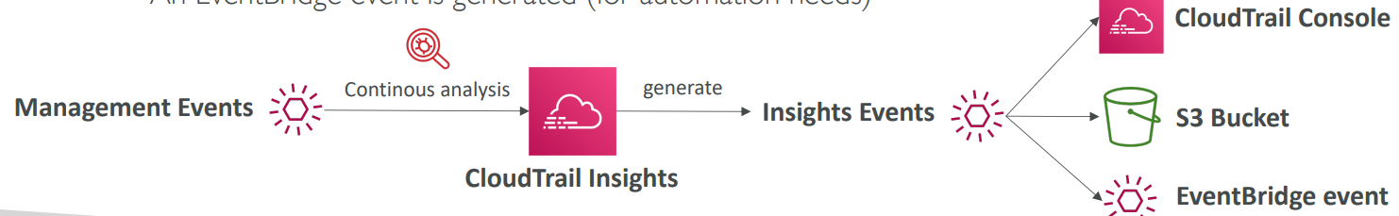

1. Enable CloudTrail Insights to detect unusual activity in your account
   1. Inaccurate resource provisioning
   2. Hitting service limits
   3. Bursts of AWS IAM actions
   4. Gaps in periodic maintenance activity
2. CloudTrail Insights analyzes normal management events to create a baseline and then

continuously analyzes write events to detect unusual patterns.

1. These insight events /Anomalies will appear in the CloudTrail console. They will also be sent to Amazon S3 if you want. An EventBridge event is generated in case you need to automate something like send email.

CloudTrail Events Retention

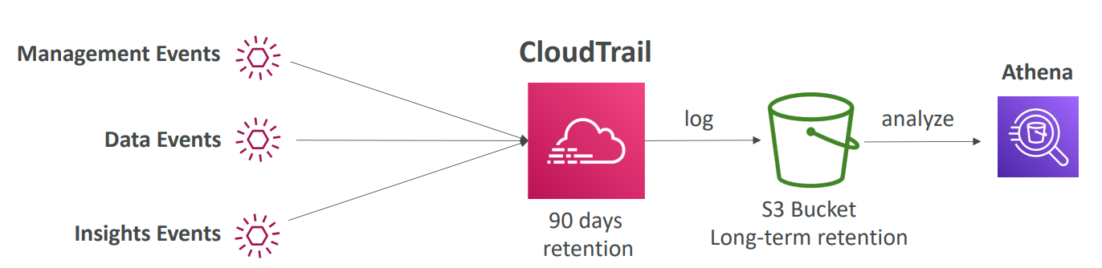

1. Events are stored for 90 days in CloudTrail.
2. To keep events beyond this period, log them to S3 and use Athena.

AWS Config

1. Helps with auditing and recording compliance of your AWS resources
2. Helps record configurations and changes over time
3. Questions that can be solved by AWS Config
   1. Is there unrestricted SSH access to my security groups?
   2. Do my buckets have any public access?
   3. How has my ALB configuration changed over time?
4. You can receive alerts (SNS notifications) for any changes)
5. AWS Config is a per-region service
6. Can be aggregated across regions and accounts
7. Possibility of storing the configuration data into S3 (analyzed by Athena)

Config Rules

1. Can use AWS managed config rules (over 75)
2. Can make custom config rules (must be defined in AWS lambda)
   1. Example
      1. Evaluate if each EBS disk is of type gp2
      2. Evaluate if each EC2 instance is t2.micro
3. Rules can be evaluated/triggered
   1. For each config change
   2. And /or at regular time intervals
4. AWS Config rules does not prevent actions from happening (no deny)
5. Pricing
   1. No free tier
   2. $0.003 per configuration item recorded per region
   3. $0.001 per config rule evaluation per region

AWS Config Resources

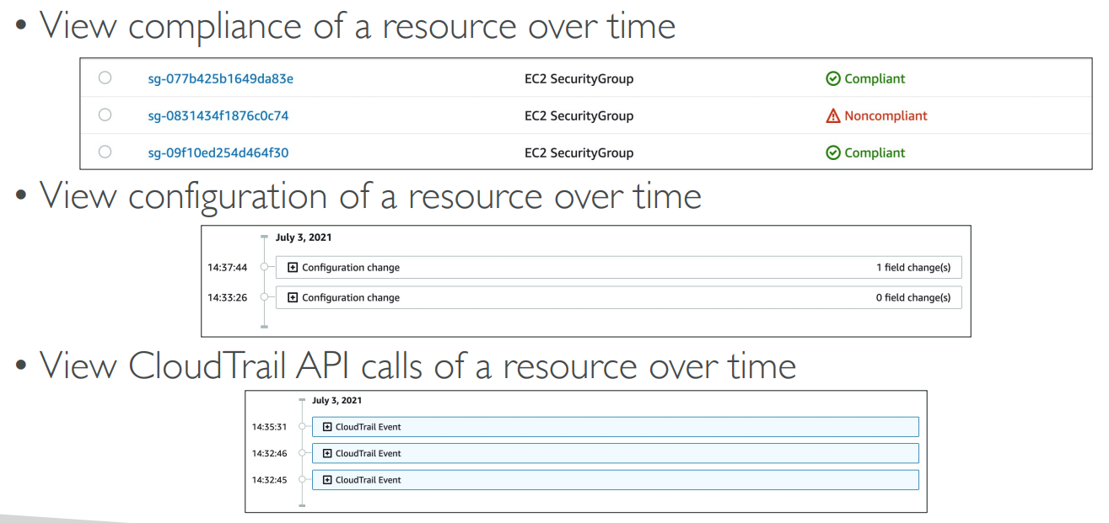

1. View compliance of a resource over time
2. View configuration of a resource over time
3. View CloudTrail API calls of a resource over time

Config Rules- Remediations

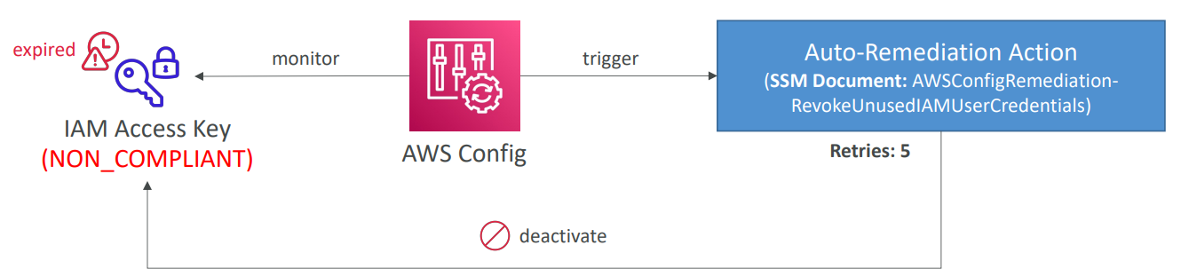

1. Although we cannot deny anything happening through AWS Config, we can automate remediation of non-complaint resources using SSM Automation Documents
2. We can either use AWS-Managed Automation Documents or create custom Automation Documents. We can create custom Automation Documents that invokes Lambda function
3. You can set Remediation retries if the resource is still non-compliant after auto-remediation (retry for 5 times)

Config Rules- Notifications

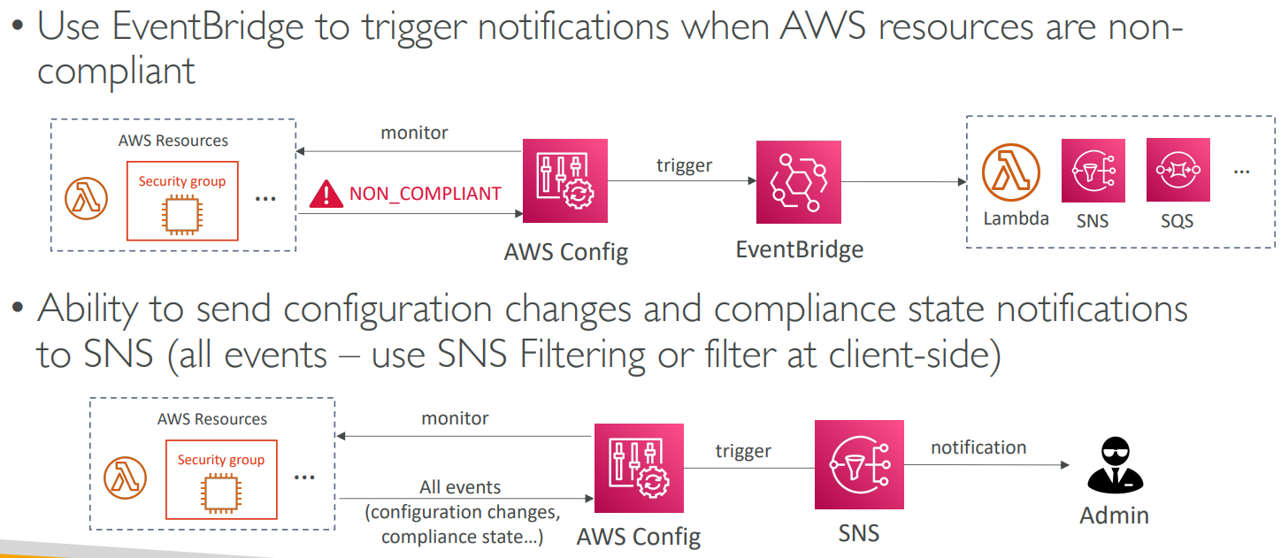

1. Use EventBridge to trigger notifications when AWS resources are non-complaint
2. Ability to send configuration changes and compliance state notifications to SNS (use SNS filtering at client side)

For an Elastic Load Balancer

1. CloudWatch
   1. Monitoring incoming connections metric
   2. Visualize error codes as a % over time
   3. Make a dashboard to get an idea of your load balancer performance
2. Config
   1. Track security group rules for the Load Balancer
   2. Track configuration changes for the load Balancer
   3. Ensure an SSL certificate is always assigned to the Load Balancer (compliance)
3. CloudTrail
   1. Track who made any changes to the Load Balancer with API calls

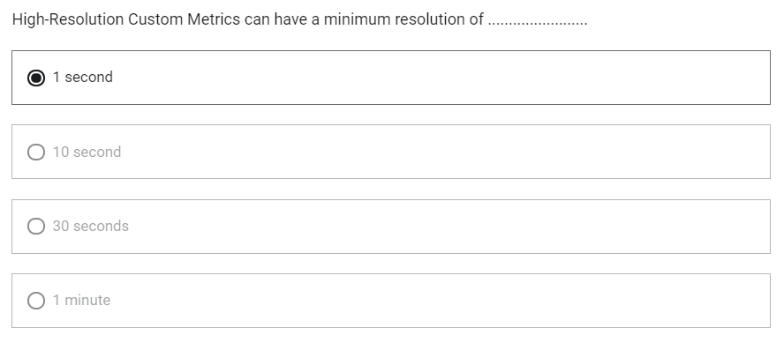

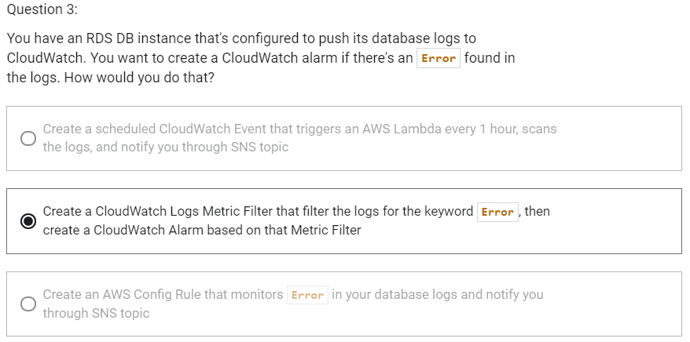

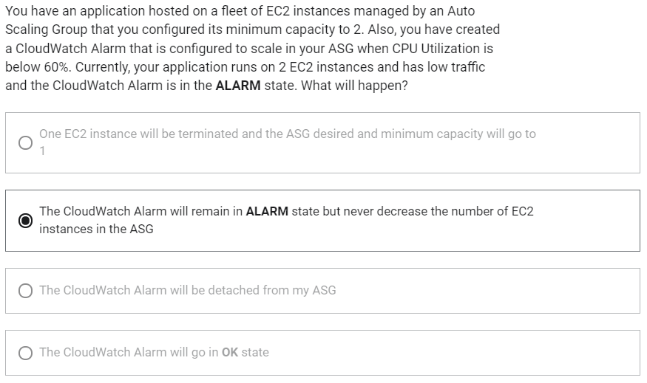

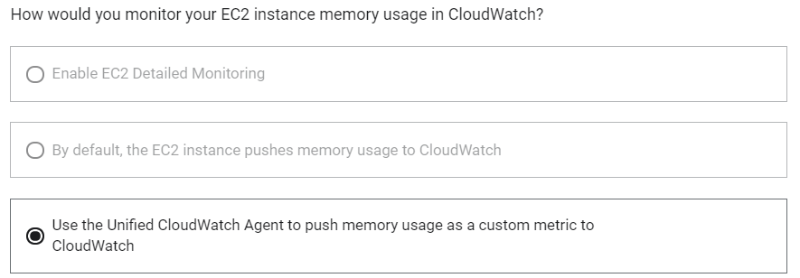

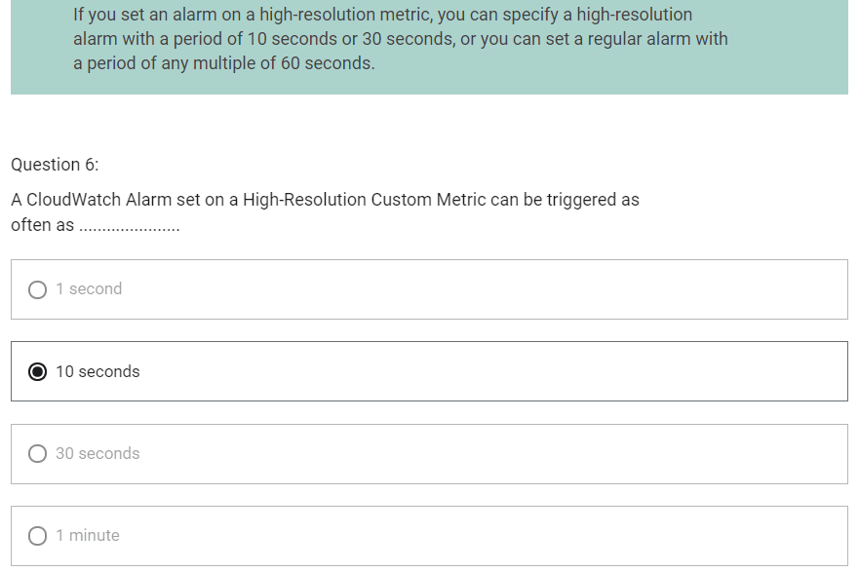

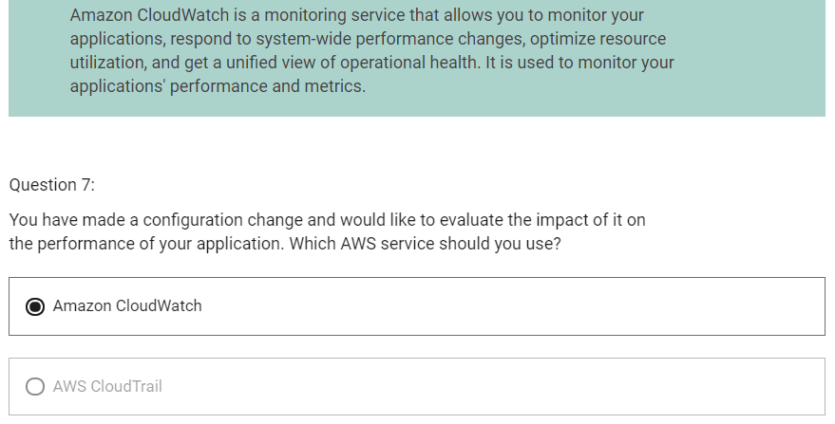

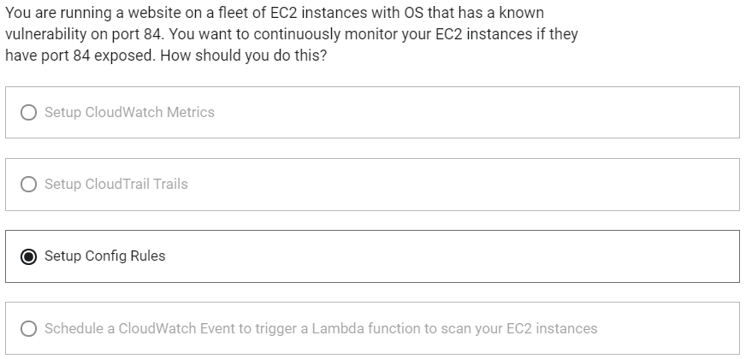

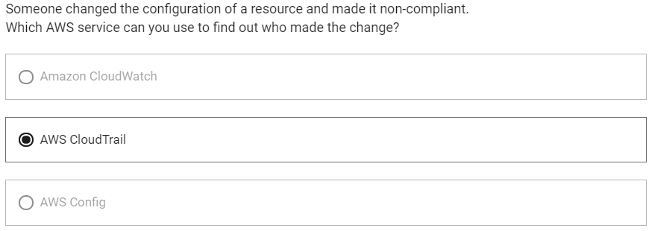

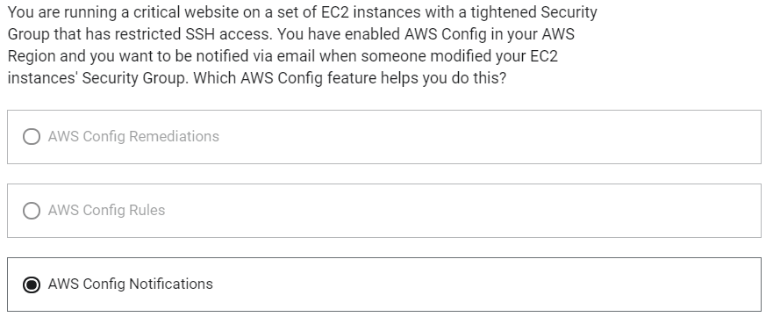

STS (Security Token Service)

1. Allows to grant limited and temporary access to AWS resources
2. Token is valid for up to one hour (must be refreshed)
3. There are bunch of APIs in STS
   1. AssumeRole
      1. Within your own account: for enhanced security
      2. Cross Account Access: assume role in target account to perform actions there
   2. AssumeRoleWithSAML
      1. Return credentials for users logged with SAML
   3. AssumeRoleWithWebIdentity
      1. Return credentials for users logged with an Identity Providers such as Facebook Login, Google Login, OIDC compatible
      2. AWS recommends against using this, and using Cognito instead
   4. GetSessionToken
      1. For MFA, from a user or AWS account root user

Using STS to Assume a Role

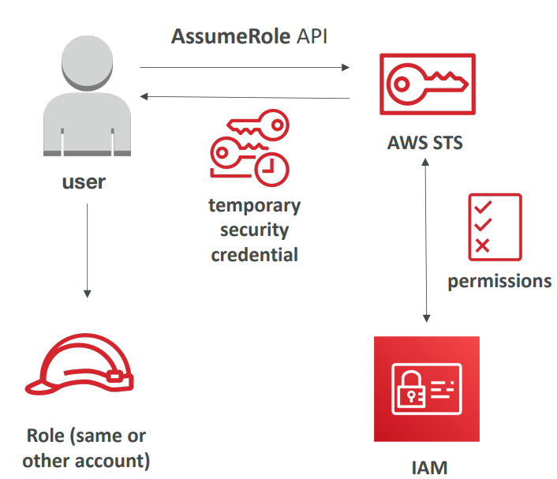

We have a user who wants to assume role in same or other account. So, we need to invoke AWS STS by using AssumeRole API. STS will check with IAM if we have permission to do so. Then it will return us temporary credentials and these credentials can be used in our account to assume that role.

1. Define an IAM Role within your account or cross-account
2. Define which principals can access this IAM Role
3. Use AWS STS (Security Token Service) to retrieve credentials and impersonate the IAM Role you have access to (AssumeRole API)
4. Temporary credentials can be valid between 15 minutes to 1 hour

Identity Federation in AWS

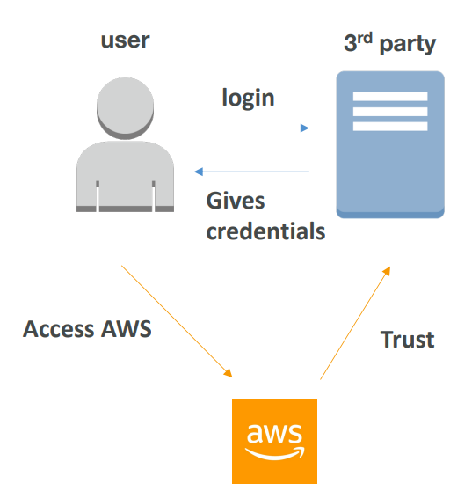

There is a user and there is a 3rd party source and AWS has to trust that 3rd party source for managing our users. User will login to 3rd party get credentials from it and will be able to access AWS.

1. Federation lets users outside of AWS to assume temporary role for accessing AWS resources.
2. These users assume identity provided access role.
3. Federations can have many flavours
   1. SAML 2.0
   2. Custom Identity Broker
   3. Web Identity Federation with Amazon Cognito
   4. Web Identity Federation without Amazon Cognito
   5. Single Sign On
   6. Non-SAML with AWS Microsoft AD
4. Using federation, you don’t need to create IAM users
5. User management is outside of AWS

SAML 2.0 Federation

1. Can integrate with Active Directory/ ADFS with AWS
2. Provides access to AWS Console or CLI (through temporary credentials)
3. No need to create an IAM user for each of your employees

SAML 2.0 Federation- Active Directory FS

1. Same process as with any SAML 2.0 compatible Identity Providers

SAML 2.0 Federation

1. Needs to setup a trust between AWS IAM and SAML
2. SAML 2.0 enables web-based, cross domain SSO
3. Uses the STS API: AssumeRoleWithSAML

Note:

Federation through SAML is the “old way” of doing things

Amazon Single Sign On (SSO) Federation is the new managed and simpler way

Custom Identity Broker Application

1. Sue only if identity provider is not compatible with SAML 2.0
2. The identity broker must determine the appropriate IAM policy
3. Uses the STS API: AssumeRole or GetFederationToken

WebIdentityFederation- AssumeRoleWithWebIdentity

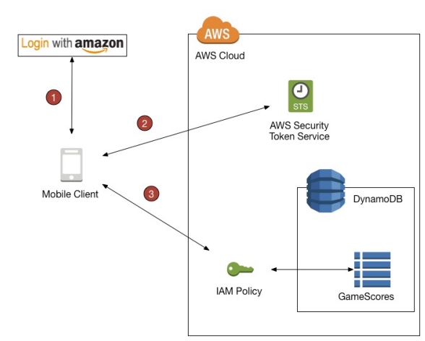

We log in with Identity Provider. We then exchange it with STS and then we have access to AWS.

1. Not recommended by AWS
2. Use Cognito instead which allows for anonymous users, data synchronization, MFA

AWS Cognito

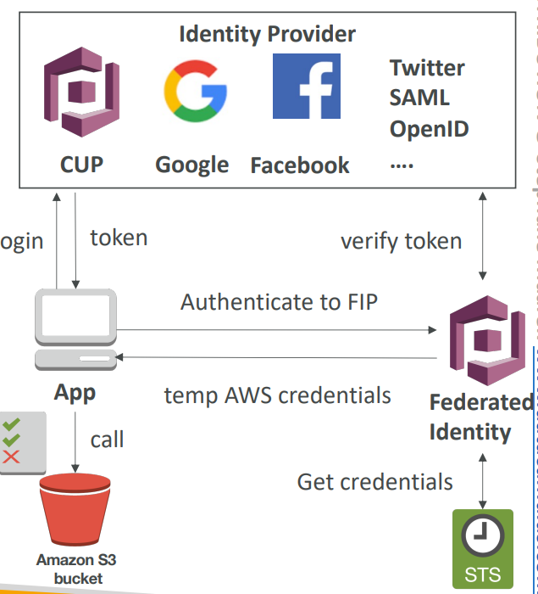

Suppose, there is a application which can be mobile application or a web application. And it is going to login with an identity provider. The identity provider can be Google, Facebook, Amazon, Twitter etc. We login with it and we get back a token, this token can be exchanged with Cognito Federated Identity which is going to verify the token first and then get the credentials from STS in the backend and give us back some temporary AWS credentials. These credentials can be used to access Amazon S3 bucket.

1. Provide direct access to AWS Resources from the Client Side (mobile, web app)
2. Example: provide temporary access to write to S3 bucket using Facebook login
3. Problem: we don’t want to create IAM users for our application users
4. How?
   1. Log in to federated identity provider- or remain anonymous
   2. Get temporary AWS credentials back from the Federated Identity Pool
   3. These credentials come with a pre-defined IAM policy stating their permissions

Microsoft Active Directory

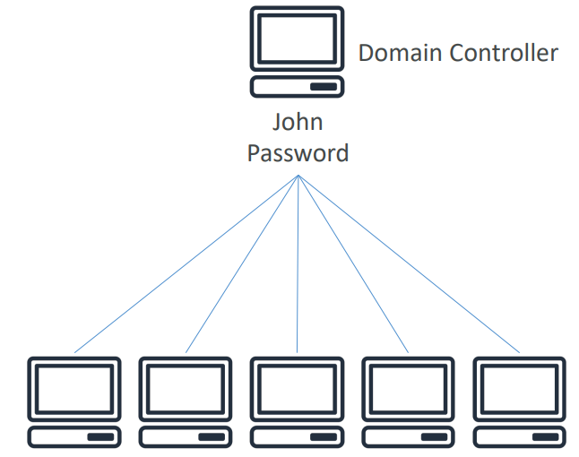

1. Found on any Windows Server with AD Domain Services
2. Database of objects: User Accounts, Computers, Printers, File Shares, Security Groups
3. Centralized security management, create account, assign permissions
4. Objects are organized in trees
5. A group of trees is a forest

AWS Directory Services

1. Provides you a way to create an Active Directory on AWS
2. There are 3 flavours on it
   1. AWS Managed Microsoft AD

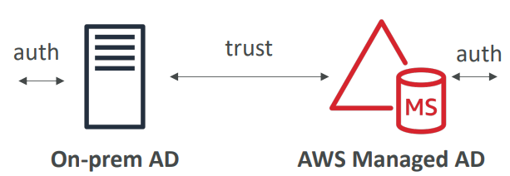

* + 1. Create you own AD in AWS
    2. Can manage users locally
    3. It supports MFA
    4. Can create a trust connection with your on-premise AD
  1. AD Connector

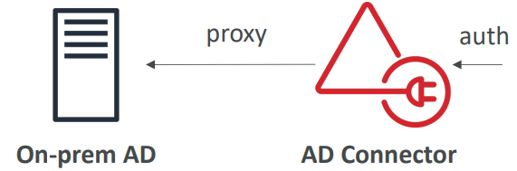

* + 1. Directory Gateway (proxy) to redirect to on-premise AD
    2. Users are managed on the on-premise AD
  1. Simple AD

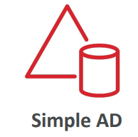

* + 1. AD-compatible managed directory on AWS
    2. Cannot be joined with on-premise AD

AWS Organizations

1. Global service
2. Allows you to manage multiple AWS accounts in your organization
3. The main account is the master account- you can’t change it
4. Other accounts are member accounts
5. Member accounts can only be part of one organization although they can be moved from one organization to another which is called migration.
6. Benefits
   1. Consolidated Billing across all accounts and with a single payment method
   2. Pricing benefits from aggregated usage (volume discounts for EC2, S3 ..)
7. API is available to automate AWS account creation

Multi Account Strategies

1. Create accounts per department
2. Create accounts per cost center
3. Create account per environment like dev/test/production
4. Create accounts based on regulatory restrictions (using SCP)
5. Create accounts for better resource isolation (ex: VPC)
6. Separate per-account service limit
7. Isolated account for logging
8. Difference between Multi Account and One Account with Multi VPC
   1. Multi account will have multiple accounts
   2. If there is one account with multiple VPC, there will be one giant account with multiple VPC and resources can talk to each other.
9. Use tagging standards for billing purposes
10. Enable CloudTrail on all accounts and send logs to central S3 account
11. Send CloudWatch Logs to central logging account
12. Establish Cross Account Roles for Admin purposes

Organizational Units (OU)

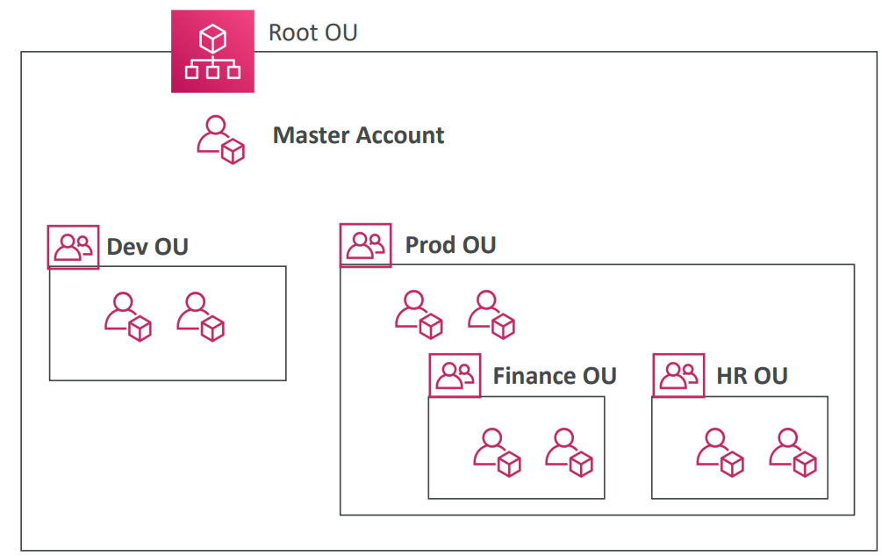

1. Accounts are organized using Organizational Units
2. OU can be
   1. Based on Business Unit (Sales OU, Marketing OU, ..)
   2. Based on Environmental Lifecycle (dev/prod/test)
   3. Based on Project based (proect1/project2/project3)
   4. And many more based on use case

SCP (Service Control Policies)

1. Whitelist or blacklist IAM actions
2. Applied at the OU or Account level
3. Does not apply to the Master Account
4. SCP is applied to all users and roles of the account, including root
5. SCP does not affect service-linked roles
   1. Service-linked roles enable other AWS services to integrate with AWS Organizations and can’t be restricted by SCPs.
6. SCP must have explicit allow (doe not allow anything by default)
7. Use case
   1. Restrict access to certain services (for example: cannot use EMR)
   2. Enforce PCI compliance by explicitly disabling services

SCP Hierarchy

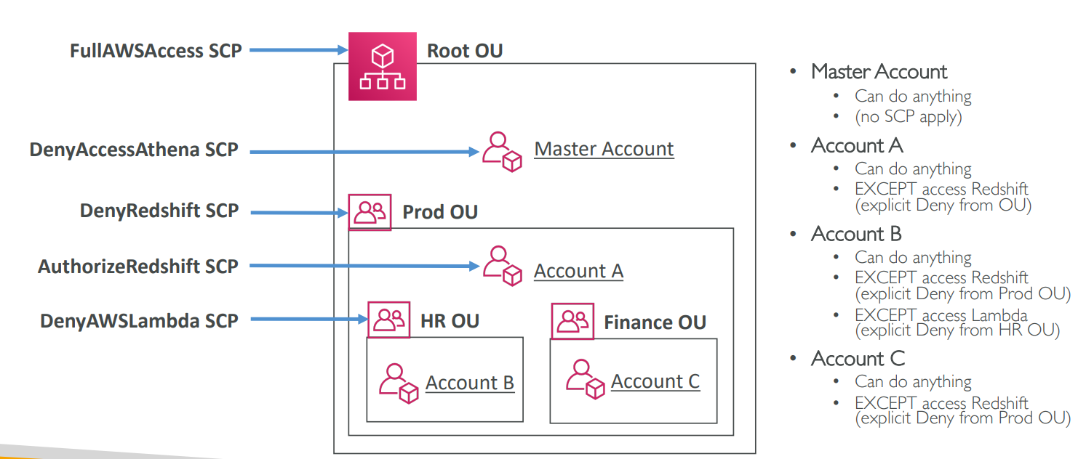

AWS Organization- Moving Accounts

1. To migrate accounts from one organization to another
   1. Remove the member account from the old organization
   2. Send an invite to the new organization
   3. Accept the invite to the new organization from the member account
2. If you want master account of old organization to also join the new organization, do the following
   1. Remove the member accounts from the organizations using procedure above
   2. Delete the old organization
   3. Repeat the process above to invite the old master account to the new oraganiztion

IAM- Advanced

IAM Conditions

1. Way to make IAM policies a bit more restrictive based on a condition

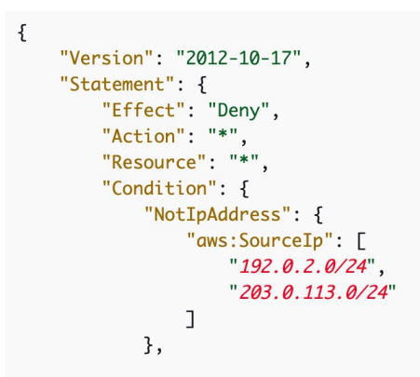

Restrict client IP from which API calls are being made

Note: SourceIP is for where the client is for where client is located

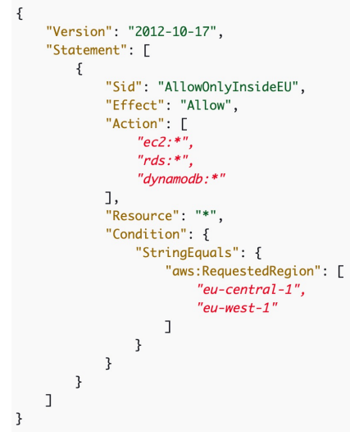

Restrict the region the API calls are made to

Note: RequestedRegion is where you are trying to make request to.

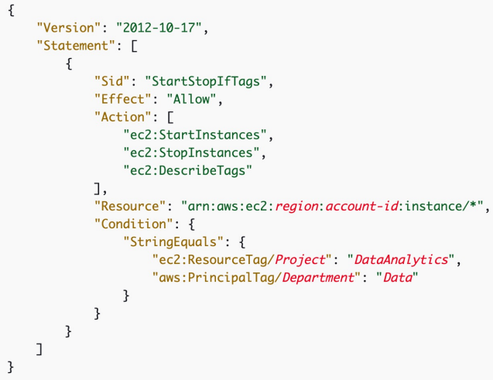

Resource based on tag

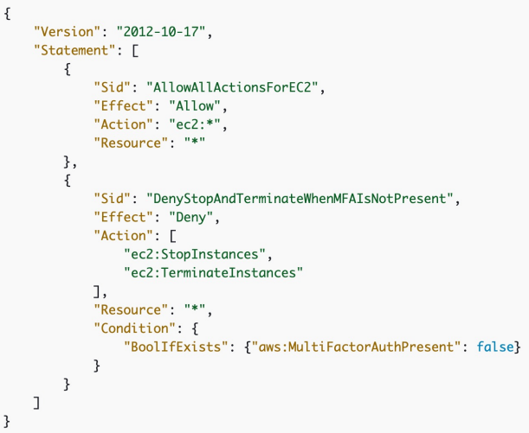

Force MFA

IAM for S3

Just / implies for that bucket

/* implies within that bucket

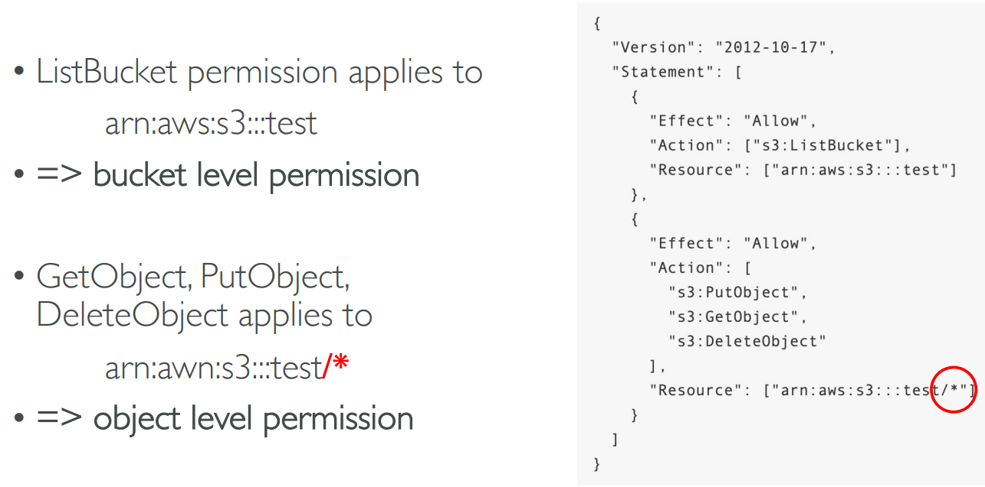

IAM Roles vs Resource Based Policies

1. When you assume a role (user, application or service), you give up your original permissions and take the permissions assigned to the role
2. When using a resource based policy, the principal does not have to give up his permissions and he does not loose the permissions
3. Example
   1. User in account A needs to scan a DynamoDB table in Account A and dump it in an S3 bucket in Account B.
      1. This is use case for resource based policy because if we use IAM role to do some stuff in account B for S3 bucket then you cannot do anything back on your DynamoDB table in Account A
4. Resource based policies can be applied to Amazon S3 buckets, SNS topics, SQS queues

IAM Permission Boundaries

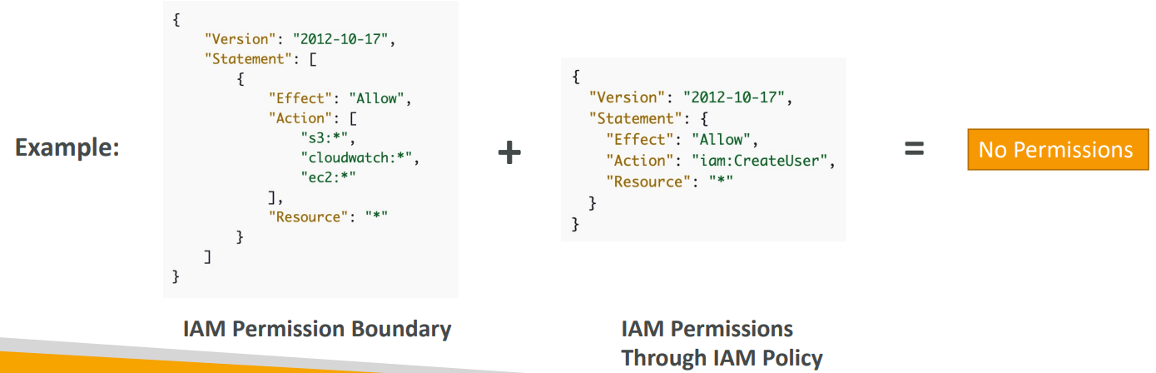

Suppose, an user has an IAM Permission Boundary which says allow everything on S3, CloudWatch and EC2. This is boundary for that user. He can now do things within S3, CloudWatch and EC2. On top of this IAM permission is defined through IAM Policy where it is saying user is allowed to create IAM user. Now, user won’t be able to create IAM user because allowing user to create IAM user is beyond the permission boundary of that user.

1. Advanced feature to use a managed policy to set the maximum permissions an IAM entity can get
2. Permission boundaries is more restrictive than IAM Permissions
3. IAM Permission Boundaries are supported for users and roles (not groups)
4. Can be used in combinations of AWS Organizations SCP
5. If organizations SCP, Permissions boundary and Identity-based policy exist, intersection of all these is effective permissions for that user

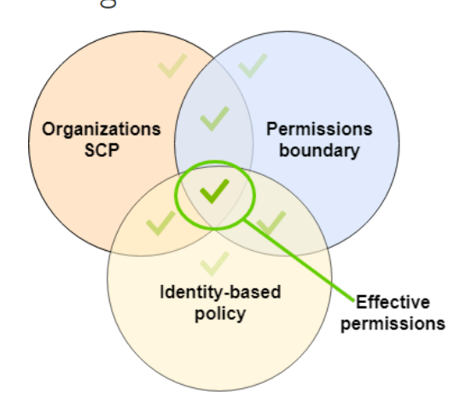

IAM Policy Evaluation Logic

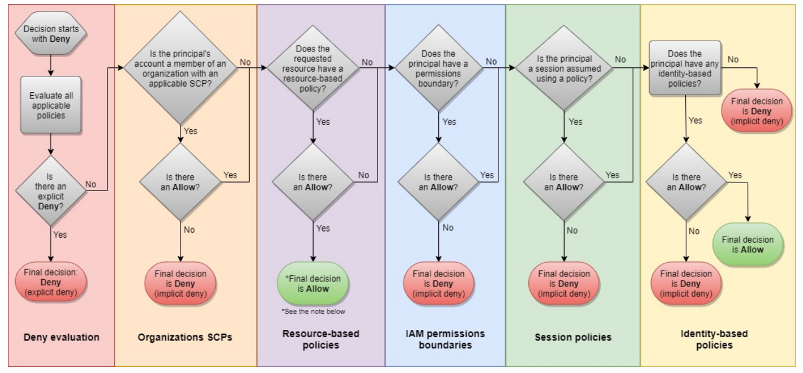

Example IAM Policy

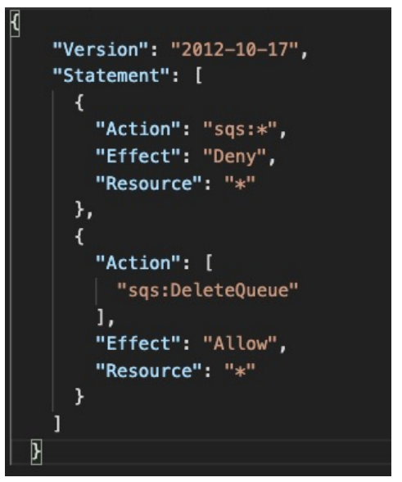

1. Can you perform sqs:CreateQueue?

No, Since all actions in SQS is denied

1. Can you perform sqs:DeleteQueue?

No

There is deny in top part and there is allow in lower part. So, there is conflict. As soon as there is explicit deny, the decision is going to be deny.

1. Can you perform ec2:DescribeInstances?

No

Since there is no explicit deny and also no explicit allow.

AWS Resource Access Manager (RAM)

1. Share AWS resources that you own with other AWS accounts
2. Share with any account or within your Organization
3. Avoid resource duplication
4. Things you can share with RAM
   1. VPC Subnet
      1. Allow to have all the resources launched in the same subnets
      2. Must be from the same AWS Organizations
      3. Cannot share security groups and default VPC
      4. Participants can manage their own resources in there
      5. Participants can’t view, modify, delete resources that belong to other participants or the owner
   2. AWS Transit Gateway
   3. Route53 Resolver Rules
   4. License Manager Configurations

Resource Access Manager - VPC Example

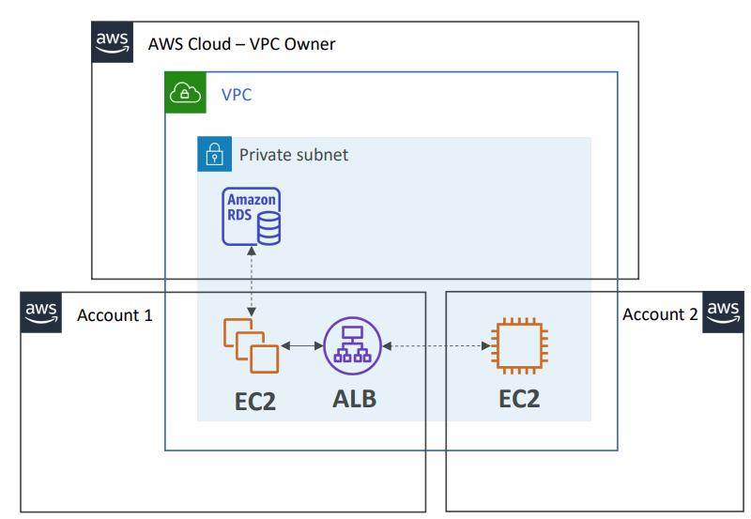

1. Network is shared among multiple account
2. Anything deployed in VPC can talk to other resources in VPC
3. But, each account is responsible for its own resources
4. One account cannot view, modify or delete resources in other accounts
5. In above example, private subnet is shared between account 1, account 2 and VPC owner. Resources launched by VPC owner (Amazon RDS) cannot be viewed, modified by account1 or account2. Similarly, resources launched by account1 (EC2, ALB) cannot be viewed, modified by VPC owner and account2. Also, resources launched by account2 (EC2) cannot be viewed, modified by VPC owner and account1.

AWS Single Sign-On (SSO)

1. Centrally manage Single Sign-On to access multiple accounts and 3rd party business applications
2. Once you log in to Single Sign-On portal, you can log in to any of your AWS accounts like Dropbox, Office 365, Slack, without reentering your login.
3. You can log in once and you have access to all the things that Single Sign-on is configured to access.
4. Integrated with AWS Organizations
5. If we have tons of accounts within our organization, we can set up AWS Single Sign-On and we will have access to login to all accounts within that organization. So, one login for all the accounts.
6. Supports SAML 2.0 markup
7. Integration with on-premise Active Directory
8. Centralized permission management
9. Centralized auditing with CloudTrail

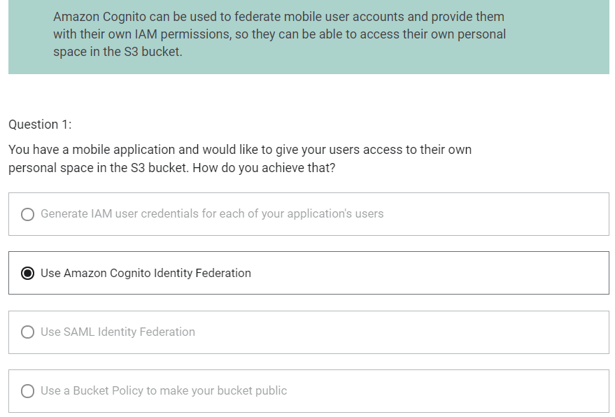

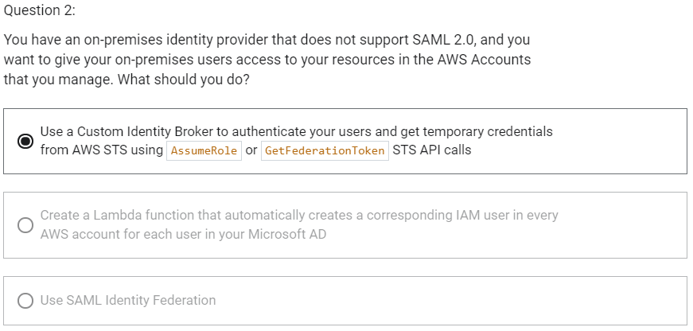

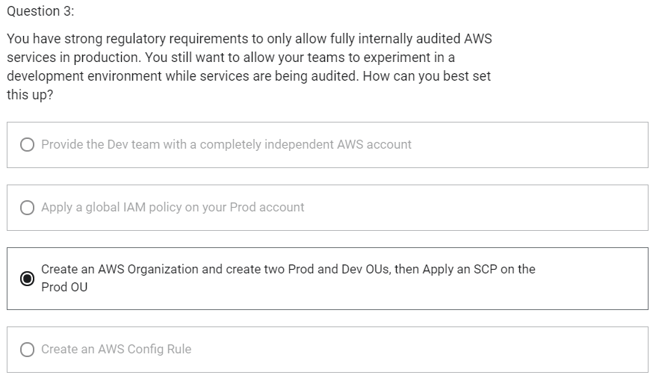

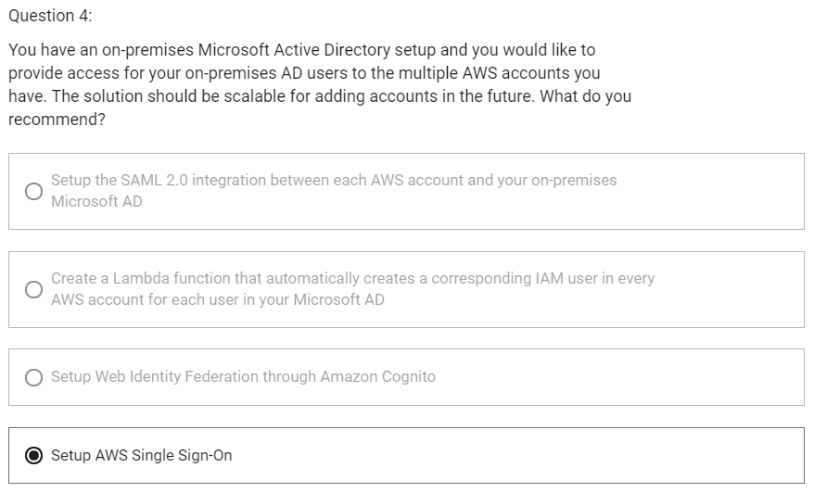

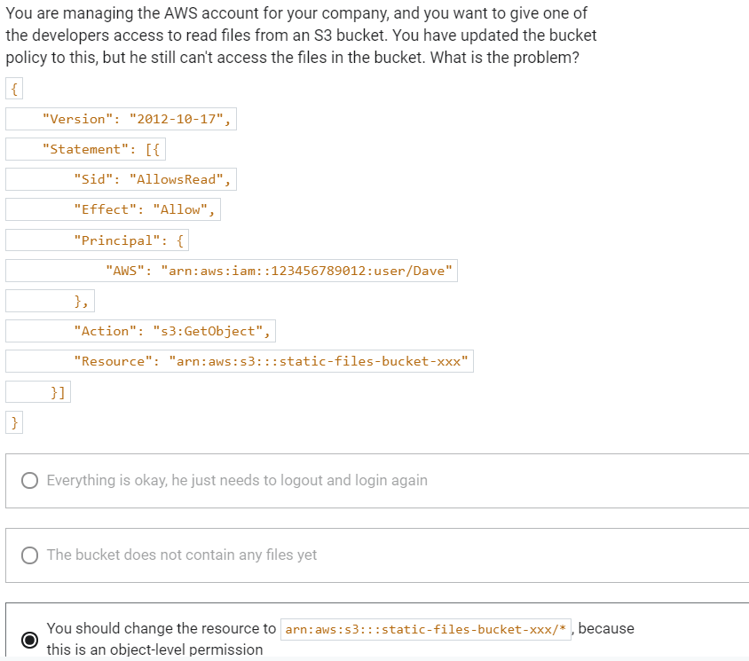

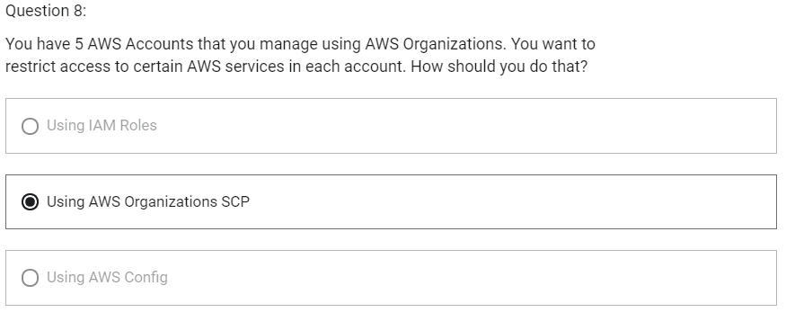

AWS Security

Encryption

1. Encryption in flight (SSL)

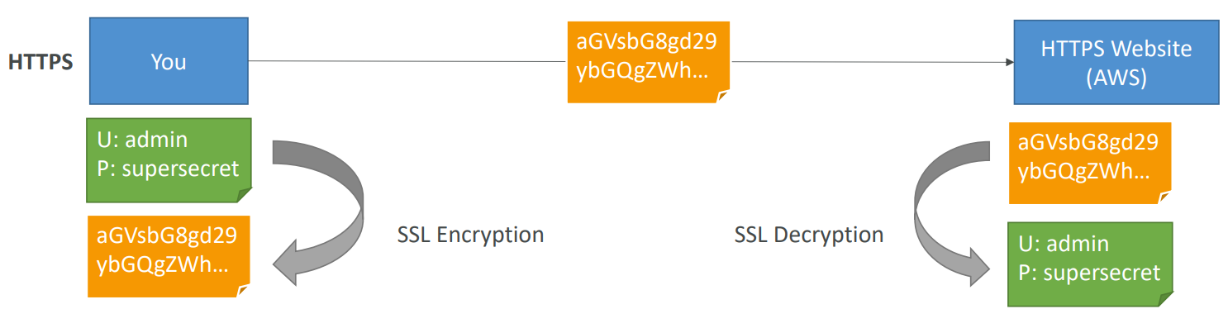

* 1. Data is encrypted before sending and decrypted after receiving
  2. SSL certificates help with encryption
  3. Encryption in flight ensures no man in the middle attack can happen

1. Server Side encryption at rest

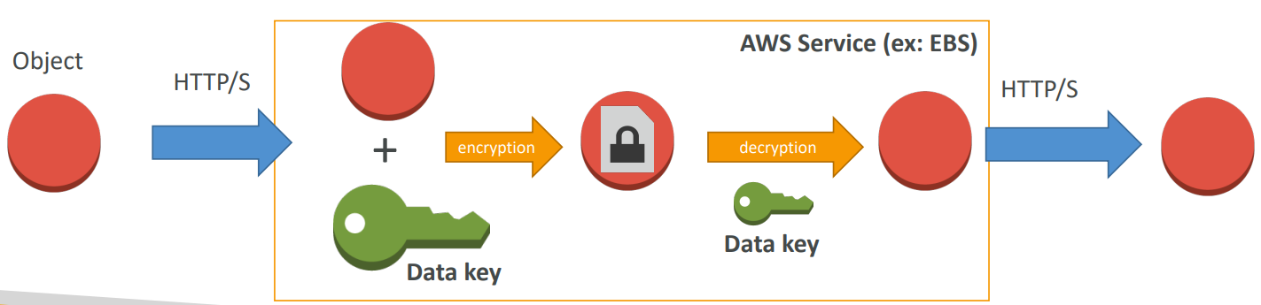

* 1. Data is encrypted after being received by the server
  2. The encryption/decryption keys must be managed somewhere and the server must have access to it

1. Client Side Encryption

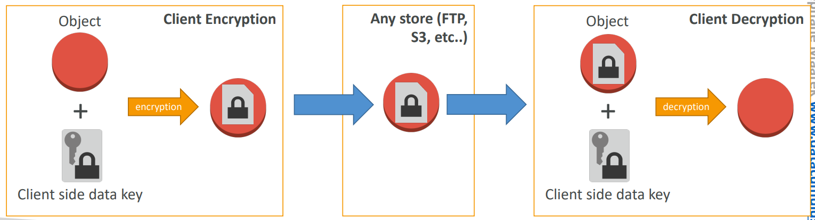

* 1. Data is encrypted by the client and never deployed by the server
  2. Data will be decrypted by a receiving client
  3. The server should not be able to decrypt the data
  4. Could leverage Envelope Encryption

AWS KMS (Key Management Service)

1. Helps us to control who and what can access to your data and AWS will manage key for us
2. KMS is fully integrated with IAM for authorization
3. Can be integrated into
   1. Amazon EBS: encrypt volumes
   2. Amazon S3: server side encryption of objects
   3. Amazon Redshift: encryption of data
   4. Amazon RDS: encryption of data
   5. Amazon SSM: Parameter store
4. KMS can also be used with CLI/SDK
5. We are able to fully manage the keys and policies
   1. Create
   2. Rotation policies
   3. Disable
   4. Enable
6. Ability to audit key usage (using CloudTrail)
7. There are three type of Customer Master Keys (CMK)
   1. AWS Managed Service Default CMK: free
   2. User Keys created in KMS: not free, $1/month
   3. User keys imported (must be 256-bit symmetric key): not free, $1/month
8. + pay for API call to KMS ($0.003/1000 calls)
9. When to use KMS?
   1. Anytime you need to share sensitive information like
      1. Database passwords
      2. Credentials to external service
      3. Private key of SSL certificates
10. KMS can only help in encrypting up to 4KB of data per call
11. If data > 4 KB, use envelope encryption
12. To give access to KMS to someone
    1. Make sure the key policy allows the user
    2. Make sure the IAM Policy allows the API calls
13. KMS keys are bound to specific region. So, when we create a KMS key in region A, it cannot be transmitted over region B.

KMS – Customer Master Key (CMK) Types

1. Symmetric (AES-256 keys)
   1. First offering of KMS
   2. Single encryption key is used for encryption and decryption
   3. Necessary for envelope encryption
   4. You cannot access the key unencrypted
   5. Must call KMS API to use this key
2. Asymmetric (RSA & ECC key pairs)
   1. Public and private key pair
   2. Public key is used for encryption
   3. Private key is used for decryption
   4. Public key is downloadable
   5. You cannot access the private key unencrypted
   6. Use case: Perform encryption outside of AWS by users who can’t call the KMS API

Copying Snapshots across regions

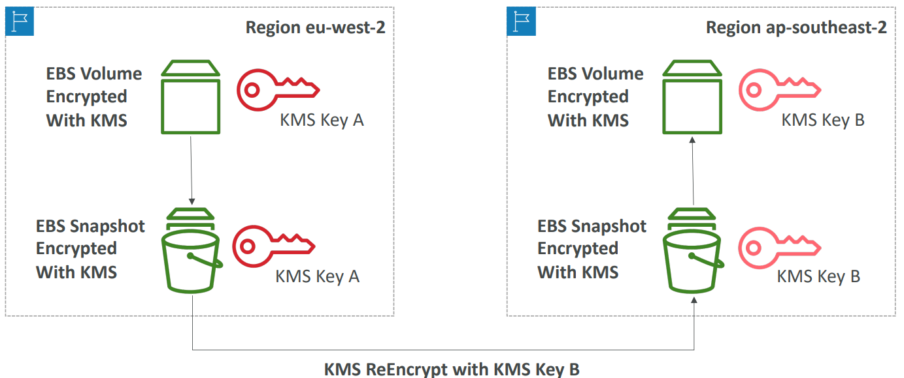

KMS keys are bound to specific region. So that means that when you create a KMS key in region A it cannot be transmitted over to region B.

Let’s say we have an encrypted EBS volume with KMS and a KMS key in the region eu-west-2 and we would like to copy that volume across to a new region for example to ap-southeast-2. SO, because KMS keys are linked to a specific region you would need to do a specific operation.

So, here is the process and this applies to EBS volumes, redshift snapshots and much more that is encrypted using AWS KMS.

So, first you would create a snapshot of your volume and any snapshot made from an encrypted volume is also encrypted with KMS and the same key. Then, you need to copy that snapshot over to the new region but you will specify a new KMS key to re-encrypt the data with. So, the KMS key B in the other region and now you have a snapshot encrypted with KMS in the other region but with a new key. And finally when you recreate a volume from that snapshot then that volume will be encrypted with a new KMS Key B.

So, the important point to see is because KMS keys are bound to a specific region, when you copy snapshots over, they have to be re-encrypted.

KMS Key Policies

1. Control access to KMS keys
2. Similar to S3 bucket policies
3. Difference: you cannot control access without them. If you don’t specify key policy, then no one can access your key.
4. Default KMS Key Policy
   1. Default KMS Key is very permissive
   2. It is created by default if you don’t provide a specific KMS Key Policy
   3. It is going to give access to the root user which means that your entire AWS account has the right to use this KMS key, if they have IAM policy available obviously
   4. Complete access to the key to the root user = entire AWS account
   5. So to give users access to KMS keys using this default KMS key policy, you need to create the correct IAM policy and attach it to user
5. Custom KMS Key Policy
   1. Define users, roles that can access the KMS key
   2. Define who can administer the key
   3. Useful for cross-account access of your KMS key

Copying Snapshots across accounts

1. Create a snapshot, encrypted with your own CMK
2. Attach a KMS Key Policy to authorize cross-account access
3. Share the encrypted snapshot
4. (in target) create a copy of the snapshot, encrypt it with a KMS Key in your account
5. Create a volume from the snapshot

KMS Automatic Key Rotation

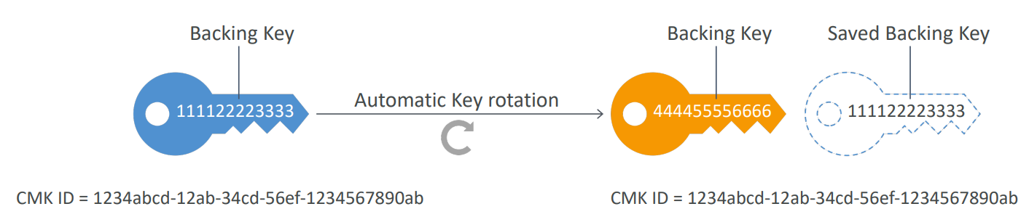

1. For Customer-managed CMK (not AWS managed CMK)
2. If enabled: automatic key rotation happens every 1 year
3. Previous key is kept active so you can decrypt old data
4. New key has the same CMK ID (only the backing key is changed)

KMS Manual Key Rotation

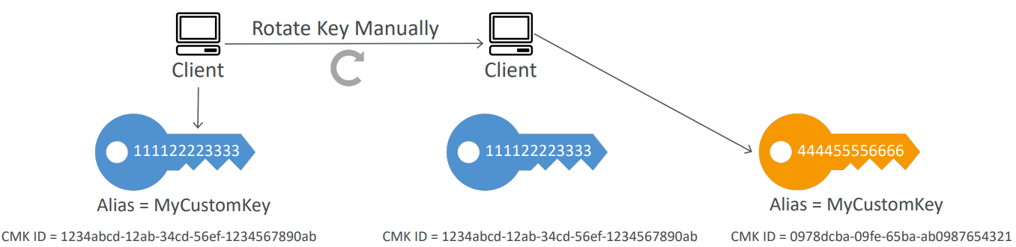

1. When you want to rotate key every 90 days, 180 days, etc
2. New key has a different CMK ID
3. You will keep previous key active so you can decrypt old data
4. Better to use aliases in this case (to hide the change of key for the application)
5. It is good solution to rotate CMK that are not eligible for automatic rotation (like asymmetric CMK)

KMS Alias Updating

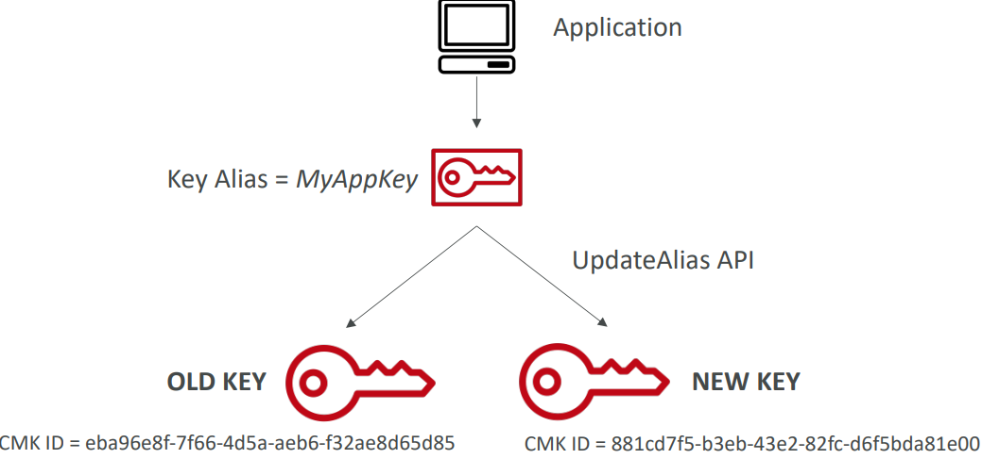

1. It is better to use alias in case to hide the change of key for the application
2. Your application only interacts from the API perspective with your key alias say MyAppKey. Then the old key, old key alias is the one that you had before rotation and after rotation you are going to create a new key and you are going to issue an UpdateAlias API code and this updated alias will have the alias point to the new key and therefore from the application perspective the change will not be detected. It will just be transparent

SSM Parameter Store

1. Serverless, scalable, durable
2. Secure storage for configuration and secrets in AWS
3. You can have optional encryption with KMS
4. You have versioning of your configuration and secrets
5. All your security for your configuration management is done using path and IAM policies
6. You can get notifications with CloudWatch Events
7. Integration with CloudFormation
8. Value of parameter can be 4096 characters long

SSM Parameter Store Hierarchy

1. /my-department/
   1. my-app/
      1. Dev/
         1. db-url
         2. db-password
      2. prod/
         1. db-url
         2. db-password
   2. other-app/
2. /other-department/
3. We are also able to reference secrets from the Secrets Manager
   1. /aws/reference/secretsmanager/secret_ID_in_Secrets_Manager
4. You are also able to reference parameters directly from AWS
   1. /aws/service/ami-amazon-linux-latest/amzn2-ami-hvm-x86_64-gp2

Standard and advanced parameter tiers

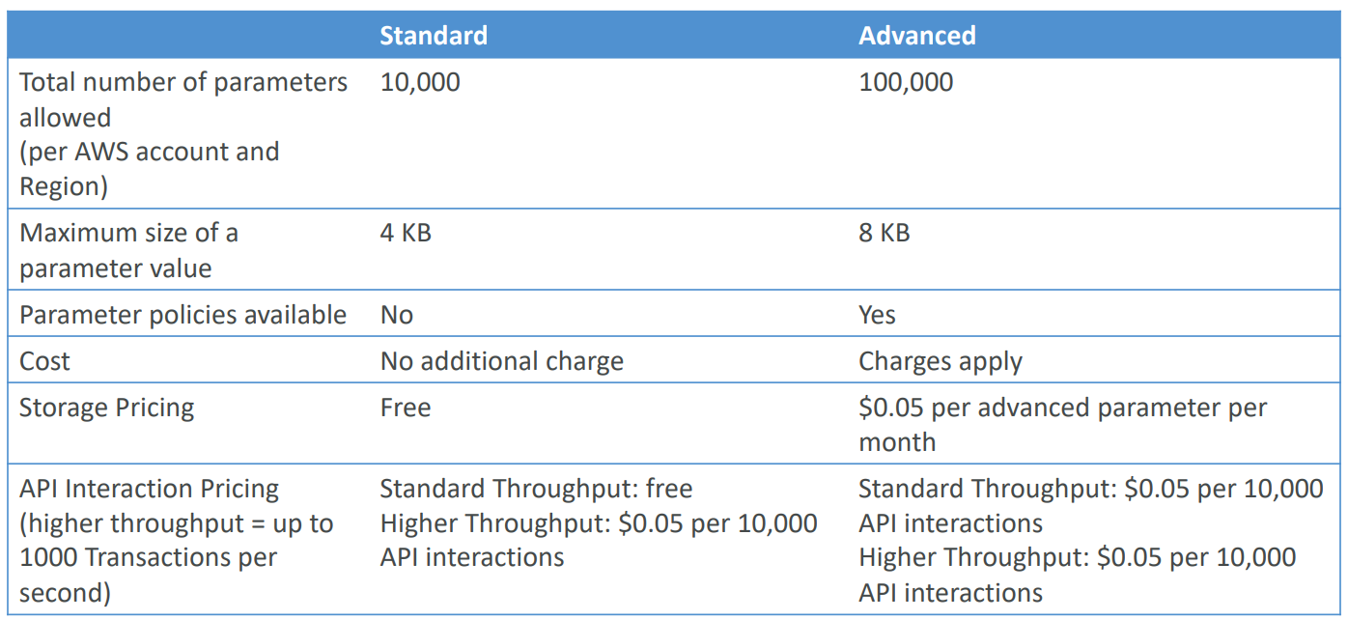

Parameter Policies

1. This is for advanced parameters
2. Allows to assign a TTL to a parameter (expiration date) to force updating or deleting sensitive data such as passwords
3. Can assign multiple policies at a time

This says my password expires in 2020-12-02

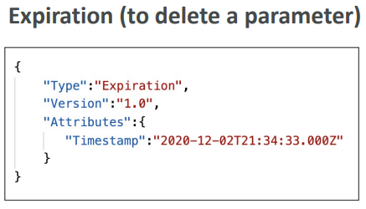

This says send me a notification through CloudWatch Events 15 days before the expiration happens

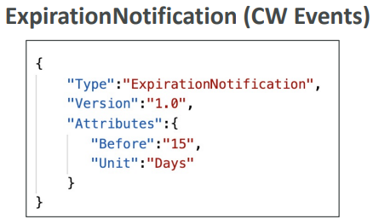

If my parameter has not been changed in 20 days then send me a notification through CloudWatch Events.

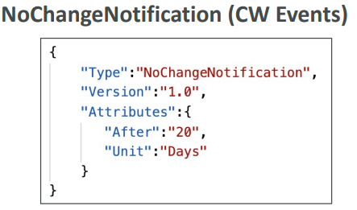

To retrieve parameters stored

1. aws ssm get-parameters –names /my-app/dev/db-url /my-app/dev/db-password
2. aws ssm get-parameters –names /my-app/dev/db-url /my-app/dev/db-password –with-decryption
3. Get parameters within path /my-app/dev/
   1. aws ssm get-parameters-by-path –path /my-app/dev/
4. Get parameters within path /my-app/ recursively
   1. aws ssm get-parameters-by-path –path /my-app/ --recursive
   2. aws ssm get-parameters-by-path –path /my-app/ --recursive –with-decryption

To retrieve parameters stored using lambda function

import boto3

ssm=boto3.client(‘ssm’, region_name=’es-east-3’)

def lambda_handler (event, context):

db_url=ssm.get_parameters (Names=[‘/my-app/dev/db-url’])

print(db_url)

db_password=ssm.get_parameters (Names=[‘/my-app/dev/db-password’], withDecryption=True)

print(db_password)

AWS Secret Manager

1. service for storing secrets
2. difference between secrets manager and the parameter store is that secrets manager is more oriented towards secret and has a capability to force the rotation of your secrets
3. has capability to force rotation of secrets every X days
4. has capability to automate generation of secrets on rotation using lambda
5. You can integrate secrets manager with Amazon RDS (MySQL, PostgreSQL, Aurora) to synchronize your secrets between your databases and secrets manager
6. Secrets are encrypted using KMS
7. Pricing
   1. 40 cents ($0.40) per secret per month
   2. 5 cents ($0.05) for 10,000 API calls
   3. 30 days free trail available

CloudHSM

1. In KMS, AWS manages the software for encryption
2. In CloudHSM, AWS provisions encryption hardware. You will manage your own encryption keys entirely (not AWS)
3. FIPS 140-2 level 3 validated HSM
4. Supports both symmetric and asymmetric encryption
5. No free tier available
6. Must use CloudHSM Client Software
7. Redshift supports CloudHSM for database encryption and key management
8. It is best if you want to implement SSE-C type of encryption

In CloudHSM

1. IAM permissions are used to do a create, read, update and delete of an HSM Cluster at a high level
2. CloudHSM Software is used to manage keys and manage the users and their permissions to access the keys

In KMS

1. Everything is managed using IAM

CloudHSM – High Availability

1. CloudHSM clusters are spread across Multi AZ
2. Great for availability and durability

KMS vs CloudHSM

For asymmetric key on-premises, CloudHSM can be used but not KMS.

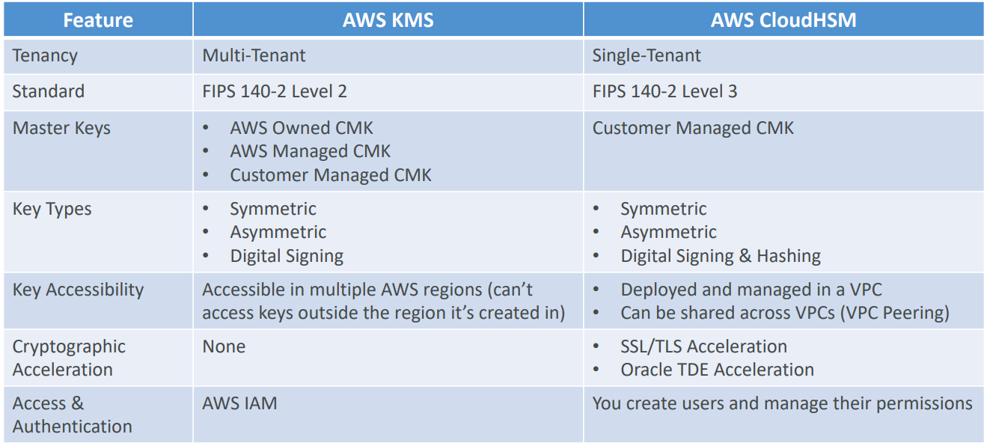

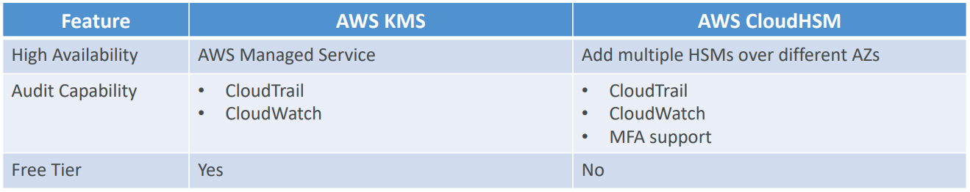

AWS Shield

1. Protection against DDoS attack
2. Has 2 flavours
   1. AWS Shield Standard
      1. Free service activated by default for every AWS customer
      2. Provides protection from attacks such as SYN/UDP floods, reflection attacks and other layer 3/layer 4 attacks
   2. AWS Shield Advanced
      1. Paid service
      2. $3000 per month per organization
      3. Protect against more sophisticated attack on CloudFront, Amazon Global Accelerator, Amazon EC2, ELB, Route 53
      4. 24/7 access to AWS DDoS response team (DRP)
      5. Protect against higher fess during usage spikes due to DDoS

AWS WAF (Web Application Firewall)

1. Protects your web applications from common web exploits (layer 7)
2. Layer 7 is HTTP
3. Can be deployed on Application Load Balancer, API Gateway, CloudFront
4. To use WAF, we need to define Web ACL (Web Access Control List)
   1. Rules can include IP addresses, HTTP headers, HTTP body or URI strings
   2. Protects from common attacks- SQL Injection and Cross-Site Scripting (XSS)
   3. Can set size constraints
   4. Geo-match to block specific countries
   5. Rate-based rules (to count occurrences of events) – for DDoS protection

AWS Firewall Manager

1. Manage all the rules of all your WAFs within an AWS Organization
2. You define a common set of security rules
3. WAF Rules (ALB, API Gateway, CloudFront)
4. AWS Shield Advanced (ALB, CLB, Elastic IP, CloudFront)
5. Security Groups for EC2 and ENI resources in VPC

GuardDuty

1. Intelligent threat detection system to protect AWS account
2. Uses machine learning algorithms, anomaly detection techniques, 3rd party data to detect an attack on your accounts
3. On click to enable (30 days trail)
4. No need to install software
5. Input data includes
   1. CloudTrail Logs to detect unusual API calls and unauthorized deployments
   2. VPC Flow Logs to detect unusual internal traffic and unusual IP address
   3. DNS Logs to detect compromised EC2 instances sending encoded data within DNS queries
6. Can setup CloudWatch Event rules to be notified in case of findings and CloudWatch Events rules can target AWS Lambda or SNS
7. Can protect against CryptoCurrency attacks

Amazon Inspector

1. Automated Security Assessments for EC2 instances
2. Analyze the running OS against known vulnerabilities
3. Analyze against unintended network accessibility
4. AWS Inspector Agent must be installed on OS in EC2 instances
5. After the assessment, you get a report with a list of vulnerabilities
6. Can send notifications to SNS
7. What does AWS Inspector evaluate?
   1. For Network assessments (agentless)
      1. Network Reachability
   2. For Host assessments (with agent)
      1. Common Vulnerabilities and Exposures
      2. Center for Internet Security (CIS) Benchmarks
      3. Security Best Practices

Amazon Macie

1. Uses machine learning and pattern matching to discover and protect your sensitive data in AWS
2. Helps identify and alert you to sensitive data, such as Personally Identifiable Information (PII)
3. Find sensitive data in S3 buckets

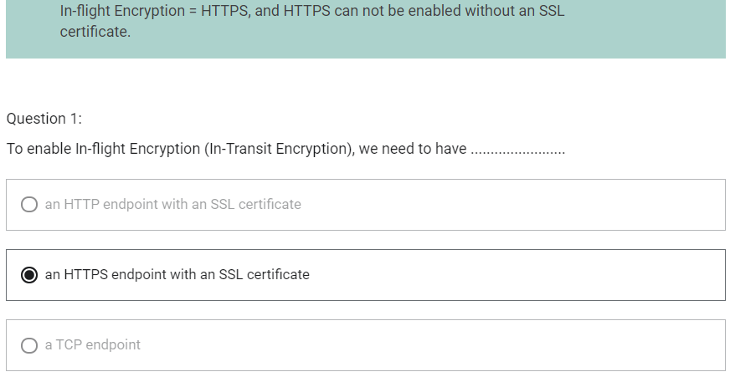

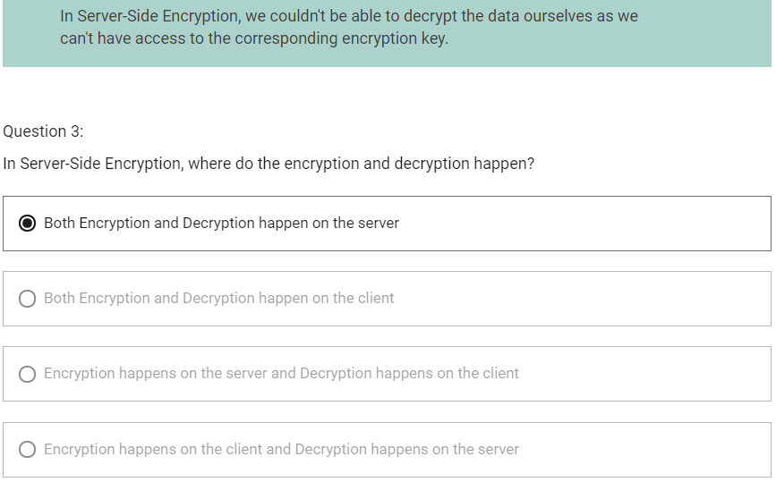

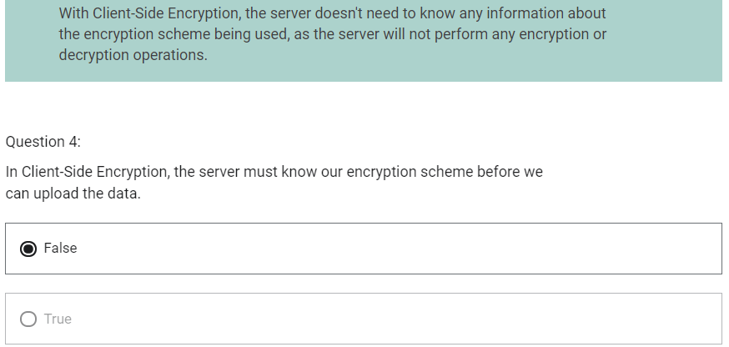

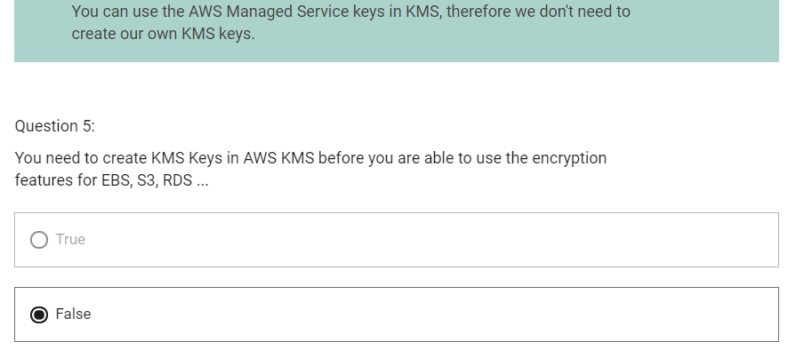

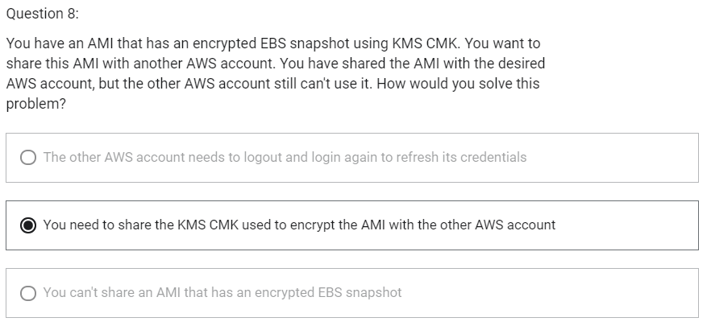

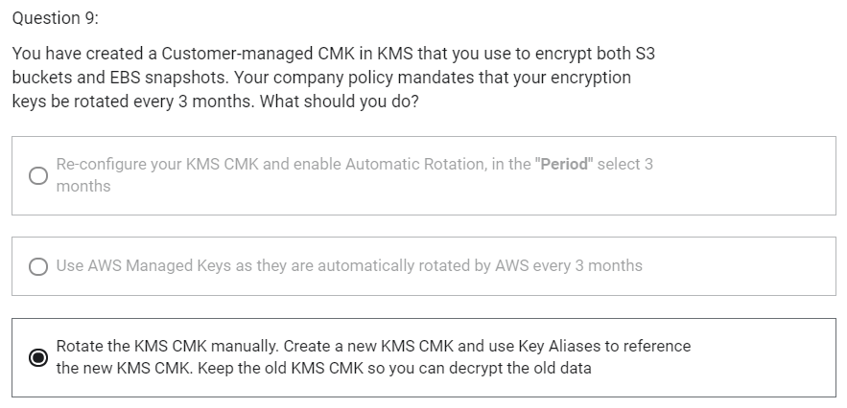

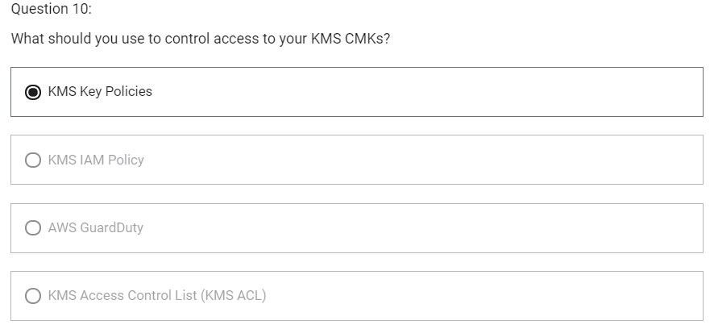

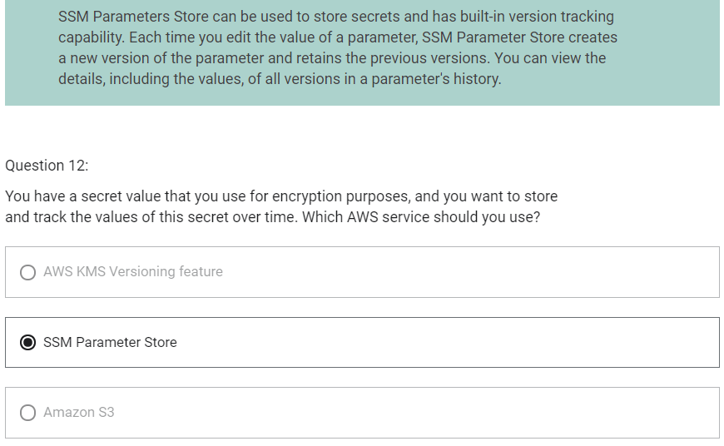

CIDR

1. Classless Inter Domain Routing
2. A method of allocating IP addresses
3. Used in Security Groups rules and AWS networking in general
4. They help to define IP address range
   1. WW.XX.YY.ZZ/32-> one IP
   2. 0.0.0.0/0-> all IPs
   3. 192.168.0.0/26-> 192.168.0.0 – 192.168.0.63 (64 IP addresses)
5. CIDR consists of two components
   1. Base IP
      1. Represents an IP contained in the range (XX.XX.XX.XX)
      2. Example: 10.0.0.0, 192.168.0.0
   2. Subnet Mask
      1. Defines how many bits can change in the IP
      2. Example: /0, /24, /32
      3. Can take two forms
         1. /8 – 255.0.0.0
         2. /16 – 255.255.0.0
         3. /24 – 255.255.255.0
         4. /32 – 255.255.255.255

Understanding CIDR – Subnet mask

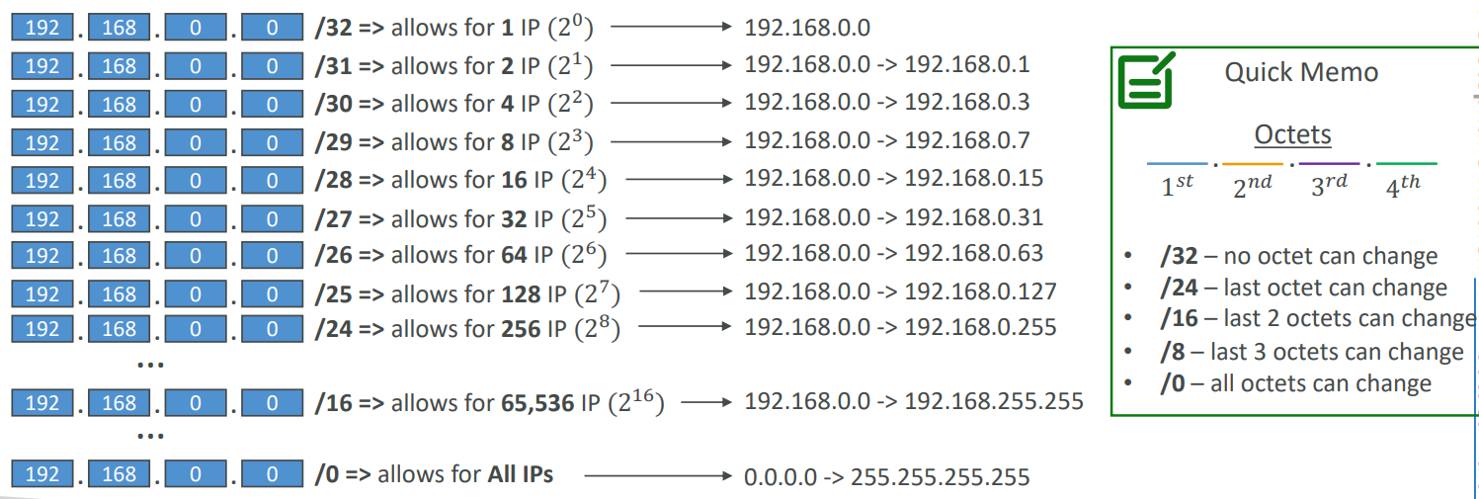

1. Subnet Mask basically allows part of the underlying IP to get additional next values from the base IP

192.168.0.0/0 – 0.0.0.0 -> 255.255.255.255

192.168.0.0/16 – 192.168.0.0 -> 192.168.255.255

192.168.0.0/24 – 192.168.0.0 -> 192.168.0.255

192.168.0.0/32 – 192.168.0.0

192.163.0.0/24 - 192.163.0.0 -> 192.163.0.255

192.168.0.0/16 – 192.168.0.0 -> 192.168.255.255

134.56.78.123/32 - 134.56.78.123

Public IP vs Private IP (IPv4)

1. The Internet Assigned Numbers Authority (IANA) established certain blocks of IPv4 addresses for the use of private (LAN) and public (Internet) addresses
2. Private IP can only allow certain values
   1. 10.0.0.0 -10.255.255.255 (10.0.0.0/8)-> in big network
   2. 172.16.0.0 – 172.31.255.255 (172.16.0.0/12)-> AWS default VPC in that range
   3. 192.168.0.0 – 192.168.255.255 (192.168.0.0/16)-> eg. Home network
3. All the rest of the IP addresses on the Internet are public

Default VPC

1. All new AWS accounts have a default VPC.
2. New EC2 instances are launched into the default VPC if no subnet is specified
3. Default VPC has Internet connectivity and all EC2 instances inside it have public IPv4 addresses
4. We also get a public and a private IPv4 DNS names
5. By default, default VPC will have 3 subnets across 3 AZ

VPC

1. Virtual Private Cloud
2. You can have multiple VPCs in an AWS region (max 5 per region – soft limit)
3. Max CIDR per VPC is 5, for each CIDR:
   1. Min size is /28 (16 IP addresses)
   2. Max size is /16 (65536 IP addresses)
4. Because VPC is private, only the private IPv4 ranges are allowed
   1. 10.0.0.0 -10.255.255.255 (10.0.0.0/8)
   2. 172.16.0.0 – 172.31.255.255 (172.16.0.0/12)
   3. 192.168.0.0 – 192.168.255.255 (192.168.0.0/16)
5. Your VPC CIDR should not overlap with that of another VPC pr other networks
6. There is option called Tenancy while creating VPC and we can choose between Default and Dedicated. This defines whether EC2 Instances launched within this VPC with have dedicated hardware or shared hardware.

VPC- Subnet (IPv4)

1. AWS reserves 5 IP addresses (first 4 and last 1) in each subnet
2. These 5 IP addresses are not available for use and can’t be assigned to an EC2 instance
3. Example: if CIDR block 10.0.0.0/24, then reserved IP addresses are:
   1. 10.0.0.0 – Network Address
   2. 10.0.0.1 – Reserved by AWS for the VPC router
   3. 10.0.0.2 – Reserved by AWS for mapping to Amazon-provided DNS
   4. 10.0.0.3 – Reserved by AWS for future use
   5. 10.0.0.255 – Network Broadcast Address
4. Exam tip
   1. If you need 29 IP addresses for EC2 instances:
      1. You cannot choose a subnet of size /27 (32 IP addresses, 32-5 = 27 < 29)
      2. You need to choose a subnet of size /26 (64 IP addresses, 64-5 = 59 > 29)

Internet Gateway

1. Allows resources in a VPC to connect to the Internet
2. Scales horizontally and is highly available and redundant
3. Must be created separately from a VPC
4. One VPC can only be attached to one Internet Gateway and vice versa
5. Internet Gateway on their own do not allow Internet access. For this, we must also edit Route Tables

Baston Hosts

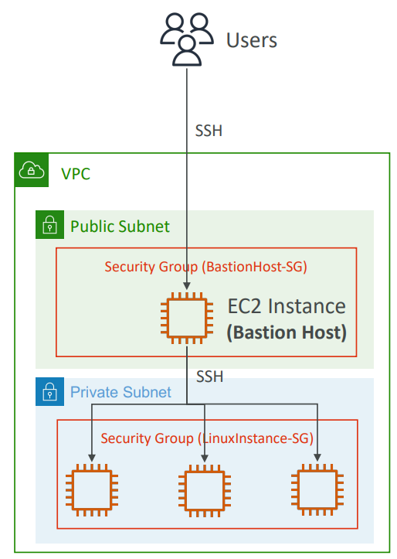

1. It is EC2 Instance in public subnet that provides us a way to SSH into our private EC2 instances from the Internet
2. The baston is in the public subnet which is then connected to all other private subnets
3. Bastion Host security group must be tightened
4. Make sure the bastion host only has port 22 traffic from the IP address you need, not from the security groups of your other EC2 instances

NAT Instance

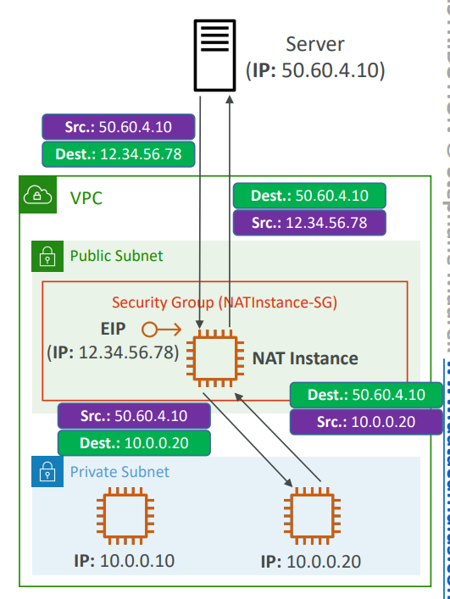

1. NAT=Network Address Translation
2. Allows EC2 instances in private subnets to connect to the Internet
3. Must be launched in a public subnet
4. Must disable setting: Source/Destination Check. This is because a NAT instance must be able to send and receive traffic when the source or destination is not itself.
5. Must have Elastic IP attached to it
6. Route tables must be configured to route traffic from private subnets to the NAT Instance

NAT Gateway

1. AWS managed NAT, higher bandwidth, high availability, no administration
2. Pay per hour for usage and bandwidth
3. NATGW is created in a specific AZ, uses an Elastic IP
4. Cannot be used by EC2 instance in the same subnet (only from other subnets)
5. Require an IGW (Private Subnet -> NATGW -> IGW)
6. 5 Gbps of bandwidth with automatic scaling up to 45 Gbps
7. No security Groups to manage/ required

NAT Gateway with High Availability

1. NAT Gateway is resilient within a single AZ
2. Must create multiple NAT Gateways in multiple AZs for fault-tolerance

NAT Gateway vs NAT Instance

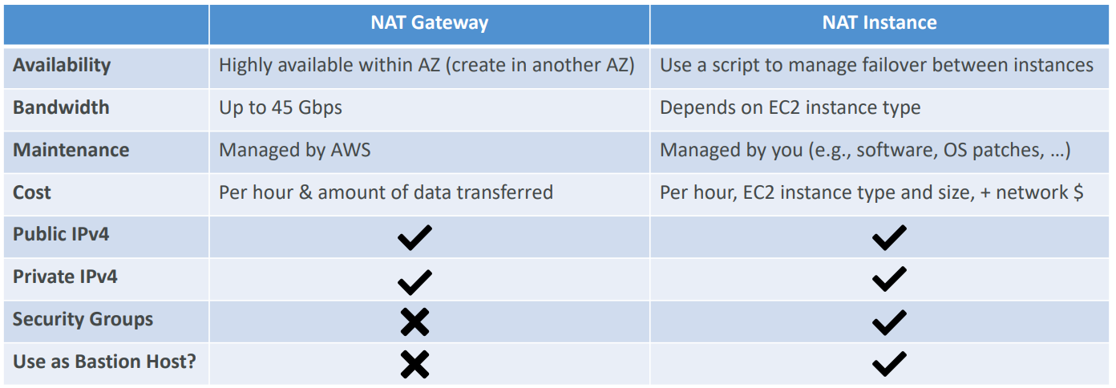

DNS Resolution in VPC

There are two DNS settings that we can find in VPC

1. DNS Resolution called enableDnsSupport

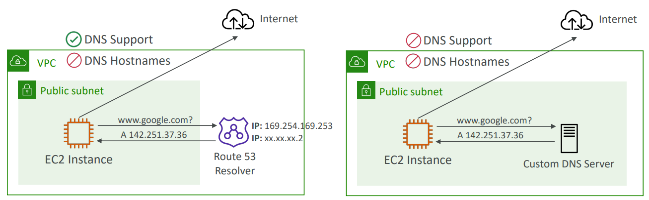

* 1. This is to decide if DNS resolution from Route 53 Resolver server is supported for the VPC
  2. By default, this setting is True
  3. This means that EC2 Instances within your VPC will be able to query Amazon Provider DNS Server at 169.254.169.253 or the reserved IP address at the base of the VPC IPv4 network range plus two (.2)

1. DNS Hostnames (enable DnsHostnames)

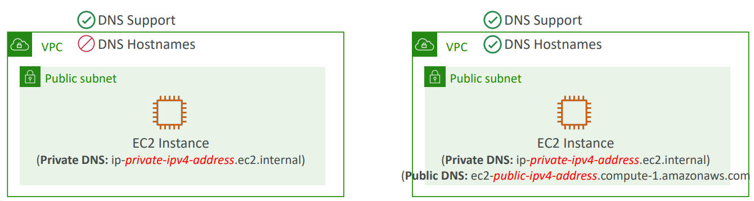

* 1. By default, it is True for default VPC and False for newly created VPC
  2. Won’t do anything unless enableDnsSupport is True
  3. If it is True, public hostname will be assigned to EC2 instance if it has a public IPv4

1. Why do we want to enable both settings?

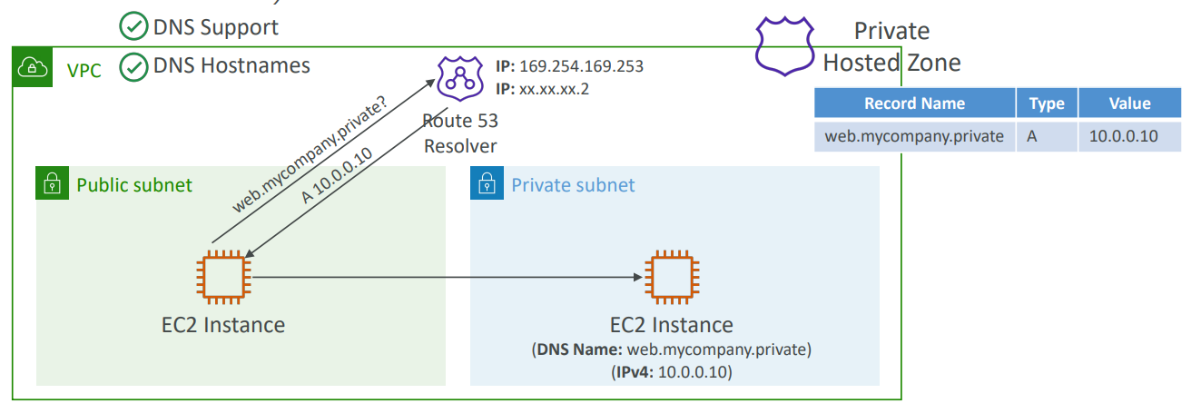

Security Groups and NACL (Network Access Control List)

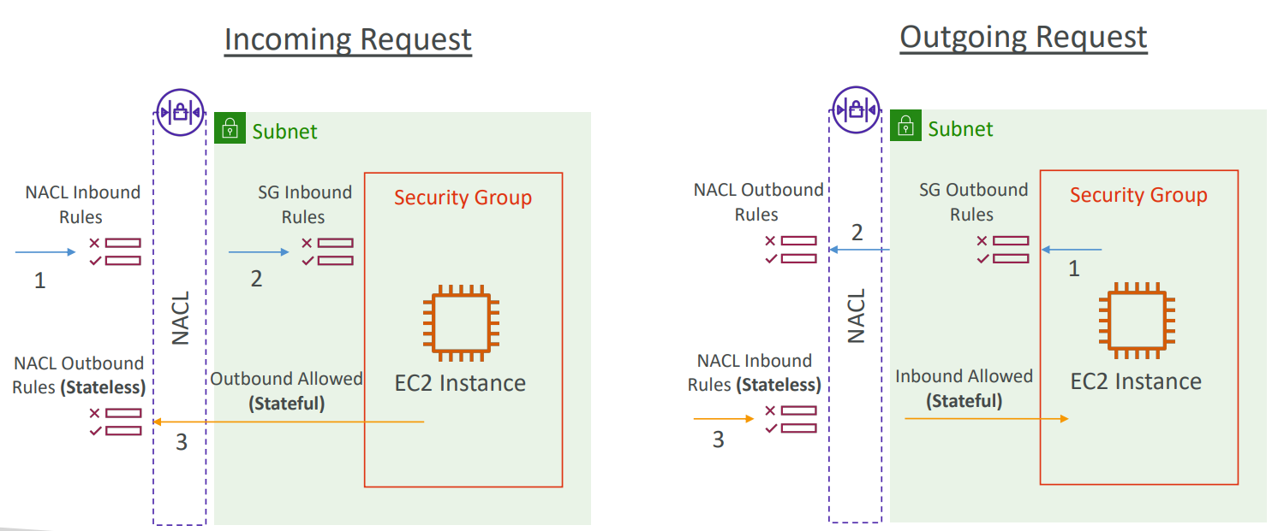

NACL

1. Network Access Control List
2. Firewall which control traffic from and to subnets
3. You can define NACL rules
   1. Rules have a number (1-32766)
   2. Higher precedence with a lower number
   3. First rule match will drive the decision
   4. Example: if you define #100 ALLOW 10.0.0.10/32 and #200 DENY 10.0.0.10/32, the IP address will be allowed because 100 has a higher precedence over 200
   5. The last rule is an asterisk (*) and denies a request in case of no rule match
   6. AWS recommends adding rules by increment of 100
4. Newly created NACLs will deny everything
5. NACL are a great way of blocking a specific IP address at the subnet level
6. Default NACL accepts everything inbound/ outbound with the subnets it is associated with

Ephemeral Ports

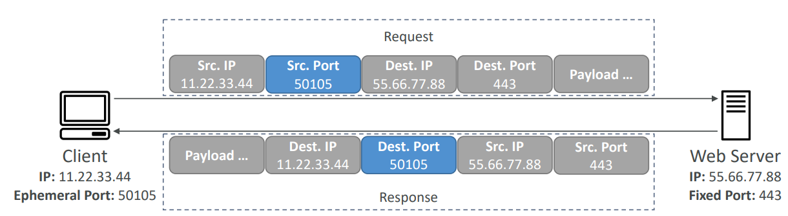

1. For any two endpoints to establish a connection, they must use ports
2. Clients connect to a defined port, and expect a response on an ephemeral port
3. They are called ephemeral as these port are random and assign for that connection life

Security group

1. Firewall at instance level
2. Supports allow rule only
3. It is stateful: return traffic is automatically allowed, regardless of any rules
4. All rules are evaluated before deciding whether to allow traffic
5. Applies to an EC2 instance when specified by someone

Security Group vs NACL

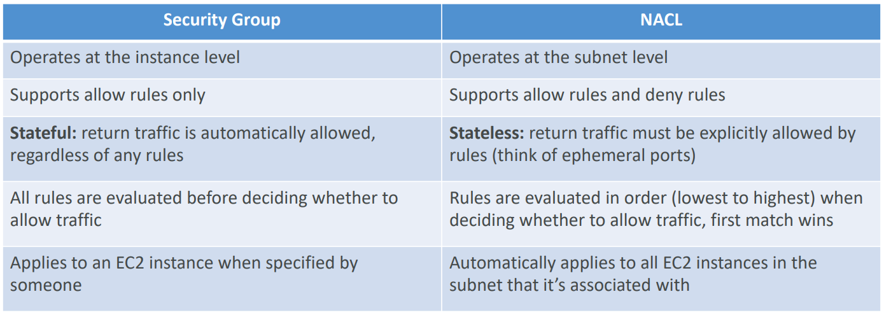

VPC- Reachability Analyzer

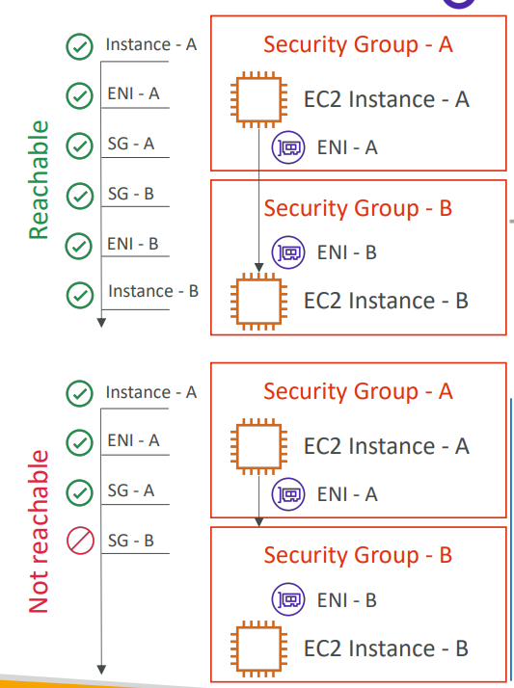 

1. A network diagnostics tool that troubleshoots network connectivity between two endpoints in your VPCs
2. It builds a model of the network configuration, then checks the reachability based on these configurations (it does not send packets)
3. When the destination is
   1. Reachable- it produces hop-by-hop details of the virtual network path
   2. Not reachable- it identifies the blocking components(s)
4. Use case
   1. Troubleshoot connectivity issues
   2. Ensure network configuration is an intended
5. Price: $0.10 (10 cents) per analysis

VPC Peering

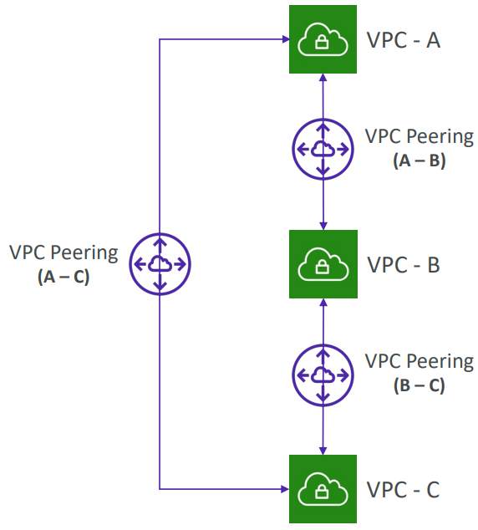

1. Privately connect two VPCs using AWS network
2. Make them behave as if they were in the same network
3. Must have overlapping CIDRs
4. VPC Peering connections is not transitive (must be established for each VPC that need to communicate with one another)
5. You must update route tables in each VPCs subnets to ensure EC2 instances can communicate with each other
6. You can create VPC Peering connection between VPCs in different AWS accounts/regions
7. You can reference a security group in a peered VPC (works cross accounts-same region)

VPC Endpoints

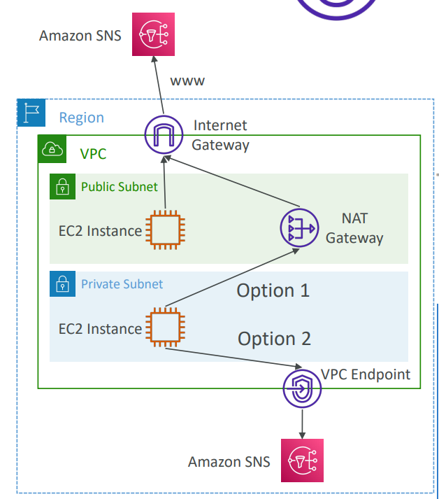

1. AWS PrivateLink
2. Every AWS service is publicly exposed (public URL)
3. VPC Endpoints allows you to connect to AWS services using a private network instead of using the public Internet
4. They are redundant and scale horizontally
5. They remove the need of Internet Gateway, NAT Gateway to access AWS Services
6. In case of issues
   1. Check if DNS Setting Resolution in your VPC is activated
   2. Check Route Tables
7. Types of Endpoints
   1. Interface Endpoints
      1. Provisions an ENI (private IP address) as an entry point (must attach a security group)
      2. Supports most AWS services
   2. Gateway Endpoints
      1. Provisions a gateway and must be used as a target in a route table
      2. Supports S3 and DynamoDB

VPC Flow Logs

1. Capture information about IP traffic going into your interfaces
2. They can be in VPC level or Subnet level or Interface level
   1. VPC Flow Logs
   2. Subnet Flow Logs
   3. Elastic Network Interface (ENI) Flow Logs
3. Helps to monitor and troubleshoot connectivity issues
4. Flow logs data can be sent to S3 or CloudWatch Logs
5. They also capture network information from AWS managed interfaces like ELB, RDS, ElastiCache, Redshift, ..
6. VPC flow log contains
   1. Version
   2. Account-id
   3. Interface-id
   4. Srcaddr – help to identify problematic IP
   5. Dstaddr – help to identify problematic IP
   6. Srcport – help to identify problematic ports
   7. Dstport – help to identify problematic ports
   8. Protocol
   9. Packets
   10. Bytes
   11. Byte
   12. Start
   13. End
   14. Action – success or failure of the request due to Security Group/ NACL
   15. Log-status
7. Can be used for analytics on usage patterns or malicious behavior
8. Query VPC flow logs using Athena on S3 or CloudWatch Logs Insights

How do we use VPC Flow Logs to troubleshoot Security Group and NACL issues?

1. Look at the “ACTION” field
2. In case of incoming requests
   1. If INBOUND is rejected, it can be NACL or SG issue
   2. If INBOUND is accepted but OUTBOUND is rejected, it is NACL issue
3. In case of outgoing requests
   1. If OUTBOUND is rejected, it can be NACL or SG issue
   2. If OUTBOUND is accepted but INBOUND is rejected, it is NACL issue

Site to Site VPN

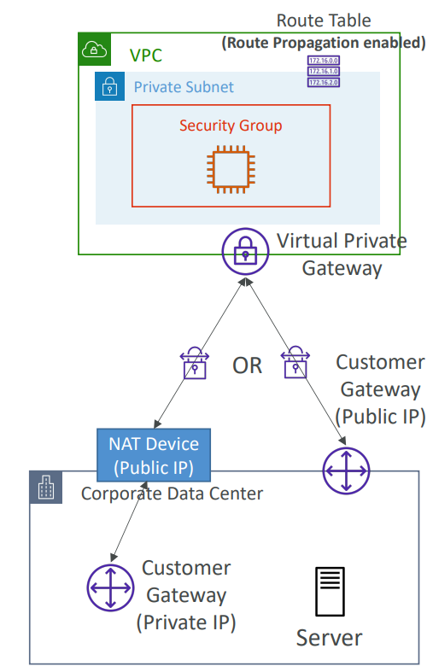

1. Connect on-premises network with cloud
2. Requires two things
   1. Virtual Private Gateway
      1. VPN on AWS side
   2. Customer Private Gateway
      1. VPN on customer side
      2. What IP to use?
         1. If your customer gateway is public, enable connection between Virtual Private Gateway and Customer Gateway using Public IP
         2. If your customer gateway is private, there should be NAT device and IP address to be used is Public IP of NAT device
3. Important Step: enable Route Propagation for the Virtual Private Gateway in the route table that is associated with your subnets
4. If you need to ping your EC2 instances from on-premises, make sure you add the ICMP protocol on the inbound of your security groups

AWS VPN CloudHub

1. Provides secure communication between multiple sites, if you have multiple VPN connections
2. Low-cost hub-and-spoke model for primary or secondary network connectivity between different locations (VPN only)
3. To set it up, connect multiple VPN connections on the same VGW, setup dynamic routing and configure route tables

Direct Connect (DX)

1. Provides a dedicated private connection from a remote network to your VPC
2. Dedicated connection must be setup between your direct connect and AWS Direct Connect Locations
3. You need to setup a Virtual Private Gateway on your VPC
4. In the same connection, you are able to access public resources such as (S3) and private resources such as (EC2)
5. Hybrid environment
6. Benefits
   1. Increased bandwidth
   2. Decrease latency
7. Supports both IPv4 and IPv6

Direct Connect Gateway

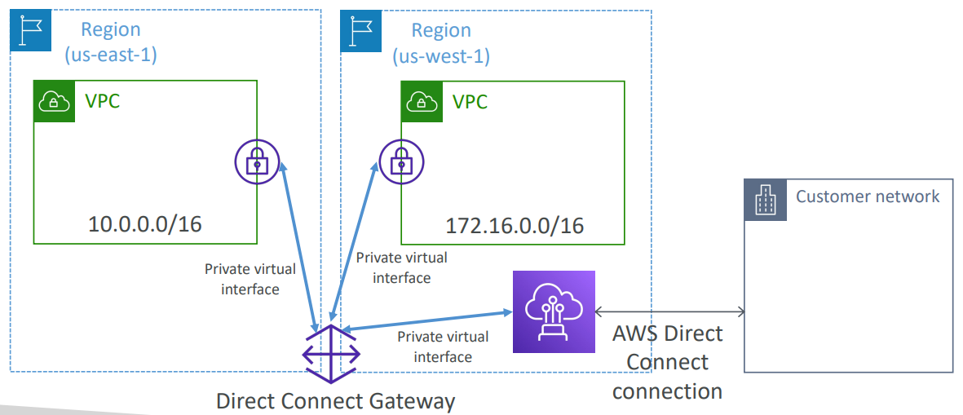

1. If you want to setup a Direct Connect between on-premises network and one or more VPC in many different regions (same account), you must use a Direct Connect Gateway

Direct Connect – Connection Types

1. Dedicated Connections
   1. 1 Gbps and 10 Gbps capacity
   2. Physical ethernet port dedicated to a customer
   3. Request made to AWS first, then completed by AWS Direct Connect Partners
2. Hosted Connections
   1. 50 Mbps, 500 Mbps to 10 Gbps
   2. Capacity can be added or removed on demand
   3. 1, 2, 5, 10 Gbps available at select AWS Direct Connect Partners
3. It takes more than 1 month to establish connection using Direct Connect

Direct Connect – Encryption

1. When we use direct connect, it is private and data in transit is not encrypted
2. If we want encryption on top of Direct Connect, we can use AWS Direct Connect + VPN which provides an IPsec-encrypted private connection
3. Good for an extra level of security

Direct Connect – Resiliency

1. High Resiliency for Critical Workloads

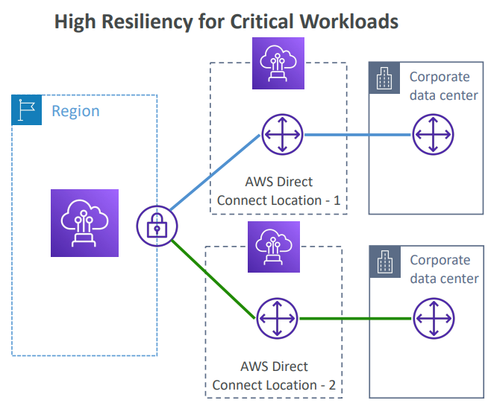

* 1. One connection at multiple locations

1. Maximum Resiliency for Critical Workloads

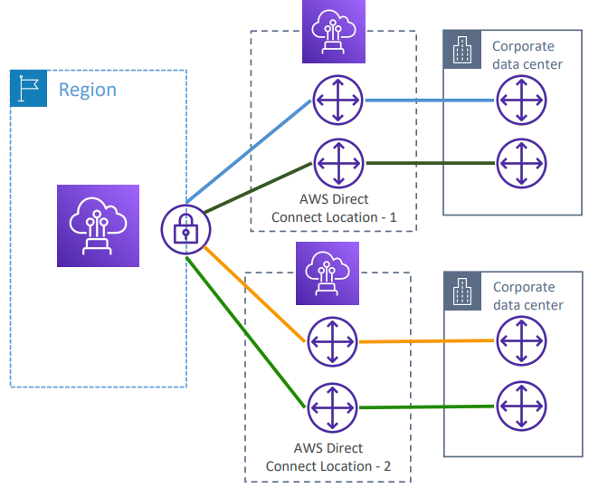

* 1. Maximum resiliency is achieved by separate connections terminating on separate devices in more than one location

AWS PrivateLink (VPC Endpoint Services)

1. Most secure and scalable way to expose a service to 1000s of VPC (own or other accounts)
2. Does not require VPC peering, Internet Gateway, NAT, Route tables, ..
3. Requires a network load balancer (Service VPC) and ENI (Customer VPC) or GWLB
4. If the NLB is in multiple AZ, and the ENI is in multiple AZ, the solution is fault tolerant

EC2-Classic and AWS ClassicLink (deprecated)

EC2-Classic

1. Instances run in a single network shared with other customers

Amazon VPC

1. Your instances run logically isolated to your AWS account

ClassicLink

1. Allows you to link EC-Classic instances to a VPC in your account
2. Must associate a security group
3. Enables communication using private IPv4 addresses
4. Removes the need to make use of public IPv4 addresses or Elastic IP addresses

Transit Gateway

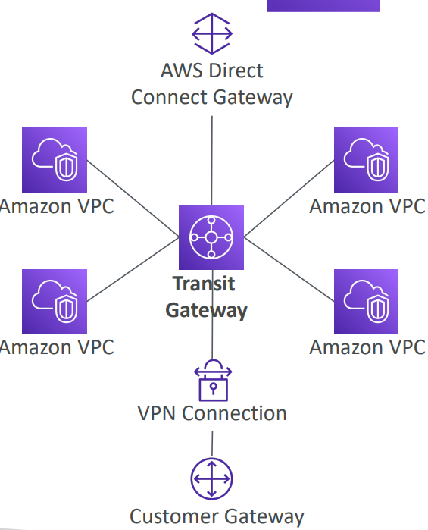

1. Hub-and-spoke (Star) connection for having transitive peering between thousands of VPC and on-premises
2. Regional resource
3. Can work cross-region
4. Share cross-account using Resource Access Manager (RAM)
5. You can peer Transit Gateways across regions
6. Route tables are used to limit which VPC can talk with other VPC
7. Works with Direct Connect Gateway, VPN Connections
8. Supports IP Multicast (it is the only service in AWS that supports IP Multicast)

Transit Gateway: Site-to-Site VPN ECMP

1. Another usecase of Transit Gateway is to increase bandwidth of your multiple Site-to-Site VPN Connection using ECMP
2. Equal-cost Multi-path routing
3. Routing strategy to allow to forward a packet over multiple best path
4. If you do VPN to Virtual Private Gateway
   1. You will get one connection into one VPC
   2. This connection will give 1.25 Gbps as maximum throughput
   3. In this case VPN connections are made up of 2 tunnels
5. But, if you are using VPN into Transit Gateway
   1. You will get one site to site VPN into many VPC
   2. 1 connection gives 2.5 Gbps of throughput using ECMP (2 tunnels)
   3. 2 connections give 5 Gbps of throughout
   4. 3 connections give 7.5 Gbps of throughput
   5. You need to pay per GB of data going through transit gateway

Transit Gateway – Share Direct Connect between multiple accounts

1. Another usecase of Transit Gateway is to share direct connect connections between multiple accounts
2. You can use AWS Resource Manager to share Transit Gateway with other accounts

VPC – Traffic Mirroring

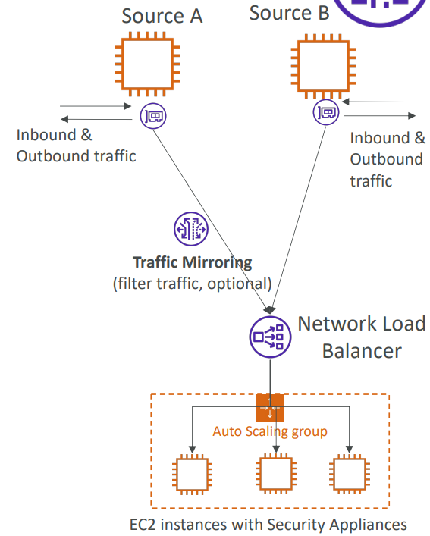

1. Allows you to capture and inspect network traffic in your VPC
2. Route the traffic to security appliances that you amange
3. Capture the traffic
   1. From (Source) – ENIs
   2. To (Targets) – an ENI or a Network Load Balancer
4. Capture all packets or capture the packets of your interest using filtering
5. Source and Target can be in the same VPC or different VPCs (VPC peering)
6. Use case
   1. Content inspection
   2. Threat monitoring
   3. Troubleshooting

IPv6

1. IPv6 is the successor of IPv4
2. IPv6 is designed to provide 3.4x10^38 unique IP addresses
3. Every IPv6 address is public and Internet- routable (no private range)
4. Format-> x.x.x.x.x.x.x.x (x is hexadecimal range and can be from 0000 to ffff)
5. Examples
   1. 2001:db8:3333:4444:5555:6666:7777:8888
   2. :: -> all 8 segments are zero
   3. 2001:db8:: -> last 6 segments are zero
   4. ::1234:5678 -> first 6 segments are zero
   5. 2001:db8::1234:5678 -> the middle 4 segments are zero

IPv6 in VPC

1. IPv4 cannot be disabled for your VPC and subnets
2. You can enable IPv6 (they are public IP addresses) to operate in dual-stack mode
3. Your EC2 instances will get at least a private internal IPv4 and a public IPv6
4. They can communicate using either IPv4 or IPv6 to the Internet through an Internet Gateway

IPv6 Troubleshooting

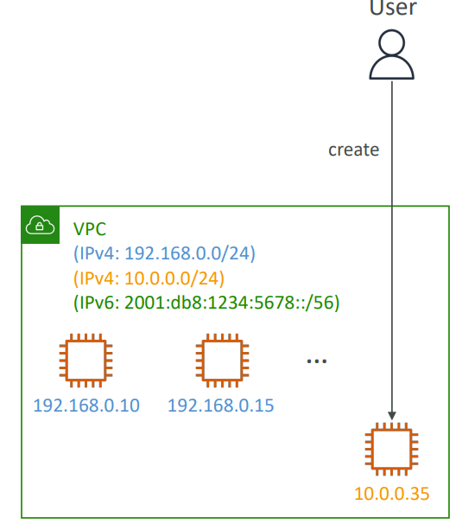

1. IPv4 cannot be disabled for your VPC and subnets
2. So, if you cannot launch an EC2 instance in your subnet
   1. It is not because it cannot acquire an IPv6 (the space is very high)
   2. It is because there are no available IPv4 in your subnet
3. Solution
   1. Create a new IPv4 CIDR in your subnet

Egress-only Internet Gateway

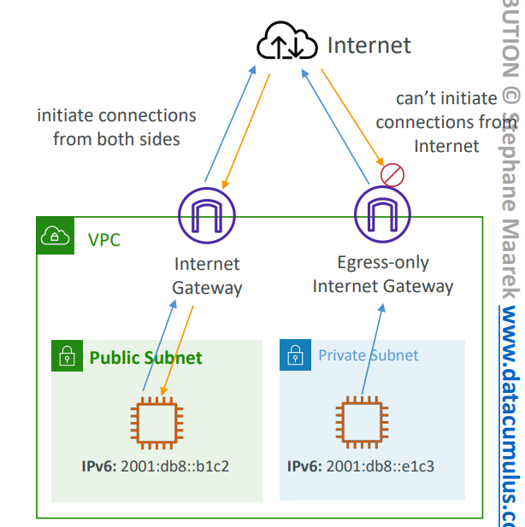

1. Used only for IPv6 traffic
2. Similar to NAT gateway but for IPv6 traffic
3. Allows instances in your VPC outbound connections over IPv6 while preventing the Internet to initiate an IPv6 connection to your instances
4. You must update the Route Tables

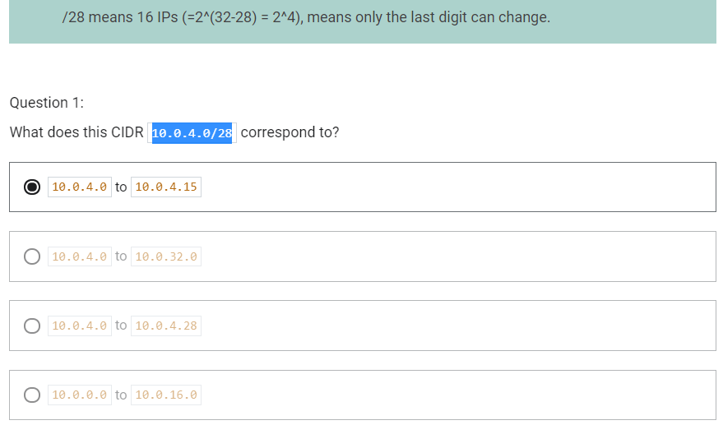

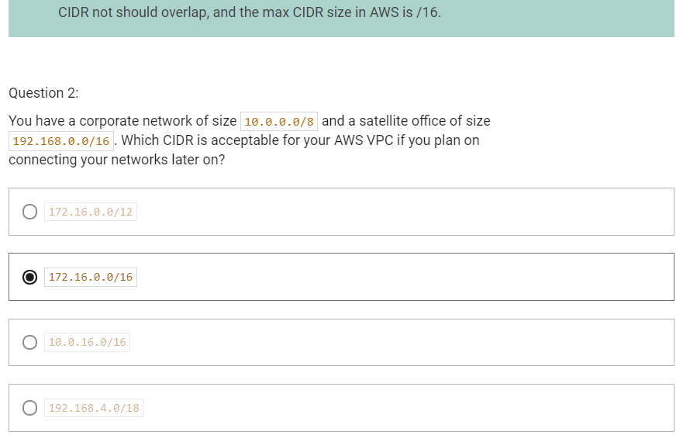

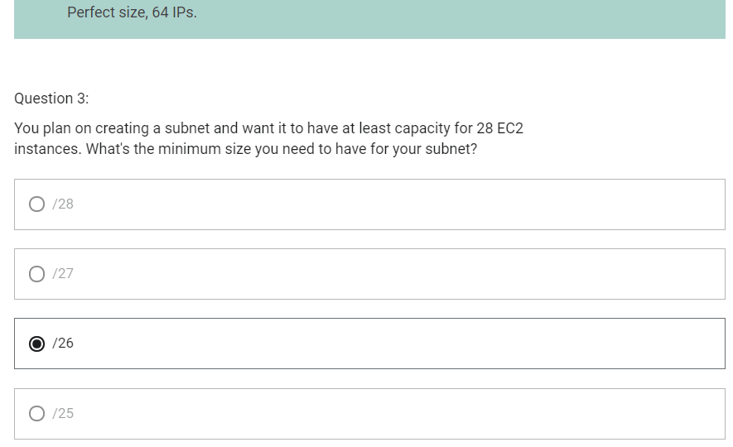

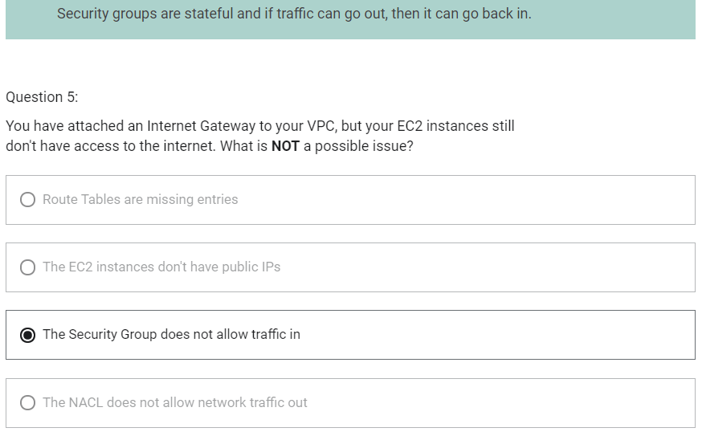

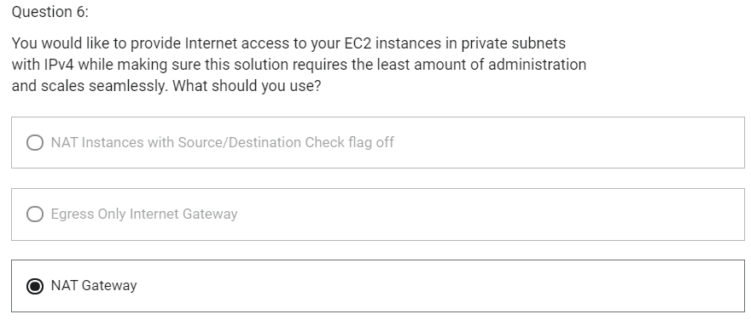

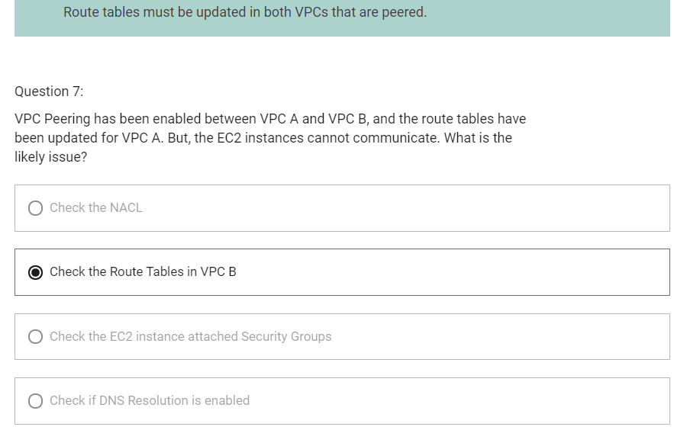

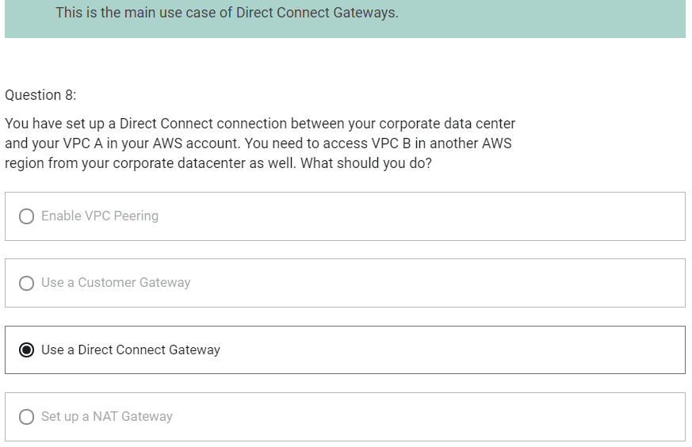

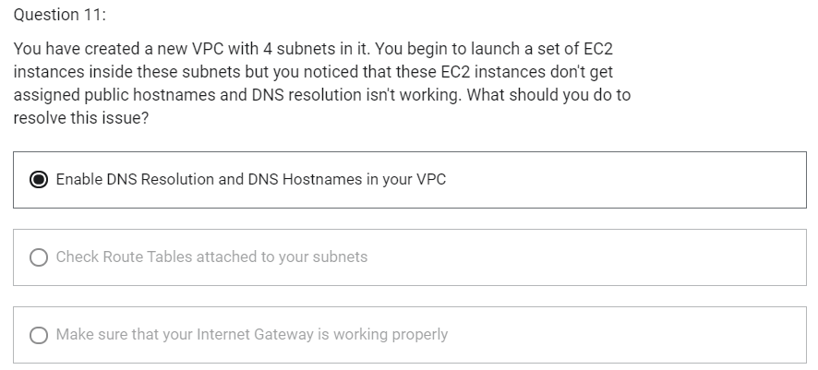

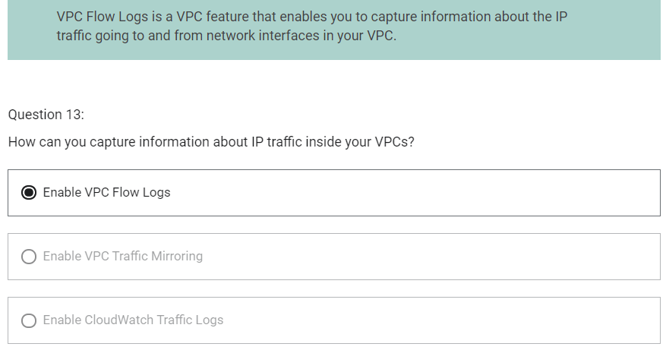

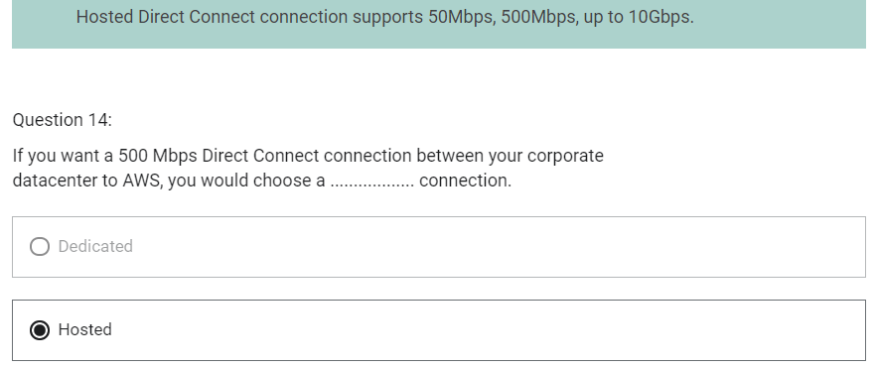

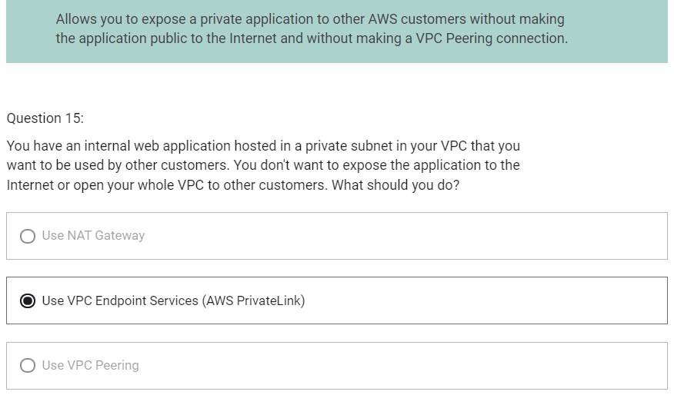

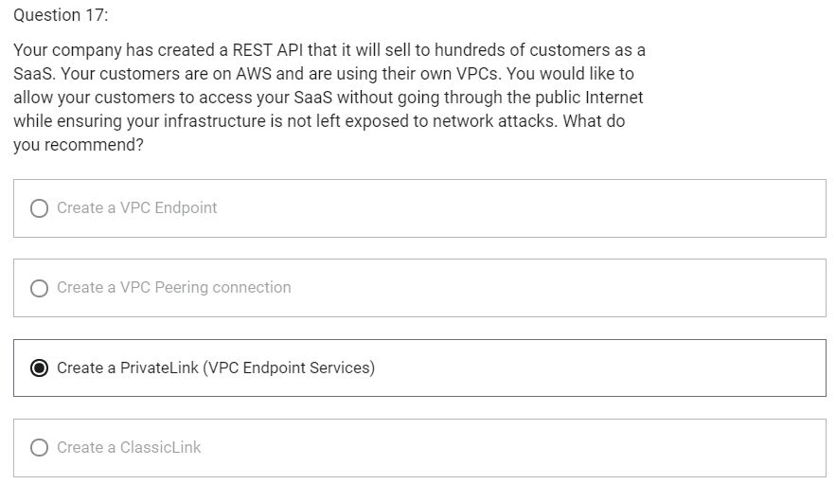

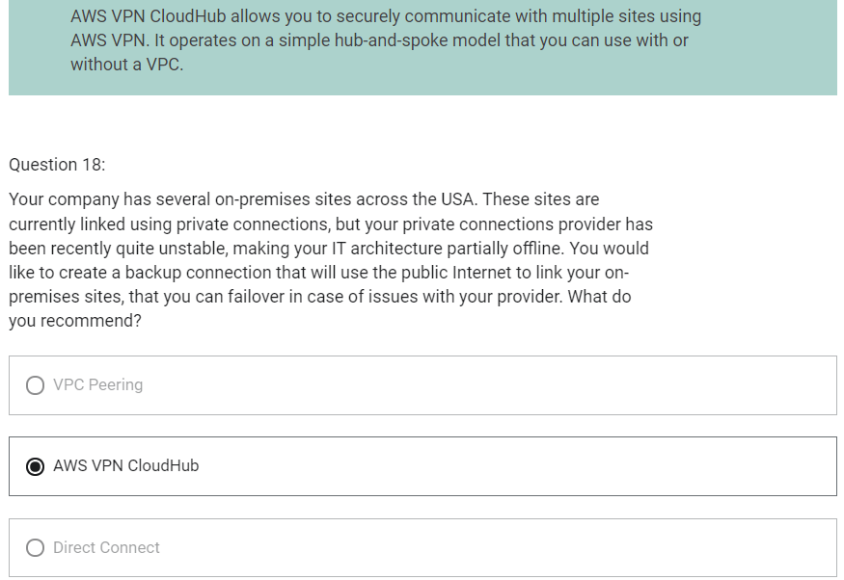

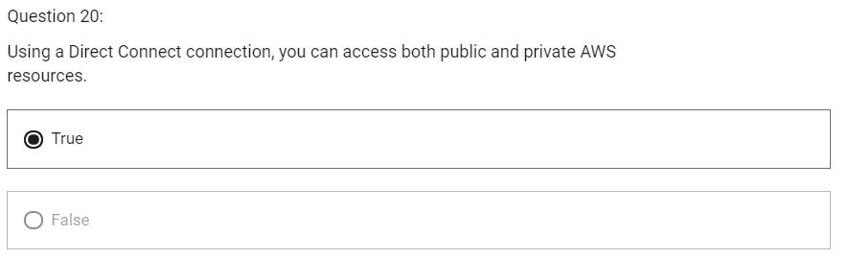

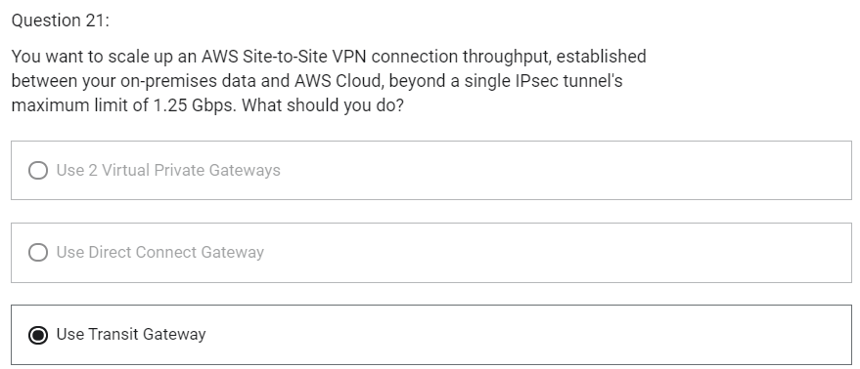

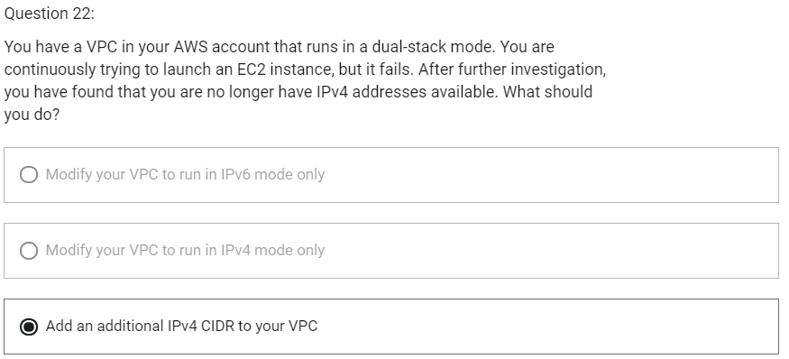

Networking Costs in AWS

1. Any traffic going into your EC2 instance is free (Any incoming traffic into EC2 is free)
2. Any traffic between two instances will be free assuming that they are using Private IP to communicate (instances in same AZ)
3. If two instances in different AZ in same region need to communicate with each other using Public IP/ Elastic IP, cost is $0.02 per GB
4. If two instances in different AZ in same region need to communicate with each other using Private IP, cost is $0.01 per GB
5. If two instances in different region need to communicate with each other, cost is $0.02 per GB

Takeaway

1. Use private IP instead of Public IP for good savings and better network performance
2. If there are instances that need to communicate much with each other, use same AZ for maximum savings

Minimizing egress traffic network cost

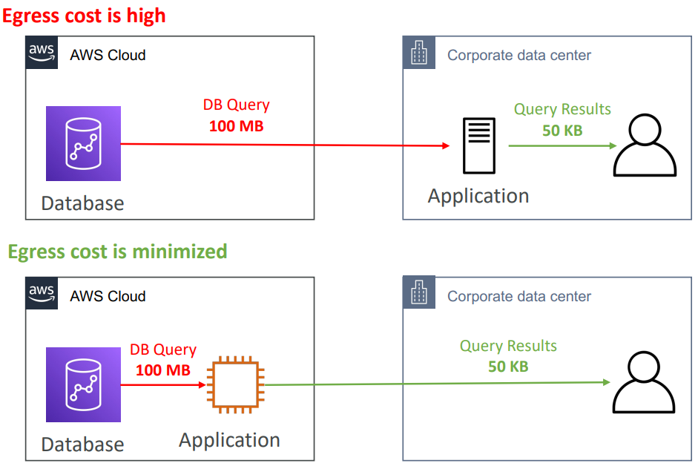

1. Egress traffic: outbound traffic from AWS to outside
2. Ingress traffic: inbound traffic- from outside to AWS (typically free)
3. Try to keep as much internet traffic within AWS to minimize costs
4. Direct Connect location that are co-located in the same AWS Region result in lower cost for egress network

S3 Data Transfer Pricing – Analysis for USA

1. S3 ingress (upload): free
2. S3 to Internet (download): $0.09 per GB
3. S3 Transfer Acceleration
   1. Faster transfer times (50 to 500% better)
   2. Additional cost on top of Data Transfer Pricing +$0.04 to $0.08 per GB
4. S3 to CloudFront: any data transfer between S3 and CloudFront is free
5. CloudFront to Internet: $0.085 per GB
6. S3 Cross Region Replication: $0.02 per GB

Pricing NAT Gateway vs Gateway VPC Endpoint

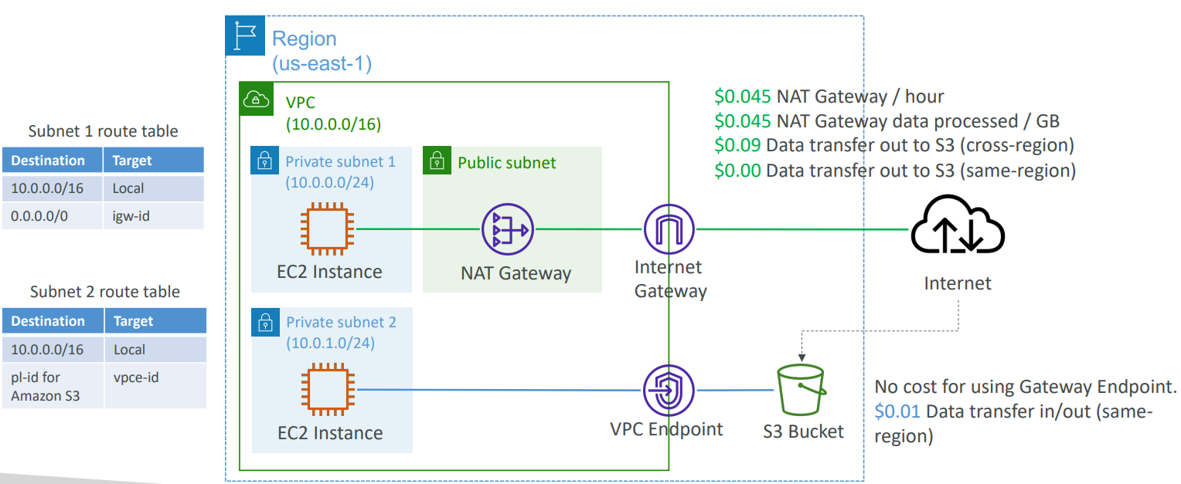

1. NAT Gateway
   1. $0.045 NAT Gateway/hour
   2. $0.045 NAT Gateway data processed/GB
   3. $0.09 data transfer out to S3 (cross-region)
   4. $0.00 data transfer out to S3 (same-region)
2. Gateway VPC Endpoint
   1. No cost for using Gateway Endpoint
   2. $0.01 data transfer in/out (same region)